

Used Cars Price Analysis – A Data Analytics Study
A Comprehensive Data Analytics Study of Used cars
Data analytics project
by
Adada Lokeswararao

Acknowledgment

I would like to express my sincere gratitude to all those who supported me throughout the completion of this project titled "Used Cars Price Analysis". Special thanks to the mentors and faculty members for their guidance, and to the CarWale platform for hosting publicly accessible data that enabled the execution of this analysis. This study was made possible through tools like Python, BeautifulSoup, Pandas, Matplotlib, and Plotly, which provided the backbone for scraping, cleaning, and visualizing data. Lastly, I thank my peers and family for their continuous encouragement and motivation.

Chapter 1: Introduction
With the surge in demand for pre-owned vehicles, especially in urban India, platforms like CarWale have become essential sources for buyers. However, there’s a lack of transparency in how prices vary across different brands, fuel types, and EMI structures. This project was initiated to examine trends in used car pricing, enabling buyers to make smarter, data-backed purchasing decisions.

Chapter 2: Problem Definition
Core Issues Identified:
- Lack of clarity on price differences across car brands and models.
- Difficulty in identifying well-performing, reliable vehicles within a budget.
- Inconsistent EMI and financing options for similar cars.
- A fragmented marketplace that doesn’t allow easy comparison.
This study addresses the above issues using a structured data analytics approach to derive useful insights from actual listings.

Chapter 3: Objectives
This project aims to:
- Extract real-time used car listings from CarWale.
- Analyze and visualize pricing trends based on brand, fuel type, EMI options, model type and location.
- Identify cars that offer the best balance of cost and value.
- Present the analysis in a clear, user-friendly format.

Chapter 4: Data Acquisition
Source:
- Website: CarWale - Used Cars Section
Scraping Methodology:
- Used Python's requests and BeautifulSoup libraries.
- Captured details such as: Car Name & Brand, Price, EMI Estimate, Fuel Type, Year of Manufacture, Location
Tools Used:
- BeautifulSoup & Requests: For HTML parsing
- Pandas: For structuring and storing scraped data

Chapter 5: Data Cleaning and Preprocessing

Steps Taken:
- Converted currency-formatted strings to numerical values.
- Handled missing or null entries.
- Standardized naming for fuel types and car brands.
- Removed duplicates and ensured consistency in data types.
Technologies Used:
- Python (Pandas, NumPy)
- Jupyter Notebook for iterative development

Chapter 6: Data Analysis and Visualization
Key Analytical Approaches:
- Brand vs. Price Analysis
- Fuel Type Insights
- EMI Analysis
- Distribution by Brand
Visualization Tools:
- Tableau(for interactive dashboards)

Chapter 7: Dashboard Overview
Included plots for:
- Price distribution per brand
- Car counts per manufacturer
- EMI vs Price scatter plots
- Pie charts showing fuel type usage

Dashboard
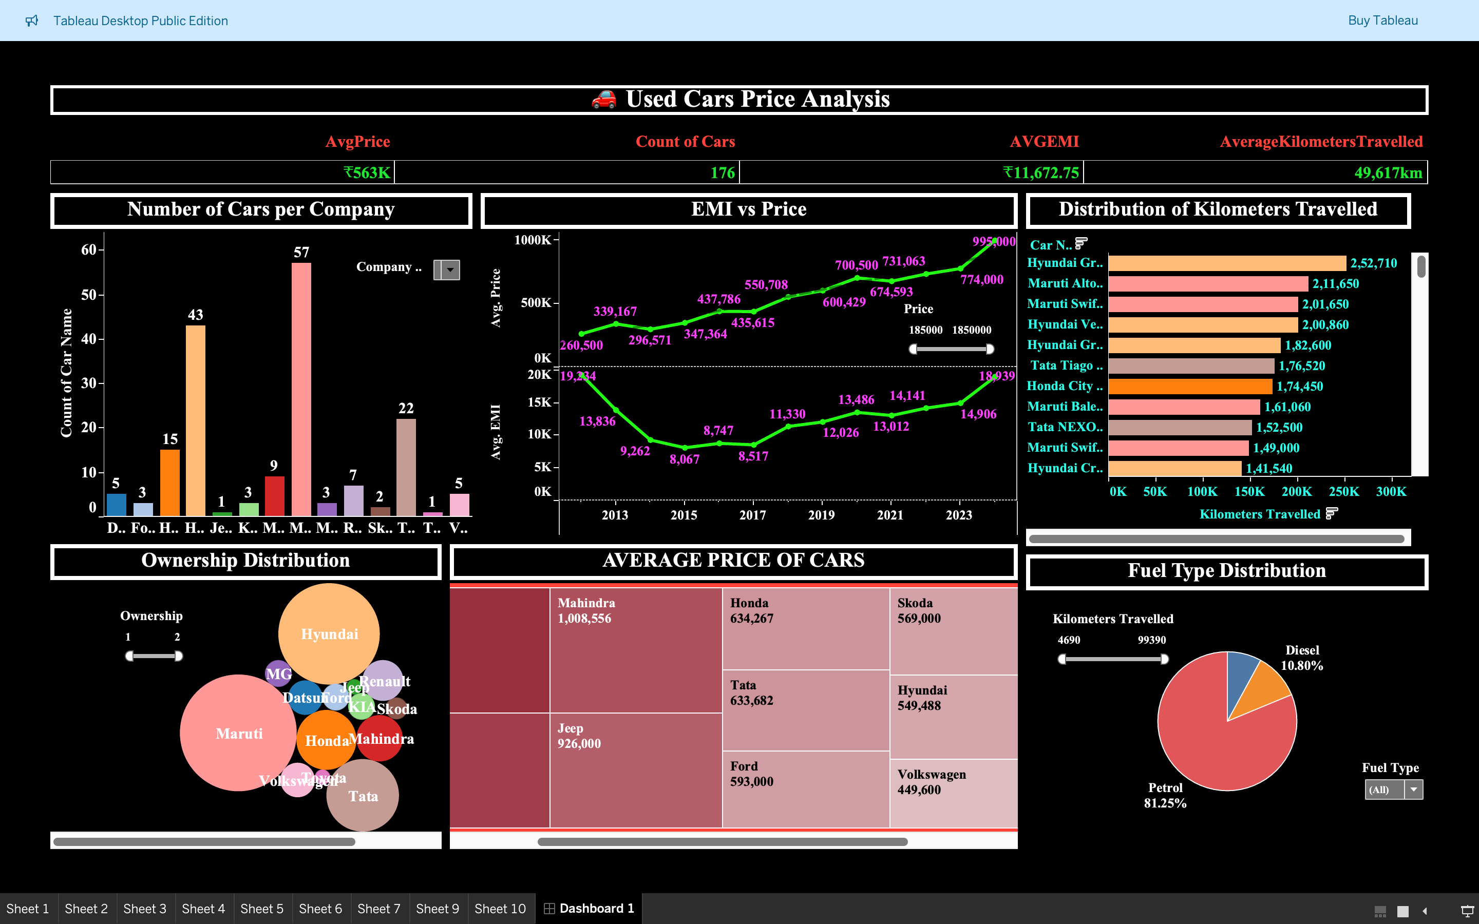

Chapter 8: Challenges Encountered
Technical Obstacles:
- Complex, dynamic HTML made scraping slow and error-prone.
- Frequent request blocking.
Data Challenges:
- Inconsistent formatting of price and EMI values.
- Missing data for some attributes.
- Noise in listings due to promotional content.

Chapter 9: Conclusion
The used car market is rich with opportunity, but scattered information hinders effective comparison. This project successfully demonstrates how data science can solve real-world decision-making problems.
Through this analysis:
- Users can target high-value deals.
- Market trends become more transparent.
- Buyers gain confidence through data validation.
This framework can be extended to predict future price trends, estimate depreciation, and rank cars based on customer preference.

Chapter 10: Tools & Technologies Used
Purpose | Tools / Libraries
Data Extraction | BeautifulSoup, requests
Data Processing | Pandas, NumPy
Visualization | Tableau
Development Environment | Jupyter Notebook
Presentation | PowerPoint

