Create three folder

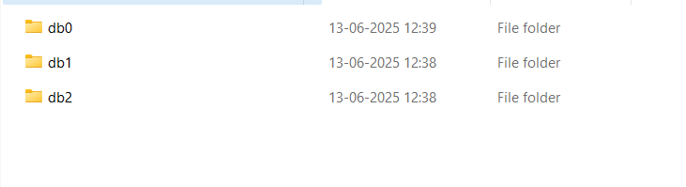

* Open three command prompts and do these steps:

In Terminal 1st:

"C:\Program Files\MongoDB\Server\8.0\bin\mongod.exe" --replSet myReplSet --dbpath C:\data\db0 --port 27019 --bind_ip localhost



In Terminal 2nd:

"C:\Program Files\MongoDB\Server\8.0\bin\mongod.exe" --replSet myReplSet --dbpath C:\data\db1 --port 27019 --bind_ip localhost



IN Terminal 3rd :

"C:\Program Files\MongoDB\Server\8.0\bin\mongod.exe" --replSet myReplSet --dbpath C:\data\db2 --port 27019 --bind_ip localhost



* Now open new 4th command prompt

1. "C:\Program Files\MongoDB\Shell\mongosh-2.5.2-win32-x64\bin\mongosh.exe" --port 27017

2.

test> rs.initiate({

... _id: "myReplSet",

... members: [

... { _id: 0, host: "localhost:27017" },

... { _id: 1, host: "localhost:27018" },

... { _id: 2, host: "localhost:27019" }

... ]

... });

