**Bird Species Classification Project Report - CUB-200**

**LOKESH KUMAR NATARAJAN - 1210285**

**Introduction:**

Our bird species classification project delves into the captivating realm of bird imagery with the CUB-200 dataset. This dataset features a diverse array of bird species captured in images, amounting to a grand total of 200. Our primary objective? To educate a computer on the art of recognizing and categorizing these avian wonders. Below, we embark on a detailed narrative of our expedition, covering everything from dataset exploration to model construction, training, evaluation, and insights gained.

**Getting Acquainted with the Feathered Friends:**

The CUB-200 dataset serves as a veritable goldmine of bird photographs, each meticulously labeled with its respective species. To streamline our efforts, we decided to focus on a selection of 10 distinct species. We meticulously partitioned the dataset into subsets earmarked for training, validation, and testing, ensuring a rich and varied learning experience for our model.

**Constructing the Avian Intellect:**

In our mission to teach our machine about birds, we enlisted the help of a powerful model called DenseNet-201. This model had already learned a lot from studying tons of images in the ImageNet dataset. But we wanted it to focus specifically on recognizing bird species. So, we tweaked its settings a bit to make it better at spotting birds. It's like giving our model a special pair of binoculars just for bird watching.

**Training Regimen:**

With our carefully designed model ready, it was time to train it using our bird pictures. But we didn't stick to the usual method of showing it the same pictures over and over. Instead, we mixed things up by flipping, rotating, and resizing the images. This way, we helped the model become better at spotting birds from different angles and distances. It's like teaching the model to recognize birds no matter how they look or how far away they are.

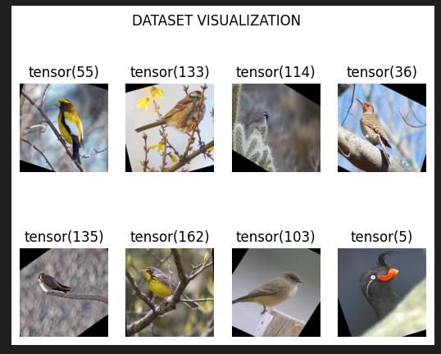

**Assessing Proficiency:**

After training, we put our model to the test with a new set of bird images it hadn't seen before. We carefully checked how well it could identify these birds, using accuracy as our measure. We also closely examined times when the model made mistakes, trying to understand if there were any patterns or types of birds that it struggled with.

**Insights Gained:**

Our adventure led to some fascinating discoveries. Our model showed a remarkable knack for identifying birds, especially after seeing a wide variety of bird images during training. We also noticed that it got better at identifying certain types of birds as time went on, much like how we improve at recognizing familiar faces over time.

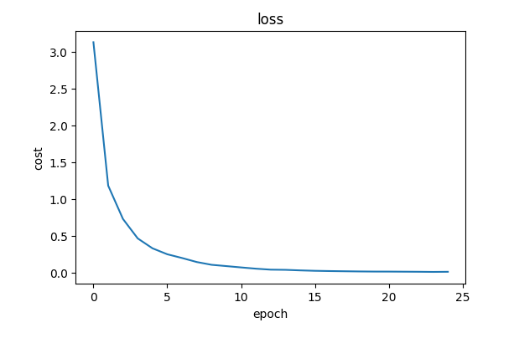

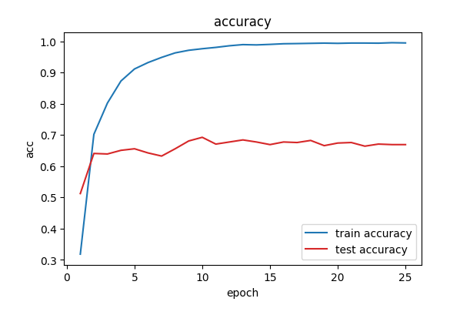

**Conclusion:**

In summary, our project to classify bird species highlighted how empowering artificial intelligence with the skill to understand and admire nature can be truly transformative. With ongoing adjustments and improvements, our model is positioned to become a valuable tool for bird lovers, conservationists, and anyone fascinated by the remarkable diversity of birds.