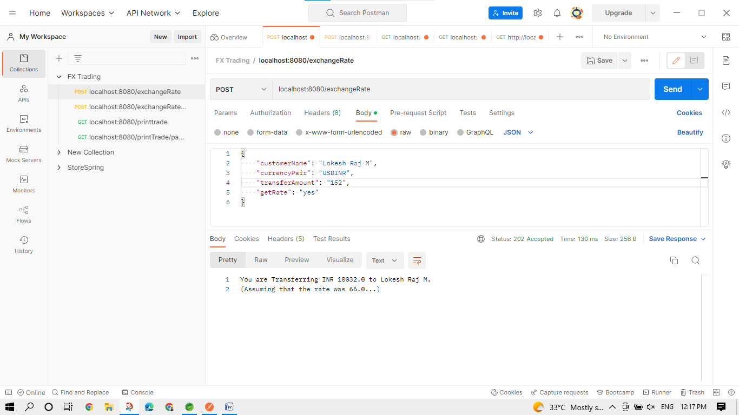**FX Trading**

* localhost:8080/exchangeRate is to get the exchange Rate.

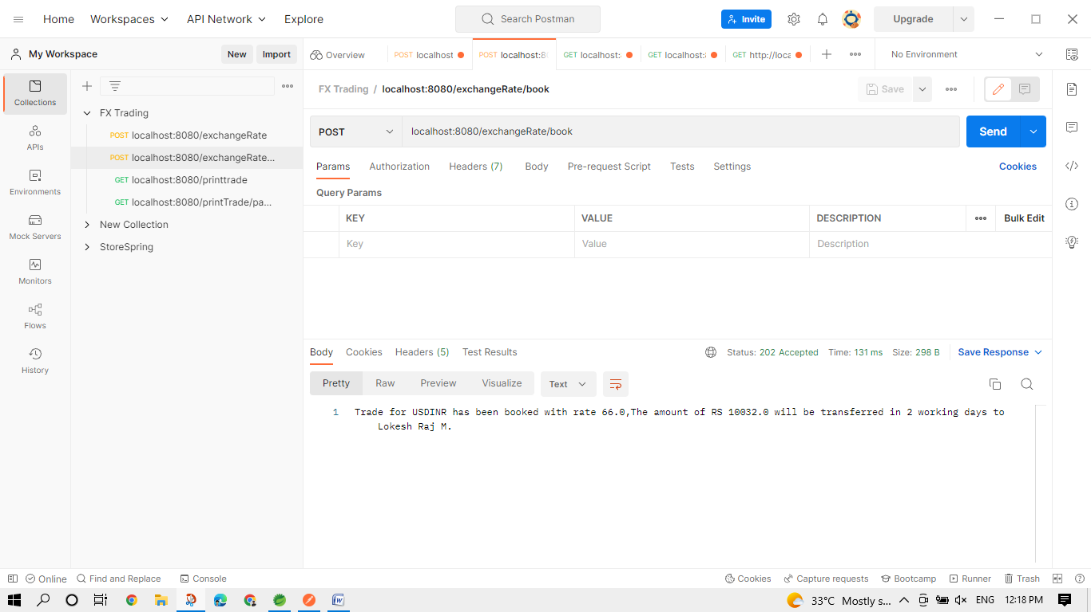

* localhost:8080/exchangeRate/book or cancel is to book/cancel the trade.
* 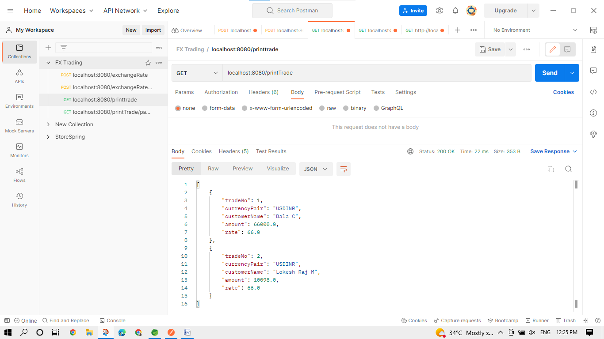localhost:8080/printTrade is to print the booked trade.

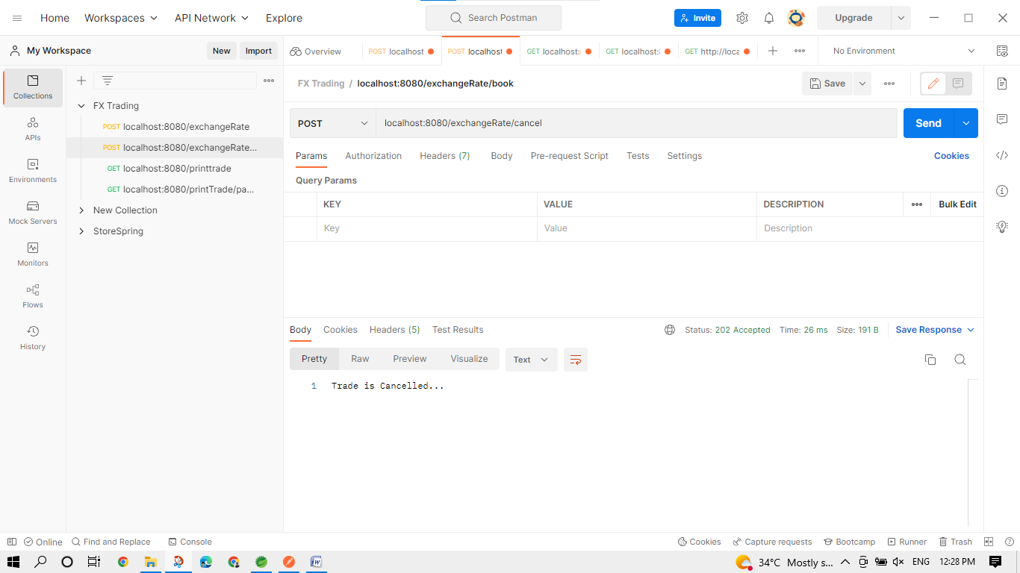

* Cancelling the trade.

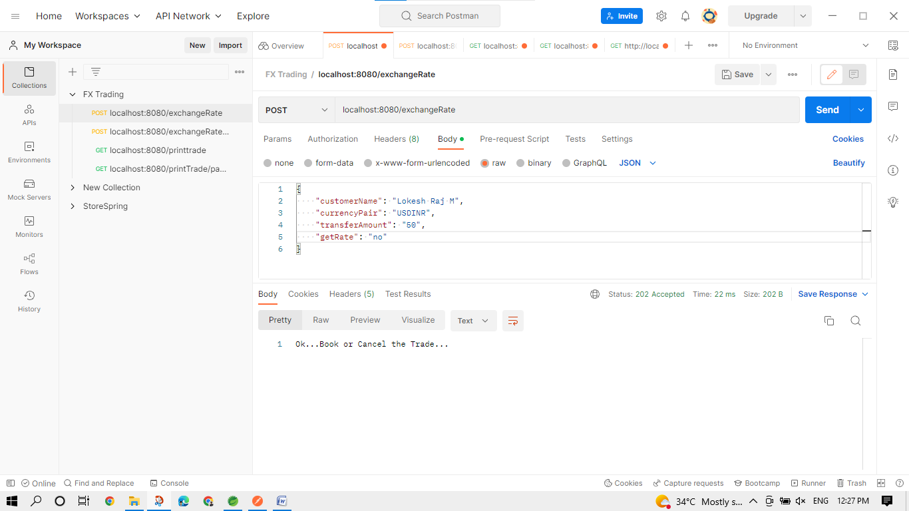

* booking the trade by without getting the exchange rate.

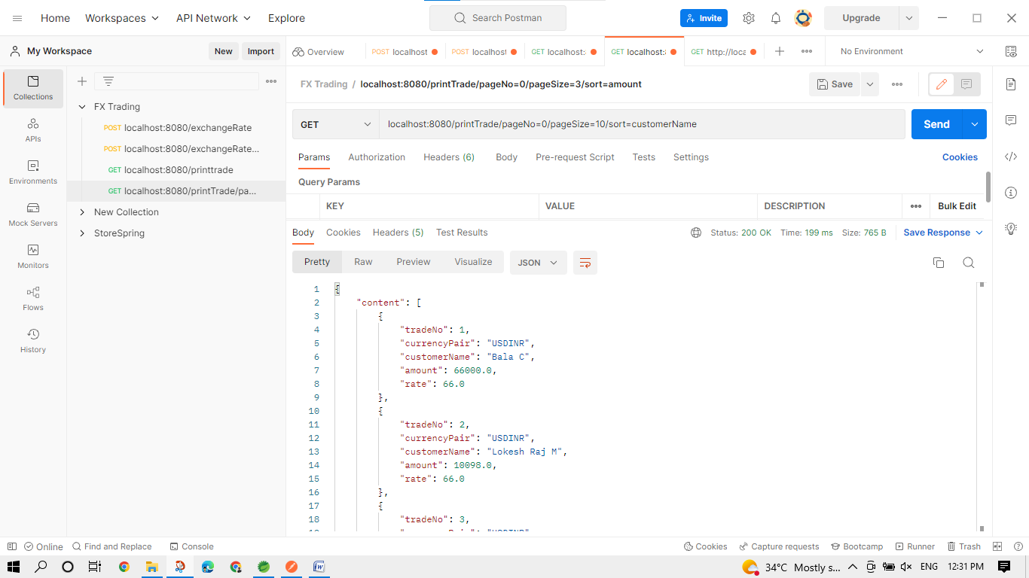

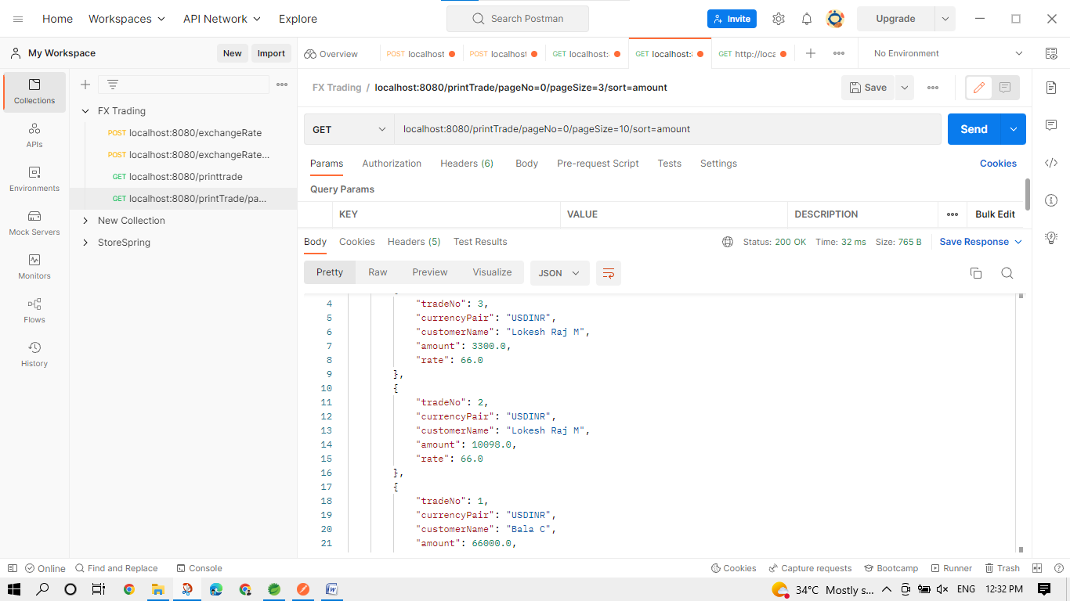

* pagination and sorted the booked trade list.