<https://www.youtube.com/watch?v=UzhqCb_lDZc>

<https://csvkit.readthedocs.io/en/latest/>

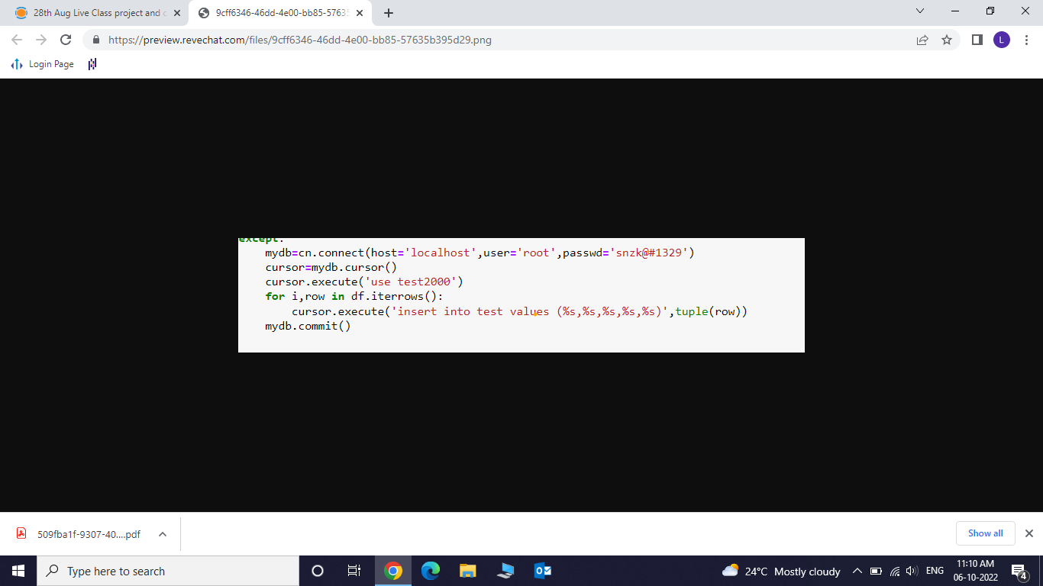

In SQL

load data local infile 'C:/bank-full.csv'  
into table bank_details   
fields terminated by ';'  
enclosed by '"'  
lines terminated by '\n'  
ignore 1 rows;  
  
OPT_LOCAL_INFILE=1  
SHOW GLOBAL VARIABLES LIKE 'local_infile';  
set global local_infile = 1;