**Industrial Internship Report on**

**”Password Manager”**

**Prepared By**

**Madineni Lokeshwar**

|  |
| --- |
| *Executive Summary* |
| This report provides details of the Industrial Internship provided by Upskill Campus and The IoT Academy in collaboration with Industrial Partner UniConverge Technologies Pvt Ltd (UCT).  This internship was focused on a project/problem statement provided by UCT. We had to finish the project including the report in 6 weeks’ time.  My project was about Password Manager.  This internship gave me a very good opportunity to get exposure to Industrial problems and design/implement solution for that. It was an overall great experience to have this internship. |

**TABLE OF CONTENTS**

1 Preface 3

2 Introduction 4

2.1 About UniConverge Technologies Pvt Ltd 4

2.2 About upskill Campus 8

2.3 Objective 9

2.4 Reference 9

2.5 Glossary 10

3 Problem Statement 11

4 Existing and Proposed solution 12

6 Performance Test 14

6.1 Test Plan/ Test Cases 14

6.2 Test Procedure 14

6.3 Performance Outcome 14

7 My learnings 15

# Preface

Summary of the whole 6 weeks’ work.

About need of relevant Internship in career development.

Brief about Your project/problem statement.

Opportunity given by USC/UCT.

How Program was planned

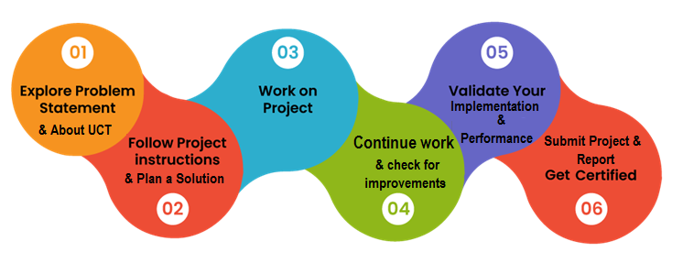

Your Learnings and overall experience.

Thanks to all (with names), who have helped you directly or indirectly.

Your message to your juniors and peers.

# Introduction

## About UniConverge Technologies Pvt Ltd

A company established in 2013 and working in Digital Transformation domain and providing Industrial solutions with prime focus on sustainability and RoI.

For developing its products and solutions it is leveraging various**Cutting Edge Technologies e.g. Internet of Things (IoT), Cyber Security, Cloud computing (AWS, Azure), Machine Learning, Communication Technologies (4G/5G/LoRaWAN), Java Full Stack, Python, Front end**etc.

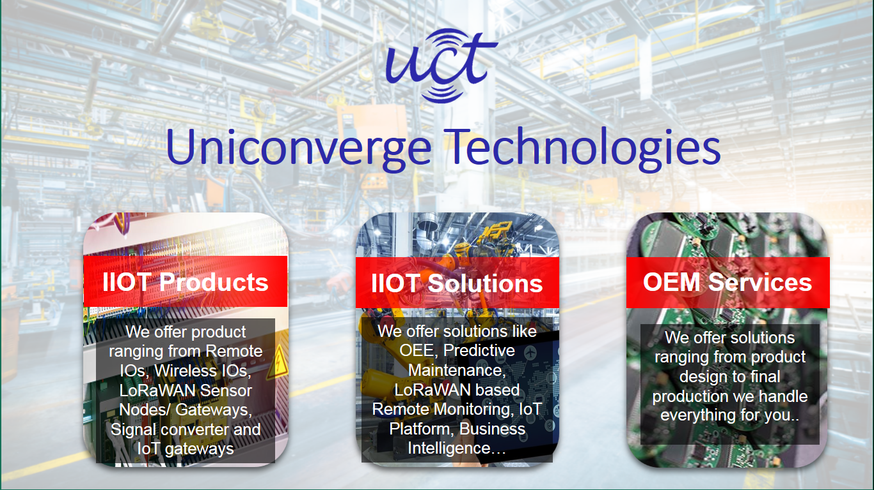

1. UCT IoT Platform **(****)**

**UCT Insight** is an IOT platform designed for quick deployment of IOT applications on the same time providing valuable “insight” for your process/business. It has been built in Java for backend and ReactJS for Front end. It has support for MySQL and various NoSQL Databases.

* It enables device connectivity via industry standard IoT protocols - MQTT, CoAP, HTTP, Modbus TCP, OPC UA
* It supports both cloud and on-premises deployments.

It has features to  
• Build Your own dashboard  
• Analytics and Reporting  
• Alert and Notification  
• Integration with third party application(Power BI, SAP, ERP)  
• Rule Engine

 

1. **Smart Factory Platform (****)**

Factory watch is a platform for smart factory needs.

It provides Users/ Factory

* with a scalable solution for their Production and asset monitoring
* OEE and predictive maintenance solution scaling up to digital twin for your assets.
* to unleased the true potential of the data that their machines are generating and helps to identify the KPIs and also improve them.
* A modular architecture that allows users to choose the service that they what to start and then can scale to more complex solutions as per their demands.

Its unique SaaS model helps users to save time, cost and money.

 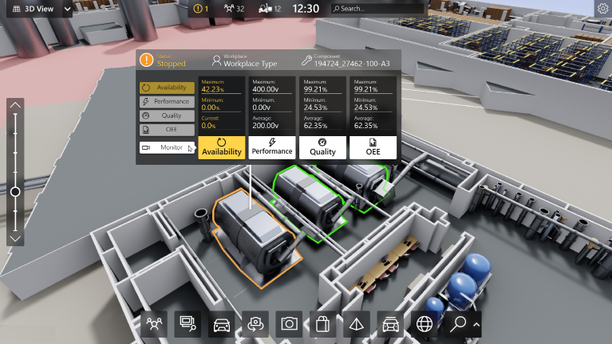

1.  based Solution

UCT is one of the early adopters of LoRAWAN teschnology and providing solution in Agritech, Smart cities, Industrial Monitoring, Smart Street Light, Smart Water/ Gas/ Electricity metering solutions etc.

1. Predictive Maintenance

UCT is providing Industrial Machine health monitoring and Predictive maintenance solution leveraging Embedded system, Industrial IoT and Machine Learning Technologies by finding Remaining useful life time of various Machines used in production process.



## About upskill Campus (USC)

upskill Campus along with The IoT Academy and in association with Uniconverge technologies has facilitated the smooth execution of the complete internship process.

USC is a career development platform that delivers **personalized executive coaching** in a more affordable, scalable and measurable way.



Seeing need of upskilling in self paced manner along-with additional support services e.g. Internship, projects, interaction with Industry experts, Career growth Services

<https://www.upskillcampus.com/>

upSkill Campus aiming to upskill 1 million learners in next 5 year

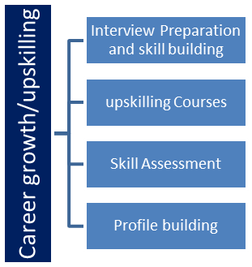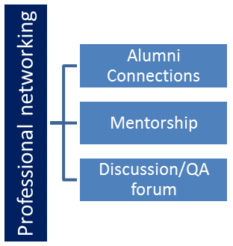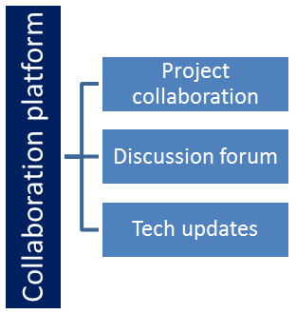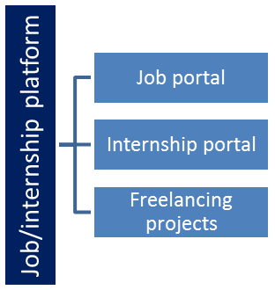

## The IoT Academy

The IoT academy is EdTech Division of UCT that is running long executive certification programs in collaboration with EICT Academy, IITK, IITR and IITG in multiple domains.

## Objectives of this Internship program

The objective for this internship program was to

 ☛ get practical experience of working in the industry.

 ☛ to solve real world problems.

 ☛ to have improved job prospects.

 ☛ to have Improved understanding of our field and its applications.

 ☛ to have Personal growth like better communication and problem solving.

**Problem Statement:**

The goal of this project is to create a password manager that offers the following features:

**Password Encryption and Storage:** Implement strong encryption techniques to securely store user passwords and related data. The password manager should prevent unauthorized access to the stored information, even in the event of a data breach.

**Multi-Platform Accessibility:** Design a password manager that is accessible across multiple platforms, including desktop computers, smartphones, and web browsers. Ensure seamless synchronization of data between devices without compromising security.

**Password Generation**: Develop a robust password generator that creates unique, random, and strong passwords for each online service or account. The generated passwords should adhere to industry best practices to ensure maximum security.

**User Authentication:** Implement a secure and user-friendly authentication mechanism to ensure that only authorized users can access the password manager and its contents. Consider various authentication methods, such as master passwords, biometrics, or multi-factor authentication.

**Autofill Functionality:** Integrate autofill capabilities into popular web browsers and mobile apps to simplify the login process for users. Ensure that autofill operations are secure and cannot be exploited by malicious software or attackers.

**Backup and Recovery:** Develop a reliable backup and recovery system to enable users to restore their passwords and data in case of device loss, damage, or accidental deletion.

**Security Auditing:** Regularly conduct security audits and vulnerability assessments to identify and mitigate potential weaknesses in the password manager's design and implementation.

**Usability and User Experience:** Focus on creating an intuitive and user-friendly interface that caters to users of all technical backgrounds. The password manager should be easy to navigate and understand, promoting widespread adoption.

**Compliance and Regulations:** Ensure that the password manager adheres to relevant data protection regulations and industry standards, such as GDPR, HIPAA, and ISO/IEC 27001, to guarantee user privacy and trust.

## Code submission (GitHub link): https://github.com/Lokeshwar965/password_manager.git

## Report submission (GitHub link) : https://github.com/Lokeshwar965/password_manager.git

# Performance Test

This is very important part and defines why this work is meant of Real industries, instead of being just academic project.

Here we need to first find the constraints.

How those constraints were taken care in your design?

What were test results around those constraints?

Constraints can be e.g. memory, MIPS (speed, operations per second), accuracy, durability, power consumption etc.

In case you could not test them, but still you should mention how identified constraints can impact your design, and what are recommendations to handle them.

## Test Plan/ Test Cases

## Test Procedure

## Performance Outcome

# My learnings

I had explored new things in this week while working on my project and also encountered many hurdles and resolved it from my sources likes,books and browsers.And I personally experienced the working process of password manager using hands on projects through my browser.