#### ✅ 1. **Install and verify Git**

* Use Homebrew to install Git.

* Confirm installation by checking the Git version.

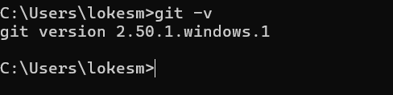

#### ✅ 2. **Configure Git**

* Set your global Git username and email to your real or test identity.



#### ✅ 3. **Create GitHub Repository**

* Go to GitHub and create a new repo named: `BugTracker`

* Do **not** initialize with README or license.

* Keep the repo **private** or **public** as needed.

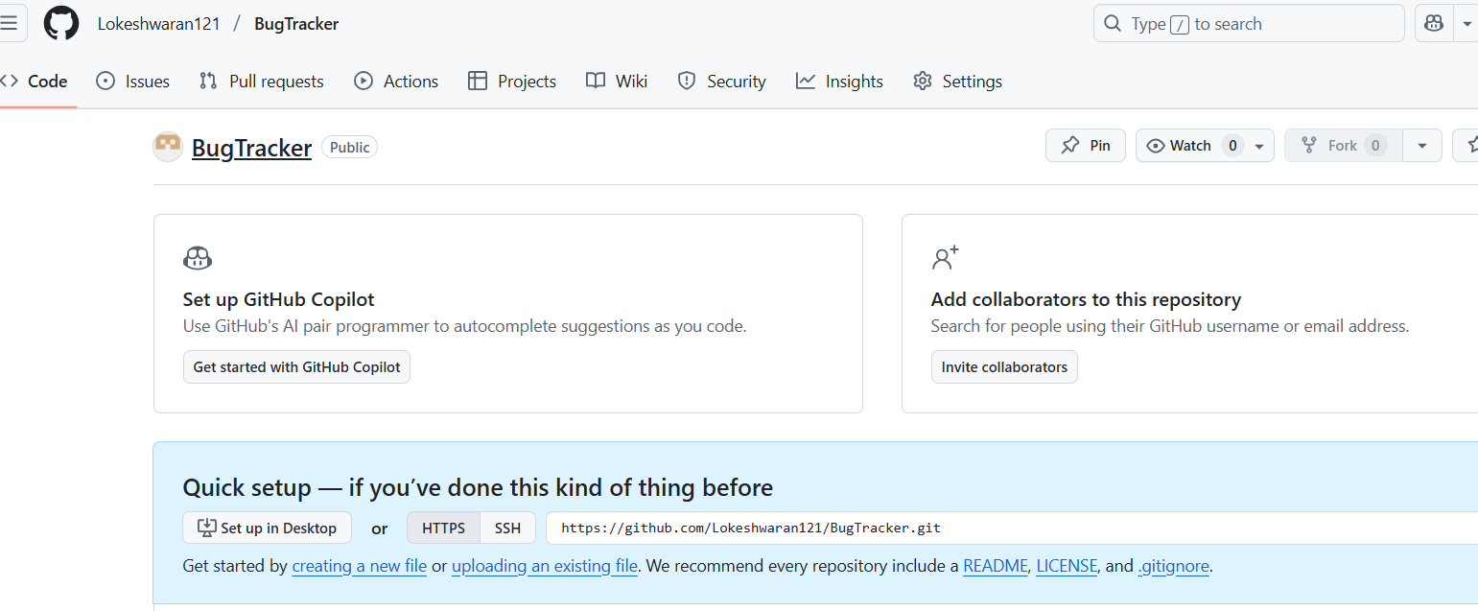

#### ✅ 4. **Clone the Repository**

* Clone the repo to your local system using HTTPS.

* Use your **GitHub token** to authenticate.



#### ✅ 5. **Verify `.git` folder**

* Inside the cloned folder, use the terminal to check if `.git` is present.



#### ✅ 6. **Create Basic Files**

* Create the following in the root of your repo:

* `README.md`

* `index.html` (basic BugTracker layout)

* `style.css` (simple styles)

* `app.js` or `main.java` or `Program.cs` (based on backend choice)

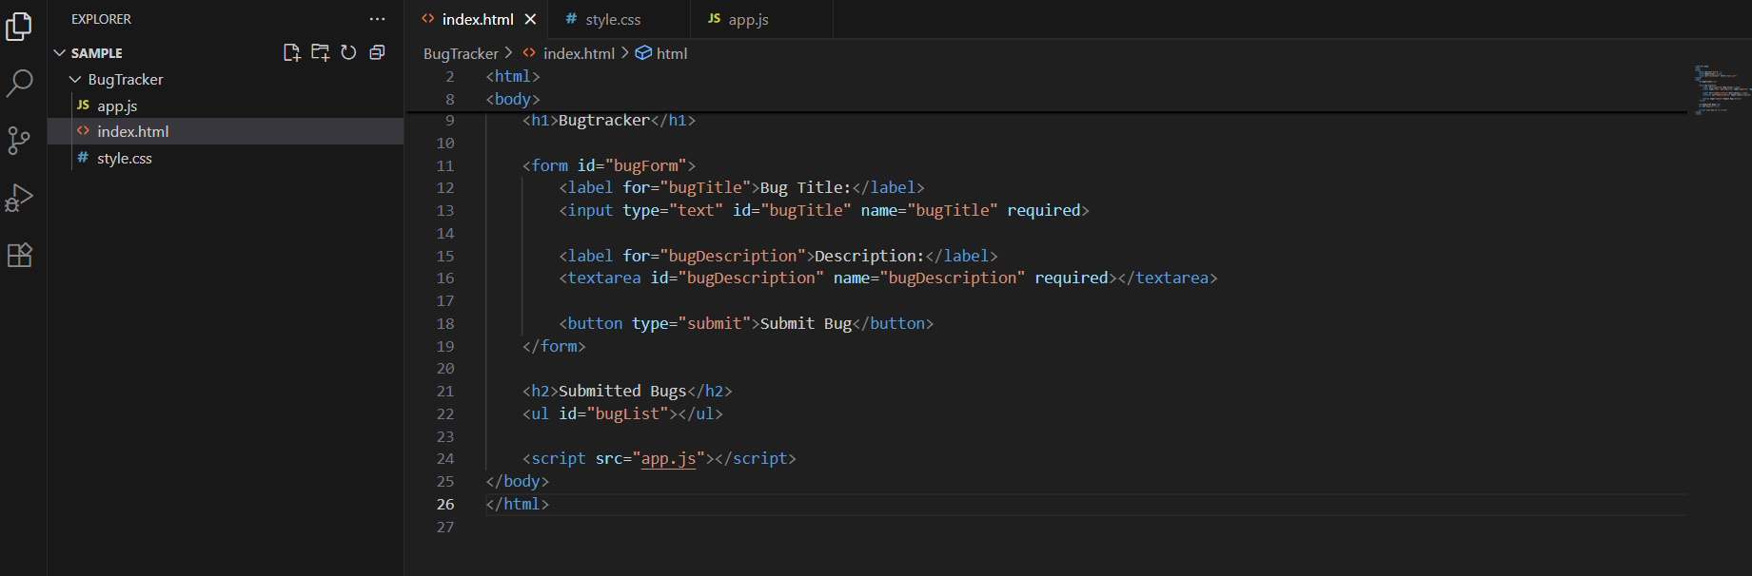

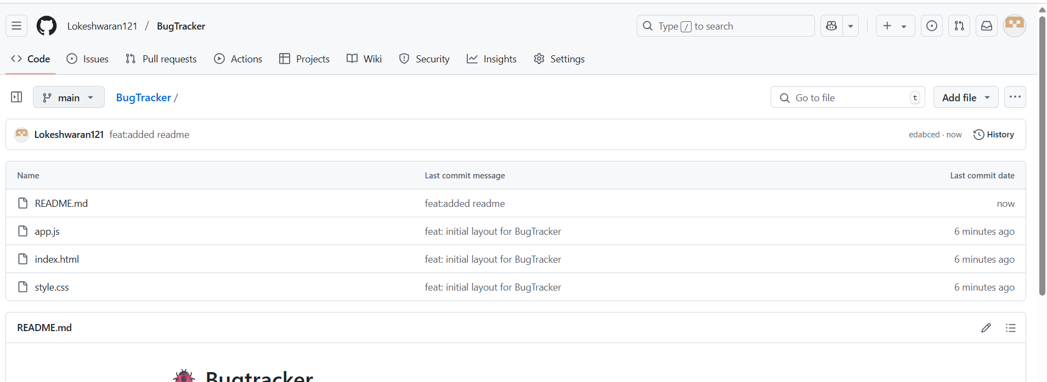

#### ✅ 7. **Track Your Work**

* Add and commit the above files using **conventional commits**:

* `feat: initial layout for BugTracker`

* `style: basic styles for homepage`

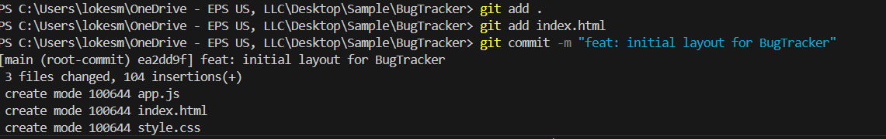

#### ✅ 8. **Push Changes to GitHub**

* Push to the `main` branch using GitHub token if needed.

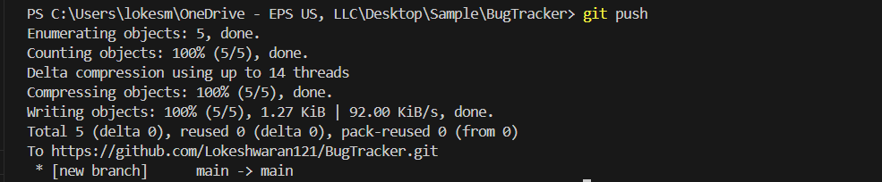



#### ✅ 9. **Edit File Remotely (Conflict Setup)**

* On GitHub, open `index.html` and change an `<h1>` tag.

* Commit the change with: `fix: updated heading remotely`



#### ✅ 10. **Change Same File Locally**

* Locally, change the **same line** in `index.html`.

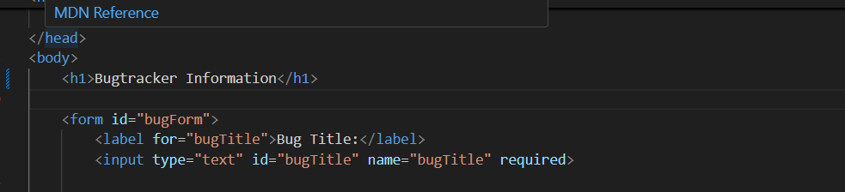

#### ✅ 11. **Trigger Merge Conflict**

* Try to push your local changes without pulling first.

* Observe the **merge conflict error**.

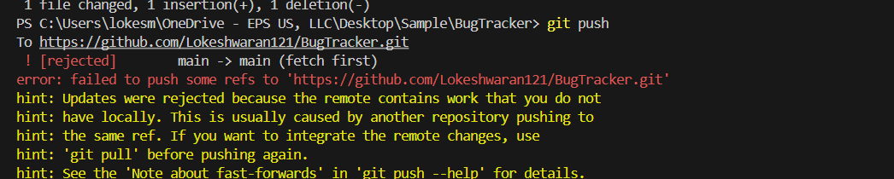

#### ✅ 12. **Resolve Conflict**

* Pull from GitHub (`git pull origin main`)

* Open conflict in VS Code and manually resolve it.

* Commit the resolved file: `fix: resolved heading conflict`

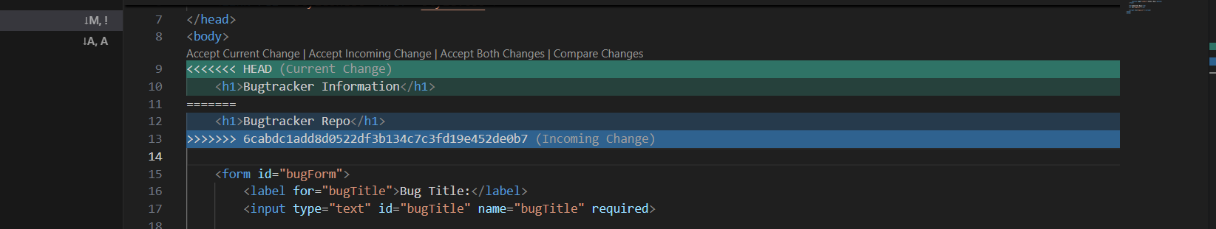

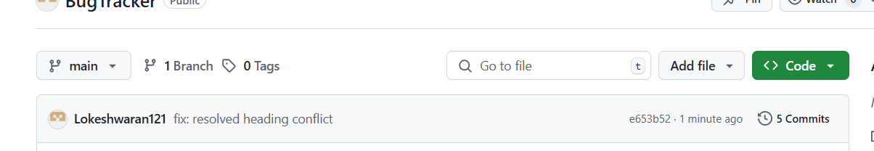

#### ✅ 13. **Branch for Frontend**

* Create a new branch `frontend`



* Modify/add to `index.html` and `style.css`

* Commit your changes with a conventional commit.

* Push the branch and create a **pull request** to `main`.

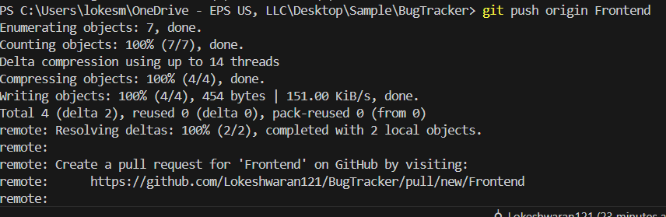

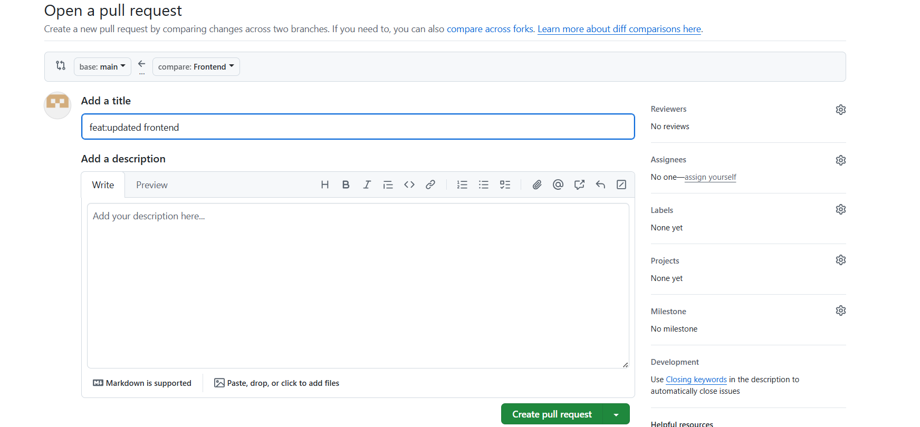

#### ✅ 14. **Branch for Backend**

* Switch to `main`, then create a new branch `backend`

* Create/modify your backend logic file (`main.java`, `Program.cs`, etc.)

* Commit and push.

* Raise a PR to `main`.

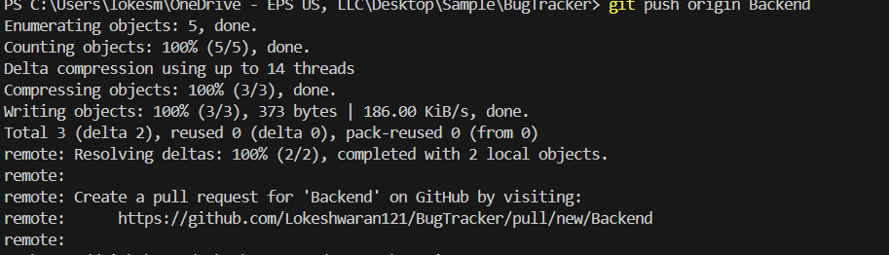

#### ✅ 15. **Create `.gitignore`**

* Add the following:

```

node_modules/

*.log

.env

```

* Commit it: `chore: add .gitignore file`

---

#### ✅ 16. **Stash Scenario**

* Edit any file (e.g., `index.html`) but **don’t commit**

* Try pulling new changes from GitHub — Git should block you

* Use `git stash`, then `git pull`, then `git stash pop`

* Resolve any conflict if it appears

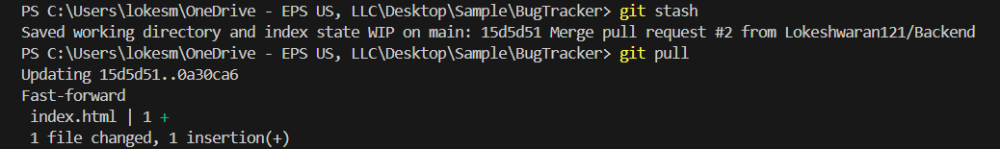

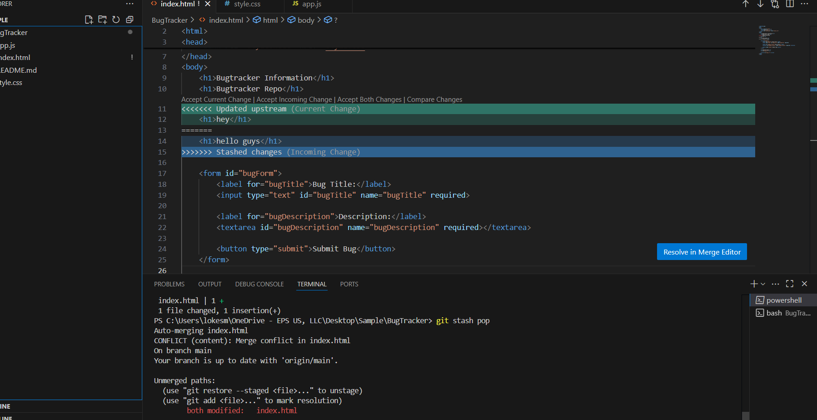

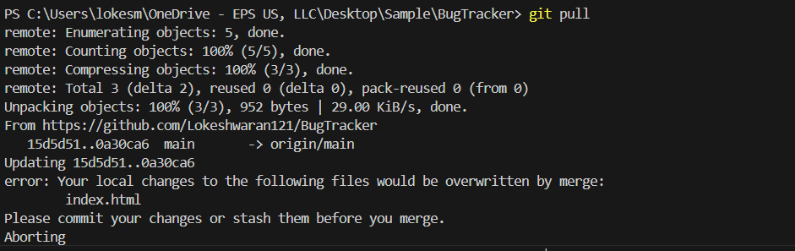

#### ✅ 17. **Reset and Restore**

* Add and stage a new dummy file (e.g., `debug.txt`)

* Then **unstage it** using `git reset`

* Restore any accidental local change using `git restore`





#### ✅ 18. **Rename Branch**

* Rename the current `main` branch to `dev-main` using Git



---

#### ✅ 19. **View Commit History**

* Use `git log` and take a screenshot showing at least 5 commits with:

* different commit types (`feat`, `fix`, `chore`, etc.)

* merge conflict resolved commit

