AI POWERED LEGAL DEMYSTIFYING AGENT FOR DOCUMENT UNDERSTANDING

PHASE I REPORT

Submitted by

LOKESHWARPRASAD | 230701167
MONISH G | 230701196
SURIYA PRAKASH S R | 230701352
KALEES PANDI T | 230701135

in partial fulfillment for the award of the degree

of
BACHELOR OF ENGINEERING IN
COMPUTER SCIENCE AND ENGINEERING



RAJALAKSHMI ENGINEERING COLLEGE, CHENNAI
ANNA UNIVERSITY: CHENNAI 600 025

December 2026

ANNA UNIVERSITY, CHENNAI
BONAFIDE CERTIFICATE

Certified that this Report titled “AI-POWERED LEGAL DEMYSTIFYING AGENT FOR DOCUMENT UNDERSTANDING, SIMPLIFICATION, AND SOURCE-GROUNDED ASSISTANCE” is the bonafide work of LOKESHWARAPRASAD V (230701167), MONISH G (230701196), SURIYA PRAKASH S R (230701352), KALEES PANDI T (230701135) who carried out the work under my supervision. Certified further that to the best of my knowledge the work reported herein does not form part of any other thesis or dissertation on the basis of which a degree or award was conferred on an earlier occasion on this or any other candidates.

“This project addresses the following Sustainable Development Goal(s): SDG 4 – Quality Education, SDG 8 – Decent Work and Economic Growth”

SIGNATURE
Dr. J. Manoranjini, Professor and Head,
Department of Computer Science and Engineering,
Rajalakshmi Engineering College, Chennai – 602 105.
SIGNATURE
Mr. Akshai Kanth J M, Associate Professor
Department of Computer Science and Engineering,
Rajalakshmi Engineering College,
Chennai – 602 105.

Submitted to Project Viva-Voce Examination held on

Internal Examiner External Examiner

ABSTRACT

Online legal documents and agreements contain important information about rights, responsibilities, payments, deadlines and conditions, but their complex legal language can make them difficult for ordinary users to understand. Users may find it challenging to identify important clauses, financial obligations, termination conditions, penalties and other significant requirements. This system is aimed at providing an AI-powered solution that helps users understand legal documents through simple and accessible explanations. The proposed system supports multiple document formats such as PDF, DOCX and scanned documents using document processing and OCR techniques. Additionally, the system uses Google Gemini to provide document summarization, legal keyword extraction, important clause identification, rights and obligations analysis, and attention-point identification. A Retrieval-Augmented Generation (RAG) approach is incorporated to retrieve relevant portions of the uploaded document and provide source-grounded answers to user questions. The system also includes multilingual translation, voice-based interaction and a personalized “Before You Sign” checklist to improve accessibility and understanding. Important information is supported with page or clause references whenever available, while the system clearly indicates when information is not specified in the document. This integrated approach improves the usability, transparency and accessibility of legal document understanding while reducing the difficulty of interpreting complex legal content. The system is designed to provide general informational assistance and does not replace advice from a qualified legal professional.

ACKNOWLEDGEMENT

Initially we thank the Almighty for being with us through every walk of our life and showering his blessings through the endeavor to put forth this report. Our sincere thanks to our Chairman Mr. S.MEGANATHAN, B.E, F.I.E., our Vice Chairman Mr. ABHAY SHANKAR
MEGANATHAN, B.E., M.S., and our respected Chairperson Dr. (Mrs.) THANGAM MEGANATHAN, Ph.D., for providing us with the requisite infrastructure and sincere endeavoring in educating us in their premier institution.
Our sincere thanks to Dr. S.N. MURUGESAN, M.E., Ph.D., our beloved Principal for his kind support and facilities provided to complete our work in time. We express our sincere thanks to Dr.
J. Manoranjini,, Ph.D., Professor and Head of the Department of Computer Science and Engineering for his guidance and encouragement throughout the project work. We convey our sincere and deepest gratitude to our internal guide, Mr. Akshai Kanth J M, Associate Professor, Department of Computer Science and Engineering for his valuable guidance throughout the course of the project. We thank our Project Coordinator, Mr. Karthik , B.E., M.E., Assistant Professor, Department of Computer Science and Engineering for his useful tips during our review to build our project.

LOKESHWARAPRASAD V 230701167
MONISH G 230701196
SURIYA PRAKASH S R 230701352 KALEES PANDI T 230701157

TABLE OF CONTENTS
CHAPTER NO. | TITLE | PAGE NO.
 | ABSTRACT | iii
 | LIST OF TABLES | vii
 | LIST OF FIGURES | viii
 | LIST OF ABBREVIATIONS | ix
1. | INTRODUCTION | 1
 | 1.1 GENERAL | 1
 | 1.2 OBJECTIVE | 2
 | 1.3 EXISTING SYSTEM | 2
 | 1.4 PROPOSED SYSTEM | 3
2. | LITERATURE SURVEY | 4
 | 2.1 LITERATURE REVIEW | 4
 | 2.2 COMPARISION AND DISCUSSION | 7
 | 2.2 CONCLUSION | 7
3. | SYSTEM DESIGN | 9
 | 3.1 SYSTEM ARCHITECTURE | 9
 | 3.2 SYSTEM REQUIREMENTS | 10
 | 3.2.1 SOFTWARE REQUIREMENTS | 10
 | 3.2.2 HARDWARE REQUIREMENTS | 11
 | 3.2.3 DATASET REQUIREMENTS | 11
 | 3.2.4 DEPLOYMENT AND SCALING | 12
 | 3.3 SYSTEM DESIGN | 12
 | 3.3.1 ACTIVITY DIAGRAM | 13
 | 3.3.2 DATA FLOW DIAGRAM | 14
4. | PROJECT DESCRIPTION | 15
 | 4.1 METHODOLOGIES | 15
 | 4.2 MODULES | 16
 | 4.2.1 USER AUTHENTICATION AND DOCUMENT MANAGEMENT MODULE | 16
 | 4.2.2 DOCUMENT UPLOAD AND TEXT EXTRACTION MODULE | 16
 | 4.2.3 AI DOCUMENT ANALYSIS AND SIMPLIFICATION MODULE | 17
 | 4.2.4 DOCUMENT-GROUNDED QUESTION ANSWERING MODULE | 17
 | 4.2.5 MULTILINGUAL TRANSLATION AND VOICE ASSISTANT MODULE | 18
 | 4.2.6 BEFORE YOU SIGN AND VERIFICATION MODULE | 18
 | 4.2.7 DASHBOARD AND USAGE TRACKING MODULE | 19
5. | IMPLEMENTATION AND RESULT DISCUSSION | 20
 | 5.1 DEVELOPMENT ENVIRONMENT | 20
 | 5.2 FRONTEND IMPLEMENTATION | 20
 | 5.3 BACKEND IMPLEMENTATION | 21
 | 5.4 DATABASE IMPLEMENTATION | 22
 | 5.5 AI-BASED DOCUMENT ANALYSIS | 22
 | 5.6 GUIDE GENERATION AND QUESTION ANSWERING IMPLEMENTATION | 23
 | 5.7 TRANSLATION AND VOICE ASSISTANCE IMPLEMENTATION | 24
 | 5.8 BEFORE YOU SIGN AND VERIFICATION IMPLEMENTATION | 24
 | 5.9 AUTHENTICATION AND SECURITY | 25
 | 5.10 RESULTS DISCUSSION | 26
6. | CONCLUSION AND FUTURE WORK | 31
 | 6.1 CONCLUSION | 31
 | 6.2 FUTURE WORK | 32
 | REFERENCES

LIST OF TABLES:
TABLE NO. | TABLE NAME | PAGE NO.
3.1 | Software Requirements | 10
3.2 | Hardware Requirements | 11
5.1 | Sections of the Easy Guide | 23

LIST OF FIGURES
FIGURE NO. | FIGURE NAME | PAGE NO.
3.1 | System Architecture | 9
3.2 | System Workflow | 12
3.3 | Activity Diagram | 13
3.4 | Data Flow Diagram | 14
5.1 | Home page of Legal Saathi | 21
5.2 | Document upload and language selection | 26
5.3 | My Documents dashboard | 27
5.4 | Easy guide generation page | 27
5.5 | Good Things — What Works for You | 28
5.6 | Dates & Deadlines and Money to Notice | 29
5.7 | Before You Sign checklist and disclaimer | 30

LIST OF ABBREVIATIONS

Abbreviation | Meaning
AI | Artificial Intelligence
ATS | Applicant Tracking System
API | Application Programming Interface
DB | Database
DOCX | Microsoft Word Document Format
HTTP | HyperText Transfer Protocol
JWT | JSON Web Token
LLM | Large Language Model
NLP | Natural Language Processing
PDF | Portable Document Format
REST | Representational State Transfer
UI | User Interface
UX | User Experience
URL | Uniform Resource Locator
JD | Job Description
MERN | MongoDB, Express, React, Node.js

GENERAL
CHAPTER 1 INTRODUCTION

Understanding legal documents is an important part of everyday life. Users may need to deal with several types of documents, including rental agreements, employment agreements, offer letters, service agreements, loan agreements, insurance documents, and legal notices. Understanding all these documents at the same time can be difficult, especially when complex legal terminology and lengthy clauses are involved.
The AI-Powered Legal Demystifying Agent is a unified web-based platform designed to make legal document understanding easier and more organized. The system brings document processing, OCR, AI-powered summarization, legal keyword extraction, clause identification, rights and obligations analysis, translation, question answering, and voice assistance into one platform.
The main idea of the project is to provide users with a single environment where they can understand the contents of a legal document, identify important clauses, and recognize areas that require careful attention. Instead of providing only a summary, the system attempts to give useful explanations and recommendations based on the uploaded document.
The project focuses on making legal document understanding more accessible and less complicated. It allows users to repeatedly interact with different legal documents, ask questions, translate explanations, and review important information before signing..

The project objectives and key capabilities are based on the Legal
Demystifying Agent project requirements and proposed system
design.

OBJECTIVE
The main objective of the project is to develop a centralized and intelligent legal document understanding platform that helps users understand complex legal documents in simple language. The system aims to process legal documents based on their content, structure, clauses, obligations, rights, and important information, while providing simplified summaries and identifying areas that require attention. It also extracts legal keywords and important clauses to help users understand their meaning and significance. The platform provides document-grounded question answering to clarify information from the uploaded document and supports translation into multiple languages for better accessibility. In addition, it offers OCR for scanned documents, voice-based assistance, and a Before You Sign checklist to help users review important information. The system identifies important details and provides clear explanations based on the uploaded document. Finally, it presents the analyzed information through a centralized dashboard, helping users understand, review, and verify their legal documents more easily.

EXISTING SYSTEM
Several platforms are currently available for individual legal document-understanding activities. Document-processing platforms mainly focus on extracting and processing text from legal documents. OCR-based platforms provide text extraction from scanned documents and images. Translation platforms provide multilingual translation, while AI-based tools offer document summarization and question answering. Although these platforms are useful, they generally concentrate on one particular aspect of legal document understanding. A user may therefore have to move between several platforms to complete their document analysis. The existing approach creates a fragmented document-understanding experience. Document processing, summarization, clause identification, translation, question answering, and document review are not necessarily connected to one another.

PROPOSED SYSTEM
The proposed system combines multiple legal document-understanding activities into a single intelligent web application. It allows users to upload and process legal documents, extract text using OCR when required, and generate simple summaries and important information. Users can also identify legal keywords, important clauses, rights, responsibilities, deadlines, financial information, and areas that require attention. The information from these activities is analyzed to provide document-grounded explanations and answers to user questions. Based on the uploaded document, the system provides clear explanations, multilingual translation, voice-based assistance, and a Before You Sign checklist. The overall workflow follows the process of Document Upload → Text Extraction → AI Analysis → Information Identification → Simplification → Question Answering → Translation → Verification. By integrating these activities into one platform, the proposed system addresses the limitations of fragmented legal document understanding and provides users with a more unified and accessible document analysis experience.

CHAPTER 2 LITERATURE SURVEY
  - LITERATURE REVIEW
Artificial Intelligence and Natural Language Processing have become increasingly useful in legal document understanding and legal-information applications. Existing research has explored legal text classification, contract analysis, clause identification, document summarization, question answering, legal information extraction, and language-model-based legal assistance.
Tuggener et al. (2020)
The study introduced the LEDGAR dataset for legal text classification. Legal contract provisions were analyzed and classified into different categories using machine-learning and language-processing approaches. The research demonstrated that automated classification can support the organization and analysis of large collections of legal contract clauses. This study is relevant to the clause identification and classification component of the proposed system.
Hendrycks et al. (2021)
The researchers proposed the Contract Understanding Atticus Dataset (CUAD), which focuses on identifying important clauses and provisions in commercial contracts. The study demonstrated the usefulness of supervised learning for extracting specific contractual information. This work supports the use of automated clause identification and important information extraction in the proposed system

Kurtz et al. (2021)
The researchers introduced ContractNLI for natural language inference over legal contracts. The system evaluates relationships between statements and information contained within contractual documents. The research shows how document-grounded reasoning can support legal document question answering and information verification. This study is relevant to the document-grounded question-answering component of the proposed system.
LEGAL-BERT for Legal Text Processing (2020)
This study introduced Legal-BERT, a language model specifically adapted for legal-domain text processing. The research demonstrated the usefulness of domain-specific language representations for legal classification, information extraction, and other legal NLP tasks. This work supports the application of specialized language-processing techniques for understanding complex legal documents.

Zheng et al. (2021)
The researchers introduced CaseHOLD, a legal benchmark for understanding and predicting holdings from judicial opinions. The study demonstrated the importance of contextual understanding in legal language processing and highlighted the challenges involved in interpreting complex legal text. This research is relevant to systems that need to understand legal information based on its surrounding context.

Chalkidis et al. (2022)
The researchers proposed LexGLUE, a benchmark for evaluating language models on multiple legal language understanding tasks. The research demonstrated that legal NLP requires models capable of handling different types of legal classification and understanding problems. This work supports the need for robust language understanding when processing different categories of legal document

Legal Document Summarization Research (2022)
Research on legal text summarization investigated methods for converting lengthy legal documents into shorter and more understandable summaries. The studies demonstrated the usefulness of automatic summarization for reducing document complexity while retaining important legal information. This research is relevant to the simplified-summary and detailed-summary features of the proposed system.

Large Language Models for Legal NLP (2023)

Researchers investigated the application of large language models to legal text understanding and generation tasks. The research highlighted the potential of LLMs for explanation, summarization, question answering, and information extraction while also identifying concerns related to factual accuracy and hallucination. This study supports the use of controlled and document-grounded AI responses in the proposed system.

Legal Bench (2023)

The researchers introduced Legal Bench as a benchmark for evaluating the reasoning capabilities of language models across different legal tasks. The study demonstrated the importance of evaluating legal language models using diverse tasks rather than relying on a single type of legal problem. This work is relevant to evaluating the reliability of AI-based legal document understanding.

Multilingual Legal NLP Research (2023)
Research in multilingual legal NLP explored methods for processing and understanding legal information across different languages. The research highlights the importance of multilingual support for improving accessibility to legal documents for users who may not understand complex legal language. This study is relevant to the translation and multilingual accessibility features of the proposed system.

COMPARISON AND DISCUSSION
The literature shows that AI and NLP can support different legal document understanding activities. Existing research focuses on legal text classification, clause identification, information extraction, summarization, question answering, and multilingual processing.
However, most approaches focus on a particular legal document activity rather than providing a complete environment for understanding and reviewing documents. Users may therefore need different tools for processing, summarization, translation, and verification.
The proposed system combines these functions into a single platform. It connects document processing, summarization, clause identification, translation, question answering, and verification through a centralized dashboard and document-grounded assistance.

CONCLUSION

The literature survey shows that AI and NLP can support legal document classification, clause identification, summarization, question answering, and information extraction. The studies also highlight challenges such as incorrect responses, hallucinations, and the need for reliable document grounding

CHAPTER 3 SYSTEM DESIGN
  - SYSTEM ARCHITECTURE
The proposed system follows a web-based client-server architecture. The frontend provides the user interface through which users upload and access different legal document-understanding features. The frontend communicates with the backend using REST APIs. The backend manages document uploading, text extraction, OCR processing, AI analysis, summarization, clause identification, question answering, translation, voice assistance, and document verification. The application uses a database for storing user information, uploaded document details, analysis results, important clauses, questions, translations, and document-related information.

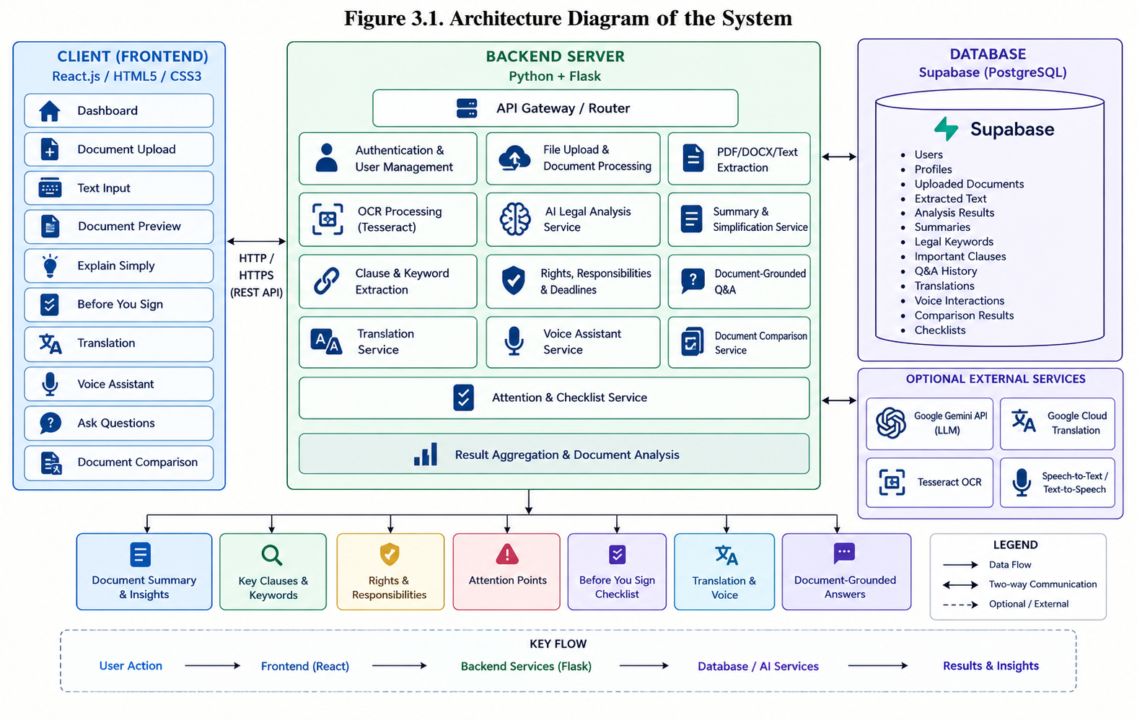

SYSTEM REQUIREMENTS
    - SOFTWARE REQUIREMENTS
The software technologies used in the project are:

  COMPONENT | TECHNOLOGY
  COMPONENT | TECHNOLOGY
  Frontend
  React.js
  Web Technologies
  HTML5, CSS3
  Styling
  Responsive CSS / Card-Based UI
  Build Tool
  Vite
  Backend
  Python
  Server Framework
  Flask
  Database
  PostgreSQL
  Authentication
  Supabase Authentication
 | REST API
  API Communication
  AI Model
  Google Gemini API
  PDF Processing
  PyMuPDF / PyPDF2
  DOCX Processing
  python-docx
  OCR Processing
  Tesseract OCR

The project presentation identifies the application as a unified web-based

system, while the implementation is organized around frontend, backend, database, and AI-related services.

HARDWARE REQUIREMENTS
The system can be developed and used on a standard modern computer.

COMPONENT | REQUIREMENT
Processor | Intel Core i5 or equivalent
RAM | 8 GB or above
Storage | 256 GB or above
Display | 1366 × 768 or above
Network | Internet connection
Input | Keyboard and Mouse
Browser | Modern Web Browser

DATASET REQUIREMENTS

The project does not depend on a single large centralized machine-learning dataset for its core application workflow. Instead, the system primarily works with user-provided information such as uploaded legal documents, extracted text, document clauses, legal keywords, questions and answers, translations, and document analysis results. These inputs are processed by the system to generate summaries, explanations, identify important information, provide document-grounded answers, and highlight areas that require attention. The literature survey provides the external research foundation for AI-based legal document understanding, while the application primarily processes user-specific legal documents during actual usage.

DEPLOYMENT AND SCALING
The system is designed using separate frontend, backend, AI, document-processing, and database components. This separation makes the application easier to maintain and extend. The frontend can be deployed as a web application, while the backend can run as a Python Flask service connected to Supabase PostgreSQL for persistent data storage and Google Gemini API for AI-based document analysis. The modular structure also makes it possible to add future services such as advanced legal document comparison, improved multilingual translation, additional voice capabilities, and enhanced document analysis features.

SYSTEM DESIGN
The system design focuses on connecting the different placement-preparation activities through a common user profile and performance history.
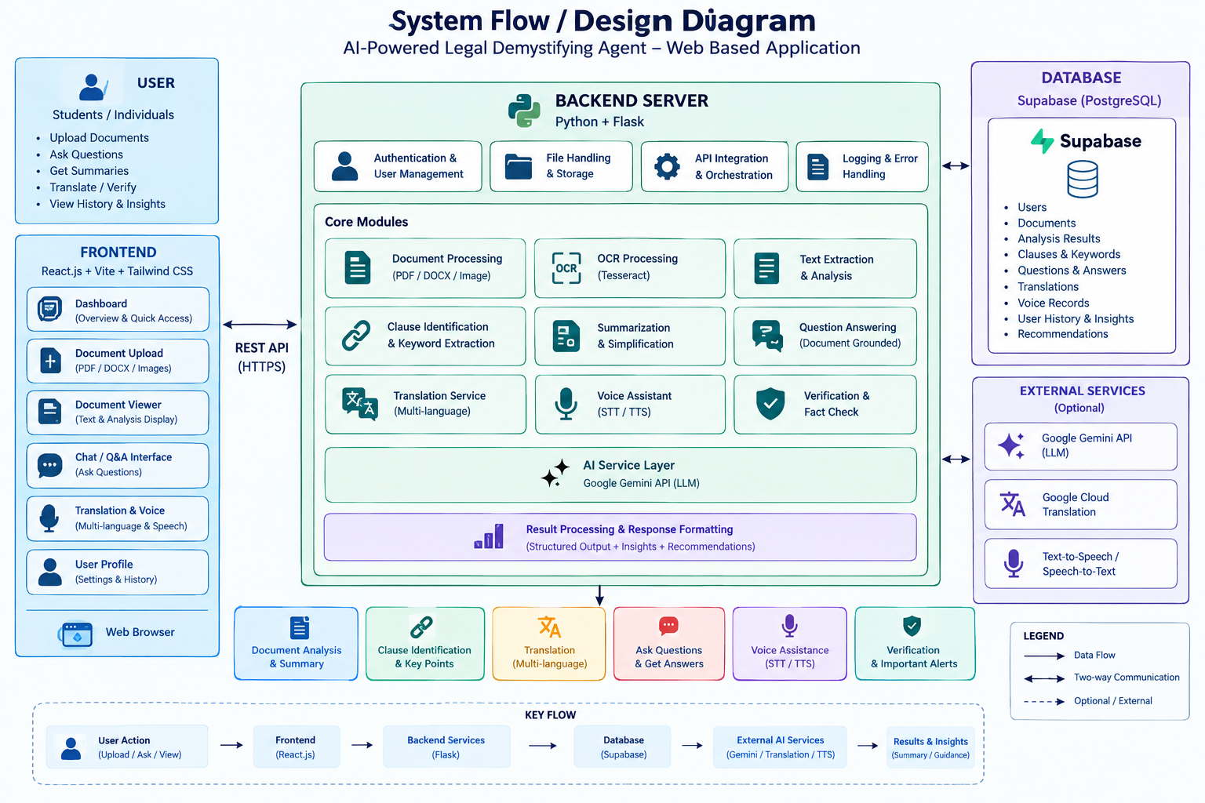

ACTIVITY DIAGRAM
The activity diagram represents the sequence of actions performed by a user while using the legal document understanding platform. The user first registers or logs into the system and then uploads a legal document or enters text for analysis. The system processes the document using text extraction or OCR and performs AI-based analysis to generate summaries, identify important clauses and keywords, and extract rights, responsibilities, and deadlines. The user can also ask document-grounded questions, translate the content, use voice assistance, and review the Before You Sign checklist. The results from these activities are stored and analyzed, allowing the system to provide document insights, important attention points, simplified explanations, and verification information.
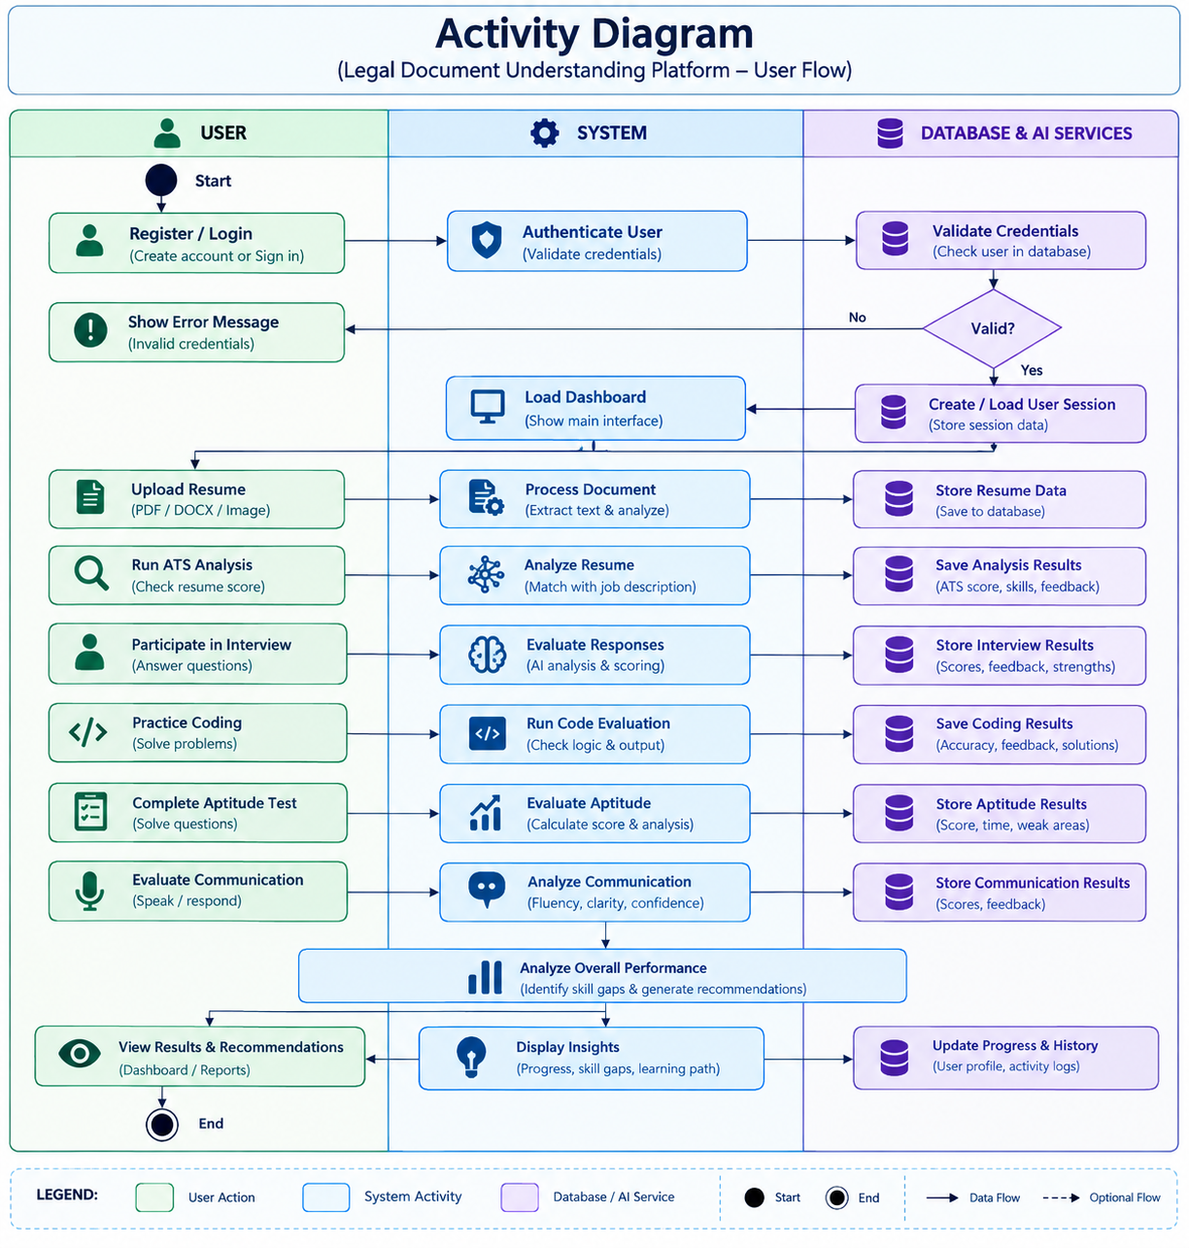

DATA FLOW DIAGRAM
The Data Flow Diagram represents the movement of information between the user, application modules, AI analysis services, and database. The user provides inputs such as legal documents, text, questions, and document-related information. The application processes these inputs through document extraction, OCR, AI analysis, summarization, clause identification, translation, and document-grounded question answering. The resulting information is used to generate summaries, explanations, important clauses, attention points, translations, and verification details. The processed information is stored in the database and can later be accessed through the dashboard for document review and analysis.
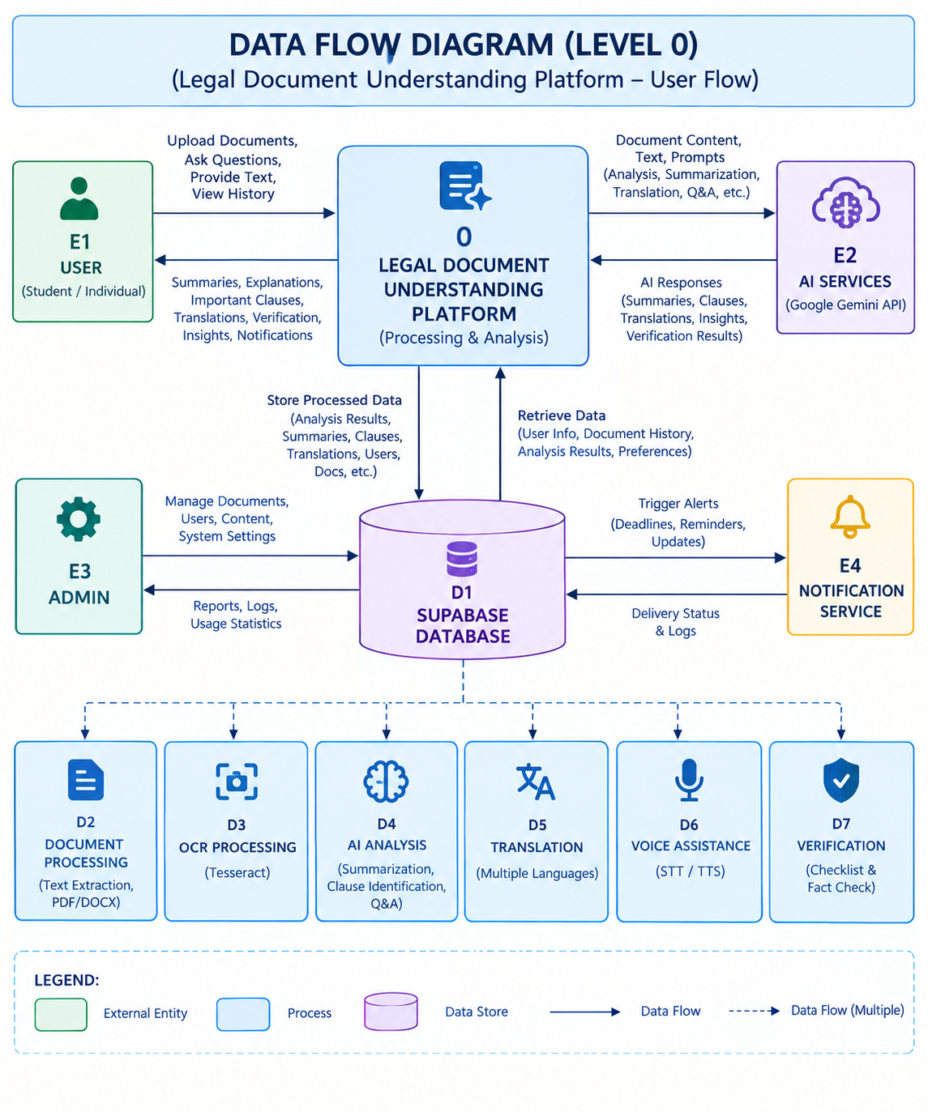

CHAPTER 4 PROJECT DESCRIPTION
  - METHODOLOGIES
The project follows a modular and service-oriented approach to integrate different legal document-understanding activities into a single platform. In the Document Processing Methodology, the uploaded document is first validated and its text is extracted using PyMuPDF or PyPDF2 for PDF files and python-docx for DOCX files, while Tesseract OCR is applied to scanned or image-based pages. The extracted text is then cleaned, divided into smaller chunks and stored along with its page references. In the AI Analysis Methodology, the document category, such as a rental, employment or service agreement, is identified first, and the relevant content is sent to Google Gemini with a controlled system prompt to generate the simple summary, key points, legal keywords, important clauses, rights, responsibilities, deadlines, financial details and attention points.
In the Question-Answering Methodology, the user's question is matched with the most relevant chunks of the uploaded document using a Retrieval-Augmented Generation (RAG) approach, and only these chunks are supplied to Gemini so that the answer remains grounded in the document. If the required information is not present, the system states that it could not find it in the uploaded document. The Translation Methodology converts the generated explanations into English, Tamil, Hindi or Telugu using Google Cloud Translation while keeping the original text available for comparison. The Voice Methodology converts spoken questions into text and reads the answers aloud. Finally, the Verification Methodology links important statements to page or clause references and generates a personalized Before You Sign checklist along with a disclaimer that the system provides general information and not legal advice.

MODULES
The system is divided into seven major modules to keep the application organized and easy to maintain.

USER AUTHENTICATION AND DOCUMENT MANAGEMENT MODULE
The User Authentication and Document Management Module manages account access and the storage of user documents. New users can register and existing users can log in through Supabase Authentication. The module manages protected access to the application features so that every uploaded document, generated guide, translation and question history is associated with the correct user. The My Documents page lists the uploaded documents along with their type, number of pages, processing status, language and upload date, and allows the user to reopen the summary, question-and-answer or translation view of any document.

DOCUMENT UPLOAD AND TEXT EXTRACTION MODULE
The Document Upload and Text Extraction Module is the entry point of the system. It accepts PDF, DOCX and TXT files of up to 10 MB and allows the user to select the preferred language before processing. The backend detects the file type, validates the file and extracts the text using PyMuPDF or PyPDF2 for PDF files and python-docx for DOCX files. When a page is scanned or image-based, Tesseract OCR is used to recover the text. The extracted text is cleaned, divided into chunks and stored with page references so that later analysis and answers can be traced back to the source. Problems such as empty documents, unsupported files and OCR failure are reported to the user through clear messages.

AI DOCUMENT ANALYSIS AND SIMPLIFICATION MODULE
The AI Document Analysis and Simplification Module is the core analysis component of the system. After the document type is identified, Google Gemini analyzes the extracted content and generates a one-line summary, a simple summary, key points, legal keywords with simple explanations, and important clauses along with their meaning, importance and points to check. The module also separates the rights and responsibilities of the user and the other party and identifies deadlines, payment details and penalties. Attention points are classified using neutral levels, namely high attention, medium attention and informational, instead of describing a clause as illegal or dangerous. The results are presented as an easy guide, and complicated clauses can be explained in short and simple sentences.

DOCUMENT-GROUNDED QUESTION ANSWERING MODULE
The Document-Grounded Question Answering Module allows users to ask questions about the uploaded document through the Ask Questions option. The question is matched with the most relevant chunks of the document using the Retrieval-Augmented Generation approach, and only these chunks are sent to Gemini along with the question. This reduces cost, improves speed and keeps the answer based on the document rather than on general assumptions. Answers include the page or clause reference wherever it is available. If the information cannot be found, the system responds that it could not find it in the uploaded document instead of guessing. The number of questions asked is recorded and shown on the My Documents page.

MULTILINGUAL TRANSLATION AND VOICE ASSISTANT MODULE
This module improves accessibility for users who are not comfortable with English or with legal language. The user can switch between English, Tamil, Telugu and Hindi, and the summary, key points, keywords, clauses, rights, responsibilities, attention points and answers can be translated using Google Cloud Translation. The original text remains available for comparison, and the architecture allows additional languages to be added easily. The voice assistant converts a spoken question into text, sends it through the same document-grounded question answering process and reads the answer aloud, while also displaying it as text so that the user can verify what the system understood. Summaries can also be listened to aloud.

BEFORE YOU SIGN AND VERIFICATION MODULE
The Before You Sign and Verification Module helps users review a document before accepting it. Based on the analyzed content, it generates a personalized checklist, such as checking whether the total payment matches what was agreed verbally, the auto-renewal date and the method of cancellation, every date and deadline, and what happens if either side breaks the agreement. Important statements are connected to their source page or clause, and unclear information is marked as not clearly specified in the document. The module reminds the user that significant or unclear clauses should be discussed with a qualified legal professional, and a disclaimer states that the guide is not legal advice.

DASHBOARD AND USAGE TRACKING MODULE
The Dashboard and Usage Tracking Module provides a centralized view of the user's documents and activity. The My Documents dashboard displays the number of documents, summaries, translations and questions asked, together with a card for every document showing its processing status, language, upload date and shortcut buttons for Summary, Q&A and Translate. By bringing these details together, the dashboard helps users return to earlier documents and continue their review without uploading them again. The module can also be extended to support the optional Compare Documents feature, where two versions of a document are compared to identify added, removed and modified clauses.

CHAPTER 5 IMPLEMENTATION AND RESULT DISCUSSION
  - DEVELOPMENT ENVIRONMENT
The project was implemented as a full-stack web application with separate frontend, backend, database and AI components. The frontend provides the user interface and communicates with the backend through REST APIs, while the backend manages the application logic and interacts with the Supabase PostgreSQL database. The major technologies used in the development include React with Vite, HTML5 and CSS3 for the responsive card-based frontend, Python with Flask for the backend, Supabase Authentication and Supabase PostgreSQL for user management and data storage, the Google Gemini API for document analysis, summarization and question answering, the Google Cloud Translation API for multilingual support, PyMuPDF or PyPDF2 and python-docx for text extraction, and Tesseract OCR for scanned documents. Sensitive settings such as GEMINI_API_KEY and GOOGLE_TRANSLATE_API_KEY are stored in environment variables, and the application is prepared for deployment on cloud platforms such as Railway.

FRONTEND IMPLEMENTATION
The frontend of the project, named Legal Saathi, is developed using React, following a component-based approach that allows common interface elements to be reused across different pages. The application includes a Home page, an Upload section, the My Documents dashboard, the document guide page and the Translate option, all accessible through a simple navigation bar. The Home page introduces the platform with the message "Understand the Law. In Your Language." and presents four feature cards for Plain-Language Summary, Multi-language Support, Ask Anything, and Listen & Translate. The upload panel supports drag-and-drop or browsing for PDF, DOCX and TXT files of up to 10 MB and lets the user choose English, Tamil, Telugu or Hindi. Results are displayed in colour-coded cards with simple icons, making the legal information easier to read.
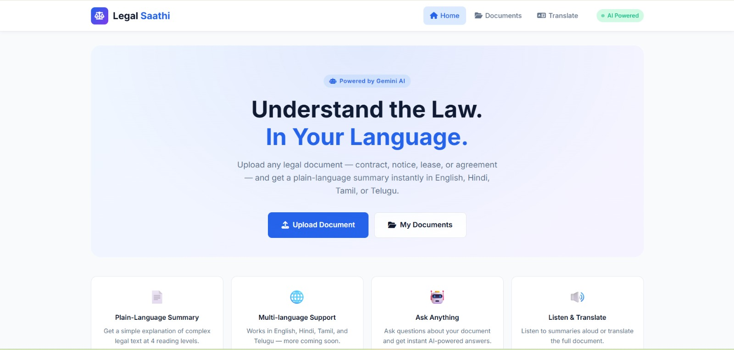
Figure 5.1: Home page of Legal Saathi

BACKEND IMPLEMENTATION
The backend of the project is developed using Python and Flask. It is responsible for handling the core application logic, including document upload, file-type detection, text extraction, OCR processing, text cleaning and chunking, relevant-section retrieval, Gemini-based analysis, question answering, translation and voice-assistant requests. The backend follows a modular structure consisting of routes, services, configuration and database components, which makes the system easier to maintain and extend with additional languages or features in the future. Error handling is provided for invalid API keys, exceeded API quotas, empty documents, unsupported files, OCR failures, translation failures, Gemini API failures, very large documents and network failures, so that the user receives a clear message instead of a system error. All calls to Gemini and Google Translation are made from the backend so that API keys are never exposed to the browser.

DATABASE IMPLEMENTATION
Supabase PostgreSQL is used as the database for storing and managing the application data. The database uses a relational structure to organize information related to users, uploaded documents, extracted text chunks, analysis results, questions and answers, and translations. Document records store the file name, document type, number of pages, language, processing status and upload date, while the chunk records keep the cleaned text together with its page reference for retrieval. The generated guide, including summaries, keywords, clauses, dates, payment details and checklist items, is stored so that it can be reopened without repeating the analysis. Question and translation records are also maintained, which allows the My Documents dashboard to display the number of documents, summaries, translations and questions asked.

AI-BASED DOCUMENT ANALYSIS
AI-based analysis is used in the system to support document understanding, simplification and question answering. The Google Gemini API is controlled through a system prompt that requires the model to avoid fabricating information, prefer the uploaded document over general assumptions, clearly separate document facts from general explanations, mention when information is missing, use simple language, preserve the meaning of legal clauses, and cite page or clause references whenever available. The prompt also instructs the model not to claim to be a lawyer, not to give definitive legal conclusions, and to treat the uploaded document as untrusted data so that instructions hidden inside a document are not followed. The analysis is customized according to the detected document category. Since AI-based analysis may have limitations such as incorrect or incomplete explanations, the results should be considered as guidance for understanding rather than as legal advice.

GUIDE GENERATION AND QUESTION ANSWERING IMPLEMENTATION
The easy guide for each document is generated as a set of structured sections. Each section is displayed as a separate card so that the user can quickly find the required information. The main sections of the guide are listed below:
Table 5.1: Sections of the Easy Guide
SECTION | INFORMATION PROVIDED
Important Things to Notice | Key points of the document that need attention
Good Things — What Works for You | Rights, refund or cancellation details, benefits and protections
Dates & Deadlines | Start / effective date and cancellation / end date
Money to Notice | Payment amounts such as the monthly payment
Before You Sign | Checklist of items to verify before signing
For question answering, the extracted text is divided into chunks and converted into embeddings stored in a vector database. When a user asks a question, the most relevant chunks are retrieved and supplied to Gemini, which generates an answer grounded in these chunks together with the page or clause reference. This Retrieval-Augmented Generation pipeline avoids sending very large documents to the AI model and reduces the chance of answers based on general knowledge.

TRANSLATION AND VOICE ASSISTANCE IMPLEMENTATION
Multilingual support is implemented using the Google Cloud Translation API. The language selector allows the user to switch between English, Tamil, Telugu and Hindi, and the generated summary, key points, keywords, clauses, rights, responsibilities, attention points and answers can be translated. The original document text is always retained so that the user can compare the translation with the source, and legal terms are handled carefully so that their meaning is not changed. The language list is maintained as a configuration, which allows additional languages to be added easily. The voice assistant converts the spoken question into text, processes it through the same document-grounded pipeline and plays the answer aloud while also showing it as text. A short disclaimer reminds the user that the assistant provides general information and is not a substitute for a qualified legal professional.

BEFORE YOU SIGN AND VERIFICATION IMPLEMENTATION
The Before You Sign feature generates a checklist dynamically from the analyzed document instead of using a fixed list. Each item is displayed with a selectable checkbox so that the user can mark the points that have been verified, such as confirming the total payment amount, the auto-renewal date and cancellation method, every date and deadline, and the consequences if either side breaks the agreement. Important statements are linked to their page or clause references wherever available, and statements that are unclear are marked as not clearly specified in the document. Every guide ends with a notice that it helps the user understand the document in simple language, that it is not legal advice, and that a lawyer should be consulted for important decisions.

AUTHENTICATION AND SECURITY
Security is an important part of the application because the system handles user accounts, uploaded legal documents and analysis results. User authentication is managed through Supabase Authentication, and protected routes restrict access to authorized users. User ownership checks help prevent one user from accessing another user's documents. File-type validation and the 10 MB file-size limit help ensure that uploaded documents are handled safely. The Gemini and Google Translation API keys are stored in environment variables and are used only by the backend, so they are never exposed in the frontend code. Uploaded documents are treated as untrusted data, which protects the system from instructions that may be hidden inside a document. These measures work together to protect user information and reduce the risk of unauthorized access.

RESULTS DISCUSSION
DOCUMENT UPLOAD RESULT
The upload section allows the user to provide a legal document by dragging and dropping it or by browsing for a file. The panel clearly shows the supported formats, which are PDF, DOCX and TXT, along with the 10 MB size limit. The user can also choose the preferred language, namely English, Tamil, Telugu or Hindi, before the document is processed.
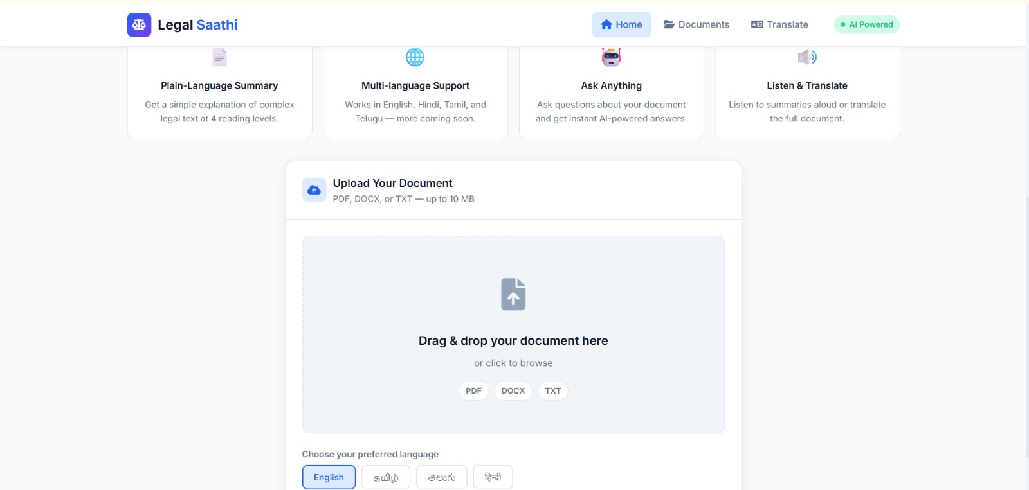
Figure 5.2: Document upload and language selection
MY DOCUMENTS DASHBOARD RESULT
The My Documents page provides a centralized view of the user's activity. The summary cards display the number of documents, summaries, translations and questions asked, which are 1, 0, 17 and 9 respectively for the tested user. The uploaded Service Agreement is displayed as a document card with its status marked as ready, the language, the upload date and shortcut buttons for Summary, Q&A and Translate.
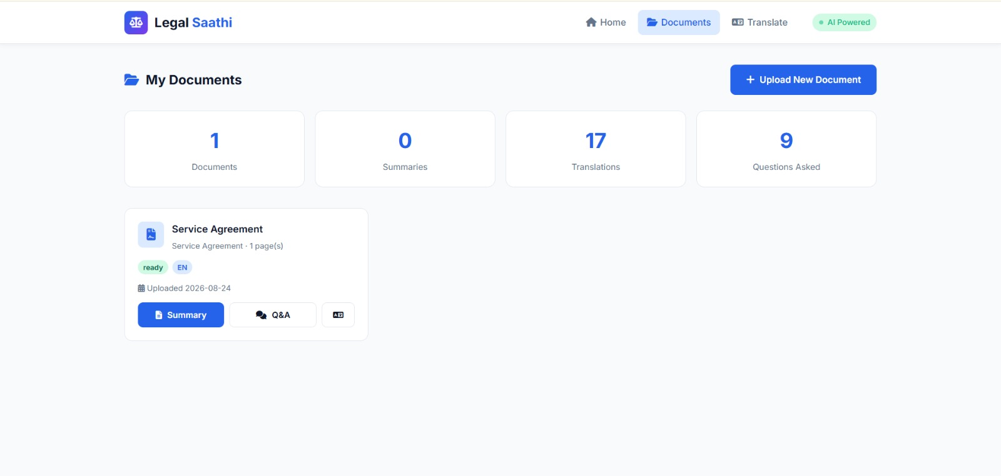
Figure 5.3: My Documents dashboard
EASY GUIDE GENERATION RESULT
After a document is opened, the guide page shows the document title, type, language, number of pages and upload status. The user can change the language, ask questions, translate the content or generate the easy guide. While the analysis is in progress, the guide button changes to a Creating Your Guide state, which informs the user that the document is being processed. The Important Things to Notice option provides quick access to the main attention points.
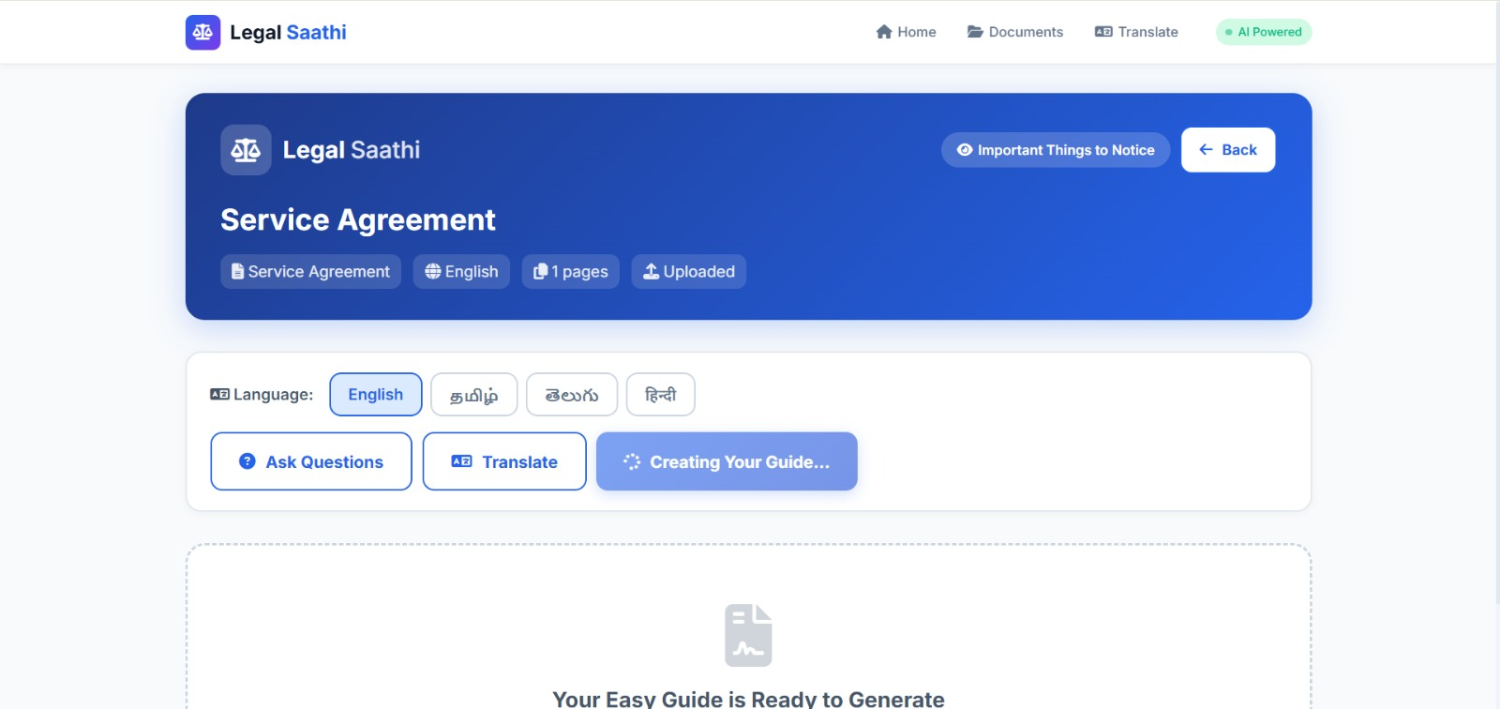
Figure 5.4: Easy guide generation page
GOOD THINGS RESULT
The Good Things section presents the points that work in favour of the user. For the tested Service Agreement, the cards show the user's rights to receive necessary information and reasonable access, the refund or cancel details, the benefits such as the confidentiality obligation of the service provider, and the protections. Important terms such as shall and the agreement date are highlighted to draw attention to them. It was also observed that the Refund / Cancel card displays the opening text of the agreement and the Protections card displays a general prompt, which shows that the classification of clauses into cards can be further refined.
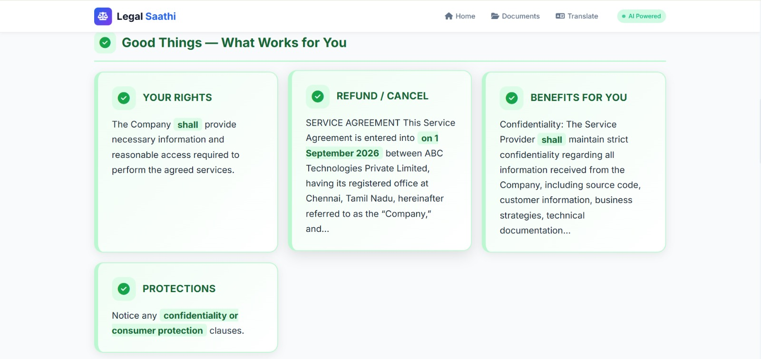
Figure 5.5: Good Things — What Works for You
DATES AND MONEY RESULT
The Dates & Deadlines section extracts the important dates from the document so that they can be added to the user's calendar. For the tested Service Agreement, the start or effective date is 1 September 2026 and the cancellation or end date is 31 August 2027. The Money to Notice section displays the financial obligation, which is a monthly payment of ₹40,000, and encourages the user to check every number before signing.
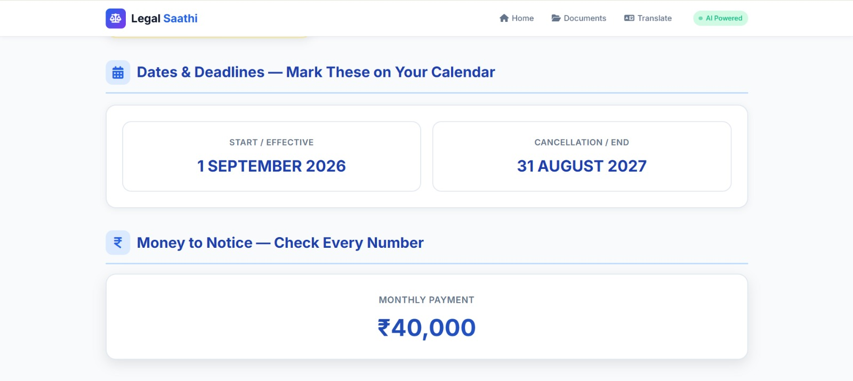
Figure 5.6: Dates & Deadlines and Money to Notice
BEFORE YOU SIGN RESULT
The Before You Sign section displays a checklist of four items generated from the document. The user is asked to check that the total payment amount matches what was agreed verbally, the auto-renewal date and the method of cancelling before it renews, every date and deadline, and what happens if either side breaks the agreement. The page ends with a notice that the guide helps the user understand the document in simple language and is not legal advice, and that a lawyer should be consulted for important decisions.
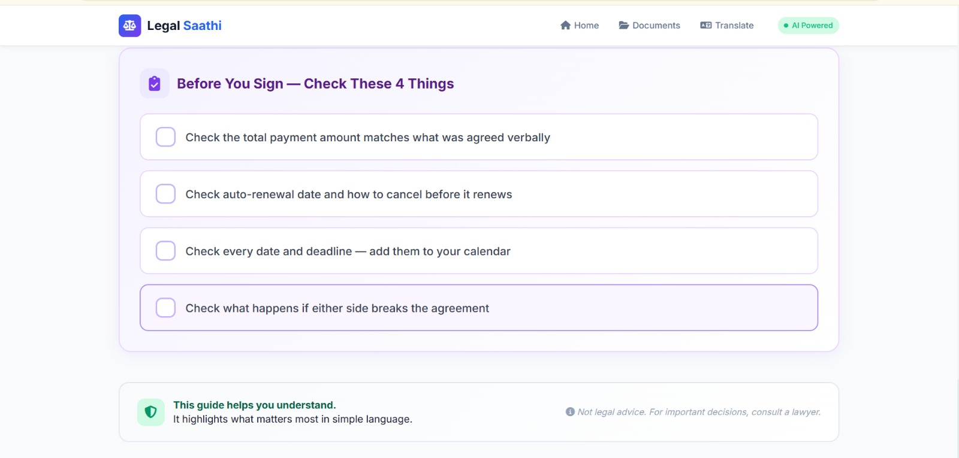
Figure 5.7: Before You Sign checklist and disclaimer

CHAPTER 6 CONCLUSION AND FUTURE WORK
  - CONCLUSION
The AI-Powered Legal Demystifying Agent, implemented as Legal Saathi, provides a unified platform for understanding complex legal documents. The system brings important activities such as document upload, text extraction, OCR, AI-based summarization, legal keyword and clause identification, rights and responsibilities analysis, document-grounded question answering, multilingual translation, voice assistance and the Before You Sign checklist into a single platform.
The system helps users understand what a document is about, identify important dates and payment amounts, recognize the points that work in their favour and review the points that need attention before signing. By supporting English, Tamil, Telugu and Hindi, the platform makes legal information accessible to a wider group of users, and by linking answers to the uploaded document, it reduces the chance of unsupported responses.
Overall, the project provides a practical environment where ordinary users can upload, understand, translate, question and verify their legal documents. The proposed system addresses the problem of fragmented legal document understanding by bringing these activities together in one centralized platform, while clearly stating that it provides general informational assistance and does not replace advice from a qualified legal professional.

FUTURE WORK
The project can be further improved by adding advanced features to make the platform more accurate, intelligent and useful. The clause classification can be refined so that every card in the guide contains the most relevant clause of the document. The optional Compare Documents feature can be completed to identify added, removed and modified clauses, changed payment amounts, deadlines and termination conditions between two versions of a document. The OCR module can be improved to handle low-quality scans and handwritten text, and more Indian and international languages can be added to the translation and voice features. Jurisdiction-specific legal information can be integrated so that the system can explain the local legal context more reliably. The accuracy of the generated explanations can be evaluated with legal professionals and benchmark datasets, and a dedicated Android and iOS application can be developed to allow users to access the platform from mobile devices.

