**Assignment:**

Develop an application using the programming language of your choice and deploy it to Azure using Terraform.

There are various methods to deploy an API on Azure, such as Azure App Service, AKS (Azure Kubernetes Service), Azure API Management , VMs etc. After considering factors like application requirements, complexity, deployment intricacies, time constraints, and Azure billing (since I don't have a free account option), I have opted to deploy the API using a Virtual Machine (VM).

I've created an API using Ruby and deployed it on an Ubuntu VM in Azure. The architecture involves provisioning the Azure infrastructure using Terraform, followed by the Continuous Deployment (CD) pipeline, which can be set up with orchestration tools like Jenkins, GitLab CI, etc.

The application is deployed to the Azure VM using the deploy.sh script, which can be found in the scripts folder. Since I haven't established an orchestration platform yet, I've manually executed the deploy script on the VM. Nevertheless, I have included a Jenkins file with a basic set of steps for future use.

The Terraform scripts are in the infrastructure folder, while the scripts folder contains the Bash script for deploying the application to the Azure VM. The API itself is defined in the hello-world.rb file. To authenticate Terraform with Azure, I used Azure login. Additionally, I've included the Terraform.tfstate file in the project, which was generated during the execution of the Terraform script.

Attached below is a screenshot displaying the resources created by Terraform on Azure.

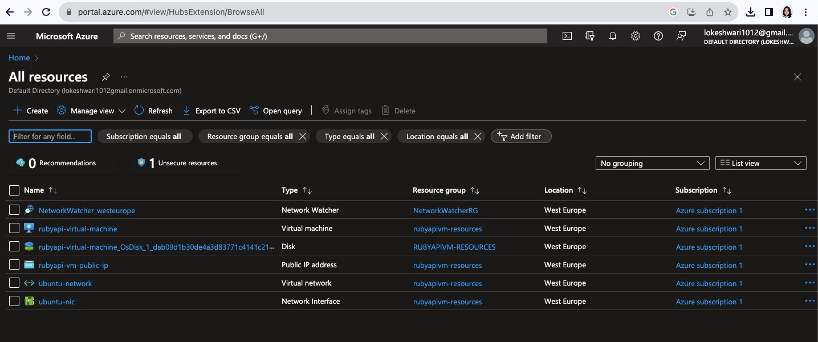  
  
Also, API with endpoint hello that was deployed on VM with deploy.sh script

