SMART BUILDING ENERGY
PEAK-SHAVING CONTROLLER

Technology Stack
Spring Boot | React | Python | NumPy | Pandas | MySQL | Snowflake | Power BI
AWS S3 | AWS EC2 | Docker | GitHub Actions

Document Purpose
This document defines the business problem, system architecture, technology responsibilities, database design, APIs, scheduling logic, analytics pipeline, deployment approach, testing strategy and four-day delivery plan for the Smart Building Energy Peak-Shaving Controller.
Database decision: MySQL is the operational relational database. Snowflake is the analytical data warehouse. PostgreSQL is not part of this solution.
Project boundary: the application produces simulated recommendations and analysis. It does not directly control physical building equipment. Any savings shown in the demo must be labelled simulated unless supported by real measurements.

1. Project Overview

1.1 Business Context
Commercial buildings use electricity for HVAC, lighting, elevators, computers and other equipment. Demand can rise sharply during certain periods, creating peak electricity demand and potentially increasing operating costs or stressing electrical infrastructure.
The project develops a simulation-backed application that recommends adjustments to eligible non-critical loads during peak periods while respecting equipment priority, occupancy, comfort and safety constraints.

1.2 Objectives
- Ingest and validate simulated electricity meter readings.
- Maintain equipment classifications, occupancy schedules and comfort rules.
- Detect peak-demand events using configurable thresholds.
- Generate explainable recommendations for eligible non-critical loads.
- Protect critical equipment from automatic shutdown or reduction.
- Allow authorized operators to approve, reject or override recommendations.
- Maintain an auditable history of scheduling decisions and overrides.
- Analyze energy and peak-shaving KPIs using Snowflake and Power BI.

2. Scope

2.1 Included
- Meter-data ingestion and validation
- Equipment/load classification
- Occupancy schedule management
- Peak-demand detection
- Constraint-aware load scheduling
- Manual override and audit logging
- KPI reporting
- Snowflake analytics pipeline
- Cloud deployment and CI/CD

2.2 Excluded
- Direct control of physical electrical equipment
- Integration with real building control systems or commercial smart meters
- Guaranteed financial savings
- Automatic shutdown of critical equipment

3. Technology Stack
Technology | Responsibility
Spring Boot | Backend REST APIs, business services, validation and deterministic scheduling engine.
React | Operator dashboard, equipment screens, peak-event views and override interface.
Python | Meter-data processing, validation and analytical preparation.
NumPy | Numerical calculations and demand analysis.
Pandas | Data cleaning, transformation, aggregation and quality checks.
MySQL | Operational transactional database for application records.
Snowflake | Analytical data warehouse for historical and aggregated data.
Power BI | Interactive energy, peak-shaving, equipment and comfort reports.
AWS S3 | Storage for exports, reports and historical data files.
AWS EC2 | Host application containers.
Docker | Package backend, frontend and processing components.
GitHub Actions | Automate build, test, image publishing and deployment workflows.

Architecture decision: keep the core scheduling rules in Spring Boot for a single, testable source of truth. Use Python for data processing and analytical tasks rather than duplicating safety-related scheduling rules across services.

4. System Architecture

4.1 High-Level Architecture
The architecture is organized around one central application: Spring Boot. React is the operator-facing user interface; MySQL is the operational source of truth; Python handles input-data processing and analytical preparation; and Snowflake/Power BI provide historical analytics. AWS S3 stores export and staging files, while AWS EC2 hosts the containerized application.
How to read the connections: arrows show the direction of data or control flow. A two-way arrow between React and Spring Boot represents REST requests and responses. A two-way arrow between Spring Boot and MySQL represents operational reads and writes. The analytics pipeline is separate from peak scheduling so that a reporting failure does not stop operational recommendations.
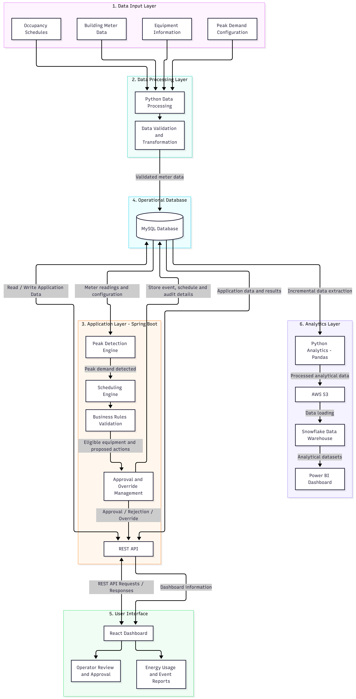

Component connections and responsibilities
Input data → Python: The simulator or configured source provides meter readings and supporting building data. Python validates timestamps, numeric demand values and basic data quality.
Python → MySQL: Only accepted operational meter readings are persisted in MySQL. Missing or invalid readings are flagged; they are not silently replaced with zero.
React ↔ Spring Boot REST APIs: React sends user actions and configuration requests to Spring Boot and receives dashboard, event and schedule responses.
Spring Boot ↔ MySQL: Spring Boot reads the latest valid readings and configuration, then writes peak events, recommendations, approvals, simulated outcomes and audit records.
Peak detection → Scheduling → Rules: When demand exceeds the active threshold, the scheduling engine evaluates equipment. The rules layer protects critical loads and checks controllability, occupancy and comfort constraints.
Approval / override → MySQL: Authorized operator decisions are saved with the original recommendation, selected action, user, timestamp and reason.
MySQL → Python analytics → S3 → Snowflake → Power BI: A separate incremental pipeline prepares historical data for reporting. It uses a durable watermark or batch identifier and retry-safe loading.
GitHub → GitHub Actions → Docker images → EC2: Source changes are built and tested, packaged as versioned images and deployed to EC2. Health checks determine whether deployment is accepted or rolled back.

Important architecture boundaries
- Spring Boot is the single source of truth for peak detection, scheduling decisions and safety-related business rules. Do not duplicate these rules in Python or React.
- Python has two separate responsibilities: validating/transforming incoming meter data and preparing analytical extracts. These are data-processing tasks, not the authority for scheduling decisions.
- MySQL is the operational database. Snowflake is the analytical warehouse. PostgreSQL is not used in this solution.
- The application is simulation-only. It must not send commands to physical building equipment. UI labels, reports and demo results must clearly say simulated.
- Analytics is an independent downstream flow. Snowflake, S3 or Power BI outages must not disable the core operational application.

4.2 End-to-End Workflow
- An operator configures equipment priorities, occupancy schedules, comfort rules and peak thresholds.
- A simulator generates meter readings at a configurable interval.
- Python validates and processes the readings; valid operational readings are stored in MySQL.
- Spring Boot evaluates current demand against the configured threshold.
- When a peak event is detected, the scheduling engine retrieves eligible equipment.
- The engine checks critical status, controllability, occupancy and comfort constraints.
- The engine generates a recommendation with an expected reduction and a reason for each decision.
- An authorized operator reviews, approves, rejects or overrides the recommendation.
- The system records the decision and override history in MySQL.
- An independent analytics pipeline transfers suitable records to S3 and Snowflake.
- Power BI displays historical trends and simulated peak-shaving performance.

5. Functional Modules

5.1 Meter Data Ingestion
Accept simulated meter readings; validate timestamp and numeric demand; identify missing, duplicate, invalid or stale records; persist accepted readings in MySQL.

5.2 Equipment Classification
Classify equipment by priority and controllability. Critical equipment must never be automatically switched off or reduced. Equipment permissions must be explicitly configured.

5.3 Occupancy Management
Maintain occupancy windows by building area. The scheduler must not assume an area is unoccupied when occupancy data is missing or stale.

5.4 Peak-Demand Detection
Compare valid current demand with a configurable threshold. Initial implementation uses threshold-based detection; forecasting is an optional enhancement.

5.5 Scheduling Engine
Evaluate eligible equipment, enforce restrictions, calculate potential demand reduction and produce an explainable recommendation.

5.6 Manual Override
Allow authorized users to approve, reject or change a recommendation. Record the user, timestamp, original action, new action and reason.

5.7 KPI Reporting
Calculate peak demand, simulated demand reduction, peak events, comfort exceptions, overrides and protected-load violations.

5.8 Analytics and Visualization
Transfer operational data to Snowflake and present reports through Power BI.

6. Business Rules and Safety Constraints
Rule | Requirement
Critical-load protection | Critical equipment is never eligible for automatic shutdown or reduction.
Equipment priority | Only explicitly controllable equipment can be considered by the scheduler.
Occupancy validation | Occupancy restrictions must be checked before a recommendation is approved or simulated as executed.
Comfort guardrails | HVAC actions must respect configured comfort limits. Example values such as 22–26°C are illustrative and must be configurable.
Meter quality | Missing, invalid, duplicate or stale readings must not be treated as reliable operational demand measurements.
Manual override | Overrides require an authorized user and a reason, and must be auditable.
Revalidation | Recheck relevant occupancy, equipment and comfort constraints before simulated execution.
Safe failure | If required data is unavailable, do not generate an unsafe load-reduction action.
Savings labelling | Label outputs as simulated unless actual measured data supports the claim.

7. Assumptions and Success Measures
Area | Initial Assumption
Building | One simulated commercial building
Meter data | Synthetic readings at a configurable interval; five minutes is the initial example
Equipment | A configurable sample set
Peak detection | Configurable threshold-based detection
Scheduling | Deterministic rule-based logic
Operational database | MySQL
Analytics | Snowflake and Power BI
Deployment | Docker containers hosted on AWS EC2
Storage | AWS S3 for files and exports
Physical control | Not included

Success is measured by correct peak-event detection, reliable data validation, zero critical-load scheduling actions, enforcement of occupancy and comfort constraints, auditable overrides, reconciled analytics data and a reproducible deployment.

8. MySQL Database Design
Create the operational database using MySQL. The following schema is a proposed starting point; adjust data types, constraints and indexes as implementation details are finalized.

8.1 Database Creation
CREATE DATABASE smart_building_db;
USE smart_building_db;

8.2 Core Tables

BUILDING
CREATE TABLE BUILDING (
BUILDING_ID BIGINT PRIMARY KEY AUTO_INCREMENT,
BUILDING_NAME VARCHAR(100) NOT NULL,
LOCATION VARCHAR(200),
CREATED_AT TIMESTAMP DEFAULT CURRENT_TIMESTAMP
);

LOAD_EQUIPMENT
CREATE TABLE LOAD_EQUIPMENT (
EQUIPMENT_ID BIGINT PRIMARY KEY AUTO_INCREMENT,
BUILDING_ID BIGINT NOT NULL,
EQUIPMENT_NAME VARCHAR(100) NOT NULL,
EQUIPMENT_TYPE VARCHAR(50),
PRIORITY_LEVEL VARCHAR(20) NOT NULL,
IS_CRITICAL BOOLEAN DEFAULT FALSE,
IS_CONTROLLABLE BOOLEAN DEFAULT FALSE,
RATED_POWER_KW DECIMAL(10,2),
CURRENT_STATUS VARCHAR(30),
AREA_NAME VARCHAR(100),
FOREIGN KEY (BUILDING_ID) REFERENCES BUILDING(BUILDING_ID)
);

METER_READINGS
CREATE TABLE METER_READINGS (
READING_ID BIGINT PRIMARY KEY AUTO_INCREMENT,
BUILDING_ID BIGINT NOT NULL,
READING_TIMESTAMP DATETIME NOT NULL,
DEMAND_KW DECIMAL(12,2) NOT NULL,
SOURCE_NAME VARCHAR(50),
DATA_QUALITY_STATUS VARCHAR(30),
CREATED_AT TIMESTAMP DEFAULT CURRENT_TIMESTAMP,
FOREIGN KEY (BUILDING_ID) REFERENCES BUILDING(BUILDING_ID),
UNIQUE (BUILDING_ID, READING_TIMESTAMP)
);

OCCUPANCY_SCHEDULE
CREATE TABLE OCCUPANCY_SCHEDULE (
OCCUPANCY_ID BIGINT PRIMARY KEY AUTO_INCREMENT,
BUILDING_ID BIGINT NOT NULL,
AREA_NAME VARCHAR(100) NOT NULL,
START_TIME DATETIME NOT NULL,
END_TIME DATETIME NOT NULL,
OCCUPANCY_STATUS VARCHAR(30),
EXPECTED_OCCUPANCY INT,
FOREIGN KEY (BUILDING_ID) REFERENCES BUILDING(BUILDING_ID)
);

PEAK_CONFIG
CREATE TABLE PEAK_CONFIG (
CONFIG_ID BIGINT PRIMARY KEY AUTO_INCREMENT,
BUILDING_ID BIGINT NOT NULL,
PEAK_THRESHOLD_KW DECIMAL(12,2) NOT NULL,
CONFIG_START_TIME DATETIME,
CONFIG_END_TIME DATETIME,
IS_ACTIVE BOOLEAN DEFAULT TRUE,
FOREIGN KEY (BUILDING_ID) REFERENCES BUILDING(BUILDING_ID)
);

COMFORT_RULES
CREATE TABLE COMFORT_RULES (
RULE_ID BIGINT PRIMARY KEY AUTO_INCREMENT,
BUILDING_ID BIGINT NOT NULL,
AREA_NAME VARCHAR(100),
MIN_TEMPERATURE DECIMAL(5,2),
MAX_TEMPERATURE DECIMAL(5,2),
MAX_ALLOWED_ADJUSTMENT DECIMAL(5,2),
IS_ACTIVE BOOLEAN DEFAULT TRUE,
FOREIGN KEY (BUILDING_ID) REFERENCES BUILDING(BUILDING_ID)
);

PEAK_EVENTS
CREATE TABLE PEAK_EVENTS (
EVENT_ID BIGINT PRIMARY KEY AUTO_INCREMENT,
BUILDING_ID BIGINT NOT NULL,
EVENT_START_TIME DATETIME NOT NULL,
EVENT_END_TIME DATETIME,
PEAK_DEMAND_KW DECIMAL(12,2),
THRESHOLD_KW DECIMAL(12,2),
EVENT_STATUS VARCHAR(30),
FOREIGN KEY (BUILDING_ID) REFERENCES BUILDING(BUILDING_ID)
);

LOAD_SCHEDULE
CREATE TABLE LOAD_SCHEDULE (
SCHEDULE_ID BIGINT PRIMARY KEY AUTO_INCREMENT,
EVENT_ID BIGINT NOT NULL,
EQUIPMENT_ID BIGINT NOT NULL,
RECOMMENDED_ACTION VARCHAR(30),
EXPECTED_REDUCTION_KW DECIMAL(10,2),
SCHEDULE_STATUS VARCHAR(30),
REASON VARCHAR(500),
CREATED_AT TIMESTAMP DEFAULT CURRENT_TIMESTAMP,
FOREIGN KEY (EVENT_ID) REFERENCES PEAK_EVENTS(EVENT_ID),
FOREIGN KEY (EQUIPMENT_ID) REFERENCES LOAD_EQUIPMENT(EQUIPMENT_ID)
);

APP_USERS
CREATE TABLE APP_USERS (
USER_ID BIGINT PRIMARY KEY AUTO_INCREMENT,
USERNAME VARCHAR(100) NOT NULL UNIQUE,
PASSWORD_HASH VARCHAR(255) NOT NULL,
ROLE_NAME VARCHAR(30) NOT NULL,
IS_ACTIVE BOOLEAN DEFAULT TRUE,
CREATED_AT TIMESTAMP DEFAULT CURRENT_TIMESTAMP
);

OVERRIDE_LOG
CREATE TABLE OVERRIDE_LOG (
OVERRIDE_ID BIGINT PRIMARY KEY AUTO_INCREMENT,
SCHEDULE_ID BIGINT NOT NULL,
USER_ID BIGINT NOT NULL,
ORIGINAL_ACTION VARCHAR(30),
OVERRIDE_ACTION VARCHAR(30),
OVERRIDE_REASON VARCHAR(500),
OVERRIDE_TIMESTAMP TIMESTAMP DEFAULT CURRENT_TIMESTAMP,
FOREIGN KEY (SCHEDULE_ID) REFERENCES LOAD_SCHEDULE(SCHEDULE_ID),
FOREIGN KEY (USER_ID) REFERENCES APP_USERS(USER_ID)
);

8.3 Relationships
erDiagram
BUILDING ||--o{ LOAD_EQUIPMENT : contains
BUILDING ||--o{ METER_READINGS : receives
BUILDING ||--o{ OCCUPANCY_SCHEDULE : maintains
BUILDING ||--o{ PEAK_CONFIG : configures
BUILDING ||--o{ COMFORT_RULES : defines
BUILDING ||--o{ PEAK_EVENTS : generates
PEAK_EVENTS ||--o{ LOAD_SCHEDULE : produces
LOAD_EQUIPMENT ||--o{ LOAD_SCHEDULE : scheduled_for
LOAD_SCHEDULE ||--o{ OVERRIDE_LOG : overridden_by
APP_USERS ||--o{ OVERRIDE_LOG : creates

8.4 Indexing and Data Management
CREATE INDEX idx_meter_timestamp
ON METER_READINGS(BUILDING_ID, READING_TIMESTAMP);

CREATE INDEX idx_equipment_building
ON LOAD_EQUIPMENT(BUILDING_ID);

CREATE INDEX idx_peak_event_time
ON PEAK_EVENTS(BUILDING_ID, EVENT_START_TIME);

CREATE INDEX idx_schedule_event
ON LOAD_SCHEDULE(EVENT_ID);

- Use transactions for related writes.
- Use schema migrations through Flyway or Liquibase.
- Store timestamps consistently, preferably in UTC, and convert to the building timezone in the application.
- Use pagination for large meter histories.
- Do not delete override history.
- If multiple meters are introduced, add a meter identifier and revise the uniqueness rule.

8.5 Database Implementation and Verification
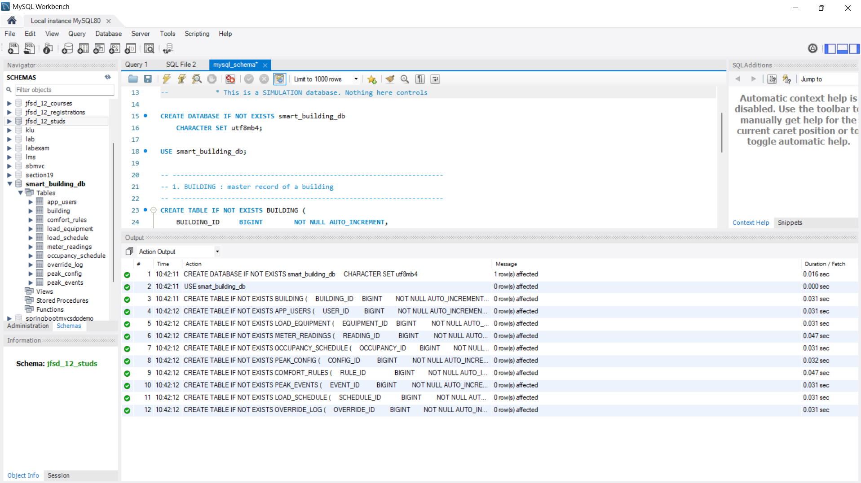
Figure 8.1 – Database and Table Creation
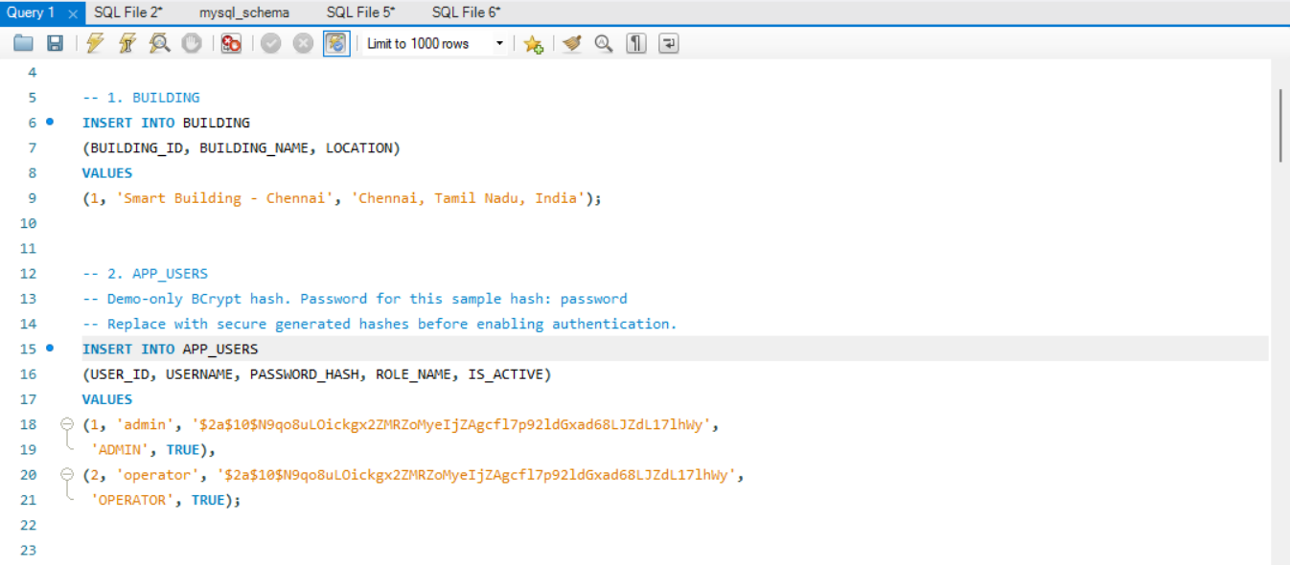
Figure 8.2.1 – Data Insertion
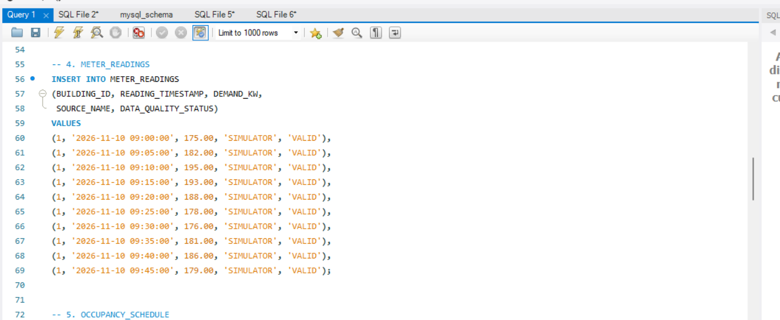
Figure 8.2.2 – Data Insertion
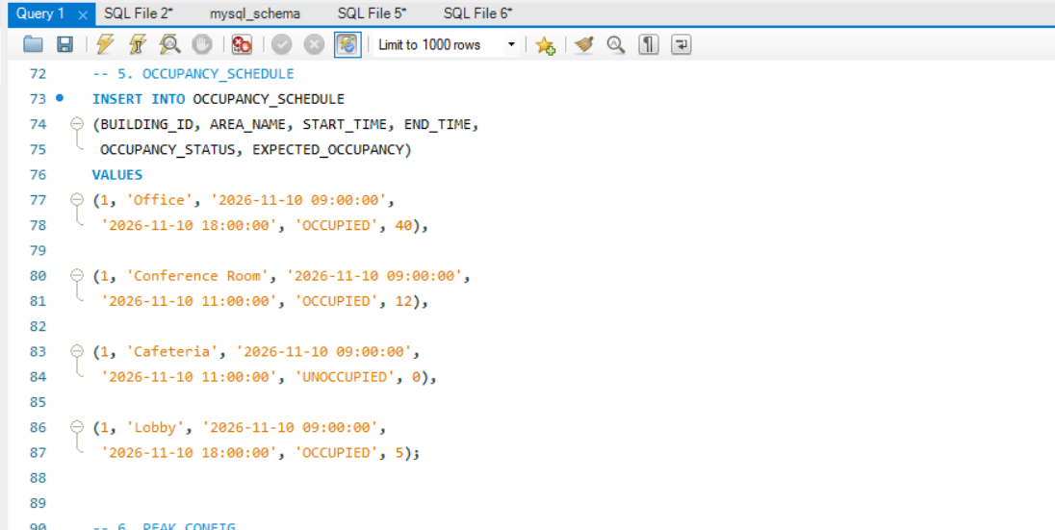
Figure 8.2.3 – Data Insertion
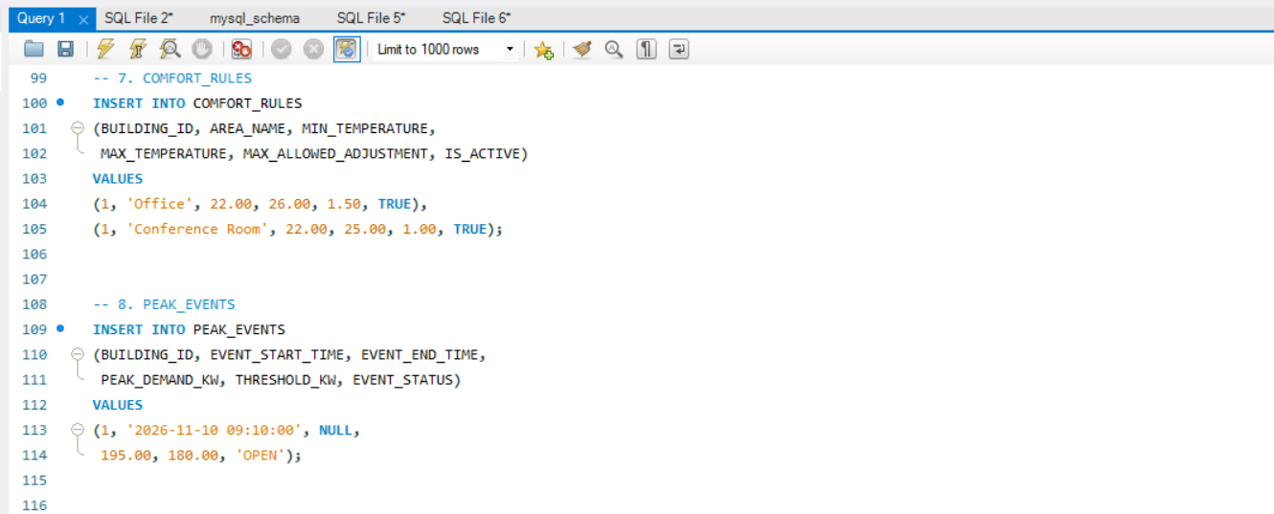
Figure 8.2.4 – Data Insertion

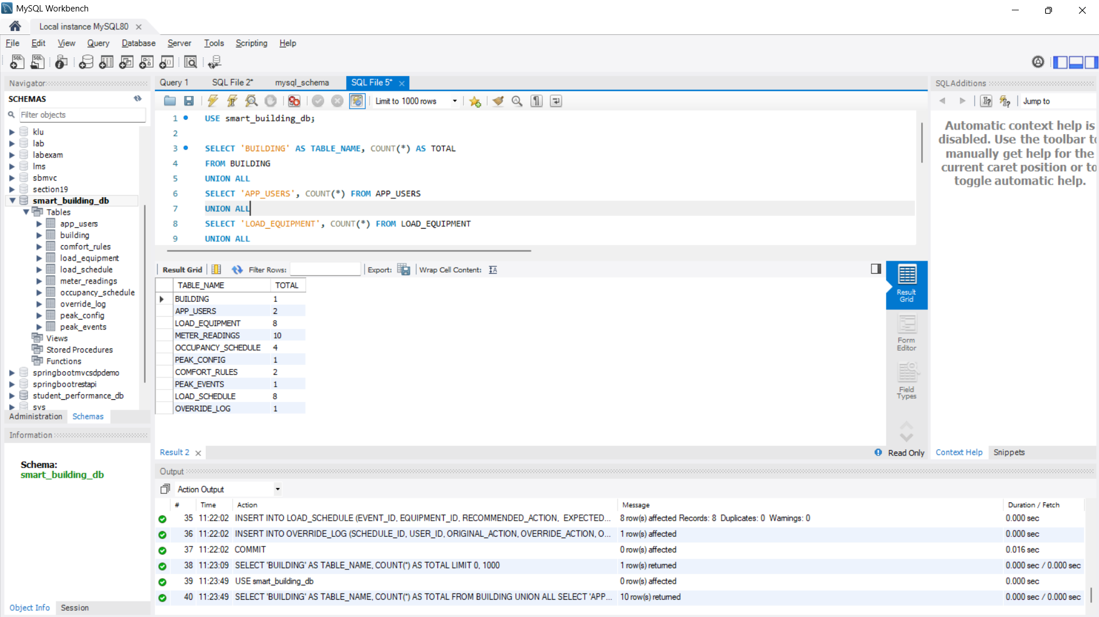
Figure 8.3– Database Table and Record Verification
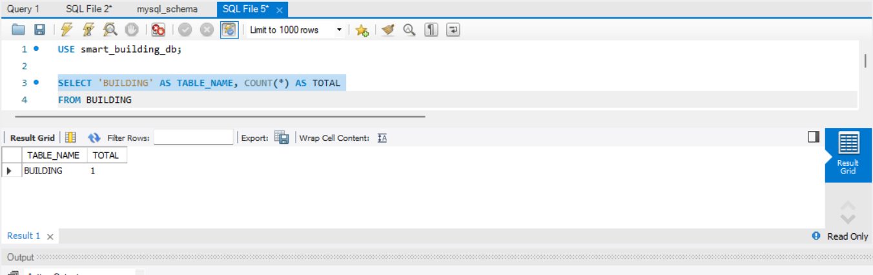
Figure 8.4 – Building Table Record Verification
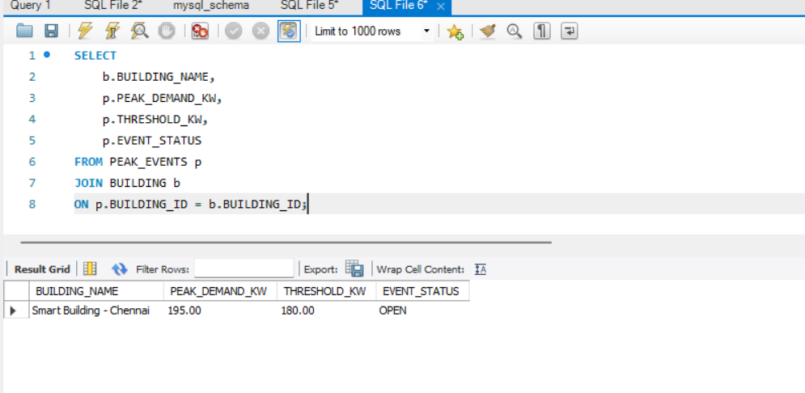
Figure 8.5 – Building Table Record Verification

9. Spring Boot Backend and API Design

9.1 Suggested Package Structure
smart-building-controller/
src/main/java/com/smartbuilding/
controller/
service/
repository/
entity/
dto/
config/
exception/
scheduler/
SmartBuildingApplication.java
src/main/resources/
application.properties
pom.xml

9.2 Suggested Dependencies
- Spring Web
- Spring Data JPA
- MySQL Driver
- Spring Validation
- Spring Security
- Spring Boot Actuator
- Lombok (optional)

9.3 MySQL Configuration
spring.datasource.url=jdbc:mysql://localhost:3306/smart_building_db
spring.datasource.username=root
spring.datasource.password=${DB_PASSWORD}
spring.datasource.driver-class-name=com.mysql.cj.jdbc.Driver

spring.jpa.hibernate.ddl-auto=validate
spring.jpa.show-sql=false
spring.jpa.properties.hibernate.dialect=org.hibernate.dialect.MySQLDialect

9.4 API Endpoints
Method | Endpoint | Purpose
POST | /api/buildings | Create a building
GET | /api/buildings | List buildings
POST | /api/equipment | Register equipment
GET | /api/equipment | Retrieve equipment
PUT | /api/equipment/{id} | Update equipment
POST | /api/meter-readings | Submit meter readings
GET | /api/meter-readings | Retrieve meter history
POST | /api/occupancy | Configure occupancy
POST | /api/peak-config | Configure peak threshold
POST | /api/peak-events/detect | Detect peak events
POST | /api/schedules/generate | Generate a recommendation
GET | /api/schedules/{id} | Retrieve a schedule
POST | /api/schedules/{id}/approve | Approve a schedule
POST | /api/schedules/{id}/override | Override a schedule
GET | /api/analytics/kpis | Retrieve KPI summaries

9.5 Example Requests
Meter reading:
{
"buildingId": 1,
"readingTimestamp": "2026-11-09T09:00:00",
"demandKw": 195.50,
"sourceName": "SIMULATOR"
}

Schedule generation:
{
"buildingId": 1,
"eventId": 10,
"requestedBy": 101
}

Manual override:
{
"overrideAction": "MAINTAIN",
"reason": "Special building event",
"userId": 101
}

10. Scheduling Engine

10.1 Decision Flow
flowchart TD
A[Start] --> B[Read Latest Meter Data]
B --> C{Data Valid and Fresh?}
C -- No --> D[Mark Unreliable; Stop]
C -- Yes --> E{Demand Above Threshold?}
E -- No --> F[No Peak Action]
E -- Yes --> G[Retrieve Equipment]
G --> H{Critical?}
H -- Yes --> I[Protect Equipment]
H -- No --> J{Controllable?}
J -- No --> K[Exclude Equipment]
J -- Yes --> L[Check Occupancy]
L --> M[Check Comfort Rules]
M --> N{All Constraints Pass?}
N -- No --> O[Reject Candidate with Reason]
N -- Yes --> P[Calculate Potential Reduction]
P --> Q[Create Recommendation]
Q --> R[Authorized Review and Approval]
R --> S[Record Decision and Audit]

10.2 Algorithm
- Retrieve the latest valid and sufficiently fresh meter reading.
- If the reading is missing or stale, mark the data unreliable and stop scheduling.
- Compare current demand with the active peak threshold.
- If demand is below threshold, do not create a peak-shaving recommendation.
- If demand exceeds threshold, retrieve equipment for the building.
- Exclude critical and non-controllable equipment.
- Check occupancy and comfort restrictions for each candidate.
- Calculate potential reduction for eligible equipment.
- Create a recommendation with an explanation for accepted and rejected candidates.
- Require authorized review and revalidate constraints before simulated execution.
- Persist the event, schedule and decision history transactionally.

10.3 Pseudocode
START
Read latest valid meter reading
IF reading missing or stale:
Mark data unreliable
Stop scheduling

IF current demand <= peak threshold:
No peak event
Stop

Retrieve equipment
FOR each equipment:
IF critical:
Protect and continue
IF not controllable:
Exclude and continue
IF occupancy restriction applies:
Reject candidate and continue
IF comfort restriction applies:
Reject candidate and continue
Calculate potential demand reduction
Add eligible recommendation

Save peak event and recommendations
Revalidate constraints before simulated execution
Wait for authorized approval or override
Record final decision and audit history
END

11. Python Data Processing
Python with Pandas and NumPy handles meter-data quality checks and analytical preparation. Core safety-related scheduling decisions remain in Spring Boot.

11.1 Example Processing Script
import pandas as pd
import numpy as np

data = {
"timestamp": [
"2026-11-09 09:00:00",
"2026-11-09 09:05:00",
"2026-11-09 09:10:00",
"2026-11-09 09:15:00"
],
"demand_kw": [120, 135, np.nan, 175]
}

df = pd.DataFrame(data)
df["timestamp"] = pd.to_datetime(df["timestamp"])
df["demand_kw"] = pd.to_numeric(df["demand_kw"], errors="coerce")
df["data_quality_status"] = np.where(
df["demand_kw"].isna(), "MISSING", "VALID"
)

print(df)

Do not silently replace missing operational readings with zero. Any imputation used for analytics must be identified and must not be used as an operational control measurement without an explicit policy.

12. Snowflake Analytics and Data Pipeline

12.1 Snowflake Setup
CREATE DATABASE SMART_BUILDING_DW;
CREATE SCHEMA SMART_BUILDING_DW.ANALYTICS;

CREATE WAREHOUSE SMART_BUILDING_WH
WAREHOUSE_SIZE = 'XSMALL'
AUTO_SUSPEND = 60
AUTO_RESUME = TRUE
INITIALLY_SUSPENDED = TRUE;

12.2 Suggested Analytical Model
Table | Purpose
FACT_METER_READINGS | Historical meter consumption
FACT_PEAK_EVENTS | Peak event history
FACT_LOAD_SCHEDULES | Recommendations and outcomes
FACT_OVERRIDE_LOG | Override analysis
DIM_BUILDING | Building attributes
DIM_EQUIPMENT | Equipment classification
DIM_DATE | Date-based analysis
DIM_TIME | Time-based analysis

12.3 Pipeline
flowchart TD
A[(MySQL Operational DB)] --> B[Extract Incremental Data]
B --> C[Python / Pandas Transform]
C --> D[Validate and Reconcile]
D --> E[AWS S3 Staging Files]
E --> F[Load into Snowflake]
F --> G[Analytics Tables]
G --> H[Power BI]

Start with scheduled batch extraction. Track a durable last-successful watermark or batch identifier. Make loading retry-safe and idempotent so a failed batch can be replayed without losing records or creating duplicate facts. Keep analytics failures independent from operational scheduling.

13. Power BI Dashboard
Report Page | Suggested Visuals
Energy Overview | Current demand, total consumption, peak demand, peak event count and demand trend
Peak-Shaving Analysis | Demand before and after scheduling, simulated reduction and event comparison
Equipment Analysis | Priority distribution, critical versus non-critical equipment and potential reduction by equipment
Comfort and Overrides | Comfort exceptions, override count and reasons, occupancy-related rejections and protected-load violations

13.1 KPI Definitions
KPI | Definition
Peak Demand Before | Maximum demand in the selected event window before simulated scheduling
Peak Demand After | Maximum demand in the same event window after simulated scheduling
Demand Reduction | Peak demand before minus peak demand after
Reduction Percentage | Demand reduction divided by peak demand before, multiplied by 100
Peak Events | Count of identified peak events
Override Count | Count of manual overrides
Comfort Exceptions | Count of comfort-rule exceptions
Protected-Load Violations | Count of attempted or recorded critical-load violations; target is zero

Before-and-after comparisons must use the same event window and comparable measurements. Distinguish expected reduction from reduction actually observed in the simulation.

14. AWS Deployment Architecture

14.1 Proposed Components
Component | Responsibility
EC2 | Run application containers
S3 | Store exports, reports and staging files
Security Groups | Restrict inbound and outbound network access
IAM | Control AWS permissions
CloudWatch | Monitor infrastructure and application logs

14.2 Deployment Flow
flowchart TD
A[User Browser] --> B[React Container]
B --> C[Spring Boot API Container]
C --> D[(Secured MySQL)]
C --> E[Scheduling Engine]
F[Python Processing Job] --> D
D --> G[Analytics Extraction]
G --> H[S3]
H --> I[Snowflake]
I --> J[Power BI]
K[GitHub Actions] --> L[Build and Test]
L --> M[Docker Images]
M --> N[EC2 Deployment]

For local development, MySQL can run in Docker with a persistent volume. For cloud deployment, use a secured MySQL service or separately secured host with persistent storage and backups. Do not expose MySQL publicly. Store credentials in environment variables or a secrets manager, not in source control.

15. Docker and GitHub Actions

15.1 Containerization
- Spring Boot backend container
- React frontend container
- Python processing container or scheduled job
- MySQL container for local development and integration testing
Use Docker Compose for local multi-service development. Keep persistent database storage outside the disposable container filesystem.

15.2 CI/CD Workflow
flowchart TD
A[Developer Push] --> B[GitHub Repository]
B --> C[GitHub Actions]
C --> D[Build Spring Boot]
D --> E[Backend Tests]
E --> F[Build React]
F --> G[Frontend Tests]
G --> H[Build Docker Images]
H --> I[Publish Versioned Images]
I --> J[Deploy to EC2]
J --> K[Health Check]
K --> L{Healthy?}
L -- Yes --> M[Deployment Complete]
L -- No --> N[Rollback to Previous Version]

- Build and test backend and frontend.
- Build versioned Docker images.
- Publish images to a container registry.
- Deploy to EC2 using a controlled workflow.
- Run health checks after deployment.
- Retain the previous known-good version for rollback.

16. Failure Handling and Reliability
Failure Scenario | Expected Handling
Missing or stale meter readings | Mark data unreliable; do not create unsafe recommendations.
Duplicate readings | Reject or deduplicate using an explicit idempotency rule.
Invalid demand values | Reject and log validation errors.
MySQL unavailable | Fail safely, report service failure and retry writes safely.
Snowflake unavailable | Keep operational scheduling independent; retry analytics loading.
S3 upload failure | Retain batch state, retry and record failures.
Occupancy data missing | Apply safe restrictions; do not assume area is unoccupied.
Comfort data missing | Do not recommend HVAC actions requiring unavailable constraints.
Override submitted | Record actor, timestamp, reason and original/new actions.
Container failure | Restart under supervision and verify health.
Deployment failure | Roll back to the previous known-good application version.

16.1 Reliability Controls
- Use transactions for related database writes.
- Use idempotency keys or unique source identifiers for ingestion retries.
- Keep a record of rejected recommendations and their reasons.
- Revalidate constraints before simulated execution.
- Preserve approved schedule and override history.
- Use backups and test recovery procedures.
- Separate analytics pipeline failures from operational application availability.

17. Testing Strategy

17.1 Functional Tests
- Create a building and register equipment.
- Submit meter readings and inspect validation.
- Configure occupancy, comfort rules and peak thresholds.
- Detect a peak event.
- Generate and retrieve a schedule.
- Approve, reject and override recommendations.
- Verify audit records and KPI summaries.

17.2 Constraint and Failure Tests
Scenario | Expected Result
Demand exceeds threshold | Peak event is detected.
Critical equipment is considered | It remains protected and is not scheduled for reduction.
Equipment is not controllable | It is excluded.
Occupancy restriction applies | Candidate is rejected or schedule is revalidated.
HVAC adjustment violates comfort limits | Recommendation is rejected.
Meter reading is missing or stale | Data is marked unreliable; unsafe scheduling stops.
Operator overrides recommendation | Audit record is created.
Snowflake is unavailable | Operational application continues; analytics load retries.

17.3 Hidden Occupancy Challenge
- Initially mark an area as unoccupied.
- Generate a recommendation that considers eligible equipment in that area.
- Change the occupancy status to occupied before simulated execution.
- Revalidate the recommendation against the new occupancy state.
- Reject or cancel any action that now violates the occupancy restriction.
- Record the decision and show the result in the demo.
Expected result: the system must not execute an outdated recommendation that violates updated occupancy constraints.

18. Four-Day Implementation Plan

Day 1 – Problem Decomposition and Architecture
Objective: understand the problem, finalize the architecture, identify business rules and prepare the implementation backlog.
- Decompose the peak-demand problem and identify actors.
- Classify critical, conditional and controllable equipment.
- Define peak thresholds, occupancy restrictions, comfort guardrails and override rules.
- Finalize the React, Spring Boot, MySQL, Python, Snowflake and AWS architecture.
- Prepare MySQL entities, table structures, keys and indexes.
- Define REST API endpoints and request/response contracts.
- Prepare data-flow diagrams, AWS topology, risks, assumptions and owner allocation.
Day 1 exit evidence: architecture diagram, MySQL ERD, database definitions, API/data contracts, data-flow diagram, AWS topology, risk/assumption register and prioritized backlog with owners.

Day 2 – Core Development and Data Pipeline
Objective: build the highest-risk working application flow.
- Create Spring Boot project and configure MySQL.
- Implement entities, repositories, services and REST APIs.
- Initialize React and create the first dashboard and management screens.
- Generate synthetic meter data and process it with Python, Pandas and NumPy.
- Implement threshold detection and basic scheduling rules.
- Implement critical-load protection, occupancy and comfort checks.
- Persist readings, peak events and recommendations in MySQL.
Day 2 exit evidence: working backend, MySQL integration, sample dataset, meter-ingestion flow, React-to-API path, basic scheduling engine, Python scripts and initial SQL transformations.

Day 3 – Cloud Deployment, Analytics and Failure Handling
Objective: deploy the application, build reporting and validate failure scenarios.
- Create Dockerfiles and Docker Compose configuration.
- Prepare EC2 and security groups; deploy containers.
- Configure S3 storage and access permissions.
- Create Snowflake database, schema and analytical tables.
- Implement extraction, transformation, loading and reconciliation.
- Connect Power BI and build report pages.
- Configure GitHub Actions for builds, tests, image publishing and deployment.
- Test missing data, database failures, analytics failures, overrides and health checks.
Day 3 exit evidence: deployed or reproducibly deployable system, Docker configuration, CI/CD workflow, Snowflake model, Power BI dashboard, KPI definitions, test results and rollback evidence.

Day 4 – Hardening, Validation and Final Demonstration
Objective: validate the complete system, improve reliability and prepare the final demonstration.
- Validate APIs, relationships, frontend and scheduling logic.
- Test critical-load, occupancy, comfort and override constraints.
- Reconcile MySQL source records with Snowflake destination records.
- Validate KPI calculations and dashboard outputs.
- Verify EC2 deployment, containers, health checks and rollback.
- Finalize architecture, ERD, API documentation and deployment runbook.
- Document known limitations, AI usage and individual contributions.
- Demonstrate peak event, protected load, override, hidden occupancy change and before/after demand profile.
Day 4 exit evidence: final demo, architecture and data-flow diagrams, MySQL ERD, API documentation, dashboard, test evidence, runbook, known limitations, AI usage log and individual contribution statement.

19. Risk and Assumption Register
Risk | Impact | Mitigation
Incorrect equipment classification | Critical equipment may be affected. | Validate classifications; protect critical loads by default.
Missing meter readings | Incorrect demand analysis. | Quality checks and safe scheduling.
Stale occupancy data | Unsafe recommendations. | Revalidate occupancy before simulated execution.
Invalid comfort configuration | Occupant discomfort. | Validate configuration and reject unsafe actions.
Duplicate readings | Incorrect calculations. | Unique constraints and idempotent ingestion.
MySQL outage | Operational service interruption. | Backups, health checks and safe retries.
Snowflake outage | Reporting delay. | Independent retryable analytics pipeline.
Deployment failure | Application downtime. | Health checks and rollback.
Incorrect KPI calculations | Misleading reports. | Reconcile source and destination data.
Scope expansion | Delivery delay. | Prioritize the required vertical slice.

20. Security and Access Control
Role | Permissions
ADMIN | Manage users and configuration.
OPERATOR | View operational data, approve schedules and submit overrides.
VIEWER | View dashboards and reports.

- Hash passwords securely.
- Apply role-based access control.
- Validate user input and protect APIs.
- Restrict database network access.
- Use HTTPS for deployed APIs.
- Store secrets outside source code.
- Audit sensitive actions and configuration changes.

21. Deployment and Recovery Runbook

21.1 Deployment
- Pull the approved source revision.
- Run backend and frontend tests.
- Build and tag Docker images.
- Publish images to the registry.
- Deploy containers to EC2.
- Apply versioned database migrations.
- Verify MySQL connectivity and backend health.
- Verify frontend access and meter ingestion.
- Verify analytics extraction and dashboard freshness.

21.2 Recovery
- Identify the failed service and inspect logs.
- Check database and network connectivity.
- Stop unsafe scheduling activity if required data is unavailable.
- Restart or recover the affected service.
- Retry failed data batches safely.
- Verify data consistency.
- Roll back if a deployment caused the failure.
- Record the incident and recovery actions.

22. Final Demonstration Scenario

22.1 Initial Conditions
Item | Illustrative Value
Initial building demand | 195 kW
Peak threshold | 180 kW
Decorative lighting | 10 kW
Non-essential equipment | 8 kW
HVAC | Subject to comfort restrictions
Emergency lighting | Critical and protected

22.2 Demonstration Steps
- Submit meter readings showing demand at 195 kW.
- Show detection of a peak event because demand exceeds 180 kW.
- Show emergency lighting excluded from scheduling.
- Show HVAC protected by comfort rules.
- Generate a recommendation for eligible loads with potential reduction of 18 kW.
- Have the operator override one recommendation and enter a reason.
- Introduce a hidden occupancy change.
- Show the system revalidating and rejecting any now-ineligible action.
- Show the audit history and resulting simulated demand profile.
Illustrative calculation: if both reductions are approved and simulated successfully, demand changes from 195 kW to approximately 177 kW. If an override prevents a reduction, the resulting demand must reflect the override. Do not report the full 18 kW reduction unless the simulation actually applies both actions.

23. Known Limitations
- The initial implementation uses synthetic meter readings.
- Peak detection initially uses configured thresholds.
- The scheduling engine is deterministic and rule-based.
- Physical equipment control is not implemented.
- Real-world savings are not measured.
- Occupancy information is simulated or manually configured.
- Forecasting is an enhancement, not a first-stage dependency.
- The initial cloud topology may be simplified for the demonstration.

24. AI Usage and Individual Contribution

24.1 AI Usage Log
Maintain a record of AI-assisted architecture discussions, code suggestions, SQL generation, test-case generation and documentation. Review and test generated material before including it in the implementation.

24.2 Individual Contribution
Record actual work completed by each team member under backend development, frontend development, database design, Python processing, Snowflake integration, Power BI, AWS deployment, Docker/CI/CD, testing and documentation. Do not claim work that was not performed.

25. Final Completion Checklist

Architecture and design
☐ Business requirements documented
☐ Architecture finalized
☐ MySQL ERD prepared
☐ API contracts documented
☐ Data flow finalized
☐ AWS topology documented

Backend and database
☐ Spring Boot project created
☐ MySQL configured
☐ Tables created
☐ REST APIs implemented
☐ Scheduling engine implemented
☐ Critical-load protection tested
☐ Override logging implemented

Frontend and processing
☐ React dashboard created
☐ Equipment and peak-event screens created
☐ Python processing completed
☐ NumPy/Pandas calculations validated

Analytics
☐ Snowflake database and tables created
☐ Data pipeline implemented
☐ Power BI connected
☐ KPI calculations validated

Cloud and DevOps
☐ Docker configuration completed
☐ EC2 deployment completed
☐ S3 integration completed
☐ GitHub Actions configured
☐ Health checks and rollback validated

Final validation
☐ Peak event demonstrated
☐ Critical-load protection demonstrated
☐ Manual override demonstrated
☐ Hidden occupancy change tested
☐ Before/after demand profile demonstrated
☐ Known limitations and contributions documented

26. Expected Final Outcome
The completed project will demonstrate an end-to-end Smart Building Energy Peak-Shaving Controller consisting of a React operator dashboard, Spring Boot backend and deterministic scheduling engine, MySQL operational database, Python/NumPy/Pandas data processing, Snowflake analytics, Power BI reporting, AWS S3 storage, AWS EC2 hosting, Docker containerization and GitHub Actions CI/CD.
The core success criterion is not simply reducing demand. It is demonstrating safe, explainable and auditable scheduling decisions while protecting critical equipment and respecting changing occupancy and comfort constraints.

27. Development Execution Guide – From Setup to Final Demo
Use this section as the working plan for upcoming development. Complete the stages in order, keep the scope medium-sized, and do not start cloud analytics before the core operational flow works locally.

27.1 Recommended Development Order

Stage 0 – Confirm scope and repository
- Create one GitHub repository and agree on the project name, branch strategy and team ownership.
- Confirm the project boundary: one simulated building, synthetic meter readings, threshold-based detection and simulated recommendations only.
- Freeze the technology responsibilities: React UI, Spring Boot backend, MySQL operational DB, Python processing, Snowflake analytics, Power BI, S3, EC2, Docker and GitHub Actions.
- Create a README with prerequisites, local startup instructions, environment variables and current project status.
Exit criteria: repository exists, scope is agreed and all developers can run the starter project.

Stage 1 – Architecture and database foundation
- Finalize the high-level architecture, end-to-end workflow, scheduler flow and MySQL ER diagram.
- Create the MySQL database and implement the ten core tables already defined in Section 8.
- Add foreign keys, uniqueness rules and indexes. Use migrations (Flyway or Liquibase) rather than relying on manual schema changes.
- Insert a small, consistent sample dataset: one building, equipment, occupancy windows, comfort rules and a peak threshold.
- Agree API request/response DTOs before frontend and backend work proceed in parallel.
Exit criteria: schema can be created from a clean database and sample records can be queried.

Stage 2 – Spring Boot backend foundation
- Create the Spring Boot application with controller, service, repository, entity, DTO, config, exception and scheduler packages.
- Configure MySQL connectivity and validate the application can read and write a test record.
- Implement building, equipment, meter-reading, occupancy and peak-configuration APIs.
- Add request validation, consistent error responses, pagination for meter history and basic role-based access.
- Keep business logic in services; controllers should only handle HTTP input/output.
Exit criteria: APIs work through Postman or an equivalent REST client and persist data in MySQL.

Stage 3 – Meter ingestion and Python processing
- Build a simple meter-data simulator that produces timestamp and demand_kW values at a configurable interval.
- Use Python with Pandas/NumPy to validate timestamps, numeric values, missing values, duplicates and basic freshness.
- Send or load accepted readings into the backend ingestion endpoint; record rejected data and reasons.
- Make ingestion retry-safe using the existing building/timestamp uniqueness rule or an explicit source identifier.
- Do not use imputed values as operational demand readings unless an explicit policy is added.
Exit criteria: valid readings are stored, invalid readings are rejected or flagged, and duplicate submissions do not create duplicate records.

Stage 4 – Peak detection and scheduling engine
- Implement a deterministic threshold comparison using the latest valid and sufficiently fresh reading.
- Create a peak event only when demand exceeds the active threshold and avoid duplicate active events for the same detection window.
- Evaluate equipment in a clear order: critical status, controllability, occupancy, comfort constraints and potential reduction.
- Create a recommendation containing proposed action, expected reduction and a reason for both eligible and rejected equipment.
- Require operator approval, then revalidate current constraints immediately before simulated execution.
- Persist the event, schedule and decision history transactionally.
Exit criteria: the 195 kW / 180 kW example produces explainable recommendations while critical equipment remains protected.

Stage 5 – Scheduler operation and reliability
- Use Spring @Scheduled for the initial periodic check; make the polling interval configurable.
- Prevent overlapping runs within one application instance. If deployment later uses multiple instances, add a database-backed lock or another distributed coordination mechanism.
- Each run should read the latest valid reading, check freshness, evaluate threshold and invoke the scheduling service only when needed.
- Record run start/end time, result, detected event ID and failure reason for troubleshooting.
- If required data is missing, stale or unavailable, fail safely and do not create a load-reduction recommendation.
Exit criteria: repeated scheduler runs are predictable, do not overlap and do not create duplicate events or schedules.

Stage 6 – React operator interface
- Create dashboard pages for current demand, threshold, peak events, equipment, recommendations and audit history.
- Connect React to Spring Boot only through documented REST APIs.
- Add operator actions to approve, reject and override a recommendation; require a reason for overrides.
- Show protected equipment and rejection reasons so that decisions are explainable.
- Label all proposed and resulting demand values as simulated.
Exit criteria: an operator can follow the full event-to-approval workflow from the browser.

Stage 7 – Analytics pipeline and Power BI
- Define the incremental extraction watermark or batch ID and store its last successful value.
- Extract eligible operational records from MySQL, transform and reconcile them using Python/Pandas.
- Write staged files to S3 and load them into Snowflake analytical tables.
- Make the load idempotent and retryable; keep analytics errors independent of operational scheduling.
- Connect Power BI to Snowflake and validate KPIs against the source event and schedule records.
Exit criteria: a repeatable batch reaches Snowflake without missing or duplicate facts and Power BI shows reconciled KPIs.

Stage 8 – Docker, AWS and CI/CD
- Create Dockerfiles for Spring Boot, React and the Python processing job; use Docker Compose for local development.
- Keep MySQL data in a persistent volume and keep secrets out of source control.
- Prepare EC2 security groups, IAM permissions and S3 access with least privilege; do not expose MySQL publicly.
- Create GitHub Actions workflows to build, test and publish versioned images, then deploy to EC2.
- Run health checks after deployment and retain the previous known-good image for rollback.
Exit criteria: a clean deployment can be repeated from the repository and a failed health check has a documented recovery path.

Stage 9 – Integration testing and final demonstration
- Test the normal peak event, no-peak case, invalid/stale meter data, critical equipment, non-controllable equipment, occupancy change, comfort restriction and manual override.
- Test MySQL outage and analytics/S3/Snowflake failure separately.
- Reconcile MySQL operational records with Snowflake facts and validate Power BI calculations.
- Prepare a demo script showing 195 kW demand against a 180 kW threshold, protected emergency lighting and the simulated 177 kW result only when both eligible reductions are actually applied.
- Document limitations, test evidence, deployment steps, AI assistance and actual individual contributions.
Exit criteria: end-to-end demo is repeatable, safety constraints pass and known limitations are clearly stated.

27.2 Suggested Project Folder Structure
smart-building-energy-controller/
├── backend/ # Spring Boot REST APIs and scheduling rules
│ ├── src/main/java/... # controller, service, repository, entity, dto
│ └── src/main/resources/ # application config and DB migrations
├── frontend/ # React operator dashboard
│ └── src/ # pages, components, services, hooks
├── data-processing/ # Python simulator, validation and analytics jobs
│ ├── ingestion/
│ └── analytics/
├── database/ # optional local SQL seed/reference scripts
├── analytics/ # Snowflake DDL and Power BI documentation
├── infrastructure/ # Docker Compose, Dockerfiles and deployment files
├── .github/workflows/ # GitHub Actions pipelines
├── docs/ # architecture, ERD, Mermaid diagrams, API notes
└── README.md

27.3 End-to-End Runtime Flow
flowchart TD
A["Simulator creates meter reading"] --> B["Python validates reading"]
B --> C{"Valid and fresh?"}
C -- "No" --> D["Reject / mark unreliable / log reason"]
C -- "Yes" --> E["Store reading in MySQL"]
E --> F["Spring scheduler checks latest reading"]
F --> G{"Demand above active threshold?"}
G -- "No" --> H["Record no-peak result"]
G -- "Yes" --> I["Create or identify peak event"]
I --> J["Scheduling engine evaluates equipment"]
J --> K["Apply critical, controllability, occupancy and comfort rules"]
K --> L["Persist explainable recommendation"]
L --> M["React displays recommendation"]
M --> N{"Authorized operator decision"}
N -- "Reject" --> O["Record rejection and audit"]
N -- "Approve / override" --> P["Revalidate current constraints"]
P --> Q{"Still eligible?"}
Q -- "No" --> R["Cancel action and record reason"]
Q -- "Yes" --> S["Record simulated outcome"]
O --> T["MySQL operational history"]
R --> T
S --> T
T --> U["Independent incremental analytics job"]
U --> V["Python / Pandas"]
V --> W["S3 staging"]
W --> X["Snowflake"]
X --> Y["Power BI"]

27.4 Scheduler Logic and Timing
Initial approach: use a configurable Spring @Scheduled job that periodically checks for a new, valid meter reading. The scheduler should orchestrate the check, not contain all business rules. Delegate threshold detection and equipment eligibility to services so they can be tested independently.
flowchart TD
A["Scheduled trigger"] --> B["Acquire local run guard"]
B --> C{"Previous run still active?"}
C -- "Yes" --> D["Skip this trigger and log overlap"]
C -- "No" --> E["Read latest valid meter reading"]
E --> F{"Reading exists and is fresh?"}
F -- "No" --> G["Mark run as data-unavailable; stop safely"]
F -- "Yes" --> H["Load active peak configuration"]
H --> I{"Demand > threshold?"}
I -- "No" --> J["Record no-peak result"]
I -- "Yes" --> K["Find or create peak event"]
K --> L["Generate recommendation through scheduling service"]
L --> M["Persist result and release run guard"]
D --> N["End"]
G --> N
J --> N
M --> N

27.5 Scheduler Design Rules
- Keep the polling interval configurable; choose the initial interval based on the simulator's reading frequency.
- Use a freshness window so an old reading is not treated as current demand.
- Prevent duplicate peak events for the same building and event window using application checks plus a database constraint or idempotency key.
- Use a local in-process guard for a single application instance. A multi-instance deployment needs distributed locking; do not assume synchronized @Scheduled methods coordinate across servers.
- Keep scheduler orchestration separate from business logic: MeterReadingService, PeakDetectionService, SchedulingService and ApprovalService should own their respective responsibilities.
- Do not automatically execute physical control actions. Approval and execution in this project mean recording a simulated outcome only.

27.6 Medium-Level Supporting Mermaid Diagrams

A. Backend component flow
flowchart LR
UI["React UI"] --> API["REST Controllers"]
API --> SVC["Application Services"]
SVC --> PEAK["Peak Detection Service"]
SVC --> SCHED["Scheduling Service"]
SVC --> APPROVAL["Approval / Override Service"]
PEAK --> REPO["Repositories"]
SCHED --> REPO
APPROVAL --> REPO
REPO --> DB[("MySQL")]
SCHED --> RULES["Business Rules Validator"]
RULES --> SCHED

B. Equipment eligibility decision
flowchart TD
A["Candidate equipment"] --> B{"Critical?"}
B -- "Yes" --> C["Protect: never reduce"]
B -- "No" --> D{"Explicitly controllable?"}
D -- "No" --> E["Exclude with reason"]
D -- "Yes" --> F{"Occupancy permits action?"}
F -- "No / unknown" --> G["Reject or defer safely"]
F -- "Yes" --> H{"Comfort rules satisfied?"}
H -- "No / unknown" --> I["Reject HVAC action"]
H -- "Yes" --> J["Calculate potential reduction"]
J --> K["Add explainable recommendation"]

C. MySQL ER relationship overview
erDiagram
BUILDING ||--o{ LOAD_EQUIPMENT : contains
BUILDING ||--o{ METER_READINGS : receives
BUILDING ||--o{ OCCUPANCY_SCHEDULE : maintains
BUILDING ||--o{ PEAK_CONFIG : configures
BUILDING ||--o{ COMFORT_RULES : defines
BUILDING ||--o{ PEAK_EVENTS : generates
PEAK_EVENTS ||--o{ LOAD_SCHEDULE : produces
LOAD_EQUIPMENT ||--o{ LOAD_SCHEDULE : considered_for
LOAD_SCHEDULE ||--o{ OVERRIDE_LOG : has_history
APP_USERS ||--o{ OVERRIDE_LOG : creates

D. Analytics pipeline
flowchart LR
DB[("MySQL Operational DB")] --> WM["Read last-successful watermark"]
WM --> EX["Incremental extract"]
EX --> PY["Python / Pandas transform"]
PY --> VAL["Validate and reconcile"]
VAL --> S3["AWS S3 staging files"]
S3 --> SF["Snowflake load"]
SF --> MART["Analytics tables"]
MART --> BI["Power BI reports"]
VAL -->|Failure| RETRY["Retain batch state and retry safely"]

E. Deployment and CI/CD
flowchart TD
DEV["Developer commit"] --> GH["GitHub repository"]
GH --> CI["GitHub Actions"]
CI --> TEST["Build and run tests"]
TEST --> IMG["Build versioned Docker images"]
IMG --> REG["Container registry"]
REG --> EC2["Deploy containers to AWS EC2"]
EC2 --> HC["Health check"]
HC --> OK{"Healthy?"}
OK -- "Yes" --> DONE["Deployment complete"]
OK -- "No" --> RB["Rollback to previous image"]

F. Manual override and audit
flowchart TD
A["Recommendation displayed"] --> B["Authorized operator reviews"]
B --> C{"Decision"}
C -- "Approve" --> D["Revalidate constraints"]
C -- "Reject" --> E["Record rejection reason"]
C -- "Override" --> F["Require override action and reason"]
F --> G["Check user authorization"]
G --> H["Save original and new action"]
D --> I{"Still eligible?"}
I -- "Yes" --> J["Record simulated outcome"]
I -- "No" --> K["Cancel and record reason"]
E --> L[("MySQL audit/history")]
H --> L
J --> L
K --> L

27.7 API Implementation Priority
First – configuration and master data: POST/GET /api/buildings; POST/GET/PUT /api/equipment; POST /api/occupancy; POST /api/peak-config.
Second – meter ingestion: POST /api/meter-readings; GET /api/meter-readings. Include validation status and clear error responses.
Third – peak event and recommendation: POST /api/peak-events/detect; POST /api/schedules/generate; GET /api/schedules/{id}.
Fourth – operator workflow: POST /api/schedules/{id}/approve; POST /api/schedules/{id}/override; add rejection handling and audit history.
Fifth – dashboard and analytics: GET /api/analytics/kpis and dashboard summary endpoints. Keep Power BI reporting sourced from Snowflake, not from UI-only calculations.

27.8 Definition of Done for Each Feature
- Requirement and business rule are documented.
- Database changes are versioned and can be applied to a clean database.
- Backend logic is implemented in the correct service layer and has positive and negative tests.
- API request and response examples are documented.
- Frontend behavior and validation messages are connected to the API.
- Failure behavior is defined; missing or stale required data fails safely.
- Audit and operational logs are present where the action is important.
- The feature is demonstrated locally and the README is updated.

27.9 Development Decisions to Confirm Before Coding
- Meter source for the first version: a Python simulator posting to the Spring Boot meter-reading API, or a Python process writing directly to MySQL. Recommended for a clean service boundary: simulator → API → MySQL.
- Initial scheduler interval and meter freshness window. These should be configurable and aligned with the simulator interval.
- Whether one active peak event is allowed per building at a time, and the rule for closing an event after demand returns below threshold.
- How expected reduction is estimated for each equipment item (for example, rated power or a configured adjustable kW value). Do not assume rated power always equals actual reducible demand.
- Whether the first release supports one operator role or ADMIN/OPERATOR/VIEWER roles from the beginning.
- Whether the initial deployment uses a single EC2 instance and local/containerized MySQL for demo purposes or a separately managed database host.

27.10 Recommended First Working Milestone
Do not start by building every technology at once. The first complete milestone should be: create one building and its equipment in MySQL; submit a simulated meter reading through the Spring Boot API; run threshold detection; generate an explainable recommendation while protecting critical equipment; approve or reject it through an API; and persist the outcome and audit record. Once this vertical slice works, add the React screens, then the independent analytics pipeline, and finally cloud deployment and CI/CD.
Planning note: the original four-day plan in Section 18 is a compressed delivery target. The stages above are the recommended dependency order and can span more than four calendar days. Do not skip validation and safety tests to meet the calendar target.

