Student Attendance Lookup System
Project Report
Documentation edition | October 2026

1. Executive Summary
The Student Attendance Lookup System is a static web application built with HTML, CSS, and JavaScript. A user enters a registration number and date of birth; the browser-side JavaScript looks up a matching record in a JSON file, calculates an attendance percentage from attended and total class counts, and displays the result in a popup. The repository is deployed through GitHub Pages, and the owner reports that attendance lookup currently works.

2. Problem Statement
The project provides a simple browser interface for looking up a student's attendance summary without requiring a locally installed desktop application. It demonstrates form handling, JSON data retrieval, a basic calculation, and a popup-based result display.

3. Objectives
- Provide a form for registration number and date of birth.
- Retrieve a matching record from the JSON data file.
- Calculate attendance percentage from attended classes and total classes.
- Display attendance information and an associated image when available.
- Provide a responsive styled interface and a static-hosting deployment.

4. Scope and Boundaries
Current implementation (as inspected) | Not established / not included in this baseline
HTML form with registration number and DOB | Server-side authentication
JavaScript lookup against static JSON | Protected database or API
Attendance percentage calculation | Admin portal or attendance editing workflow
Popup result and image handling | Role-based access control
CSS styling and responsive rules | Verified automated test suite
GitHub Pages static deployment | Secure handling of confidential student data

5. System Flow
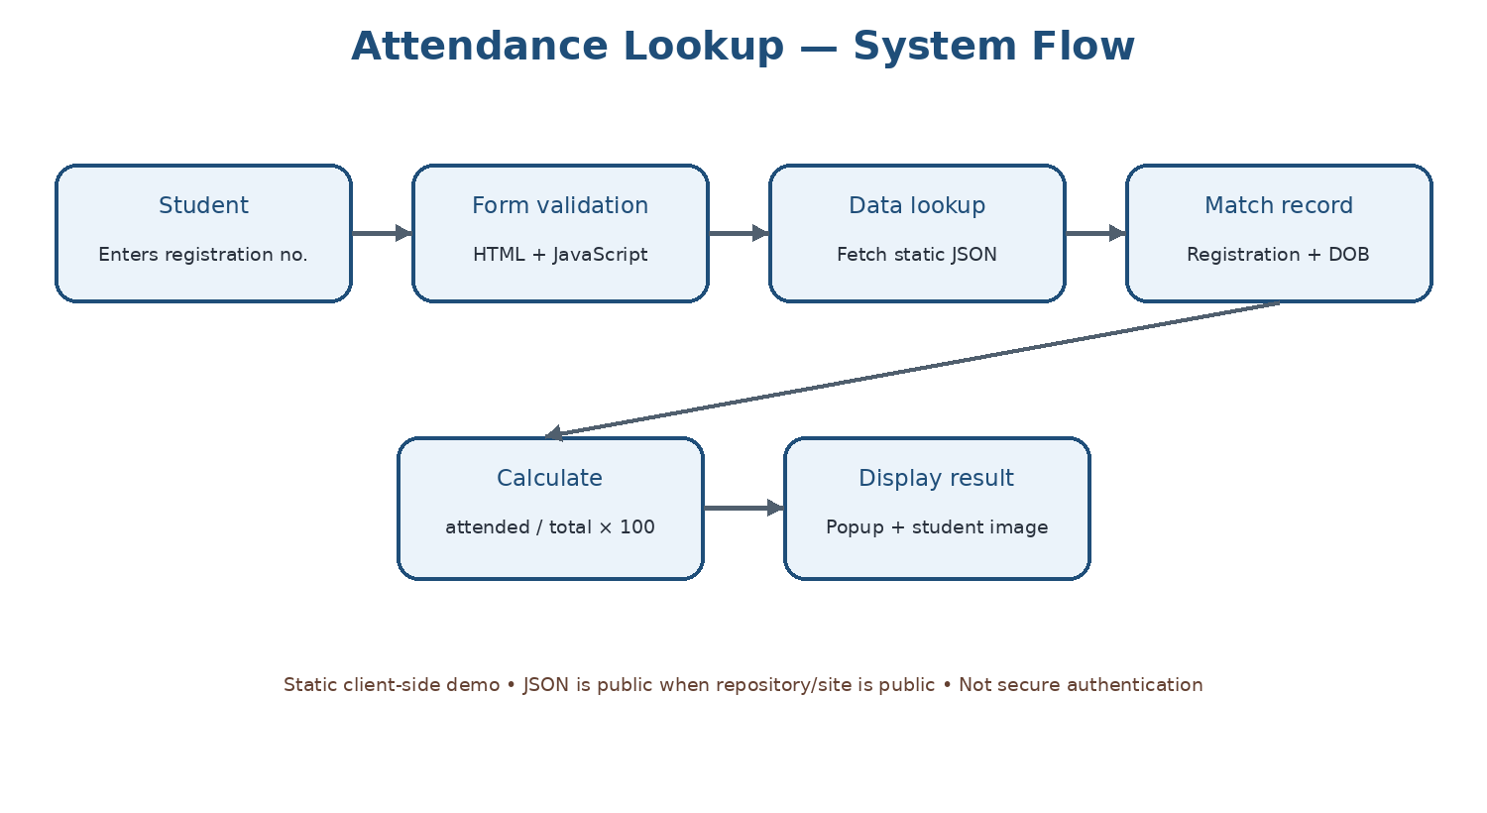

6. Technology Stack
Technology | Role
HTML5 | Form and page structure
CSS3 | Layout, gradient background, form, popup and responsive styling
JavaScript | Form handling, JSON lookup, percentage calculation, popup and browser storage
JSON | Static student-record data
GitHub Pages | Static hosting

7. Repository Structure
Current repository files observed: index.html, 404.html, scripts.js, styles.css, and data/users.json. A README.md and docs/README.md have been added during the repository organization steps described by the project owner.

8. How It Works
- The user enters a registration number and date of birth in the form.
- The page uses JavaScript to validate the required inputs.
- The JavaScript fetches the static JSON data and searches for a matching record.
- The attendance percentage is calculated as attended classes divided by total classes, multiplied by 100.
- The result is displayed in a popup, with image handling for the associated filename.
- The website is served as a static GitHub Pages site.

9. Testing Status
The project owner reports that the GitHub Pages attendance lookup works correctly. The exact behaviour of edge cases and security controls has not been independently tested as part of this documentation task. Refer to the test plan for suggested verification.

10. Limitations and Responsible Use
- Static JSON served by a public repository or public site can be read by visitors; a registration number and date of birth in client-side code are not secure authentication.
- The browser stores entered registration number and date of birth in localStorage, according to the inspected HTML. Consider whether this is necessary and disclose/avoid it where appropriate.
- Client-side calculation and validation can be inspected or altered by users.
- Use fictional data in the public demo; do not publish real student details, photographs, or attendance records.
- The application is a demonstration, not a secure production student information system.

11. Conclusion
The project demonstrates a complete basic frontend workflow: form input, JSON lookup, attendance calculation, and popup presentation. The safest next improvements are privacy-conscious sample data, clearer error handling, tests, accessibility improvements, and—if real data is ever needed—a backend with proper authentication and authorization.

