Attendance Lookup System
Technical Explanation
Documentation edition | October 2026

1. Architecture Overview
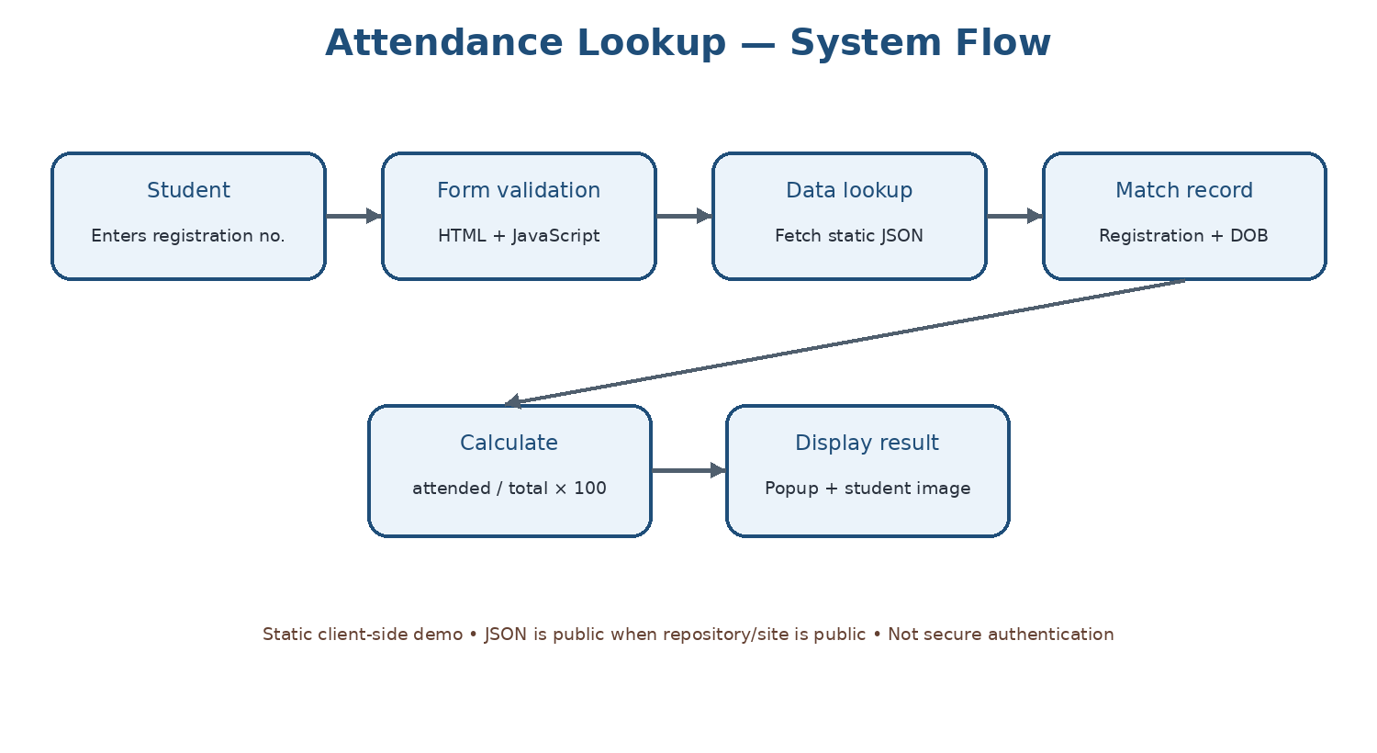

2. Main Files
File | Responsibility
index.html | Page metadata, form inputs, external links, popup containers, localStorage prefill/save logic, and script references
scripts.js | Form submit handler, input validation, attendance lookup, percentage calculation, popup/image handling, and storage/cache cleanup
styles.css | Typography, gradient background, form layout, buttons, popup styles, animations and responsive rules
data/users.json | Static array of student-like records with registration number, DOB, name, total classes, attended classes, image filename, percentage and date
404.html | Custom missing-page document for the static site

3. Attendance Calculation
The visible JavaScript indicates the attendance percentage is calculated from the attended and total class values. The basic formula is:
Attendance percentage = (attended ÷ total classes) × 100
The implementation should guard against a total of zero or missing/non-numeric values and display a clear message rather than NaN or Infinity. Stored percentage values in JSON should not be treated as authoritative if the code calculates the value dynamically.

4. Lookup Flow
- Read registration number and date of birth from the submitted form.
- Validate required fields.
- Fetch the JSON file and parse the response.
- Search the record list for a matching registration number and date of birth.
- If no record matches, show a clear error.
- If a record matches, calculate the percentage from the attendance counts.
- Display the result and attempt to load the image file; handle missing images.
- Clean up UI state and storage only according to the intended user experience.

5. Browser Storage
The inspected index.html stores registration number and date of birth in localStorage and restores them on page load. This is convenient but leaves those values on the device until removed. For a public demo, consider removing date of birth persistence, providing a clear “forget my details” control, or not storing credentials at all.

6. Installation and Local Testing
- Clone or download the repository.
- Keep data/users.json at its existing path because scripts.js fetches the static JSON file.
- Open index.html through a local development server (recommended for consistent fetch behaviour).
- Enter a known sample registration number and DOB.
- Check matching, non-matching, missing-field, image-missing and percentage cases.
- Confirm GitHub Pages still works after every committed change.

7. Deployment Notes
GitHub Pages serves static files and does not provide server-side secrecy. Any JSON file published as part of the site should be considered public. Keep the existing file paths unless references are updated and tested together.

8. Security and Privacy
- Do not place real student data in a public JSON file.
- Do not treat DOB matching as strong authentication.
- Do not store sensitive identifiers in browser storage without a clear need and user notice.
- If actual student records are required, use a backend API and database with server-side authentication, authorization, rate limiting, and appropriate data protection.
- If real information was previously committed, removing it in a new commit does not erase it from Git history.

