1. Create an EC2 instance in US-East-1 (N. Virginia) with Linux OS and prepare it as a Web Server using AMI

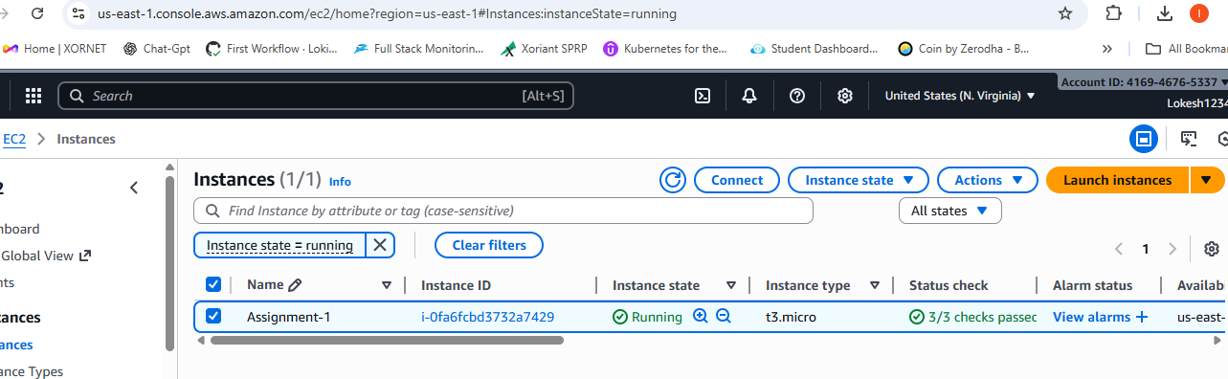

sudo yum update -y
sudo yum install httpd -y
sudo systemctl start httpd
sudo systemctl enable httpd
echo "<h1>My Web Server in US-East-1</h1>" | sudo tee /var/www/html/index.html

Connected from the public IP of the Assignment-1 instance

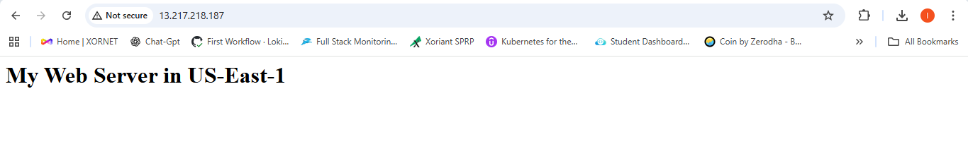

2. Create AMI from this web server
a.Create an AMI replica from the existing AMI of US-East-1 (N. Virginia)
b.Copy the AMI to the az that you want to have a replica US-West-2 (Oregon)
c.Launch a new Instance using the AMI that was created earlier on US-East-1 (N. Virginia) on US-West-2 (Oregon)

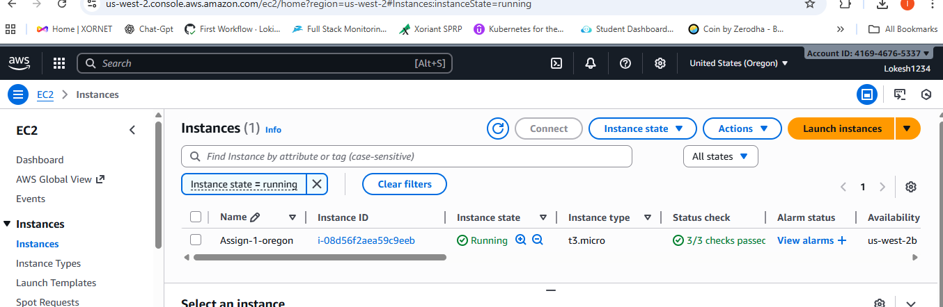

3. Create two additional EBS volumes and attach to the US-East-1 instance

a.Create Volume size 5GB And AZ us-east-1a
b.Create another 5GB Volume
c. Attach the volume to the EC2 instance
d. Both Volumes are attached

4. Delete one volume after detaching it & extend the size of the other
a. EC2 → Volumes → Select Volume-1
b.Actions → Detach Volume
c.Wait until status = available
d.Select the detached volume
e.Actions → Delete Volume

f.Select Volume-2
g.Actions → Modify Volume
h.Change size:
i.Click Modify

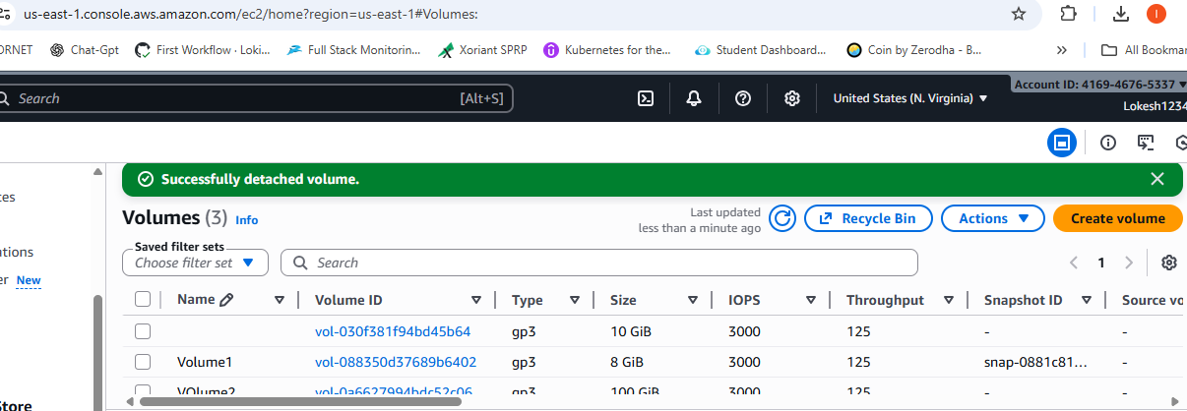

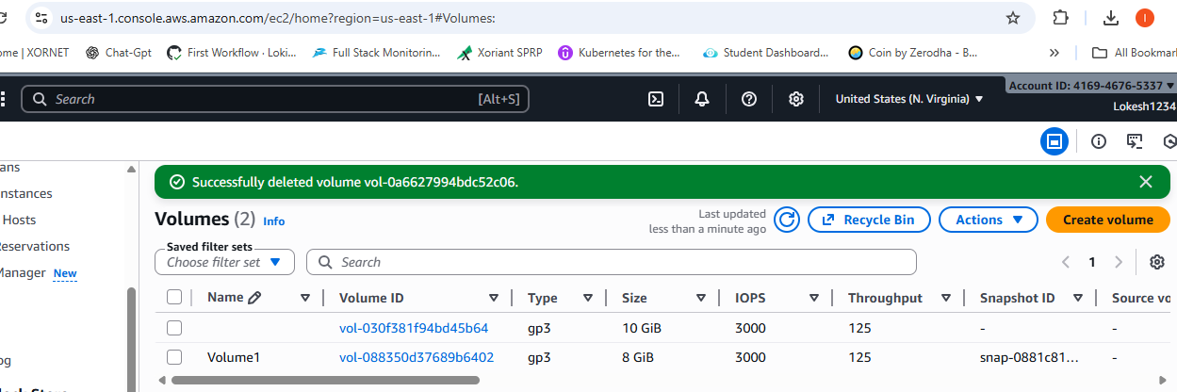

5. Take backup of this EBS volume

a.EC2 → Volumes
b.Select Volume-2 (the extended volume)
c.Actions → Create Snapshot
d.Add name: WebServer-Backup-East-Volume

