Create an EFS and connect it to 3 different EC2 instances. Make sure that all instances have different operating systems. For instance, Ubuntu, Red Hat Linux and Amazon Linux 2.

- Create 3 EC2 instances from different AMI’s and get new updates
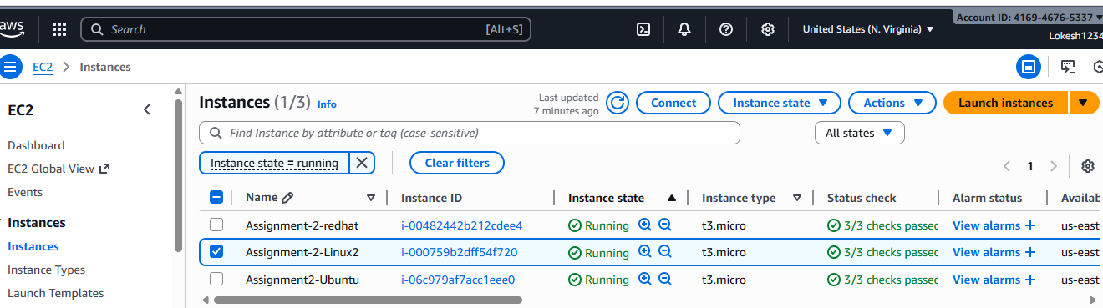

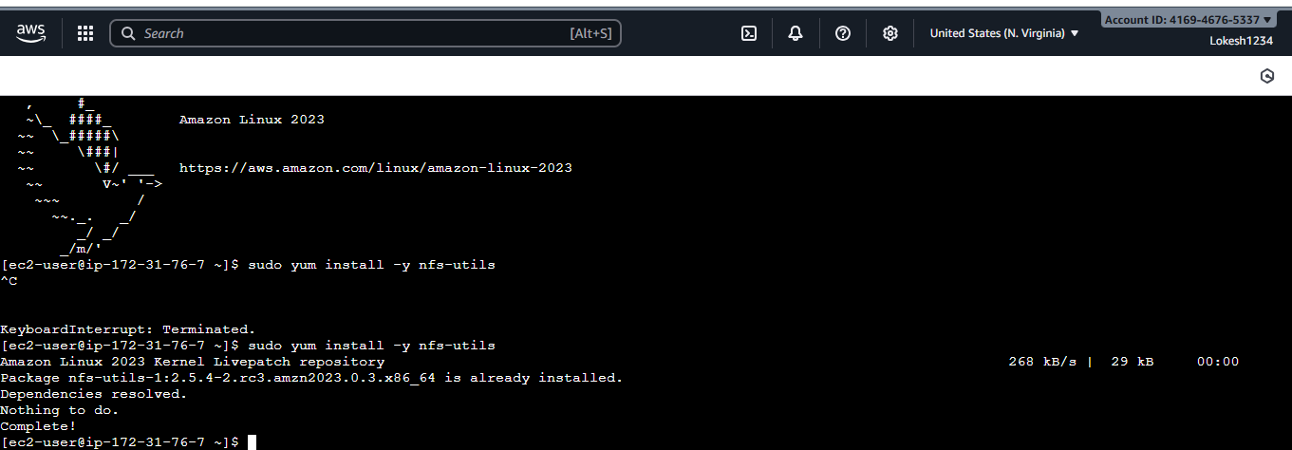

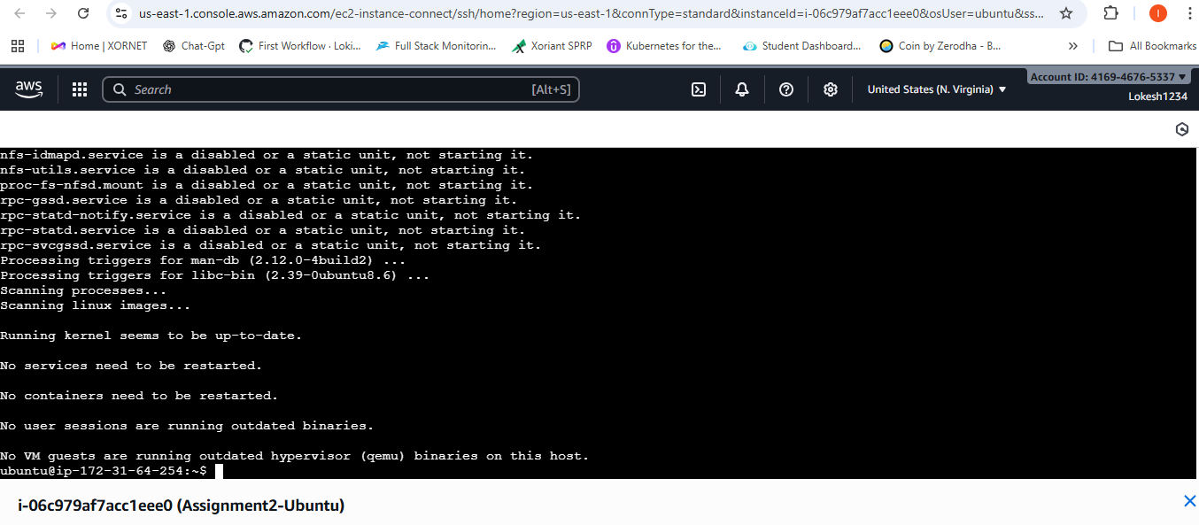

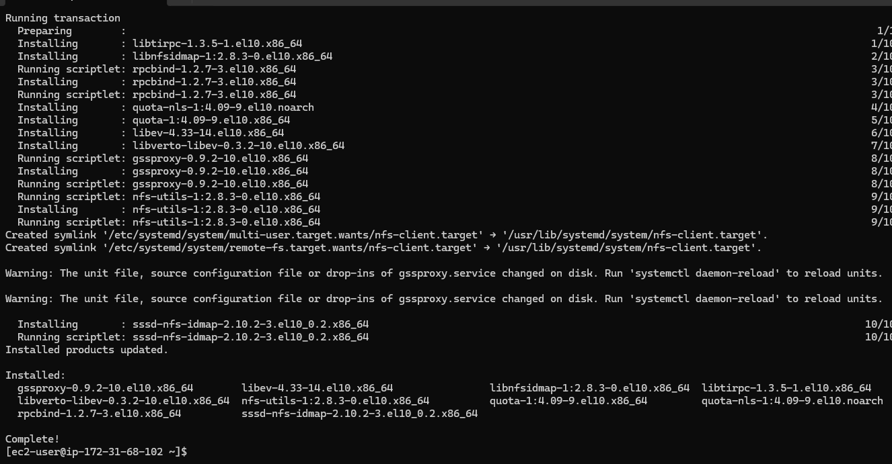

- Mount the directory on all these 3 instances
sudo mkdir -p /mnt/efs

- sudo mount -t nfs4 -o nfsvers=4.1,rsize=1048576,wsize=1048576,hard,timeo=600,retrans=2,noresvport fs-0473dcbe59c53c944.efs.us-east-1.amazonaws.com:/ /mnt/efs
on all the 3 instances now all 3 are mounted / shared

- Once all the instances are mounted create a file under one instance to check if this file is available on all the instances as this is shared now .

