A Project Report/Thesis/Dissertation on

***DYNAMICS OF QUANTUM SYSTEMS MODELED BY JAYNES CUMMINGS HAMILTONIAN UNDER THE INFLUENCE OF MEMORY CHANNELS***

*Submitted for the partial fulfillment of the requirement for the award of the Degree of*

***Bachelor of Science (Honors)***

In

***Chemistry***

by

***Lokesh***

Under the Supervision/Guidance of

***Dr. Manas Ranjan Dash and Dr. Natasha Awasthi***

Designation and affiliating University/Organization

**DIT UNIVERSITY, DEHRADUN, INDIA**

May 2024

A Project Report/Thesis/Dissertation on

***DYNAMICS OF QUANTUM SYSTEMS MODELED BY JAYNES CUMMINGS HAMILTONIAN UNDER THE INFLUENCE OF MEMORY CHANNELS***

*Submitted for the partial fulfillment of the requirement for the award of the Degree of*

***Bachelor of Science (Honors)***

In

***Chemistry***

by

***Lokesh***

Under the Supervision/Guidance of

***Dr. Manas Ranjan Dash and Dr. Natasha Awasthi***

Designation and affiliating University/Organization

**DIT UNIVERSITY, DEHRADUN, INDIA**

May 2024

**DECLARATION**

This is to certify that the Project / Thesis / Dissertation entitled **“Dynamics of Quantum Systems Modeled by Jaynes Cummings Hamiltonian under the influence of Memory Channels**”in partial fulfillment of the requirement for the award of the degree of **Bachelor of Science (Honors)** in **Chemistry** submitted to **DIT University, Dehradun, Uttarakhand, India,** is an authentic record of bona fide work carried out by me, under the supervision /guidance of **Dr. Manas Ranjan Dash** and **Dr. Natasha Awasthi.**

The matter embodied in this Project/Thesis/Dissertation has not been submitted for the award of any other degree or diploma to any University/Institution.

***Signature***

***Name of Candidate: Lokesh***

***Roll No: 211075007***

***Date: 24, May 2024***

***Place: Dehradun***

**CERTIFICATE**

This is to certify that the Project / Thesis / Dissertation entitled **“Dynamics of Quantum Systems Modeled by Jaynes Cummings Hamiltonian under the influence of Memory Channels**”in partial fulfillment of the requirement for the award of the degree of **Bachelor of Science (Honors)** in **Chemistry** submitted to **DIT University, Dehradun, Uttarakhand, India,** is an authentic record of bona fide work carried out by **Mr. Lokesh, Roll No.** – **211075007** under my supervision/ guidance.

***Signature***

***Name of Supervisor: Dr. Manas Ranjan Dash***

***Date: 24, May 2024***

***Place: Dehradun***

***Signature***

***Name of Supervisor: Dr. Natasha Awasthi***

***Date: 24, May 2024***

***Place: Dehradun***

**LIST OF ABBREVIATIONS**

|  |  |
| --- | --- |
| int | Interaction |
| TLS  JCM  ADC  PDC  PF | Two-Level System  Jaynes-Cummings Model  Amplitude Damping Channel  Phase Damping Channel  Phase Flip |

**ACKNOWLEDGEMENT**

I would like to express my sincere gratitude to my supervisors Dr. Manas Ranjan Dash and Dr. Natasha Awasthi for constantly supporting and guiding me throughout my work. I appreciate continual efforts of encouragement and professional and moral support.

I want to extend my utmost regard to Dr. Manisha Duseja, Head of the Department of Chemistry, for offering me advice and guidance at every step of my inter-departmental research. I feel indebted to you for allowing me to pursue inter-departmental research with the Department of Physics.

I convey my deepest gratitude to Dr. Atanu Bhatta, Assistant Professor, Department of Physics, for helping me through the mathematical aspects of my research. Your help has been pivotal in the completion of my research work.

I acknowledge the efforts of Dr. Sanjeev Saini, Dr. Ashish Khanna, and Dr. Anita Bhatia for constantly inspecting my work and offering suggestions for improvement.

I am also grateful to all my colleagues of B.Sc. Hons. Chemistry and B.Sc. Hons. Physics for helping and motivating me in times of need.

**ABSTRACT**

The study investigates the evolution of quantum systems described by the Jaynes Cummings Hamiltonian under the action of various decoherence channels with and without memory parameters. It probes into the effect of memory parameters on entanglement between a two-level atom and the photons of a single-mode radiation field.

Sustaining entanglement against noise is crucial to any kind of quantum technology. Thus, the effect of various noise channels on quantum systems has been widely studied and measures to prevent collapse of entanglement have been suggested. In my work, I have investigated the resilience offered to a quantum system by the application of memory parameters. Concurrence is taken as a measure of entanglement. The concurrence of the entangled system is measured against decoherence strength for various noise channels, once with memory parameters applied and once without memory parameters and the results are compared.

On application of memory, entanglement shows meagre signs of decay with increased decoherence strength. For memoryless channel, a sharp decay of entanglement was observed with increase in decoherence strength. The comparison confirmed that entanglement shows resilience against noise in memory channels than the memoryless channels.

**LIST OF TABLES AND FIGURES**

|  |  |  |
| --- | --- | --- |
| **Figures & Tables** | **Description** | **Page No.** |
| Figure 2.1 | Energy states of a two-level atom | 4 |
| Figure 2.2 | Atom-field interaction | 6 |
|  |  |  |

**CONTENTS**

|  |  |
| --- | --- |
| **TITLES**  **List of Abbreviations**  **Acknowledgement**  **Abstract**  **List of Tables and Figures** | **Page No.**  **iv**  **v**  **vi**  **vii** |
| **CHAPTERS**   1. INTRODUCTION    1. General    2. Coherence and Decoherence    3. System of Study    4. Objective of the Thesis    5. Organization of the Thesis 2. LITERATURE REVIEW    1. The Two-level Atom    2. Quantized Radiation Field    3. Atom-Field Interaction    4. The Jaynes Cummings Hamiltonian    5. Entanglement and its Measures    6. Evolution under Noisy Channels    7. Memory Channels and Memoryless Channels 3. CALCULATIONS    1. Methodology    2. Initial State of the System    3. Time Evolution    4. Density Operator    5. Dynamics of Amplitude Damping Channel    6. Dynamics of Phase Damping Channel    7. Dynamics of Phase Flip Channel    8. Dynamics of Depolarizing Channel 4. RESULTS AND DISCUSSION | 1  1  2  2  2  4  5  5  7  7  8  10  12  12  12  13  14  15  16  17 |

**CHAPTER 1 - INTRODUCTION**

* 1. General

The bizarre dynamics of the quantum realm have been studied for decades in the hopes of exploiting its vast potential. Quantum world operates very differently from our macroscopic monotonous world. The well-defined concept of position and momentum breaks down, objects start existing as a superposition of states and “spooky actions” like entanglement start taking hold. Every event is decided by probabilities, just like a coin toss or roll of some dice.

These uncanny phenomena that fuelled debates among luminaries like Bohr and Einstein are now seen as grounds for unprecedented scientific advancement. With extensive research and investment, quantum systems have been developed to apply principles of quantum mechanics to the fields of cryptography, communication, computation etc [1].

However, these systems, in comparison, are like the computers of 1960’s that occupied a whole room and used vacuum tubes for transistors. Without sophisticated instruments and highly controlled conditions, operating a quantum system is still impossible.

* 1. Coherence and Decoherence

Quantum states are very fragile. Even minute interactions with environment can cause these states to collapse, a phenomenon the scientists call *decoherence*. Therefore, quantum systems need to be isolated and protected from the environment. Any factor that can cause decoherence in a quantum system constitutes *noise*.

On the other hand, the ability of quantum systems to maintain a definite phase relation between different states in a superposition is called *coherence.* In layman’s terms, it is the ability of a quantum system to maintain a state. The duration for which a system sustains coherence is coined as *coherence time.* Longer coherence times are critical as they allow for more complex operations without errors. Different quantum systems show different coherence times [2].

* 1. **System of Study**

For this study, the system at hand is a quantum TLS comprised of a two-level atom in an optical cavity subjected to a single-mode radiation field. The atom-photon interactions in such systems are efficiently described by the Jaynes Cummings Model [3].

For coherent systems, the entanglement can be studied efficiently against various decoherence channels. Decoherence channels induce noise to the system. The effect of noise on coherence of the system can be studied by observing the entanglement between the bipartite system [4].

Various efforts have been made to sustain coherence for longer durations. Memory channels have shown promise of maintaining coherence and postponing the decay of quantum entanglement[5]. My work is one more of such endeavours.

* 1. **Objective of the Thesis**

This study is woven around discovering the effect of memory channels on evolution of systems described by JCM.

Specifically, the study deals with the evolution of the quantum state of such systems under the influence of decoherence channels, with and without memory. The concurrence of our system of study is measured against decoherence parameters and the results with and without memory channels are compared.

The objective is to demonstrate the resilience of quantum systems, described by JCM with memory channels over memoryless channels.

* 1. **Organization of the Thesis**

The study has been organized into 3 chapters.

Chapter 1- Introduction: The chapter introduces the foundational concepts of the study and the objective that guides it.

Chapter 2- Literature Review: The chapter sheds light on the literature and work published relevant to the motion.

Chapter 3- Calculations: The chapter deals with mathematics involved in our study and calculations of the result.

Chapter 4- Results and Discussion: The results of the study are presented and discussed in this chapter.

Chapter 5- Conclusion and Scope for Future Work: The study is concluded and recommendations for potential future work are discussed in this chapter.

**CHAPTER 2 – LITERATURE REVIEW**

* 1. **The Two-level Atom**

Quantum two level systems, better known as *Qubits*, are quantum systems that can exist as a superposition of two separate quantum states. A simple example is an atom with a single electron that can transit only between two electronic levels.

The atom has a low energy ground state, $\left|g\right\rangle$ and a high energy excited state $\left|e\right\rangle$. The energy difference between the two states becomes $ℏω_{0}$ with a transition frequency of $ω_{0}$.

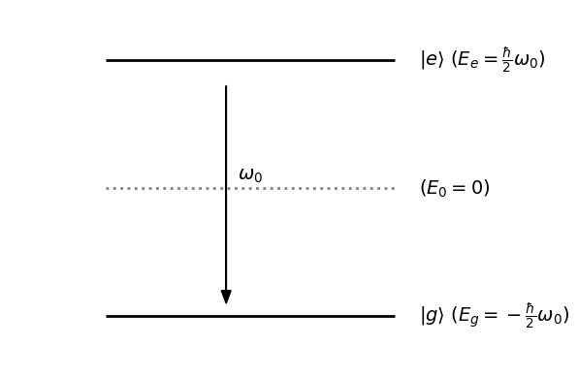

*Figure 2.1:Energy states of a two-level atom.*

We consider the zero-energy state $E_{0}$ to be midway between the two energy levels (Gerry & Knight, 2004 ). The energies of ground and excited states simply become $E_{g} =-\frac{1}{2}ℏω_{g}$ and $E_{e}=\frac{1}{2}ℏω_{e}$ where $ω_{g}$ and $ω_{e}$ are frequencies of ground and excited state respectively. Transitions to energy states higher than $\left|e\right\rangle$ are forbidden, making the atom a two-level system with only $\left|g\right\rangle$ and $\left|e\right\rangle$ energy levels [6].

The Hamiltonian of our two-level atom can now be written as:

|  |  |  |
| --- | --- | --- |
|  | $$H_{atom}=\frac{1}{2}ℏω_{0}σ_{z}$$ | …(2.1) |

where $σ_{z}$ is the atomic inversion operator, also called Pauli-Z operator:

$σ_{z}\left|g\right\rangle =-\left|g\right\rangle$ $σ_{z}\left|e\right\rangle =\left|e\right\rangle$

The eigenvalues of $H_{atom}$ for eigenstates $\left|g\right\rangle$ and $\left|e\right\rangle$ give the energy of respective states:

* 1. **Quantized Radiation Field**

The system in our study is subjected to a single-mode radiation field inside an optical cavity. The electromagnetic radiation field has a frequency of $ω$. The number of photons is denoted as $n$ and the state of our single mode field can be written as $\left|n\right\rangle$.

The number of photons in a state are changed by the application of annihilation and creation operator. The photon annihilation operator, $\hat{a}$, decreases the number of photons by one. The photon creation operator, ${\hat{a}}^{†}$, is the Hermitian adjoint of annihilation operator and increases the photon number by one [7].

|  |  |  |
| --- | --- | --- |
|  |  | …(2.2) |
|  |  | …(2.3) |

The number operator, $\hat{n} = {\hat{a}}^{†}\hat{a}$, gives the number of photons for a given state.

|  |  |  |
| --- | --- | --- |
|  |  | …(2.4) |

The Hamiltonian of our field can now be written as:

|  |  |  |
| --- | --- | --- |
|  | $$H_{field}=ℏω{\hat{a}}^{†}\hat{a}$$ | …(2.5) |

For state $\left|n\right\rangle$, the eigenvalue of the is:

* 1. **Atom-Field Interaction**

Our system is a bipartite system made up of a two-level atom and a single mode radiation field. The combined system can be expressed as a product state of field and the atom. Consider that initially our atom is in the ground state $\left|g\right\rangle$ and the field is in state $\left|n\right\rangle$. The combined wavefunction of our initial state, $\left|ψ\right\rangle$ will be:

|  |  |  |
| --- | --- | --- |
|  |  | …(2.6) |

On interaction with the applied field, the atom experiences transition from ground to excited state if $ω≈ω_{0}$. On excitation, a photon is annihilated, and the atom jumps to the higher energy state. It returns to the ground by emission (creation) of a photon.

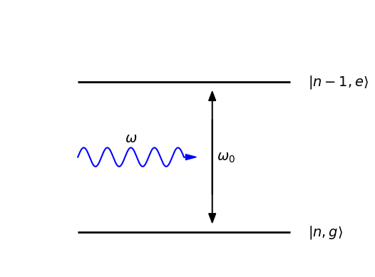

*Figure 2.2: Atom-field interaction.*

Mathematically, the interaction is implemented through the atomic transition operators $σ_{+}$ and $σ_{-}$.

$σ_{+}=\left|e\right\rangle \left\langle g\right|$ $σ_{-}=\left|g\right\rangle \left\langle e\right|$

Such that,

$$σ_{+}\left|g\right\rangle =\left|e\right\rangle ⟨g\left|g\right\rangle =\left|e\right\rangle$$

$$σ_{-}\left|e\right\rangle =\left|g\right\rangle \left\langle e\right|e⟩= |g⟩$$

The Hamiltonian of atom field interaction is expressed as[7]:

$$H_{int}=ℏλ\left(\hat{a}σ_{+}+\hat{a}σ_{-}\right)$$

Where $λ$ is the atom-field coupling constant [8]

Eigenvalues of $H_{int}$ for state $\left|n,g\right\rangle$ and $\left|n,e\right\rangle$ will be:

* 1. **The Jaynes Cummings Hamiltonian**

The Hamiltonian of systems such as ours are efficiently described by the Jaynes Cummings Model. The Jaynes Cummings Hamiltonian has three terms – Hamiltonian of the field, Hamiltonian of the atom and Hamiltonian of the atom field interaction. All these terms have been defined in the previous section.

Putting them together, the Jaynes Cummings Hamiltonian takes the form:

|  |  |  |
| --- | --- | --- |
|  |  | …(2.7) |

* 1. **Entanglement and its Measures**

A bipartite system can be explained as a system made up of two constituent subsystems – like the atom and the field in our case. The state of a pure bipartite system can be expressed as [9]: $${|Ψ}_{af}⟩∈H_{af}= H_{a}⊗H_{f}$$

Technically, entanglement in pure bipartite system is expressed as the inability to write them as a product of two states corresponding to the two subsystems [9].

$$\left|Ψ_{af}\right\rangle =\left|ψ_{a}\right\rangle \left|ϕ_{f}\right\rangle$$

In simple terms, it can be said that the state of one subsystem is not independent of another. The states of one subsystem determine the states of the other subsystem. For our system, it can be inferred that the absorption of a photon excites the atom to a higher energy state. Therefore, if the field was initially in the state $\left|n,g\right\rangle$, after absorption the state changes to $\left|n-1,e\right\rangle$. It can be inferred that the state of field being $\left|n\right\rangle$ or $\left|n-1\right\rangle$ decides whether the atom has $\left|g\right\rangle$ or $\left|e\right\rangle$.

This dependence easily reveals the entanglement between the atom and the field in our system.

Quantification of entanglement is done by defining measures of entanglement like Von Neumann Entropy, Negativity, Concurrence, Logarithmic Negativity etc. [10].

In our study, the measure of entanglement opted for is Concurrence. Concurrence was introduced by Wooters, 1998[11]. He gave a simple closed expression for calculating the concurrence in bipartite system can be written down as follows:

|  |  |  |
| --- | --- | --- |
|  | $$C\left(ρ\right)=max\left(0,λ_{1}-λ_{2}-λ_{3}-λ_{4}\right)$$ | …(2.8) |

Where, $λ_{i}^{'}s$ are the square roots of eigenvalues of the non-Hermitian matrix $ρ\tilde{ρ}$ arranged in decreasing order. Here $\tilde{ρ}$ is derived by applying the spin-flip matrix to $ρ$*, the complex conjugate of $ρ$ derived in computational $\{|00⟩,|01⟩,|10⟩,|11⟩\}$ [11]:

$$\tilde{ρ}=\left(σ_{2}⊗σ_{2}\right)ρ*\left(σ_{2}⊗σ_{2}\right)$$

In this study, we will later look at the density matrices with an X structure, where the formula for concurrence can be tweaked a little to make the calculations easier.

* 1. **Evolution under Noisy Channels**

Before introducing noise channels, I would like to discuss the evolution of a system through any quantum channel. It can be explained using the application of Kraus operators on the density operator of the system.

Evolution of the system, $ε\left(ρ\right)$, is given by:

|  |  |  |
| --- | --- | --- |
|  | $$ε\left(ρ\right)=\sum_{i}{E_{i}}ρE_{i}^{†}$$ | …(2.9) |

Where $E_{i}$ and ${E_{i}}^{†}$ represent the Kraus operators and their complex conjugates. Kraus operators must satisfy the completeness relation:

$$\sum_{i}{E_{i}^{†}}E_{i} = I$$

Where $I$ is the Identity matrix of same dimensions as the Kraus operators. The evolution of the quantum systems through various noise channels calculated by the putting Kraus operators of each noise channel into the Eq. (2.9).

This is the case for a single qubit. For multiple qubits, the Kraus operators are applied on each qubit individually. Therefore, the overall Kraus operators for the system can be constructed as the tensor product of the operators for single qubit. We will investigate this with respect to our system of study in a while.

Noisy channels or Decoherence channels are basically the various sources of noise that affect our quantum system and induce errors. These channels can be classified into the following categories [12]:

1. *Amplitude Damping Channel* – This channel describes the energy dissipation of a qubit. A qubit in higher energy states loses energy to the environment and relaxes to the lower energy state with spontaneous emission of a photon.
2. *Phase Damping Channel* – This describes the dephasing of qubits without the loss of energy. Generally, it is due to random fluctuations in the environment of the qubits.
3. *Phase Flip Channel –* This channel represents the inversion of phase between two states of a qubit with a certain probability.
4. *Depolarizing Channel –* In this channel, the qubit loses its quantum information and becomes a mixed state with a certain probability. The state of the qubit becomes random.

The overall Kraus operators for each channel can be derived by taking tensor products of the individual Kraus operators of each channel:

|  |  |  |
| --- | --- | --- |
|  | $$E_{ij}=E_{i}^{1}⊗E_{j}^{2}$$ | …(2.10) |

Where $i,j$ represent the Kraus operators and the superscripts represent the qubits on which the operator is applied. Plugging in these operators into Eq. (2.9) gives the evolution of our system made up of two subsystems.

* 1. **Memory Channels and Memoryless Channels**

Open quantum systems can be broadly classified into two types – Markovian and non-Markovian Systems. In the case of Markovian systems, evolution depends only on the present state of the system. Previous operations on the state do not affect the future state of the system.

However, in a non-Markovian System, the evolution of the system depends on the history of operations. The effects of the previous operations are retained in the current state of the system, thus affecting the future states of the system. These remanent effects of previous events are termed as memory effects.

Quantum Channels where memory effects are not considered are called memoryless channels. The environmental correlation time in memoryless channels is smaller than the time between successive operations of channel over the qubits. Correlation time is nothing but the time till which the effects of previous operations persist in the system. This infers that memory effects from operation first qubit decay before the operations on the second qubits are performed. Therefore, no memory effects are observed.

Quantum channels which consider the effects of memory channels are called Memory channels. Here the environmental correlation time is larger than the time between successive operations. Therefore, the effects of previous operations remain during the second operation and affect the evolution of the system. [5]

In memory channels, when the same operations are applied to both the qubits with probability $μ$, the operations are termed as correlated. On the other hand, if operations are different, they are uncorrelated, and probability becomes $\left(1-μ\right)$. Here, the probability $μ$ gives us the memory parameter such that $0≤ μ≤$ 1. The evolution under the influence of memory channels is given by modifying Eq. (2.9) [13]; [14]:

|  |  |  |
| --- | --- | --- |
|  | $$ε\left(ρ\right)=\left(1-μ\right)\sum_{i,j}{E_{i,j}^{u}}ρE_{i,j}^{u†}+μ\sum_{k}{E_{k,k}^{c}}ρE_{k,k}^{c†}$$ | …(2.11) |

It is evident that $E_{i,j}^{u}$ describes the contribution from uncorrelated parts with probability $\left(1-μ\right)$ and $E_{k,k}^{c}$ describes the contribution of correlated parts with probability $μ$. Kraus operators for uncorrelated and correlated parts are calculated separately.

**CHAPTER 3– CALCULATIONS**

**3.1. Methodology**

Now, after building a grasp of the necessary concepts, it is time to investigate the effects of memory channels on the systems described by Jaynes Cummings Hamiltonian.

The calculations start with defining the initial state of our system. We determine the time evolution of the system at time $t$. Further, we derive the density operator. Then, we use the Kraus operator approach to calculate evolution of our system without memory parameters reproducing the results of Ahadpour & Mirmasoudi, 2020 [8]. Further, for our objective, we calculate the evolution with different values of memory parameter and compare the results.

Throughout the course of our calculations, we will consider $ℏ=1$ for the ease of our calculations. With this, the Jaynes Cummings Hamiltonian takes the form:

|  |  |  |
| --- | --- | --- |
|  | $$H=ω{\hat{a}}^{†}\hat{a}+\frac{1}{2}ω_{0}σ_{z}+λ\left(\hat{a}σ_{+}+\hat{a}σ_{-}\right)$$ | …(3.1) |

**3.2. Initial State of the System**

Initially, at time $t=0$, we consider our state to be the following for the purpose of this study [8]:

|  |  |  |
| --- | --- | --- |
|  |  | …(3.2) |

The atom is in the excited state $\left|e\right\rangle$ with $P_{n}=exp\left(-\frac{\overline{n}}{2}\right) \sqrt{\frac{{\overline{n}}^{n}}{n!}}$ for a coherent state with mean photon number, $\overline{n}$.

**3.3. Time Evolution**

The time evolution of the state at time $t$ is given by:

|  |  |  |
| --- | --- | --- |
|  |  | …(3.3) |

Where $U\left(t\right)$ is the unitary time evolution operator such that, $U\left(t\right)=e^{-iHt}$. The atom and field Hamiltonian remain roughly constant throughout the interaction. We only consider the effects of interaction in our calculations i.e. only $H_{int}$ is used for the calculation. For the interaction picture in case of resonance i.e. $ω_{0}≈ω$, $U\left(t\right)$ takes the matrix form [15] (See Appendix A):

|  |  |  |
| --- | --- | --- |
|  | $$U\left(t\right)=\left(\begin{matrix}cos\left(τ\sqrt{a^{†}a}\right) & \frac{-ia^{†}}{\sqrt{a^{†}a+1}}sin\left(τ\sqrt{a^{†}a+1}\right) \\ \frac{-ia}{\sqrt{a^{†}a}}sin\left(τ\sqrt{a^{†}a}\right) & cos\left(τ\sqrt{a^{†}a+1}\right)\end{matrix}\right)$$ | …(3.4) |

Here, $τ=tλ$ is the dimensionless interaction time.

**3.4. Density Operator**

For any atom-field system, there are infinite photons in the field. Therefore, our atom-field space has dimensions $2×∞$. We are only interested in a $2×2$ system with atomic states $\left|e\right\rangle$, $\left|g\right\rangle$ and field states $\left|n\right\rangle$, $\left|n+1\right\rangle$. Therefore, we project this space into a $2×2$ subspace. The density operator in this space becomes (See Appendix A):

|  |  |  |
| --- | --- | --- |
|  |  | …(3.5) |

In the matrix form it can be written as:

|  |  |  |
| --- | --- | --- |
|  | $$ρ_{af}\left(t\right)=\left(\begin{matrix}κ_{1} & 0 & 0 & 0 \\ 0 & κ_{2} & κ_{3} & 0 \\ 0 & -κ_{3} & κ_{4} & 0 \\ 0 & 0 & 0 & κ_{5}\end{matrix}\right)$$ | …(3.6) |

where,

$$κ_{1}=\frac{P_{n-1}^{2}}{N}sin^{2}\left(τ\sqrt{n}\right)$$

$$κ_{2}=\frac{P_{n}^{2}}{N}cos^{2}\left(τ\sqrt{n+1}\right)$$

$$κ_{3}=i\frac{P_{n}^{2}}{N}cos\left(τ\sqrt{n+1}\right) sin\left(τ\sqrt{n+1}\right)$$

$$κ_{4}=\frac{P_{n}^{2}}{N}\sin^{2}\left(τ\sqrt{n+1}\right)$$

$$κ_{5}=\frac{P_{n+1}^{2}}{N}cos^{2}\left(τ\sqrt{n+2}\right)$$

And $N$ is the normalization coefficient such that:

$$N=P_{n-1}^{2}sin^{2}\left(τ\sqrt{n}\right)+P_{n}^{2}+P_{n+1}^{2}cos^{2}\left(τ\sqrt{n+2}\right)$$

In the next section, we shall use the density operator given in Eq. (3.5) and Eq. (3.6) to derive the evolution of our system under various noise channels.

**3.5. Dynamics of Amplitude Damping Channel**

For ADC, the Kraus operators for single qubits are as follows[16]:

$E_{0}=\left(\begin{matrix}1 & 0 \\ 0 & \sqrt{1-λ}\end{matrix}\right)$ $E_{1}=\left(\begin{matrix}0 & \sqrt{λ} \\ 0 & 0\end{matrix}\right)$

The uncorrelated Kraus operators for two qubits have the form (See Appendix B):

$E_{ij}^{u}=E_{i}⊗E_{j}$ $\left(i=0,1\right)$

The correlated Kraus operators are[17]:

|  |  |  |
| --- | --- | --- |
|  | $E_{00}^{c}=\left(\begin{matrix}\sqrt{1-λ} & 0 & 0 & 0 \\ 0 & 1 & 0 & 0 \\ 0 & 0 & 1 & 0 \\ 0 & 0 & 0 & 1\end{matrix}\right)$ $E_{11}^{c}=\left(\begin{matrix}0 & 0 & 0 & 0 \\ 0 & 0 & 0 & 0 \\ 0 & 0 & 0 & 0 \\ \sqrt{λ} & 0 & 0 & 0\end{matrix}\right)$ | …(3.7) |

For memoryless channel, using Eq. (2.9) we derive the evolved density matrix $ρ_{AD}$ as:

$$\left(\begin{matrix}κ_{1}+λ\left(κ_{5}λ+κ_{2}+κ_{4}\right) & 0 & 0 & 0 \\ 0 & \left(1-λ\right)\left(κ_{5}λ+κ_{2}\right) & κ_{3}\left(1-λ\right) & 0 \\ 0 & -κ_{3}\left(1-λ\right) & \left(1-λ\right)\left(κ_{5}λ+κ_{4}\right) & 0 \\ 0 & 0 & 0 & κ_{5}{\left(λ-1\right)}^{2}\end{matrix}\right)$$

Using Eq. (2.11) to derive the evolved density matrix with memory, $ρ_{AD}^{\left(m\right)}$:

**3.6. Dynamics of Phase Damping Channel**

For PDC, the Kraus Operators for single qubits are given using[17];[5]:

$E_{i}=\sqrt{P_{i}}σ_{i}$ ($i∈\{0,3\})$

The uncorrelated Kraus operators for two qubits have the form (See Appendix B):

|  |  |  |
| --- | --- | --- |
|  | $E_{ij}^{u}=\sqrt{P_{i}P_{j}}σ_{i}⊗σ_{j}$ $(i,j∈\{0,3\})$ | …(3.8) |

The Kraus operators for the Correlated parts are given by[18]:

|  |  |  |
| --- | --- | --- |
|  | $E_{k,k}^{u}=\sqrt{P_{k}}σ_{k}⊗σ_{k}$ ( $k∈0,3)$ | …(3.9) |

In the above equations, $P_{0}=1-λ$ and $P_{3} =λ$. Also, $σ_{0}=I$ i.e. identity matrix of dimensions $2×2$ and $σ_{3}$ is the Pauli z operator.

The evolved density, $ρ_{PD}$, for memoryless evolution is:

$$ρ_{PD} =\left[\begin{matrix}κ_{1} & 0 & 0 & 0 \\ 0 & κ_{2} & {\left(1-λ\right)}^{2}κ_{3} & 0 \\ 0 & -{\left(1-λ\right)}^{2}κ_{3} & κ_{4} & 0 \\ 0 & 0 & 0 & κ_{5}\end{matrix}\right]$$

Using Eq. (2.11), the density matrix for PDC with memory, $ρ_{PD}^{\left(m\right)}$ becomes:

**3.7. Dynamics of Phase Flip Channel**

For the Phase Flip Channel, the Kraus operators are

* *Evolution without Memory Parameters*

Using the above operators and Eq. (2.9), we obtain the following density operator, $ρ_{PF}$, for memoryless PF channel:

$$ρ_{PF}=\left[\begin{matrix}κ_{1} & 0 & 0 & 0 \\ 0 & κ_{2} & {\left(1-λ\right)}^{2}κ_{3} & 0 \\ 0 & -{\left(1-λ\right)}^{2}κ_{3} & κ_{4} & 0 \\ 0 & 0 & 0 & κ_{5}\end{matrix}\right]$$

* *Evolution with Memory Parameters*

Using Eq. (2.11), the density matrix for PF channel with memory, $ρ_{PF}^{\left(m\right)}$ becomes:

**3.8. Dynamics of Depolarizing Channel**

The single qubit Kraus operators for Depolarizing channel are as given as:

$E_{i}=\sqrt{P_{i}}σ_{i}$ ($i=0,1,2,3)$

$P_{1}=1-λ$ and $P_{1}=P_{2}=P_{3}=\frac{λ}{3}$.

The uncorrelated Kraus operators will have the form (See Appendix B):

|  |  |  |
| --- | --- | --- |
|  | $E_{ij}^{u}=\sqrt{P_{i}P_{j}}σ_{i}⊗σ_{j}$ ( $i=0,1,2,3)$ | …(3.10) |

The Kraus operators for the Correlated parts are given by[18]:

|  |  |  |
| --- | --- | --- |
|  | $E_{k,k}^{u}=\sqrt{P_{k}}σ_{k}⊗σ_{k}$ ( $k=0,1,2,3)$ | …(3.11) |

Eq. (2.9), the density operator for memoryless Depolarizing Channel, $ρ_{De}$ can be calculated. Various elements of the $ρ_{De}$ are as follows.

$$ρ_{11}=\frac{1}{4}\left({\left(2-λ\right)}^{2}κ_{1}+λ\left(\left(2-λ\right){(κ}_{2}+κ_{4})+λκ_{5}\right)\right)$$

$$ρ_{22}=\frac{1}{4}\left({\left(2-λ\right)}^{2}κ_{2}+λ\left(\left(2-λ\right)(κ_{1}+κ_{5})+λκ_{4}\right)\right)$$

$$ρ_{33}=\frac{1}{4}\left({\left(2-λ\right)}^{2}κ_{4}+λ\left(\left(2-λ\right)(κ_{1}+κ_{5})+λκ_{2}\right)\right)$$

$$ρ_{44}=\frac{1}{4}\left({\left(2-λ\right)}^{2}κ_{5}+λ\left(\left(2-λ\right)(κ_{2}+κ_{4})+λκ_{1}\right)\right)$$

$$ρ_{23}=ρ_{32}*={\left(1-λ\right)}^{2}κ_{3}$$

**CHAPTER 4– RESULTS AND DISCUSSION**

**4.1. Results of AD channel**

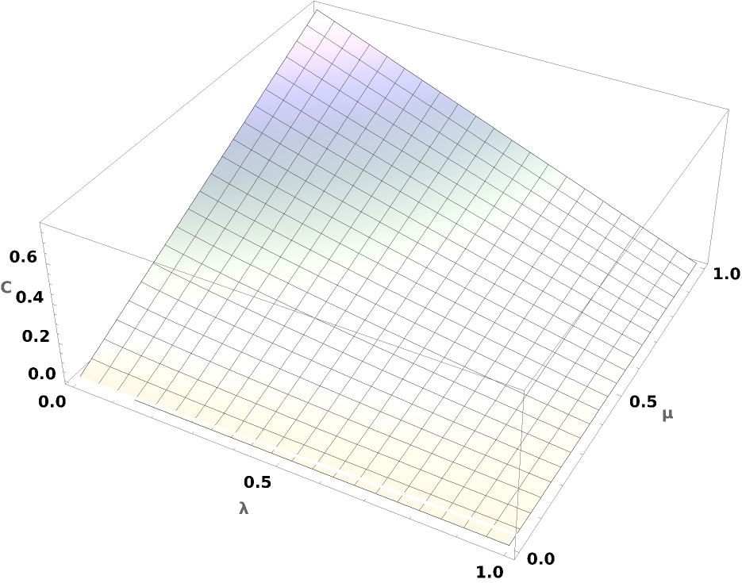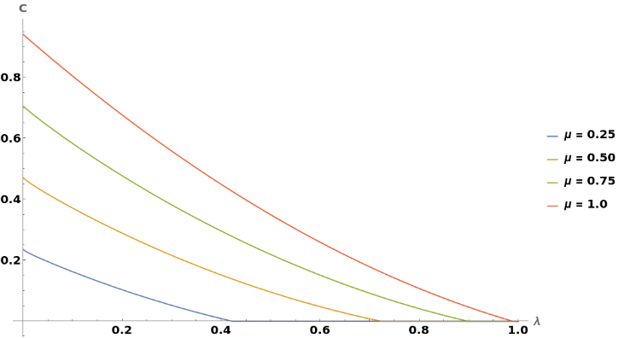

**4.2. Results of Phase Damping**

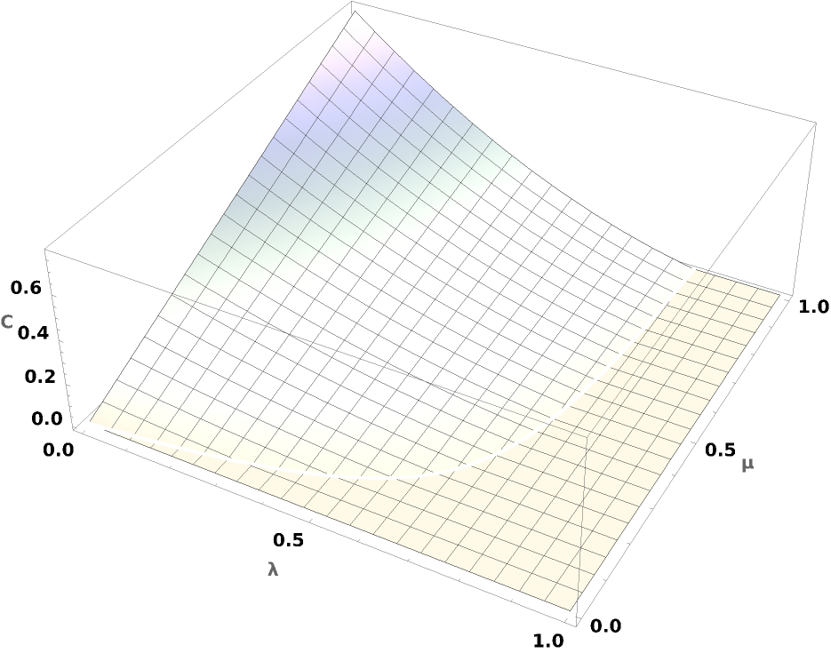

**4.3. Results of Depolarizing channel**

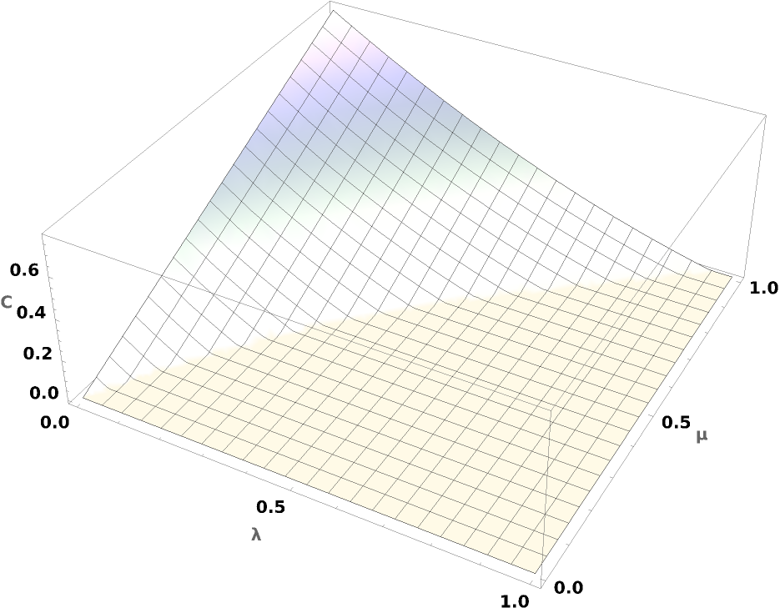

**4.4. Results of PF Channel**

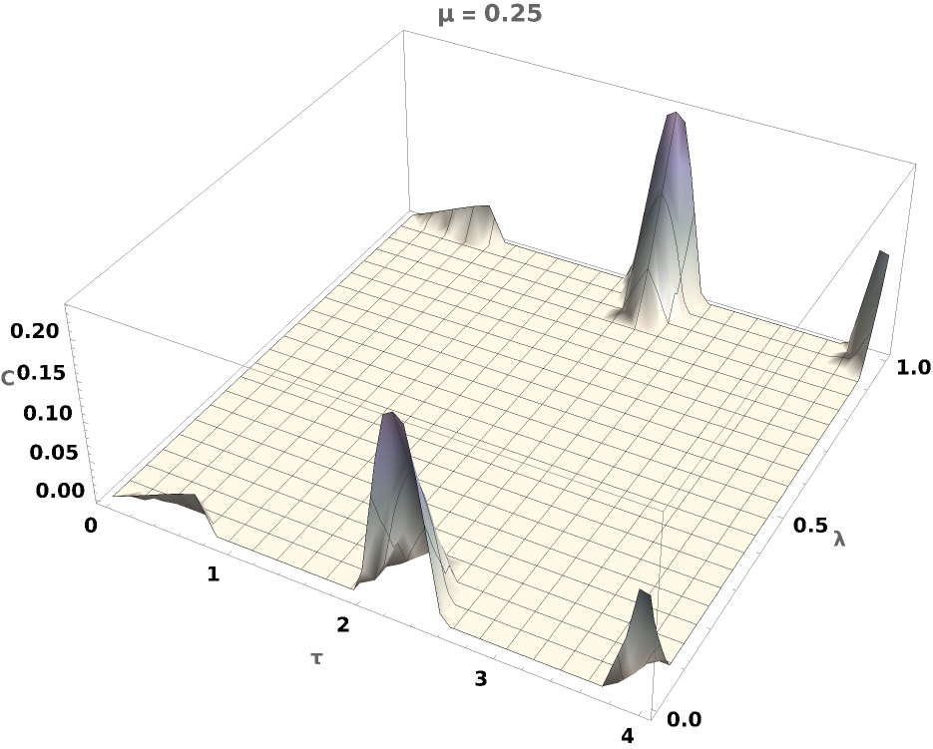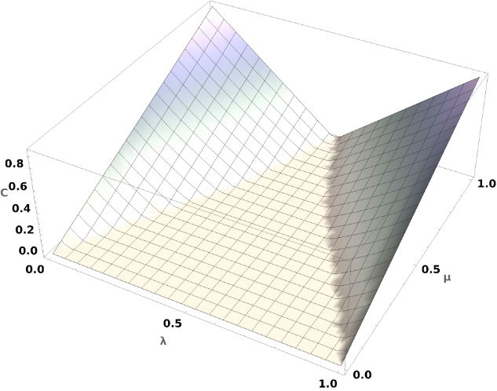

**CHAPTER 5– CONCLUSION AND SCOPE FOR FUTURE WORK**

**BIBLIOGRAPHY**

[1] W. P. Schleich *et al.*, “Quantum technology: from research to application,” *Applied Physics B*, vol. 122, no. 5, p. 130, May 2016, doi: 10.1007/s00340-016-6353-8.

[2] D. P. DiVincenzo and D. Loss, “Quantum computers and quantum coherence,” *J Magn Magn Mater*, vol. 200, no. 1–3, pp. 202–218, Oct. 1999, doi: 10.1016/S0304-8853(99)00315-7.

[3] E. T. Jaynes and F. W. Cummings, “Comparison of quantum and semiclassical radiation theories with application to the beam maser,” *Proceedings of the IEEE*, vol. 51, no. 1, pp. 89–109, 1963, doi: 10.1109/PROC.1963.1664.

[4] A. Streltsov, U. Singh, H. S. Dhar, M. N. Bera, and G. Adesso, “Measuring Quantum Coherence with Entanglement,” *Phys Rev Lett*, vol. 115, no. 2, p. 020403, Jul. 2015, doi: 10.1103/PhysRevLett.115.020403.

[5] N. Awasthi, A. Singh, and D. Kumar Joshi, “Postponing the decay of entanglement and quantum coherence for maximally entangled mixed states under the action of correlated noise channels,” *Frontiers in Quantum Science and Technology*, vol. 2, Nov. 2023, doi: 10.3389/frqst.2023.1207793.

[6] J. Liu and Z.-Y. Li, “Interaction of a two-level atom with single-mode optical field beyond the rotating wave approximation,” *Opt Express*, vol. 22, no. 23, p. 28671, Nov. 2014, doi: 10.1364/OE.22.028671.

[7] C. Gerry and P. Knight, *Introductory Quantum Optics*. 2004.

[8] S. Ahadpour and F. Mirmasoudi, “Dynamics of quantum correlations for different types of noisy channels,” *Opt Quantum Electron*, vol. 52, no. 8, p. 369, Aug. 2020, doi: 10.1007/s11082-020-02474-7.

[9] R. Horodecki, P. Horodecki, M. Horodecki, and K. Horodecki, “Quantum entanglement,” *Rev Mod Phys*, vol. 81, no. 2, pp. 865–942, Jun. 2009, doi: 10.1103/RevModPhys.81.865.

[10] M. B. Plenio and S. Virmani, “An introduction to entanglement measures,” *Quantum Inf Comput*, vol. 7, no. 1 & 2, pp. 1–51, Jan. 2007, doi: 10.26421/QIC7.1-2-1.

[11] W. K. Wootters, “Entanglement of Formation of an Arbitrary State of Two Qubits,” *Phys Rev Lett*, vol. 80, no. 10, pp. 2245–2248, Mar. 1998, doi: 10.1103/PhysRevLett.80.2245.

[12] M. A. Nielsen and I. L. Chuang, *Quantum Computation and Quantum Information*. Cambridge University Press, 2012. doi: 10.1017/CBO9780511976667.

[13] Y. Guo, Q. Tian, K. Zeng, and Z. Li, “Quantum coherence of two-qubit over quantum channels with memory,” *Quantum Inf Process*, vol. 16, no. 12, p. 310, Dec. 2017, doi: 10.1007/s11128-017-1749-x.

[14] N. Awasthi, J. Dheeraj Kumar, and S. Sachdev, “Variation of quantum speed limit under Markovian and non-Markovian noisy environment,” *Laser Phys Lett*, vol. 19, no. 3, p. 035201, Mar. 2022, doi: 10.1088/1612-202X/ac4be5.

[15] Y.-H. Hu and J.-Q. Wang, “Quantum correlations between two non-interacting atoms under the influence of a thermal environment,” *Chinese Physics B*, vol. 21, no. 1, p. 014203, Jan. 2012, doi: 10.1088/1674-1056/21/1/014203.

[16] J. . Preskill, *Lecture notes for physics 229: Quantum information and computation.* California Institute of Technology, 1988.

[17] S. Datta, S. Mal, and A. S. Majumdar, “Protecting temporal correlations of two-qubit states using quantum channels with memory,” *2018*, Accessed: Jun. 05, 2024. [Online]. Available: https://arxiv.org/abs/1808.10345

[18] A. D’Arrigo, G. Benenti, and G. Falci, “Quantum capacity of dephasing channels with memory,” *New J Phys*, vol. 9, no. 9, pp. 310–310, Sep. 2007, doi: 10.1088/1367-2630/9/9/310.

**APPENDICES**

**Appendix A: Derivations Followed in the Thesis**

Initially, our system is in the state:

Hamiltonian can be described as:

**Appendix B: Kraus Operators**

Using Eq. (2.10), the Kraus operators of ADC for two qubits can be written as following:

|  |  |
| --- | --- |
| $$E_{00}=\left(\begin{matrix}1 & 0 & 0 & 0 \\ 0 & \sqrt{1-λ} & 0 & 0 \\ 0 & 0 & \sqrt{1-λ} & 0 \\ 0 & 0 & 0 & 1-λ\end{matrix}\right)$$ | $$E_{11}=\left(\begin{matrix}0 & 0 & 0 & λ \\ 0 & 0 & 0 & 0 \\ 0 & 0 & 0 & 0 \\ 0 & 0 & 0 & 0\end{matrix}\right)$$ |
| $$E_{10}=\left(\begin{matrix}0 & 0 & \sqrt{λ} & 0 \\ 0 & 0 & 0 & \sqrt{\left(1-λ\right)λ} \\ 0 & 0 & 0 & 0 \\ 0 & 0 & 0 & 0\end{matrix}\right)$$ | $$E_{01}=\left(\begin{matrix}0 & \sqrt{λ} & 0 & 0 \\ 0 & 0 & 0 & 0 \\ 0 & 0 & 0 & \sqrt{\left(1-λ\right)λ} \\ 0 & 0 & 0 & 0\end{matrix}\right)$$ |

Now, for PDC, the Kraus operators are:

|  |  |
| --- | --- |
| $$E_{00}=\left(\begin{matrix}1-λ & 0 & 0 & 0 \\ 0 & 1-λ & 0 & 0 \\ 0 & 0 & 1-λ & 0 \\ 0 & 0 & 0 & 1-λ\end{matrix}\right)$$ | $$E_{11}=\left(\begin{matrix}λ & 0 & 0 & 0 \\ 0 & 0 & 0 & 0 \\ 0 & 0 & 0 & 0 \\ 0 & 0 & 0 & 0\end{matrix}\right)$$ |
| $$E_{01}=\left(\begin{matrix}\sqrt{\left(1-λ\right)λ} & 0 & 0 & 0 \\ 0 & 0 & 0 & 0 \\ 0 & 0 & \sqrt{\left(1-λ\right)λ} & 0 \\ 0 & 0 & 0 & 0\end{matrix}\right)$$ | $$E_{22}=\left(\begin{matrix}0 & 0 & 0 & 0 \\ 0 & 0 & 0 & 0 \\ 0 & 0 & 0 & 0 \\ 0 & 0 & 0 & λ\end{matrix}\right)$$ |
| $$E_{02}=\left(\begin{matrix}0 & 0 & 0 & 0 \\ 0 & \sqrt{\left(1-λ\right)λ} & 0 & 0 \\ 0 & 0 & 0 & 0 \\ 0 & 0 & 0 & \sqrt{\left(1-λ\right)λ}\end{matrix}\right)$$ | $$E_{12}=\left(\begin{matrix}0 & 0 & 0 & 0 \\ 0 & λ & 0 & 0 \\ 0 & 0 & 0 & 0 \\ 0 & 0 & 0 & 0\end{matrix}\right)$$ |
| $$E_{20}=\left(\begin{matrix}0 & 0 & 0 & 0 \\ 0 & 0 & 0 & 0 \\ 0 & 0 & \sqrt{\left(1-λ\right)λ} & 0 \\ 0 & 0 & 0 & \sqrt{\left(1-λ\right)λ}\end{matrix}\right)$$ | $$E_{21}=\left(\begin{matrix}0 & 0 & 0 & 0 \\ 0 & λ & 0 & 0 \\ 0 & 0 & 0 & 0 \\ 0 & 0 & 0 & 0\end{matrix}\right)$$ |
| $$E_{10}=\left(\begin{matrix}\sqrt{\left(1-λ\right)λ} & 0 & 0 & 0 \\ 0 & \sqrt{\left(1-λ\right)λ} & 0 & 0 \\ 0 & 0 & 0 & 0 \\ 0 & 0 & 0 & 0\end{matrix}\right)$$ |  |

Kraus operators of PF channel for two qubits:

|  |  |
| --- | --- |
| $$E_{00}=\left(\begin{matrix}1-λ & 0 & 0 & 0 \\ 0 & 1-λ & 0 & 0 \\ 0 & 0 & 1-λ & 0 \\ 0 & 0 & 0 & 1-λ\end{matrix}\right)$$ | $$E_{11}=\left(\begin{matrix}0 & 0 & 0 & -λ \\ 0 & 0 & λ & 0 \\ 0 & λ & 0 & 0 \\ -λ & 0 & 0 & 0\end{matrix}\right)$$ |
| $$E_{01}=\left(\begin{matrix}0 & -i\sqrt{\left(1-λ\right)λ} & 0 & 0 \\ i\sqrt{\left(1-λ\right)λ} & 0 & 0 & -i\sqrt{\left(1-λ\right)λ} \\ 0 & 0 & 0 & 0 \\ 0 & 0 & i\sqrt{\left(1-λ\right)λ} & 0\end{matrix}\right)$$ | |
| $$E_{10}=\left(\begin{matrix}0 & 0 & -i\sqrt{\left(1-λ\right)λ} & 0 \\ 0 & 0 & 0 & -i\sqrt{\left(1-λ\right)λ} \\ i\sqrt{\left(1-λ\right)λ} & 0 & 0 & 0 \\ 0 & i\sqrt{\left(1-λ\right)λ} & 0 & 0\end{matrix}\right)$$ | |

Kraus operators of Depolarizing channel for two qubits:

|  |  |
| --- | --- |
| $$E_{00}=\left(\begin{matrix}1-\frac{3λ}{4} & 0 & 0 & 0 \\ 0 & 1-\frac{3λ}{4} & 0 & 0 \\ 0 & 0 & 1-\frac{3λ}{4} & 0 \\ 0 & 0 & 0 & 1-\frac{3λ}{4}\end{matrix}\right)$$ | $$E_{11}=\left(\begin{matrix}0 & 0 & 0 & \frac{λ}{4} \\ 0 & 0 & \frac{λ}{4} & 0 \\ 0 & \frac{λ}{4} & 0 & 0 \\ \frac{λ}{4} & 0 & 0 & 0\end{matrix}\right)$$ |
| $$E_{22}=\left(\begin{matrix}0 & 0 & 0 & -\frac{λ}{4} \\ 0 & 0 & \frac{λ}{4} & 0 \\ 0 & \frac{λ}{4} & 0 & 0 \\ -\frac{λ}{4} & 0 & 0 & 0\end{matrix}\right)$$ | $$E_{33}=\left(\begin{matrix}\frac{λ}{4} & 0 & 0 & 0 \\ 0 & -\frac{λ}{4} & 0 & 0 \\ 0 & 0 & -\frac{λ}{4} & 0 \\ 0 & 0 & 0 & \frac{λ}{4}\end{matrix}\right)$$ |
| $$E_{12}=\left(\begin{matrix}0 & 0 & 0 & -\frac{ⅈλ}{4} \\ 0 & 0 & \frac{ⅈλ}{4} & 0 \\ 0 & -\frac{ⅈλ}{4} & 0 & 0 \\ \frac{ⅈλ}{4} & 0 & 0 & 0\end{matrix}\right)$$ | $$E_{21}=\left(\begin{matrix}0 & 0 & 0 & -\frac{ⅈλ}{4} \\ 0 & 0 & -\frac{ⅈλ}{4} & 0 \\ 0 & \frac{ⅈλ}{4} & 0 & 0 \\ \frac{ⅈλ}{4} & 0 & 0 & 0\end{matrix}\right)$$ |
| $$E_{13}=\left(\begin{matrix}0 & 0 & \frac{λ}{4} & 0 \\ 0 & 0 & 0 & -\frac{λ}{4} \\ \frac{λ}{4} & 0 & 0 & 0 \\ 0 & -\frac{λ}{4} & 0 & 0\end{matrix}\right)$$ | $$E_{23}=\left(\begin{matrix}0 & 0 & -\frac{ⅈλ}{4} & 0 \\ 0 & 0 & 0 & \frac{ⅈλ}{4} \\ \frac{ⅈλ}{4} & 0 & 0 & 0 \\ 0 & -\frac{ⅈλ}{4} & 0 & 0\end{matrix}\right)$$ |
| $$E_{31}=\left(\begin{matrix}0 & \frac{λ}{4} & 0 & 0 \\ \frac{λ}{4} & 0 & 0 & 0 \\ 0 & 0 & 0 & -\frac{λ}{4} \\ 0 & 0 & -\frac{λ}{4} & 0\end{matrix}\right)$$ | $$E_{32}=\left(\begin{matrix}0 & -\frac{ⅈλ}{4} & 0 & 0 \\ \frac{ⅈλ}{4} & 0 & 0 & 0 \\ 0 & 0 & 0 & \frac{ⅈλ}{4} \\ 0 & 0 & -\frac{ⅈλ}{4} & 0\end{matrix}\right)$$ |
| $$E_{02}=\left(\begin{matrix}0 & -\frac{1}{2}ⅈ\sqrt{\left(1-\frac{3λ}{4}\right)λ} & 0 & 0 \\ \frac{1}{2}ⅈ\sqrt{\left(1-\frac{3λ}{4}\right)λ} & 0 & 0 & 0 \\ 0 & 0 & 0 & -\frac{1}{2}ⅈ\sqrt{\left(1-\frac{3λ}{4}\right)λ} \\ 0 & 0 & \frac{1}{2}ⅈ\sqrt{\left(1-\frac{3λ}{4}\right)λ} & 0\end{matrix}\right)$$ | |
| $$E_{20}=\left(\begin{matrix}0 & 0 & -\frac{1}{2}ⅈ\sqrt{\left(1-\frac{3λ}{4}\right)λ} & 0 \\ 0 & 0 & 0 & -\frac{1}{2}ⅈ\sqrt{\left(1-\frac{3λ}{4}\right)λ} \\ \frac{1}{2}ⅈ\sqrt{\left(1-\frac{3λ}{4}\right)λ} & 0 & 0 & 0 \\ 0 & \frac{1}{2}ⅈ\sqrt{\left(1-\frac{3λ}{4}\right)λ} & 0 & 0\end{matrix}\right)$$ | |
| $$E_{10}=\left(\begin{matrix}0 & 0 & \frac{1}{2}\sqrt{\left(1-\frac{3λ}{4}\right)λ} & 0 \\ 0 & 0 & 0 & \frac{1}{2}\sqrt{\left(1-\frac{3λ}{4}\right)λ} \\ \frac{1}{2}\sqrt{\left(1-\frac{3λ}{4}\right)λ} & 0 & 0 & 0 \\ 0 & \frac{1}{2}\sqrt{\left(1-\frac{3λ}{4}\right)λ} & 0 & 0\end{matrix}\right)$$ | |
| $$E_{03}=\left(\begin{matrix}\frac{1}{2}\sqrt{\left(1-\frac{3λ}{4}\right)λ} & 0 & 0 & 0 \\ 0 & -\frac{1}{2}\sqrt{\left(1-\frac{3λ}{4}\right)λ} & 0 & 0 \\ 0 & 0 & \frac{1}{2}\sqrt{\left(1-\frac{3λ}{4}\right)λ} & 0 \\ 0 & 0 & 0 & -\frac{1}{2}\sqrt{\left(1-\frac{3λ}{4}\right)λ}\end{matrix}\right)$$ | |
| $$E_{01}=\left(\begin{matrix}0 & \frac{1}{2}\sqrt{\left(1-\frac{3λ}{4}\right)λ} & 0 & 0 \\ \frac{1}{2}\sqrt{\left(1-\frac{3λ}{4}\right)λ} & 0 & 0 & 0 \\ 0 & 0 & 0 & \frac{1}{2}\sqrt{\left(1-\frac{3λ}{4}\right)λ} \\ 0 & 0 & \frac{1}{2}\sqrt{\left(1-\frac{3λ}{4}\right)λ} & 0\end{matrix}\right)$$ | |
| $$E_{30}=\left(\begin{matrix}\frac{1}{2}\sqrt{\left(1-\frac{3λ}{4}\right)λ} & 0 & 0 & 0 \\ 0 & \frac{1}{2}\sqrt{\left(1-\frac{3λ}{4}\right)λ} & 0 & 0 \\ 0 & 0 & -\frac{1}{2}\sqrt{\left(1-\frac{3λ}{4}\right)λ} & 0 \\ 0 & 0 & 0 & -\frac{1}{2}\sqrt{\left(1-\frac{3λ}{4}\right)λ}\end{matrix}\right)$$ | |