**GitHub:**

GitHub is a web-based hosting service for software development projects that use the Git revision control system.

**GitHub's products:**

1. GitHub Free
2. GitHub Pro
3. GitHub Team for Open Source
4. GitHub Team
5. GitHub Enterprise

GitHub offers free and paid products.

**1. GitHub Free Features:**

With GitHub Free, your personal account gets:

* Unlimited free public repositories with a full feature set
* Unlimited free private repositories with a limited feature set
* Up to three other people as collaborators on each private repository

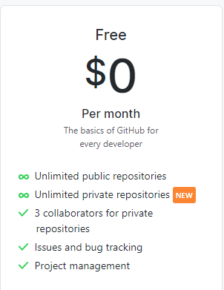

**2. GitHub Pro Features:**

With GitHub Pro, your personal account gets unlimited public and private repositories with unlimited collaborators.

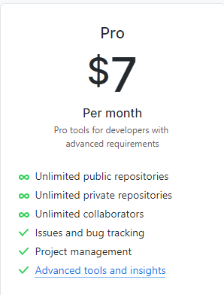

In addition to the features available with GitHub Free, private repositories on GitHub Pro include advanced tools and insights:

* Unlimited collaborators
* GitHub Pages

Build your own site from scratch or generate one for your project. You get one site per GitHub account and organization, and unlimited project sites.

* Wikis

You can host documentation for your repository in a wiki, so that others can use and contribute to your project.

* Protected branches

Repository administrators can enable protected branches for limiting branch manipulation, as well as enforce required status checks before a branch is merged in a pull request or before commits on a local branch can be pushed to the protected remote branch.

* Code owners

You can use a CODEOWNERS file to define individuals or teams that are responsible for code in a repository.

* Repository insights graphs: Pulse, contributors, traffic, commits, code frequency, network, and forks

Repository graphs help you view and analyze data for your repository. A repository's graphs give you information on traffic, projects that depend on the repository, contributors and commits to the repository, and a repository's forks and network. If you maintain a repository, you can use this data to get a better understanding of who's using your repository and why they're using it.

**3. GitHub Team for Open Source Features:**

With GitHub Team for Open Source, you can collaborate on unlimited public repositories with a full feature set and unlimited collaborators in a free organization.

**4. GitHub Team Features:**

With GitHub Team, organizations include

* Unlimited public and private repositories
* Unlimited collaborators
* Two-factor authentication enforcement

Organization owners can require organization members, outside collaborators, and billing managers to enable two-factor authentication for their personal accounts, making it harder for malicious actors to access an organization's repositories and settings.

* Team discussions

Your team can plan together, update one another, or talk about any topic you'd like in discussion posts on your team's page in an organization.

* Team access controls for managing groups

Teams give organizations the ability to create groups of members and control access to repositories. Team members can be granted read, write, or admin permissions to specific repositories.

* Advanced tools and insights:
* GitHub Pages
* Wikis
* Protected branches
* Code owners
* Repository insights graphs: Pulse, contributors, traffic, commits, code frequency, network, and forks
* Draft pull requests

GitHub has added a new feature to pull requests, allowing developers to mark their requests as a draft. Marking a request as a draft allows the developer to highlight to other collaborators that their code is a work-in-progress and requires feedback before being integrated into the main project.

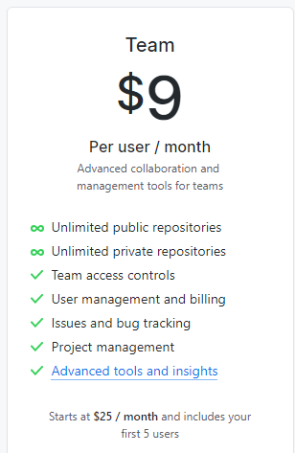

**5. GitHub Enterprise Features:**

GitHub Enterprise comes with two deployment options:

* cloud-hosted
* self-hosted

GitHub Enterprise Server is distributed as a virtual machine image that you install and manage within your existing infrastructure.

With GitHub Enterprise, you can use every feature available with GitHub Team, plus:

* Additional security, compliance, and deployment controls
* Authentication with SAML single sign-on
* Access provisioning with SAML or SCIM
* GitHub Connect

How is GitHub Enterprise different from GitHub.com?

GitHub Enterprise is the on-premises version of GitHub.com. It makes collaborative coding possible and enjoyable for large-scale enterprise software development teams.

GitHub Enterprise includes the same great set of features as GitHub.com but packaged for running on your organization's local network. All repository data is stored on machines that you control, and access is integrated with your organization's authentication system (LDAP, SAML, or CAS).

We can use GitHub Enterprise when you need complete control over repository and project information.

GitHub Enterprise Cloud also includes:

* A service level agreement for 99.95% monthly uptime
* A target eight-hour response time for priority support requests, Monday to Friday in your local time zone
* The option to centrally manage policy and billing for multiple GitHub.com organizations with an enterprise account.

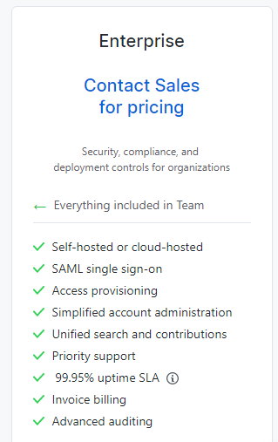

**Types of GitHub accounts:**

Our user account is our identity on GitHub. Your user account can be a member of any number of organizations. Organizations can belong to enterprise accounts.

* Personal user accounts
* Organization accounts
* Enterprise accounts

**1. Personal user accounts:**

Every person who uses GitHub has their own user account, which include:

* Unlimited public and private repositories with GitHub Free
* Additional features for private repositories with GitHub Pro
* Ability to invite repository collaborators

**2. Organization accounts:**

Organizations are shared accounts where groups of people can collaborate across many projects at once. Owners and administrators can manage member access to the organization's data and projects with sophisticated security and administrative features.

Organizations include:

* A free option, GitHub Team for Open Source, with unlimited collaborators on unlimited public repositories.
* The option to upgrade to GitHub Team or GitHub Enterprise Cloud for additional features, including private repositories, sophisticated user authentication and management, and escalated support options.
* Unlimited membership with a variety of roles that grant different levels of access to the organization and its data.
* The ability to give members a range of access permissions to your organization's repositories.
* Nested teams that reflect your company or group's structure with cascading access permissions and mentions
* The ability for organization owners to view members' two-factor authentication (2FA) status
* The option to require all organization members to use two-factor authentication

**3. Enterprise accounts:**

With enterprise accounts, you can centrally manage policy and billing for multiple GitHub.com organizations. Enterprise accounts are available with GitHub Enterprise Cloud.