PROJECT TWO DASHBOARD README
Derek Heiney
CS-340
2026-04-19

Project Overview

This project builds a MongoDB-backed dashboard for Grazioso Salvare so staff can identify dogs suited for rescue training. The dashboard includes branding, interactive rescue-type filters, a data table, a geolocation map, and a dynamic Pie chart.

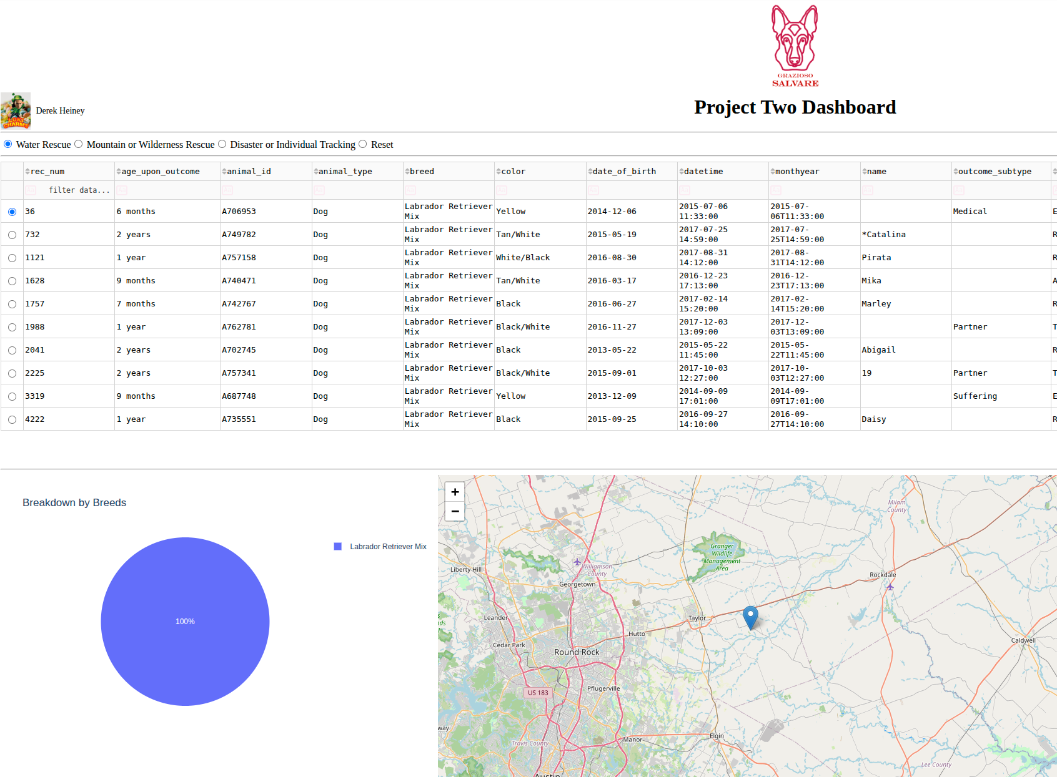

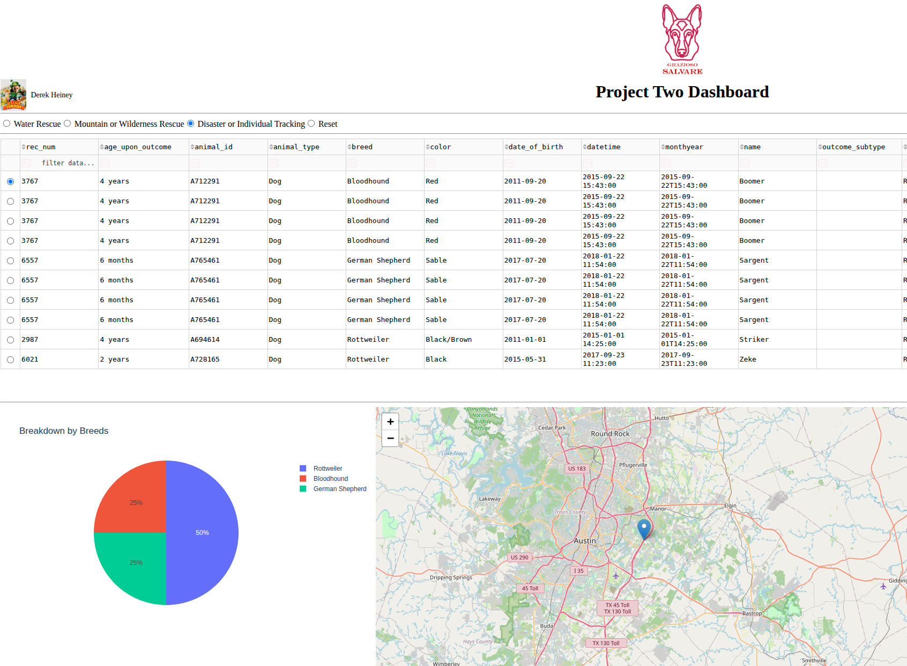

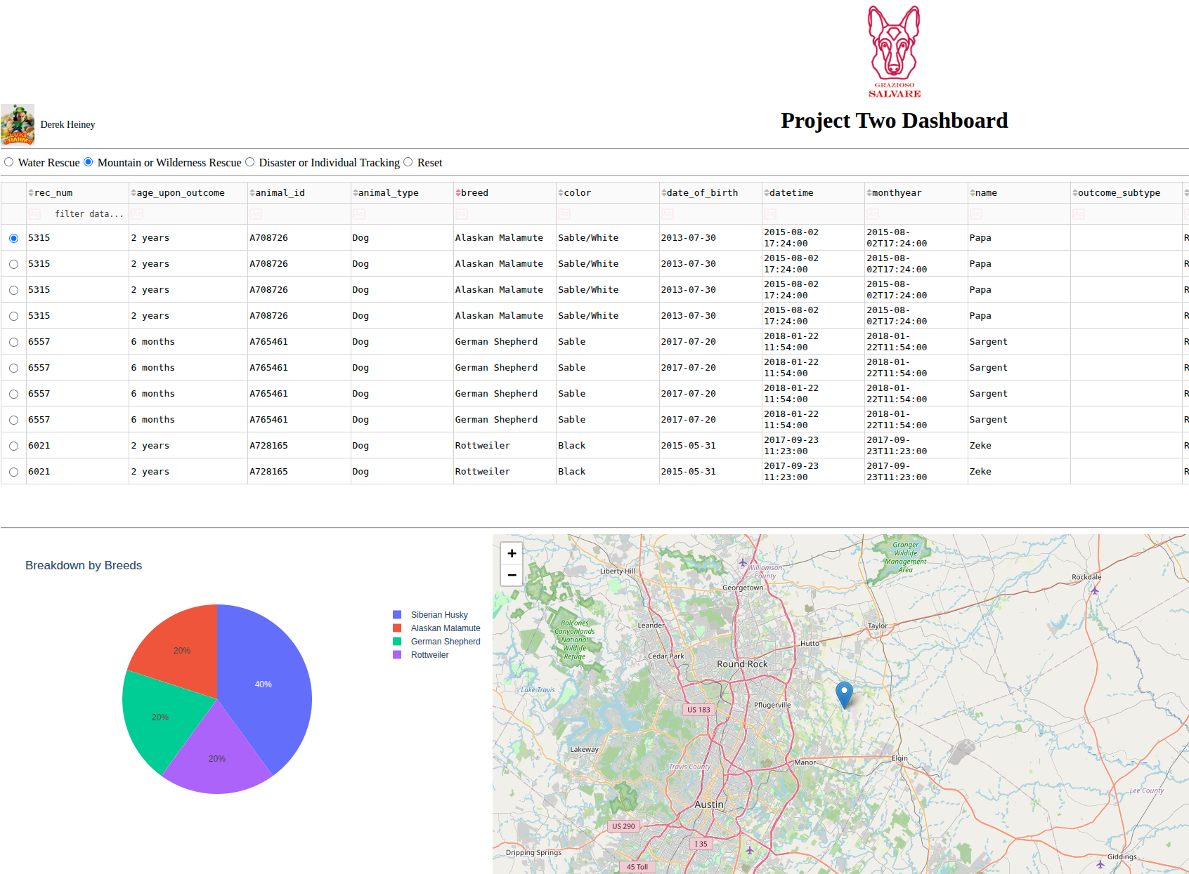

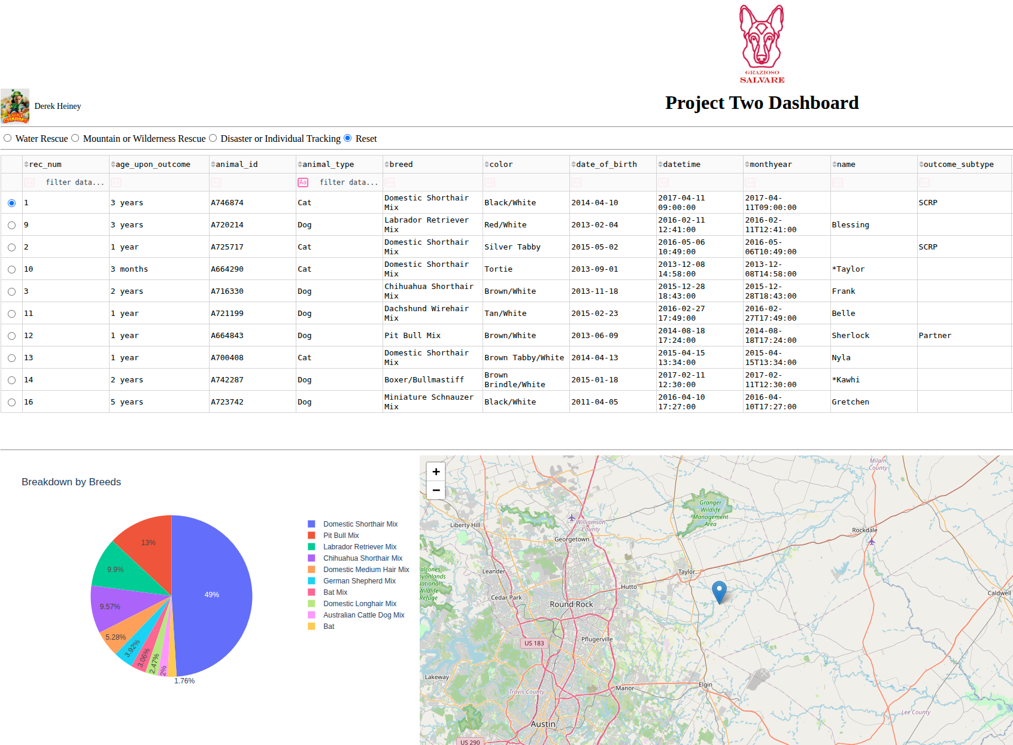

Required Functionality Implemented

- Grazioso Salvare logo with hyperlink to SNHU
- Unique identifier with creator name
- Filter options for:
- ***Water Rescue
- ***Mountain or Wilderness Rescue
- ***Disaster or Individual Tracking
- ***Reset (unfiltered)
- Interactive data table
- Geolocation map
- Breed Breakdown pie chart (Top 10)

Tools Used

- MongoDB: stores flexible JSON-like animal shelter records and works naturally with Python through PyMongo.
- PyMongo: used in the CRUD module to connect Python to MongoDB.
- Dash / JupyterDash: provides the dashboard interface and callback system.
- dash_table: used for the interactive data table.
- dash_leaflet: used for geolocation mapping.
- Plotly Express: used for the pie chart visualization.
- Pandas: transforms MongoDB query results into DataFrames for display.

Why MongoDB?

MongoDB is the model component in the MVC structure. It stores document-style records that map cleanly to Python dictionaries, which makes CRUD operations and dashboard filtering straightforward. This is especially useful for the Austin Animal Center data because the records are semi-structured and can be queried efficiently by breed, sex, age, and location.

Why Dash?

Dash provides both the view and controller portions of the dashboard. It makes it easy to connect filter widgets to tables and charts through callbacks. That helped keep the project clean and made the interface easier for the client to use.

Steps Completed

1. Imported the CRUD Python module from Project One.
2. Connected to the `aac.animals` MongoDB collection with the `aacuser` account.
3. Loaded all shelter records into a Pandas DataFrame.
4. Added rescue filter queries based on the dashboard specifications.
5. Created an interactive DataTable.
6. Added a breed pie chart that updates with the table data.
7. Added a leaflet map that updates from the selected table row.
8. Added the Grazioso Salvare logo and creator unique identifier.

Challenges and Fixes and Known Issues:

- Authentication errors: since the user credentials are hardcoded authSource was edited to avoid traceback errors
- Callback errors with empty data: added safeguards so the table, map, and chart still render when no rows are returned. (i.e. searching for “bat” or “turtle” when “Other” should be searched)
- Map crashes from missing coordinates: defaulted the map location to Austin when latitude or longitude is missing.
- hardcoded map center default (Austin) changed to float so map centered around selected animal
- Constructor mismatch: updated the CRUD module so `AnimalShelter()` works cleanly (again because of hardcoded values)
- Numerous callback errors: (map.ID.children and datatable-id.data) causing traceback errors: due to syntax coder errors. Editing numerous parts of the starter code I forgot to change queries which threw “not defined” errors
- Pie chart visualization clutter: added code to display top 10 breeds in unfiltered view (otherwise the chart created a “tearing” effect displaying every single breed in the CSV table (warp speed Mr Sulu)
- Initial upload had tons of unnecessary whitespace: changed header format to utilize Project header with unique identifier, adjusted image sizes, small font adjustments
- Known Issues: overall the dash has required functionality, however, it does not dynamically adjust to different resolutions, nor is there a lot of visual enhancements to make the page pop. Resetting the filters also takes a few seconds to reload the data set. Graphical design and code optimization passes are needed.

Files Included:

- `ProjectTwoDashboard.ipynb`
- `CRUD_Python_Module.py`

Run Instructions

1. Make sure MongoDB is running locally.
2. Make sure the `aac` database and `animals` collection are loaded.
3. Install required packages:
- `pymongo`
- `pandas`
- `dash`
- `jupyter-dash`
- `dash-leaflet`
- `plotly`
4. Place `CRUD_Python_Module.py` in the same folder as the notebook.
5. Open `ProjectTwoDashboard.ipynb` in JupyterLab.
6. Run the notebook cell to launch the dashboard.

