**ASSIGNMENT 1 FRONT SHEET**

|  |  |  |  |
| --- | --- | --- | --- |
| **Qualification** | **BTEC Level 5 HND Diploma in Computing** | | |
| **Unit number and title** | Unit 16: Cloud computing | | |
| **Submission date** |  | **Date Received 1st submission** |  |
| **Re-submission Date** |  | **Date Received 2nd submission** |  |
| **Student Name** | Nguyen Quoc Anh | **Student ID** | GCH18888 |
| **Class** | GCH0718 | **Assessor name** |  |
| **Student declaration**  I certify that the assignment submission is entirely my own work and I fully understand the consequences of plagiarism. I understand that making a false declaration is a form of malpractice. | | | |
|  |  | **Student’s signature** |  |

**Grading grid**

|  |  |  |  |  |  |  |
| --- | --- | --- | --- | --- | --- | --- |
| P1 | P2 | P3 | P4 | M1 | M2 | D1 |
|  |  |  |  |  |  |  |

|  |  |  |
| --- | --- | --- |
| **❒ Summative Feedback: ❒ Resubmission Feedback:** | | |
| **Grade:** | **Assessor Signature:** | **Date:** |
| **Internal Verifier’s Comments:** | | |
| **Signature & Date:** | | |

Contents

**A. INTRODUCTION** 5

**B. CLOUD COMPUTING** 6

**I. Fundamental concepts of Cloud Computing.** **1. What is the Cloud Computing.** 6

**2. Client / Server** 7

**3. P2P model** 9

**4.** **High Performance Computing** 12

4.1. Parallel Computing 13

4.2. Cluster Computing 14

4.3. Distributed Computing 15

**5. Deployment Models** 16

5.1. Private Cloud 16

5.2. Public Cloud 18

5.3. Hybrid Cloud 19

5.4 Community Cloud 20

**6. Service Model** 21

6.1 IAAS (Infrastructure as a Service) 21

6.2 SAAS (Software as a Service) 23

6.3 PAAS (Platform as a Service) 24

6.4 Typical Example for each model. 25

**7. Drivers Of Cloud** 27

7.1 Virtualization 27

7.2 Multicore 29

**8. Characteristic of cloud** 30

8.1 Multitenancy 30

8.2 Elasticity 31

8.3 Heterogeneous cloud platform 31

8.4 Quantitative measurement 31

8.5 On-demand service 31

**II. Evolution of Cloud Computing.** 32

**1. 1950-1960s: Mainframes And Terminals** 32

**2. 1970s: Virtual Machines** 32

**3. 1990s: The Web And Software-As-A-Service** 32

**4. 2000s: Infrastructure-as-a-Service And The Modern Cloud** 33

**5. 2020: High-Availability Cloud.** 33

**III. Solution** 33

**1. Scenario and solution** 33

**2. Deployment model** 34

**3. Service model.** 34

**4. Service Provider** 35

**5. Programming** 36

**6. Database** 38

**7. Other tools** 39

**8. Cloud Architecture** 39

**C. CONCLUSION** 40

References 41

Figure 1: Cloud computing 6

Figure 2: Cloud Computing 7

Figure 3: Interprocess communication among client and server (Oluwatosin, 2014) 8

Figure 4: File Transfer 8

Figure 5: Hypertext Transfer Protocol 9

Figure 6: Peer to peer model 10

Figure 7: Torrent Sharing Files Example with Utorrent App 11

Figure 8: Torrent Sharing Files 12

Figure 9: Cluster computing operation 15

Figure 10: Distributed Computing 16

Figure 11: Private Cloud 17

Figure 12: Greenwich CMS Read and submit file 17

Figure 13: Login Interface Of Greenwich CMS 18

Figure 14: Different between Private and Public cloud 18

Figure 15: Netflix Original Film By Year 19

Figure 16: Hybrid Cloud 20

Figure 17: Community Cloud 21

Figure 18: Magento Enterprise - Example for IAAS 26

Figure 19: Amazon Web Service - Example for PAAS 26

Figure 20: BigCommerce - Example for SAAS 27

Figure 21: Virtual Machine 28

Figure 22: Multicore Processor 29

Figure 23: Task Manager 30

Figure 24: The Different between 3 models (Hou, 2017) . 35

Figure 25: ASP.NET Azure SignalR Pricing detail [Microsoft, 2020] 38

Figure 26: Cloud Usage Monitor 39

# **A. INTRODUCTION**

In the 21th century, technology is more and more development. Technology has been applied to many side in life. High-tech products gradually replaced the traditional ways. Data need to storage are bigger and bigger. We can build physical servers for storage, but the cost of maintaining a physical uncle is not small. There are many problems with security as well as technology to deploy and use. For small organizations or small businesses, this is a big problem. But we have a new solution in place, cloud computing. In this report, i will introduce some information about Cloud Computing and also provide some solution for ATN’s company issues.

# **B. CLOUD COMPUTING**

## **I. Fundamental concepts of Cloud Computing.** **1. What is the Cloud Computing.**

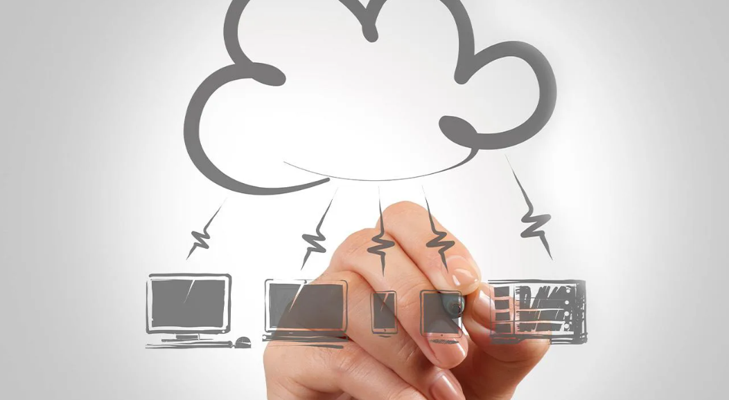

Figure 1: Cloud computing

Cloud computing is then related to technologies that have been around for ages. Finally, it is explained that cloud computing is the same old networking technology, but with the integration to the Internet a lot can be done differently with wider implications.

In the simplest terms, cloud computing means storing and accessing data and programs over the internet instead of your computer's hard drive. Ultimately, the "cloud" is just a metaphor for the internet. It goes back to the days of flowcharts and presentations that would represent the gigantic server-farm infrastructure of the internet as nothing but a [puffy cloud](https://www.wikiwand.com/en/Computer_network_diagram), accepting connections and doling out information as it floats (Anon., 2011).

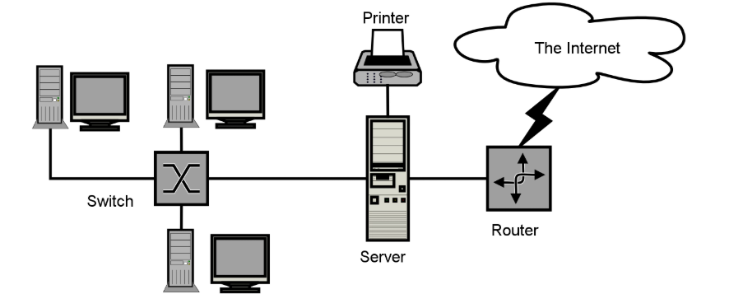

Figure 2: Cloud Computing

What cloud computing is not about is your hard drive. When you storage data or run a program from the hard driver, that's called local storage and computing. Everything you need is physically close to you. It’s meaning that very easy and very fast to you or anyone who also in the local network to access your data. But it’s not the same for other people who stay so far from you. But, storing data on a home or office network does not count as utilizing the cloud (Griffith, 2020).

For it to be considered "cloud computing," you need to access your data or your programs over the internet, or at the very least, have that data synced with other information over the web.

## **2. Client / Server**

**a) Definition**

In the computing world today, client-server system has become so popular because it is being used

virtually every day for different applications. Some of the standardized protocols that client and servers use to communicate with themselves include: File Transfer Protocol (FTP), Simple Mail Transfer Protocol (SMTP) and Hypertext Transfer Protocol (HTTP). Thus, Client-server system can be define as a software architecture made up of both the client and server, whereby the clients always send requests while the server responds to the requests sent. Client-server provides an inter-process communication because it involves the exchange of data from both the client and server whereby each of them performs different functions (Oluwatosin, 2014) .

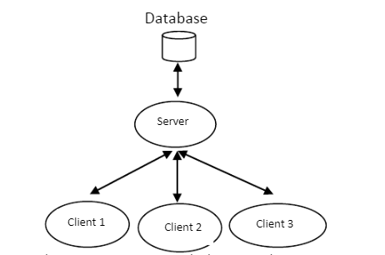

Figure 3: Interprocess communication among client and server (Oluwatosin, 2014)

**b) Pros**

* It splits the processing of application across multiple machines
* It allows easier sharing of resources from client to servers.
* It reduces data replication by storing data on each server instead of client.

**c) Example**

* File transfer: In FPT Greenwich, all student have to submit their assignment throught CMS website. All their submitted will be storage in server.

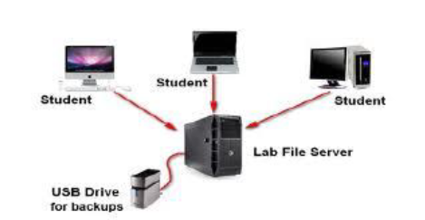

Figure 4: File Transfer

* HTTP– Hypertext Transfer Protocol: It’s the most polular example for Client/Server model. We will use a website as example.

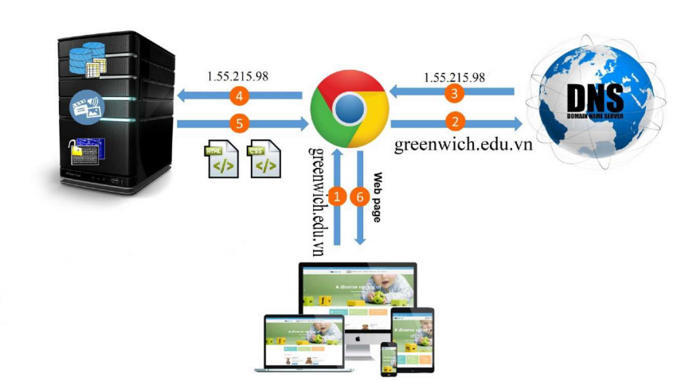

Figure 5: Hypertext Transfer Protocol

User enter a domain name to browser and in this example, it’s greenwich.edu.vn. Next, browser will send these domain name to the DNS server. DNS server will handle it then return ip address of website to browser. Browser will access to web server via this ip address. After get request from browser. Web server will return HTML,CSS,… file to browser. Lastly, Browser will translate that file and display them in our screen. Each user has accessed to server is a client.

## **3. P2P model**

**a) Definition**

According to (Choon Hoong Ding, 2018), Peer-to-peer (P2P) technologies have been widely used for content sharing, popularly called “file-swapping” networks. P2P is a computer network whose operation is based on the computing power and bandwidth of all participating machines, not like normal networks, the operation of the computer is usually based on a centralized server. It’s the group of computer and each computer can be used as a storage server. But in reality ,when a peer to peer network is established over the internet, we can use a central server can be used to index files or distribution can be setup. It’s help for each user can find what data they want. In the P2P, each computer is a client but also a server for other computer in network. Therefore, a peer to peer network is established when two or more computer have connected and shared data without a separate computer.

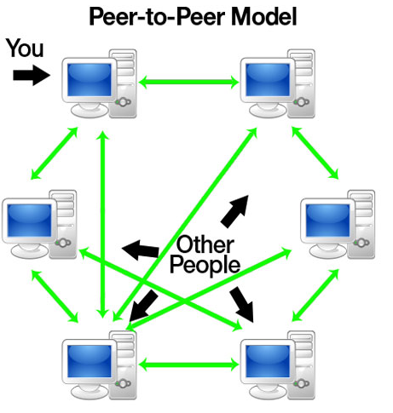

Figure 6: Peer to peer model

**b) Pros**

* All the computer joining the network can contribute information include bandwidth, data and processing power. The more computer involved, the more information which provided to the user.
* The computer in system act both client and server
* Depend on the distributed nature, the network still work if there are any computer has error.
* The software is easy to use and well integrated The software has many different supporting tools and Service functions The software supports network protocols such as SOAP or XML-RP

**c) Cons**

* requirements can be customized, so the results received are also different
* Requests will not be returned because there is no guarantee that a machine will be able to fulfill it.
* The resources will disappear because the node providing the resource is disconnected at any time.

**d) Example**

* **TorrentTransfer**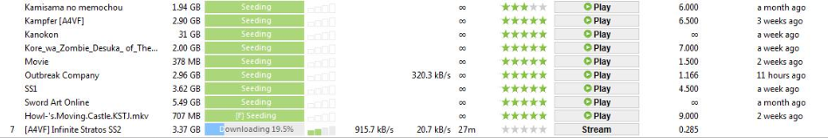

Figure 7: Torrent Sharing Files Example with Utorrent App

Torrent is type peer to peer sharing file technology. Which this technology, each user can connect and share their data without a website or source to download. Each user can download from many other user which has the same torrent. This Torrent, user can also download and upload for other user in the same time.

**How Torrent Works.**

**Peers:** All users participating in file sharing through torrent P2P sharing are called peers. They are supposed to be peers as long as they continue to share files on the network.

**Seeders:** A user who is downloading a file from a torrent and simultaneously uploading it for other users to use is called a seeder.

**Indexers:** There are a number of websites that act as a search engine for files and content will be downloaded through a torrent. These are called Indexers. Some well-known indexes are widely used Piratebay, Extratorrent or Torrentz.

**Trackers:** Trackers are servers that act as a bridge between peers. They connect from user to user and also help find peers online to download.

**Swarms:** A number of peers that download or upload the same torrent file are called swarms.

**Leechers:** Peers who download a file but restrict uploading from their machine or stop torrents as soon as their file is downloaded to prevent uploads are known as Leechers. Their purpose is not for other peers to download.

**BitTorrent** **Client:** One of the main requirements for a torrent is the presence of a client. Usually ‘uTorrent’ enables processing by combining segments from multiple seeders, assembling them and managing downloads.

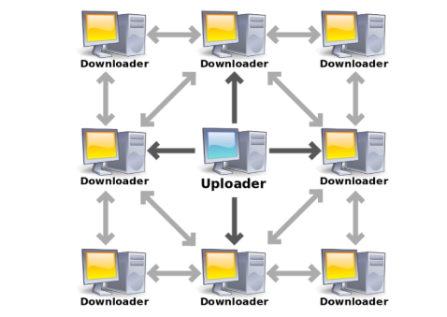

Figure 8: Torrent Sharing Files

**4.** High Performance Computing

a) Definition

High-performance computing (HPC) is the use of distributed computing facilities for solving problems that need large computing power. Historically, [supercomputers](https://www.sciencedirect.com/topics/computer-science/supercomputer) and clusters are specifically designed to support HPC applications that are developed to solve “Grand Challenge” problems in science and engineering. The general profile of HPC applications is constituted by a large collection of compute-intensive tasks that need to be processed in a short period of time. It is common to have parallel and tightly coupled tasks, which require low-latency [interconnection networks](https://www.sciencedirect.com/topics/computer-science/interconnection-networks) to minimize the data exchange time. The metrics to evaluate HPC systems are [floating-point operations](https://www.sciencedirect.com/topics/computer-science/floating-point-operation) per second (FLOPS), now tera-FLOPS or even peta-FLOPS, which identify the number of floating-point operations per second that a computing system can perform (Rajkumar Buyya, Christian Vecchiola and S. Thamarai Selvi, 2013).

**b) Pros**

* **High Performance**

High Performance Computing systems combines very high speed networ, parallel file systems and powerful hardware with clever design to utilize parallel computing on the cluster. This approach enables the system to perform calculations very fast. For the supported applications, a GPGPU card can speed up the calculations significantly.

* **Scalability**

Parallel nature of the HPC systems enables them to be scaled very easily and effortlessly. A well designed HPC Cluster can be scaled in a matter of minutes, depending on the number of nodes it contains. This easy scalability gives users a chance to start small and built their cluster up when they feel the need.

* **Stability**

Today most the World’s top HPC Clusters are built on top of Linux operating systems. This high level of utilization of Linux provides HPC systems, a very well designed & tested foundation to lay their cluster design on top. This rock solid foundation when combined with reliable hardware, redundant disks, redundant power supplies and more, delivers a very high uptime and a peace of mind.

**c) Cons**

* Base on the power of the HPC, it will be more difficult to implement and build. There is not the puzzle game. Therefore, choose the suitable accessories for HPC is very difficult. It might not fit or conflict with each other parts. Beside, it also difficult to find the suitable place to put HPC.
* After finish the implement phase, HPC need a experiened IT staff to manage the system and keep it running.
* Expensive: Lead to two cons above, a HPC system is very expensive for a personal. But it’s not cheapest for a group. The cost include price for implement, accessories, place, maintaince,…

**d) Example**

* [Research labs](https://www.netapp.com/pdf.html?item=/media/7459-ds-na-306-0618.pdf) . HPC is used to help scientists find sources of renewable energy, understand the evolution of our universe, predict and track storms, and create new materials.
* [Media and entertainment](https://www.netapp.com/pdf.html?item=/media/9243-ds-performance-e-series-solution.pdf) . HPC is used to edit feature films, render mind-blowing special effects, and stream live events around the world.
* [Oil and gas](https://www.netapp.com/pdf.html?item=/media/12621-hpc-oil-gas-use-case.pdf) . HPC is used to more accurately identify where to drill for new wells and to help boost production from existing wells.
* [Artificial intelligence](https://www.netapp.com/artificial-intelligence/what-is-artificial-intelligence) and [machine learning](https://www.netapp.com/artificial-intelligence/what-is-machine-learning). HPC is used to detect credit card fraud, provide self-guided technical support, teach self-driving vehicles, and improve cancer screening techniques.

(Anon., 2018)

### 4.1. Parallel Computing

Parallel computing refers to the process of breaking down larger problems into smaller, independent, often similar parts that can be executed simultaneously by multiple processors communicating via shared memory, the results of which are combined upon completion as part of an overall algorithm. The primary goal of parallel computing is to increase available computation power for faster application processing and problem solving (Chandrasekaran, 2014).

Parallel computing infrastructure is typically housed within a single datacenter where several processors are installed in a server rack; computation requests are distributed in small chunks by the application server that are then executed simultaneously on each server .

Parallel computer architecture exists in many types of parallel computers, classified according to the  
degree that hardware supports them in parallel. Parallel computer architecture and programming  
techniques work together to make effective use of these machines (Chandrasekaran, 2014).

Let's look at a simple example. Say we have this equation:

* *Y* = (4 x 5) + (1 x 6) + (5 x 3)

On a single processor, the steps needed to calculate a value for *Y* might look like:

* Step 1: *Y* = 20 + (2 x 6) + (4 x 3)
* Step 2: *Y* = 20 + 12 + (4 x 3)
* Step 3: *Y* = 20 + 12 + 12
* Step 4: *Y* = 44

But in a parallel computing scenario, with three processors or computers, the steps look something like:

* Step 1: *Y* = 20 + 12 + 12
* Step 2: *Y* = 44

### 4.2. Cluster Computing

Cluster computing refers to the fact that several machines on a network are related and operate as a single entity. A node is named for each device that is linked to the network. Cluster computing provides solutions by offering higher computational speed and better data integrity to solve complicated issues. The linked computers conduct operations together, producing the impression like a single machine (virtual machine). This mechanism is known as machine transparency. This networking technology carries out its operations based on the distributed systems theory. And here the connection unit is LAN. This process is described as the system's transparency. Cluster computing works with the characteristics of:

* The same kind of machines are all the related computers They are closely linked through dedicated network connections.
* A common home directory is used by all computers.

(WatElectronics, 2020)

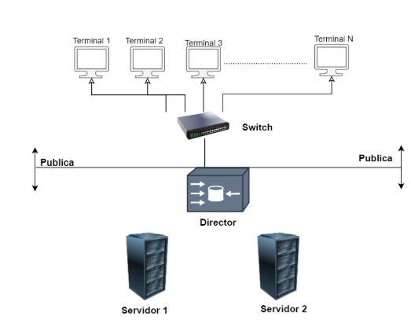

Figure 9: Cluster computing operation

### 4.3. Distributed Computing

Distributed computing (or distributed processing) is the method of linking several computer servers into a cluster over a network, exchanging information and coordinating processing power. Distributed computing provides advantages in scalability (through a' scale-out architecture'), efficiency (through parallelism), flexibility (through redundancy), and cost-effectiveness. Such a cluster is referred to as a' distributed system' (through the use of low-cost, commodity hardware) (Hazel, 2018).

As data volumes have exploded and demands for application performance have increased, in database and application design, distributed computing has become increasingly popular. This is why it is particularly useful for scaling so that the increased load can be managed by simply adding more hardware to the device as data volumes increase. Contrast this with conventional "big iron" environments consisting of powerful computer servers, in which upgrading and replacement of the hardware must manage load development (Hazel, 2018).

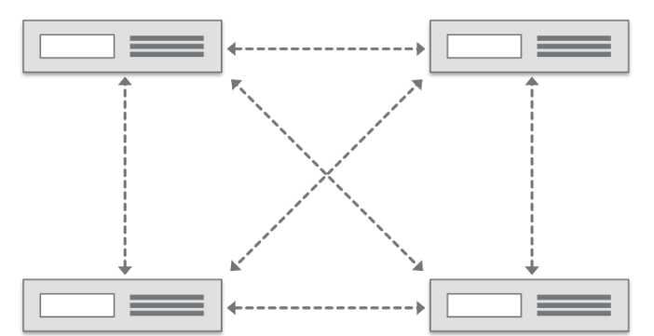

Figure 10: Distributed Computing

## **5. Deployment Models**

According to National Institute of Standards and Technology (NIST, the cloud computing characteristics as on-demand self-service, ubiquitous network access, resource pooling, rapid elasticity and pay per use. The rapid transition towards cloud computing has increased the demands for more deployment models. Selection of these models depends on clients’ data sensitivity and management requirements (P., Mell, T., Grance, 2009).

### 5.1. Private Cloud

Private cloud infrastructure is dedicated to a single particular organization or group. It is not shared with other organizations. Private cloud can be owned or leased. It may be managed by the organization or a third party and can exist at on-premises or off-premises. Private cloud is more expensive and secure when compared to public cloud (Savu, 2011). Private cloud is hosted inside the organization’s firewall. It can be accessed by users within the organization via intranet (Klančnik., 2011). Private clouds are flexible and service-based. Processes, services and data are managed within the organization. In private cloud there are no additional security regulations, legal requirements or bandwidth limitations that can be present in a public cloud environment, by using a private cloud, the cloud service providers and the clients have optimized control of the infrastructure and improved security, since user’s access and the networks used are restricted (P., Metri, G., Sarote., 2011).

* **When to use:** The private cloud is best suited for: Highly regulated industries and government agencies. Sensitive data. Companies that require strong control and security over their IT workloads and the underlying infrastructure

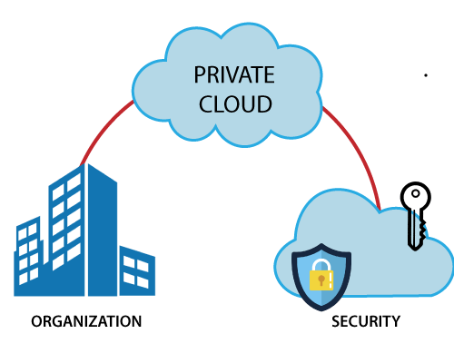

Figure 11: Private Cloud

For example:

Relate to the definition of private cloud: “Private cloud infrastructure is dedicated to a single particular organization or group”. We have a very close example of using private cloud, it’s Greenwich CMS System. This system is used for staff and student of Greenwich University In Vietnam. This thing is satisfy the condition “a single particular organization or group”. Student and Staff can interactive with this system through website or mobile apps. For Student, they have some features like show course list, course material, submit the assignment,



Figure 12: Greenwich CMS Read and submit file

Some security solution is also applied. It help that only member of GoU Vietnam can access to the data in this website.

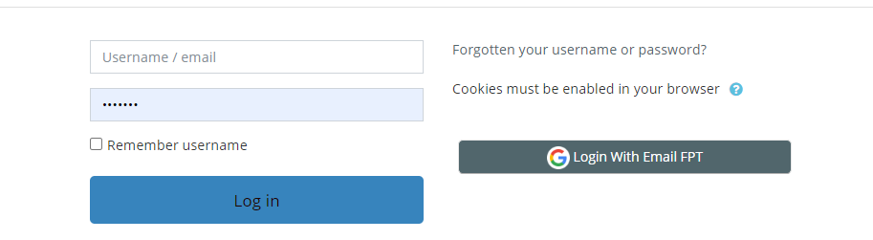

Figure 13: Login Interface Of Greenwich CMS

But, there is private cloud. Therefor, staff still need to login to another network (VPN, VPS,…) to accesss to the private data. It include salary, staff list with some personal information f…

### 5.2. Public Cloud

Public cloud (external cloud) infrastructure is offered via web applications as well as web services over the internet to the public or a large industry group and is owned by an organization selling cloud services as shown figure below.

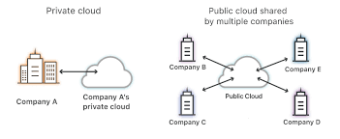

Figure 14: Different between Private and Public cloud

Public cloud provides an elastic, cost-effective way to deploy IT solutions. The term public doesn’t mean that users’ data is publicly visible. Public cloud involves applications such as customer relationship management (CRM), messaging and office productivity (Anon., 2011). Public cloud providers such as Google or Amazon offer an access control to their clients (P., Mell, T., Grance, 2009).

**When to use:** The public cloud is most suitable for these types of environments: Predictable computing needs, such as communication services for a specific number of users. Apps and services necessary to perform IT and business operations. Additional resource requirements to address varying peak demands.

**For example:** Public cloud is the most popular cloud type. In nowadays, we can see it in everywhere in internet. An application for that cloud is streaming video. Relate to the development of streaming, the number of people who using that service are increasing quickly. Resource size (in this example is video) also increased. According to the figure below. The number of original series of netflix in a year have increased 10 times compare with 2013.

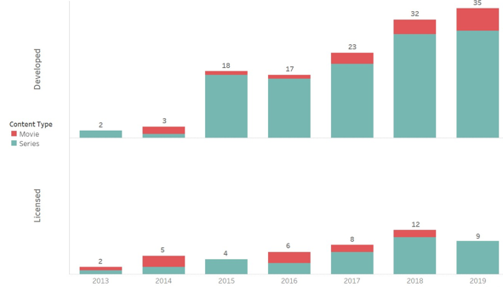

Figure 15: Netflix Original Film By Year

Therefore, Netflix and other business need a solution to storage them and they has completed its move to the public cloud, having shut down its last in-house data center and moved all its back-office services to the Amazon Web Services (AWS) public cloud . They can use cloud to extend their storage capacity but don’t need to care about some problem with the tradition storage.

### 5.3. Hybrid Cloud

This cloud deployment model exists due to mixed needs of an organization. It is combination of two or more cloud service deployment models (Private, Public, Community) as shown figure below (Klančnik., 2011). Organizations may host critical applications on private clouds and applications with relatively less security concerns on the public cloud. This cloud deployment model exists due to mixed needs of an organization. It is combination of two or more cloud service deployment models (Private, Public, Community) as shown figure below. Organizations may host critical applications on private clouds and applications with relatively less security concerns on the public cloud .A combination of a public and a private cloud is joined together for the purpose of keeping business-critical data and services in their control on private cloud and outsourcing less-critical processing to the public cloud (Metri, 2010).

**When to use:** Virtually anyone can benefit from using hybrid cloud, but medium-size businesses and enterprises are more apt to take advantage of its services. The cost can run more than public cloud alone, as private cloud solutions often do, but since you are limiting or eliminating independent software and hardware costs, it’s a more cost-effective solution than keeping just your own data center.

**For example:**

ViettelPost is one of the leading carriers today. The number of orders per day is extremely large, this requires the cloud system to always ensure the ability to store and allocate data. Since this is an enterprise under the Viettel group, they have the resources to build Private Cloud. However, during the holidays, when the number of transactions spikes, the use of the hybrid cloud will help access expanded resources from the Public Cloud. Because maintaining a private cloud system that is too large will incur a significant cost. Beside, ViettelPost some private information and must storage it in private cloud and some public information for other organization or personal like user, shipper,….

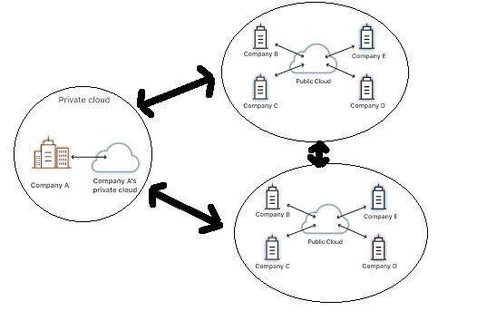

Figure 16: Hybrid Cloud

### 5.4 Community Cloud

Community cloud is a shared infrastructure by several organizations and supports a specific community that has shared concerns e.g., mission, security requirements, policy, and compliance considerations. It may be managed by the organizations or a third party and may exist at on-premises or off-premises (Anon., 2009). Community cloud offers higher level of privacy, security and policy compliances.

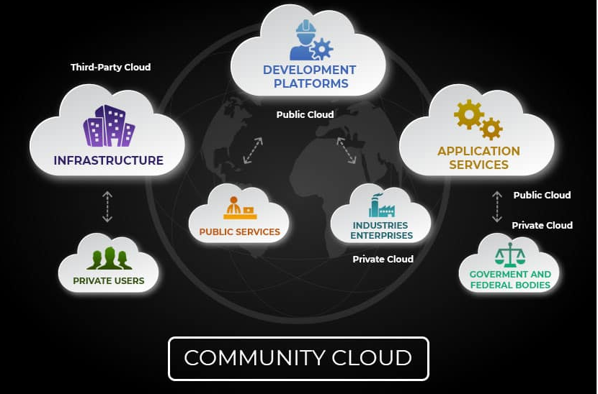

Figure 17: Community Cloud

**When to use:**

For example: A particular application that resides on one set of cloud servers may be requested by many organizations. The hosting company allows multiple customers to link into their environment and logically segment their sessions instead of providing each entity with their own cloud server for this app. The consumer, however also uses the same pieces of hardware that most people do. All, however, hits these servers for the same purpose—to access the single application—which is what makes it happen.

Maybe for example by Apple and AMD are cooperating to deploy Ryzen cpu in next generation macbook. They will have many test and need to exchange a lot of information including specifications, testing, development plan, statistics information, .... Therefore they will deploy a community cloud. It helps to simplify the exchange of information between two parties during the working process.

## 6. Service Model

### 6.1 IAAS (Infrastructure as a Service)

**a) Definition**

Cloud infrastructure services, known as Infrastructure as a Service (IaaS), are made of highly scalable and automated compute resources. IaaS is fully self-service for accessing and monitoring computers, networking, storage, and other services. IaaS allows businesses to purchase resources on-demand and as-needed instead of having to buy hardware outright [Watts, 2019]. Some example for IAAS are: DigitalOcean, Linode, Rackspace, Amazon Web Services (AWS), Cisco Metapod, Microsoft Azure, Google Compute Engine (GCE).

**b) Pros**

* IaaS offers many advantages, including:
* The most flexible cloud computing model
* Easy to automate deployment of storage, networking, servers, and processing power
* Hardware purchases can be based on consumption
* Clients retain complete control of their infrastructure
* Resources can be purchased as-needed
* Highly scalable

[Watts, 2019]

**c) Cons**

**Security.** Security threats can be init from the host or other virtual machines (VMs). While the user is in control of the apps, data, middleware, and the OS platform. Insider threat or system vulnerabilities can expose data communication between the host infrastructure and VMs to unauthorized entities (Watts, 2019).

**Internal resources and training.** To learn how to efficiently operate the infrastructure, additional resources and training may be needed for the workforce. For data protection, backup, and business continuity, users would be accountable. Due to inadequate control into the infrastructure however, monitoring and management of the resources may be difficult without adequate training and resources available inhouse.

**d) Characteristic of IAAS**

Characteristics that define IaaS include:

* Resources are available as a service
* Cost varies depending on consumption
* Services are highly scalable
* Multiple users on a single piece of hardware
* Organization retain complete control of the infrastructure
* Dynamic and flexible

**e) When to use IAAS**

IaaS is beneficial to businesses of all shapes and sizes, as it allows complete control over your infrastructure, and operates on a pay-as-you-use model, so it fits into most budgets. With most IaaS platforms, you get access to ongoing support and have the option of scaling up your requirements at any time. Utilizing IaaS is a great way to future-proof your business [Hou, 2017].

### 6.2 SAAS (Software as a Service)

**a) Definition**

Due to its web delivery model, SaaS eliminates the need to have IT staff download and install applications on each individual computer. With SaaS, vendors manage all potential technical issues, such as data, middleware, servers, and storage, resulting in streamlined maintenance and support for the business (Watts, 2019). Some example for SAAS are: Google Workspace, Dropbox, Salesforce, Cisco WebEx, Concur, GoToMeeting [Watts, 2019].

**b) Pros**

SaaS provides numerous advantages to employees and companies by greatly reducing the time and money spent on tedious tasks such as installing, managing, and upgrading software. This frees up plenty of time for technical staff to spend on more pressing matters and issues within the organization.

**c) Cons**

* **Lack of integration support:** Deep integrations must have for on-premise apps, data, and services in many organizations. The SaaS vendor may offer limited support in this regard, forcing organizations to invest internal resources in designing and managing integrations. The complexity of integrations can further limit how the SaaS app or other dependent services can be used (Watts, 2019).
* **Lack of control:**SaaS solutions entail the transition of power to a third-party service provider. In terms of version, changes, or presentation, these controls are not limited to the program, but also to the data and governance. Therefore, clients could need to redefine their data protection and governance models to suit the SaaS service's features and functionality.
* **Feature limitations.**Since SaaS apps often come in a standardized form, the choice of features may be a compromising tradeoff against security, cost, performance, or other organizational policies. Furthermore, vendor lock-in, cost, or security concerns may mean it’s not viable to switch vendors or services to serve new feature requirements in the future (Watts, 2019).

**d) SaaS Characteristics**

There are a few ways to help you determine when SaaS is being utilized:

* Managed from a central location
* Hosted on a remote server
* Accessible over the internet
* Users not responsible for hardware or software updates

**e) When to use SAAS**

Take for example, your email server. You want to know that you'll continue to send and receive emails without having to fiddle with your email settings or worry about updates. Imagine if your email server went down because you failed to update it and didn't have an email for days? In today's marketplace, that is simply not an option. If you are running your email inbox using a SaaS platform, the chances of anything going wrong are very small. And if something went wrong, then it would be up to the SaaS [Hou, 2017].

### 6.3 PAAS (Platform as a Service)

**a) Definition**

Cloud platform services, also known as Platform as a Service (PaaS), provide cloud components to certain software while being used mainly for applications. PaaS delivers a framework for developers that they can build upon and use to create customized applications. All servers, storage, and networking can be managed by the enterprise or a third-party provider while the developers can maintain management of the applications (Watts, 2019). Some example for PAAS are: AWS Elastic Beanstalk, Windows Azure, Heroku, Force.com, Google App Engine, Apache Stratos, OpenShift [Watts, 2019].

**b) Pros**

No matter the size of your company, using PaaS offers numerous advantages, including:

* Simple, effective development and deployment of apps.
* Scalable.
* Highly available.
* Developers can customize apps without the headache of maintaining the software.
* Automation of business policy.
* Easy migration to the [hybrid model](https://www.bmc.com/blogs/hybrid-cloud-vs-multi-cloud-whats-the-difference/).

**c) Cons**

* **Data security.**Organizations may use PaaS solutions to operate their apps and services, but data residing on third-party, supplier-controlled cloud servers poses security risks and concerns. As clients may not be able to deploy services with particular hosting policies, your security choices may be limited [Watts, 2019].
* **Integrations.**The complexity of connecting the data stored within an onsite data center or off-premise cloud is increased, which may affect which apps and services can be adopted with the PaaS offering. Particularly when not every component of a legacy IT system is built for the cloud, integration with existing services and infrastructure may be a challenge [Watts, 2019].
* **Runtime issues.**The difficulty of linking data stored in an on-site data center or off-site cloud is enhanced, which can affect the applications and services with the PaaS offering can be adopted. In particular, integration with existing services and infrastructure may be a challenge particularly when not every aspect of a legacy IT system is designed for the cloud [Watts, 2019].

**6) PAAS Characteristic**

PaaS has many characteristics that define it as a cloud service, including:

* Builds on virtualization technology, so resources can easily be scaled up or down as your business changes
* Provides a variety of services to assist with the development, testing, and deployment of apps
* Accessible to numerous users via the same development application
* Integrates web services and databases

**e) When to use PAAS**

For a developer, PaaS is also the most cost-effective and time-effective way of developing a specific application. As compared to menial tasks such as handling software updates or security fixes, PaaS enables the developer to concentrate on the innovative side of app creation. It will go into developing, testing, and launching the software all of their time and brainpower (Hou, 2017).

### 6.4 Typical Example for each model.

**a) IAAS**

Magento 1 Enterprise Edition can be either on-premise or IaaS depending on how the merchant chooses to host their store. In the case of IaaS, the merchant is paying Magento for the licensing of the software and then using a [third party vendor for the best web hosting](https://www.adamenfroy.com/best-web-hosting-services) such as Rackspace. Merchants are able to pay for a hosting plan that meets their own needs without the cost of maintaining their own physical servers. The merchant is still responsible for installing and managing updates to their Magento software.

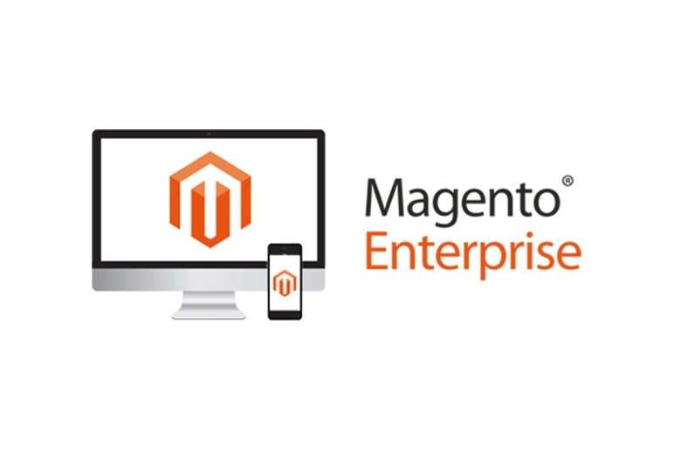

Figure 18: Magento Enterprise - Example for IAAS

**b) PAAS**

A good example of PaaS is [AWS Elastic Beanstalk](https://docs.aws.amazon.com/elasticbeanstalk/latest/dg/Welcome.html). Amazon Web Services (AWS) offers over 100 cloud computing services such as EC2, RDS, and S3. Most of these services can be used as IaaS, and most companies who use AWS will pick and choose the services they need. However, managing multiple different services can quickly become difficult and time-consuming for users.

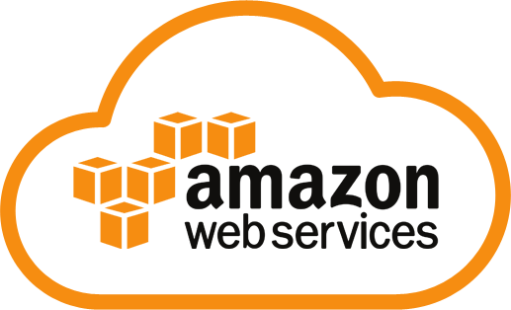

Figure 19: Amazon Web Service - Example for PAAS

**c) SAAS**

BigCommerce is an example of a [SaaS ecommerce platform](https://www.bigcommerce.com/articles/ecommerce/ecommerce-platforms/). The BigCommerce platform also has regular updates that automatically roll out for users, and all the software licenses, upgrades, and hosting costs are covered in the monthly subscription fee.



Figure 20: BigCommerce - Example for SAAS

## **7. Drivers Of Cloud**

### 7.1 Virtualization

**a) Definition**

Virtualization uses software to create an abstraction layer over the physical hardware. In doing so, it creates a virtual compute system, known as virtual machines (VMs). This allows organizations to run multiple virtual computers, operating systems, and applications on a single physical server. Simply put, it’s a more efficient use of the physical computer hardware; this, in turn, provides a greater return on a company’s investment. When we mention virtualization, we need to pay attention to 2 important things are VM (Virtual Machine) and hypervisor (Shamir, 2020).

* **Virtual Machine:** VM is a virtual representation of a physical device in the simplest terms possible. As described above, virtualization enables an enterprise to build several virtual machines on a single physical computer, each with its own operating system (OS) and applications. However a virtual machine can't communicate with a real device directly. Instead to communicate with the physical hardware on which it operates, it requires a lightweight software layer called a hypervisor.
* **Hypervisor**: For virtualization, the hypervisor is crucial; it is a thin software layer that enables several operating systems to operate side by side and share the same physical computing resources. These operating systems come as the aforementioned virtual machines (VMs), a real computer's virtual representations, and the hypervisor assigns each VM its own portion of the processing capacity, memory and storage underlying them.

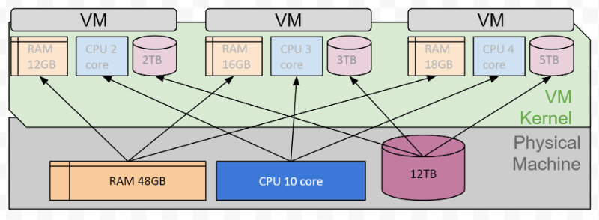

Figure 21: Virtual Machine

**b) Benefits of virtualization**

* **Slash your IT expenses**

Using a non-virtualized environment can be inefficient because when the application on the server is not consumed, the computer is idle and can not be used for other applications. That single physical server turns into many virtual machines when you virtualize an environment. These virtual machines can have various operating systems and run various applications, all of which are still hosted on a single physical server (Shamir, 2020).

* **Reduce downtime and enhance resiliency**

If a physical server is affected by a disaster, someone is responsible for replacing it or fixing it, which may take hours or even days. With a virtualized environment, it is easy to deploy and deploy, allowing you to replicate or clone the affected virtual machine. In contrast to the hours it would take to provide and set up a new physical server, the recovery process would take mere minutes, significantly improving the environment's resilience (Shamir, 2020).

* **Increase efficiency and productivity**

Your IT teams will be able to spend less time maintaining the physical hardware with fewer servers. Instead of going through the laborious and tedious process of applying server-by-server updates, you will be able to install, update and maintain the environment across all of the virtual machines on the server. Less time devoted to managing the atmosphere improves the effectiveness and efficiency of the staff (Shamir, 2020).

* **Control independence and DevOps**

Since the virtualized environment is segmented into virtual machines, your developers can quickly spin up a virtual machine without impacting a production environment. This is ideal for Dev/Test, as the developer can quickly clone the virtual machine and run a test on the environment (Shamir, 2020).

* **Move to be more green-friendly (organizational and environmental)**

When you are able to cut down on the number of physical servers you’re using, it’ll lead to a reduction in the amount of power being consumed. It reduces expenses for the business, and that money can be reinvested elsewhere and the carbon footprint of the data center (Shamir, 2020).

### 7.2 Multicore

**a) Definition**

The Central Processing Unit, or processor for short, is the brain of the computer. It is in charge of reading and executing the instructions. The directives here can be computation requests, data transfer between components, etc. Initially, the CPU had a single core, called a uniprocessor. When a system has more than one core, it is called multi-core. A CPU with two cores is called a dual-core processor, while a processor with four cores is called a quad-core processor. What's more, today's high-performance computers can have six to eight cores. Experts predict in the future can integrate dozens of cores, up to hundreds of cores on one chip (Dina R. Salem, M. Haggag, Mostafa Sami M. Mostafa, 2016).

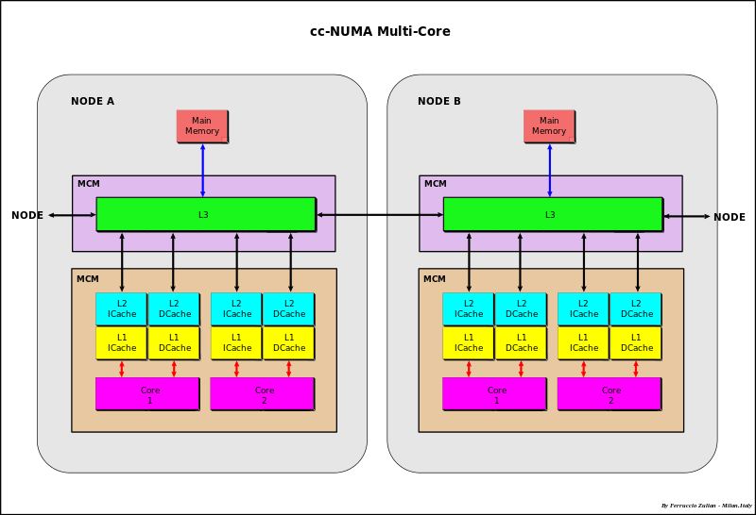

Figure 22: Multicore Processor

**b) Benefits of virtualization**

The main advantage of multi-core is that it has the ability to execute multiple instructions simultaneously on separate cores. It has low latency, the cores can communicate faster, since they are all integrated on the same chip, increasing overall speed as well as performing parallel computation. In general, multi-core is used for applications such as embedded systems, networking, Digital Signal Processing (DSP) and graphics (GPU).

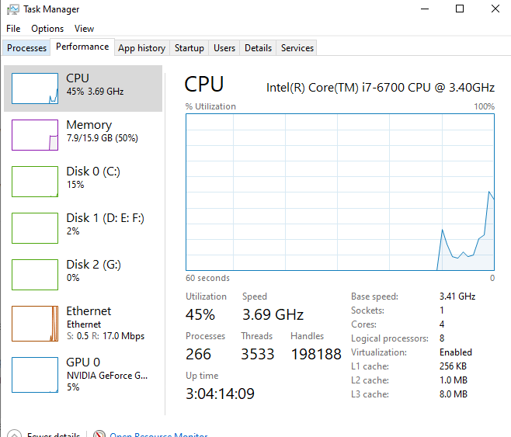

Figure 23: Task Manager

For example, the image above is the Task Manager app on Windows showing an actual system with 1 CPU (socket) and 4 cores. With Hyperthreading technology, which allows each core to execute 2 threads, thus displaying 8 logical processors, which means the system can execute 8 parallel processors.

## **8. Characteristic of cloud**

### 8.1 Multitenancy

In [cloud computing](https://www.cloudflare.com/learning/cloud/what-is-the-cloud/), multitenancy means that multiple customers of a cloud vendor are using the same computing resources. Despite the fact that they share resources, cloud customers aren't aware of each other, and their data is kept totally separate. Multitenancy is a crucial component of cloud computing; without it, cloud services would be far less practical. Multitenant architecture is a feature in many types of public cloud computing, including IaaS, [PaaS](https://www.cloudflare.com/learning/serverless/glossary/platform-as-a-service-paas/), [SaaS](https://www.cloudflare.com/learning/cloud/what-is-saas/), [containers](https://www.cloudflare.com/learning/serverless/serverless-vs-containers/), and [serverless computing](https://www.cloudflare.com/learning/serverless/what-is-serverless/) [Chandrasekaran, 2014].

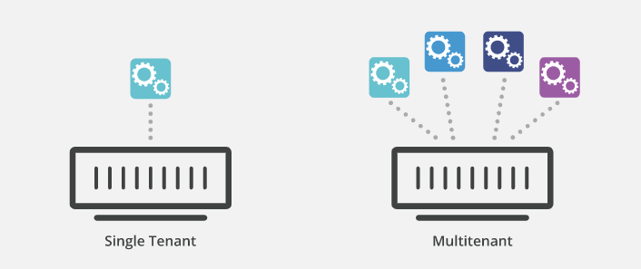

### 8.2 Elasticity

This capability allows to automatically expand or shrink the system according to the needs of the user quickly. As demand increases, the system automatically expands by adding resources. When demand decreases, the system will automatically reduce resources. The resilience helps the supplier to use resources efficiently, make full use of redundant resources, and serve many customers. For service users, scalability helps them reduce costs because they only pay for the resources they actually use [Chandrasekaran, 2014].

### 8.3 Heterogeneous cloud platform

A heterogeneous cloud, on the other hand, integrates public and private components from more than one vendor, either at:

* Different levels, such as a management tool from one vendor driving a hypervisor from another
* The same level, where a single management tool drives multiple hypervisors

For example, you’d choose a public cloud provider, like Azure, GCP, or AWS, and then pair it with a private offering like those from VMware, CloudStack, or OpenStack.

### 8.4 Quantitative measurement

Measured service: Cloud systems automatically control and optimize resource use by leveraging a metering capability at some level of abstraction appropriate to the type of service (e.g., storage, process- ing, bandwidth, and active user accounts). Resource usage can be monitored, controlled, and reported providing transparency for both the provider and consumer of the utilized service [Chandrasekaran, 2014].

### 8.5 On-demand service

On-demand self service refers to the service provided by cloud computing vendors that enables the provision of cloud resources on demand whenever they are required. In on-demand self service,the user accesses cloud services through an online control panel. On-demand self service resource sourcing is a prime feature of most cloud offerings where the user can scale the required infrastructure up to a substantial level without disrupting the host operations [Chandrasekaran, 2014].

# **II. Evolution of Cloud Computing.**

## **1. 1950-1960s: Mainframes And Terminals**

Let's start with mainframes in the 1950s. This makes it possible for multiple users to access a central computer through Points or terminals for entry. Nevertheless, because of the expense of purchasing and maintaining large computers (let alone Multiple computers), it is not cost efficient to arrange the procurement of terminals for each employee.

The Advanced Research Project Agency created ARPANET in the late 1960s, the forerunner of the The Web. It became a reality in 1969 by linking four university computers, each with different computers. Geographical points all over the United States. Initially, ARPANET was developed as a tool for the sharing of communication and computing resources between the four organizations' scientific departments, but It has evolved, as we know it today, on the internet.

## **2. 1970s: Virtual Machines**

Without the virtualization that enables us to operate several virtual servers on a physical server, scalable computing cloud services today would not be feasible. At IBM in the 1970s, the first glimmerings of virtualization were created. Mainframe owners may run virtual machines by using the VM operating system, just like we do today.

Interestingly, while the VM operating system was first released in 1972, 45 years ago, it is still in use today by mainframe companies. It’s often used to run virtual machines with Linux or a commercial Unix variant. As you might expect, virtualization has come a long way in the almost five decades since it was implemented. Today, the launch of multiple virtual servers on our laptops and enterprise-grade virtualization software such as VMWare, Xen and Microsoft Hyper-V is trivially simple.

## **3. 1990s: The Web And Software-As-A-Service**

The World Wide Web was[invented](http://info.cern.ch/hypertext/WWW/TheProject.html) in 1989 at CERN by Tim Berners-Lee, an English researcher. The first web browser was released a couple of years later.

The web was — and is — a technology for linking hypertext documents and other resources. The web rides atop the internet, and has been called the internet’s killer application. The development of the web led directly to the massive expansion of the internet, huge investment in networking technology, and a wave of social changes we’re still riding today.

Many larger organizations at this time used onpremises data centers, but in the late 90s and early 2000s, the data center industry boomed, and shared hosting and dedicated servers became the hosting platforms of choice.

It was also in this era that the first Software-as-a-Service applications were released. Salesforce, which used enhanced bandwidth and hosting technologies to provide enterprise-grade CRM software accessible by a web browser, was one of the first major successes in the SaaS space.

## **4. 2000s: Infrastructure-as-a-Service And The Modern Cloud**

The first recognizable[Infrastructure-as-a-Service](https://blog.servermania.com/what-is-iaas/) platforms became publicly available in 2006. Offering on-demand compute and storage, Amazon Web Services and its competitors radically changed the way businesses pay for, think about, and manage their infrastructure, as well as powering rapid innovation in the startup space.

Several years before the first Infrastructure-as-a-Service platforms were released, ServerMania was founded to provide inexpensive infrastructure hosting to small and medium businesses. Over the next decade and a half, ServerMania embraced virtualization and the cloud.

## **5. 2020: High-Availability Cloud.**

The deal between cloud providers and their customers when the cloud was first created was this: we provide the infrastructure, it's up to you to take the infrastructure and create a stable and regularly accessible platform for cloud computing. Most cloud vendors haven’t evolved much beyond that approach. Another tactic was to include a stable cloud computing platform such as the EC2 elastic computing cloud, but to conceal support behind paywalls and a complex control panel. For now, cloud server platform is fully redundant and highly accessible.

# **III. Solution**

## **1. Scenario and solution**

ATN is a Vietnamese company which is selling toys to teenagers in many provinces all over Vietnam. The company has the revenue over 700.000 dollars/year. Currently each shop has its own database to store transactions for that shop only. Each shop has to send the sale data to the board director monthly and the board director need lots of time to summarize the data collected from all the shops. Besides the board can’t see the stock information update in real time.

**Solution:** After researching and learning about the current system of ATN. I proposed to re-deploy the new system in the cloud. ATN's system is not too big but is thriving with steady sales of $ 700,000 per year. With the chain of stores spread across the country, the amount of information about goods as well as invoices and customers is increasing. Therefore, the upgrading of storage and handling of the system is extremely necessary. However, the deployment of physical servers requires a large amount of finance including the costs of IT staff and maintenance. The physical servers will also be difficult during extensive upgrades. But designing a large server unnecessarily will lead to waste of resources. Therefore, cloud is a good solution for ATN company.

## 2. Deployment model

Based on the characteristics of different models. I decided to use Public Cloud for ATN's project.

* Public cloud is very easy to deploy. There are many services provide in the market. Due to the competition among providers, the price will be much higher than other models. In addition, with reputable service providers, we will be assured of security as well as stability.
* In addition, the use of the public cloud simplifies maintenance. Therefore, the cost for maintaince is reduced.
* The scalability of the public cloud also helps in the growth and future expansion of the business.

## **3. Service model.**

Each cloud model offers specific features and functionalities, and it is crucial for your organization to understand the differences. Whether you need cloud-based software for storage options, a smooth platform that allows you to create customized applications, or complete control over your entire infrastructure without having to physically maintain it, there is a cloud service for you. No matter which option you choose, [migrating to the cloud](https://www.bmc.com/blogs/new-multi-cloud-world-means/) is the future of business and technology.

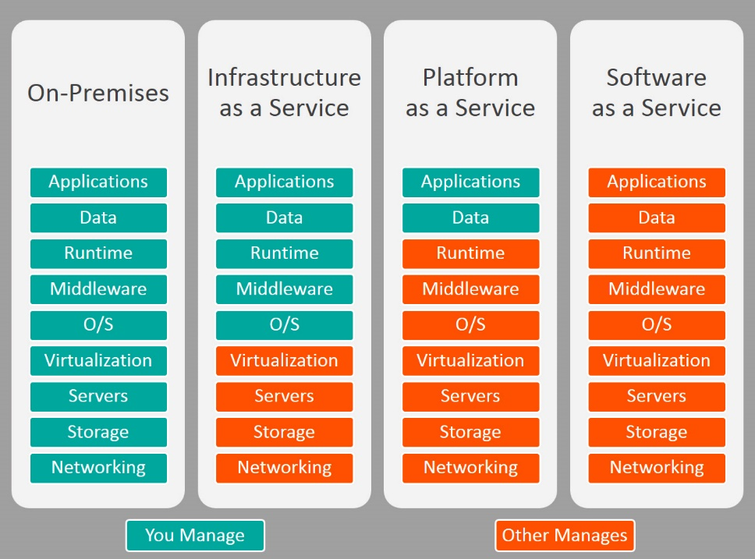

Figure 24: The Different between 3 models (Hou, 2017) .

After considering the advantages and disadvantages of all 3 models. Besides, I also calculated about the demand and economy of ATN and decided to use Platform as a Service model in this project. Compare to the PAAS. With SASS, User is not responsible for hardware and software updates. Everything is setting up by provider include website,server,…. They also have responsible for maintaince and implement. But it will make increase the costs. Beside, SASS restricts the user's ability to set and customize. Other way, we can custom our website and data when we use PAAS. It’s better because ATN's staff are the ones who know their system best. They know best what they need and what they need to do. With PAAS, they can custom their system. In-house software application gives businesses a higher degree of control than hosted solutions where control resides with a third party. If we want to link SaaS to existing local applications face software integration challenges. The internal APIs en data structures they may not integrate properly with the external software. But with PAAS, we can easier to sync it.

PAAS meeting most of ATN's current needs and the requirement of business. In addition, a web application deployed on tools can cut the time it takes to code new apps. It help developer can easier to develop and deploy applications.

## 4. Service Provider

The next thing I need to consider is to choose a service provider. Nowadays, there are many Service Provider around the world such as Microsoft, Google, Heroku, and so on. And I decided to use Heroku as our service provider.

Heroku is a platform as a service based on a managed container system, with [integrated data services](https://www.heroku.com/managed-data-services) and a powerful ecosystem, for deploying and running modern apps. The Heroku developer experience is an app-centric approach for software delivery, integrated with today’s most popular developer tools and workflows. Heroku has many advantages including:

* Simplicity: It makes deployment, environment configuration, and simple manageability extraordinarily simple and easy to do, and getting up and going is a wonderfully simple process. For beginners, Heroku is an excellent tool, making initial deployment and environment configuration wonderfully easy and fast.
* Stability: Heroku is highly stable because it has a team of leading experts in the field always checking to ensure the system is always working 24/7. In case of errors arising during the operation, users will also be consulted and corrected as soon as possible.
* Security: Due to holding a large customer base with important data, heroku has invested heavily in security with top security experts. In fact, the vast majority of Heroku users have little or no systematic security issues. However, the security issue still needs attention because hackers have different ways to attack instead of targeting Heroku
* Scalability: Because this is a public cloud, it is feasible to expand whenever the business has a need. As the amount of work and resources increases, memory upgrades or processor power do not affect the current system's performance.

All advantages about is the same for other popular service provider. So I will provide more reason to choose heroku over other service provider.

Let’s compare with AWS (Amazon Web Service), a other poluar service provider. Cost is always one of the problems for small companies, and the same goes for ATN. After consulting several forums, I found aws a lot of billing scandals. In addition to the expensive costs to implement a project, AWS will also incur many other costs during use. In many cases, this is out of control. But in heroku, all pricing detail is provided and all of them are transparent.

The second downside of AWS is its resource limitations by region. So your location or your region can determine the amount of resources you will have access to.

The Third, Heroku can meet low computational demands, it fit with the needs of ATN. Because our system only use for storage and transfer data about goods, statistics data like bills, documents,… But AWS can meet high/very high computational demands and it lead to waste.

The Last, Heroku offers you a ready-to-use environment, it help us push code and make a few configuration changes before running in as soon as possible whereas aws is quite hard to deploy. ATN's systems need to operate continuously, so the long implementation will lead to business stall. Therefore, deploying the system on heroku will minimize the impact on your business.

## 5. Programming

After considering the programming language for this project, I will use NodeJs for some reason.

Let’s compare with the ASP.NET, a other popular language for server-side. In this case, Nodejs have many other advantages like

* Nodejs has written by javascript, so it has big ecosystem when developed and supplemented by the community . With such a vast variety of free tools accessible in a few clicks, there is a huge potential for the use of Node.js. At the same time, [open source software](https://www.altexsoft.com/blog/engineering/how-to-use-open-source-software-features-main-software-types-and-selection-advice/) enjoys growing popularity as it allows you to build new solutions reducing the overall costs of development and time to market.
* Synchronism: Nowadays, we have a lot technology and framework in client side like React, AngularJS, VueJS. All of them are written by javascript also. Therefore, Using nodejs keeps your code consistent and in sync with the languages on the client side
* Nodejs runs cross-platform on the Server side, using Event-driven architecture, non-blocking I / O mechanism to make it lightweight and efficient.

ATN is small company with $700.000 / year. Therefor development costs are limited. Using nodejs has more economic value than ASP in the following point. Nodejs is a open-source so it is completely free, while for ASP.NET you have to pay for certain features. To use ASP.NET, you will have to purchase the Windows operating system. Another cost consideration is the development environment. The most popular IDE for ASP.NET development is Visual Studio. Microsoft offers a free version called Visual Studio Express for beginners but not experts. Nodejs has the advantage that it's free, runs on a Linux web server, can be used with Windows, Mac or Linux, and is supported by multiple IDEs (Visual Studio Code for our solution).

In the scenario, we can see that ATN has some problem in send the sale data to the board director monthly and the board director need lots of time to summarize the data collected from all the shops. With nodejs, it supports response depending on the event-driven server that assists in non-blocking functioning. So data transmission shifts quickly. We can call it is real-time application. Nodejs is one of the best choices for real-time app and web. ASP can also run real-time apps with Azure SignalR, but you will have to pay extra fees or have limited functionality.

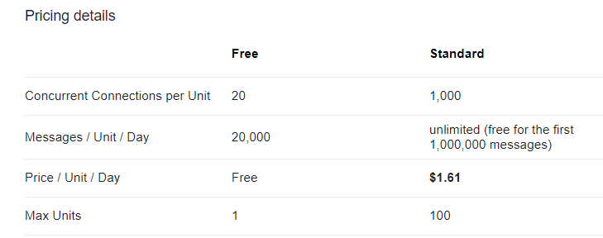

Figure 25: ASP.NET Azure SignalR Pricing detail [Microsoft, 2020]

## **6. Database**

There are many database systems supported by nodejs. We can have some selection like mysql,mongodb,… **But in this project, I will use Mongodb for the following reason:**

MongoDB is one of the most popular NoSQL open source databases known in C ++. As of February 2015, MongoDB is ranked 4th among the most popular database systems. It was developed by the 10gen company later known as MongoDB Inc.

ATN has many stores over the country and data volume is quite large, assuming our web application has 10 million records, it is quite difficult to query with Mysql. Choose MongoDB because MongoDB can find related information quite quickly, so we should use it in this case. Because, Mysql is a relational database so sql queries have many drawbacks with a large number of records.

Due to the nature of the system, the data stored in the ATN system is highly variable. This is dependent on each record, consistency, or data integrity characteristic for relational database systems. But with NoSQL, it is possible to freely expand data without worrying about a foreign key or primary key, or tasks such as constraint checking like a traditional database management system.

MongoDB is a document-oriented database that stores data in JSON-format documents with a very flexible dynamic schema. That means you can save records without worrying about the data structure such as the number of fields and the type of the stored field. MongoDB documents are similar to JSON objects. As I mentioned above, Nodejs is very powerful in handling JSON format data files.

## 7. Other tools

Besides, I also use some tools included in project development.

* Github: This is the software that helps me manage and synchronize source code. Help control and track workflow. Besides, github also helps a lot in teamwork.
* Visual Studio Code: This is one of the most popular code editors currently. It features light and easy to use and many plugins developed by the community.
* Visual Paradigm: Visual Paradigm: This is a program that helps programmers to conceptualize the program with diagrams such as Entity relationship diagram, class diagram, flowchart.

## 8. Cloud Architecture

Cloud Usage Monitor

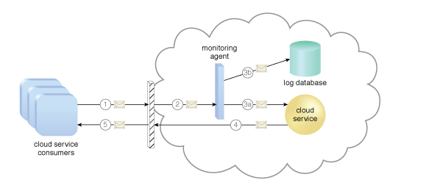

Figure 26: Cloud Usage Monitor

**Cloud Usage Monitor**

The cloud usage monitor mechanism is a lightweight and autonomous software program responsible for collecting and processing IT resource usage data. Depending on the type of usage metrics they are designed to collect and the manner in which usage data needs to be collected, cloud usage monitors can exist in different formats. The upcoming sections describe three common agent-based implementation formats. Each can be designated to forward collected usage data to a log database for post-processing and reporting purposes.

**Monitoring Agent**

A monitoring agent is an intermediary, event-driven program that exists as a service agent and resides along existing communication paths to transparently monitor and analyze dataflows. This type of cloud usage monitor is commonly used to measure network traffic and message metrics.

**Resource Agent**

A resource agent is a processing module that collects usage data by having event-driven interactions with specialized resource software. This module is used to monitor usage metrics based on pre-defined, observable events at the resource software level, such as initiating, suspending, resuming, and vertical scaling.

(1). A cloud service consumer sends a request message to a cloud service

(2) The monitoring agent intercepts the message to collect relevant usage data before allowing it to continue to the cloud service

(3a). The monitoring agent stores the collected usage data in a log database

(3b). The cloud service replies with a response message

(4) That is sent back to the cloud service consumer without being intercepted by the monitoring agent.

# **C. CONCLUSION**

In this report, I have introduce some concept of Cloud computing include some definition about cloud computing like service model, deployment model and 5 main characteristic of cloud. Beside some related technologies such as hypervisor and virtual machine and two network model are P2P and Client have been mentioned. In the next part, i’ve provided some information about history of cloud computing when start of cloud computing till nowadays. In the last part of report, I have provided a solution for issue of ATN company. It include deployment model, service model, service provider, programming language, database and other tools suitable for ATN company's situation. Solution include

* The deployment model: Public cloud
* The service model: PAAS (Platform as a service).
* The service provider: Heroku
* The programming language: NodeJS
* Database: Postgre (in Heroku) and MongoDB in local.
* Other tool: Visual Studio Code, Github, Visual Paradigm.

# References

Anon., 2009. *Security Guidance for Critical Areas of Focus in Cloud Computing.* [Online]   
Available at: http://www.cloudsecurityalliance.org/guidance/csaguide.v1.0.pdf   
[Accessed 12 9 2020].

Anon., 2011. *HPC in the Cloud: Frost & Sullivan: Australia Leads Asia Pacific Adoption of Cloud Computing.* [Online]   
Available at: http://www.hpcinthecloud.com/hpccloud/2011-05 30/frost_sullivan_australia_leads_asia_pacific_adoption_of_cloud_computing.html   
[Accessed 9 12 2020].

Anon., 2018. *netapp.* [Online]   
Available at: https://www.netapp.com/data-storage/high-performance-computing/what-is-hpc/  
[Accessed 8 12 2020].

Anon., n.d. [Online]   
Available at: https://www.javatpoint.com/private-cloud  
[Accessed 12 8 2020].

Anon., n.d. [Online]   
Available at: https://www.cloudflare.com/learning/cloud/what-is-multitenancy/  
[Accessed 9 12 2020].

Chandrasekaran, K., 2014. *Essentials of Cloud Computing.* s.l.:CPC Press.

Choon Hoong Ding, S. N. a. R. B., 2018. *Grid Computing and Distributed Systems Laboratory,,* Melbourne, Australia: s.n.

Dina R. Salem, M. Haggag, Mostafa Sami M. Mostafa, 2016. *Multi-core Processors in Cloud Computing using Cloudsim.* New York: s.n.

Griffith, E., 2020. *pcmag.* [Online]   
Available at: https://sea.pcmag.com/networking-communications-software/2919/what-is-cloud-computing  
[Accessed 8 12 2020].

Hazel, 2018. *What Is Distributed Computing?.* [Online]   
Available at: https://hazelcast.com/glossary/distributed-computing/  
[Accessed 9 12 2020].

Hou, T., 2017. *IaaS vs PaaS vs SaaS Enter the Ecommerce Vernacular: What You Need to Know, Examples & More.* [Online]   
Available at: https://www.bigcommerce.com/blog/saas-vs-paas-vs-iaas/#the-three-types-of-cloud-computing-service-models-explained  
[Accessed 9 12 2020].

Klančnik., T., 2011. *NIL - In the Core of the Cloud.* [Online]   
Available at: http://www.nil.si/ipcorner/CoreCloud/  
[Accessed 8 12 2020].

Metri, 2010. Privacy Issues and Challenges in Cloud Computing. In: *International Journal of Advanced Engineering Sciences and Technologies (IJAEST).* s.l.:s.n., pp. 1-6.

Oluwatosin, H. S., 2014. *researchgate.* [Online]   
Available at: https://www.researchgate.net/publication/271295146_Client-Server_Model  
[Accessed 12 8 2020].

P., Metri, G., Sarote., 2011. Privacy Issues and Challenges in Cloud Computing. In: *International Journal of Advanced Engineering Sciences and Technologies (IJAEST).* s.l.:s.n., pp. 5-6.

P., Mell, T., Grance, 2009. *The NIST definition of cloud computing.* [Online]   
Available at: http://csrc.nist.gov/groups/SNS/cloud-computing/cloud-def-v15.doc  
[Accessed 8 12 2020].

Rajkumar Buyya, Christian Vecchiola and S. Thamarai Selvi, 2013. *Mastering Cloud Computing.* s.l.:Elsevier.

Savu, L., 2011. Cloud Computing: Deployment Models, Delivery Models, Risks and Research Challenges. In: *Computer and Management.* s.l.:s.n., pp. 1-4.

Shamir, J., 2020. *5 Benefits of Virtualization.* [Online]   
Available at: https://www.ibm.com/cloud/blog/5-benefits-of-virtualization  
[Accessed 9 12 2020].

WatElectronics, 2020. *Cluster Computing : Architecture & Its Types.* [Online]   
Available at: https://www.watelectronics.com/cluster-computing-architecture-its-types/  
[Accessed 9 12 2020].

Watts, S., 2019. *SaaS vs PaaS vs IaaS: What’s The Difference & How To Choose.* [Online]   
Available at: https://www.bmc.com/blogs/saas-vs-paas-vs-iaas-whats-the-difference-and-how-to-choose/  
[Accessed 9 12 2020].