**BATTERY MANAGEMENT SYSTEM (BMS) REQUIREMENT**

"Copyright 2018 - 2019 The MathWorks, Inc."

# Overview

This document describes a requirement specification for Battery Management System (BMS). The BMS system provides functionalities to control the battery pack.

# BMS Interfaces

## BMS Inputs

|  |  |  |  |
| --- | --- | --- | --- |
| **Name** | **Data type** | **Units** | **From** |
| StateRequest | enum | / | CAN |
| Cell_Voltages | single | V | Sensors |
| Cell_Temperatures | single | K | Sensors |
| Pack_Voltage | single | V | Sensors |
| Pack_Current | single | A | Sensors |
| Vout_Chgr | single | V | Sensors |
| Vout_Invtr | single | V | Sensors |

### Cell_Voltages

BMS shall measure voltage across each cell block (cells in series) at sample rate of 10Hz.

### Cell_Temperatures

BMS shall measure battery cell Temperatures (Cell_Temperatures)

### Pack_Current

BMS shall measure current flowing through battery pack at sample rate of 10Hz. Pack_Current > 0 indicates battery pack charging. Pack_Current < 0 indicates battery pack discharging.

### Pack_Voltage

BMS shall measure voltage across Pack terminals (+Ve Batt and -Ve Batt) at sample rate of 10Hz.

### Vout_Chgr

BMS shall measure terminal voltage at charger contactor (Vout_Chgr).

### Vout_Invtr

BMS shall measure terminal voltage at Inverter contactor (Vout_Invtr)

### StateRequest

BMS shall read State Request from CAN Bus (StateRequest)

## BMS Outputs

|  |  |  |  |
| --- | --- | --- | --- |
| **Name** | **Data type** | **Units** | **To** |
| SOC | boolean | % | CAN |
| BMS_State | boolean | enum | CAN |
| Current Limits | single | A | Other BMS modules / Plant (DriveLoad) |
| BalCmd | boolean | / | Plant (DriveLoad) |
| ChargeCurrentReq | boolean | / | Plant (Charger) |
| PosContactorChgrCmd | boolean | / | Plant (BatteryPack CellMonitoring) |
| PreChargeRelayChgrCmd | boolean | / | Plant (BatteryPack CellMonitoring) |
| NegContactorChgrCmd | boolean | / | Plant (BatteryPack CellMonitoring) |
| PosContactorInvtrCmd | boolean | / | Plant (BatteryPack CellMonitoring) |
| PreChargeRelayInvtrCmd | boolean | / | Plant (BatteryPack CellMonitoring) |
| NegContactorInvtrCmd | boolean | / | Plant (BatteryPack CellMonitoring) |

### SOC

State of Charge

### BMS_State

(State: Standby-Charging-Discharging-Fault)

### Current Limits

(Limits for Charge and Discharge

### BalCmd

(Command to balance the battery cells)

### ChargeCurrentReq

(Current request during charging)

### PosContactorChgrCmd (

Command for contactor on the Positive pole of the charger)

### PreChargeRelayChgrCmd

(Command for contactor for pre-charge of the charger)

### NegContactorChgrCmd

(Command for contactor on the Negative pole of the charger)

### PosContactorInvtrCmd

(Command for contactor on the Positive pole of the inverter)

### PreChargeRelayInvtrCmd

(Command for contactor for pre-charge of the inverter)

### NegContactorInvtrCmd

Command for contactor on the Positive pole of the Inverter)

# BMS Architecture and module specifications

BMS software must be divided in 4 modules:

1. Main State Machine
2. Current Power Limits Calculation
3. SOC Estimation
4. Balancing Logic

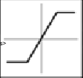 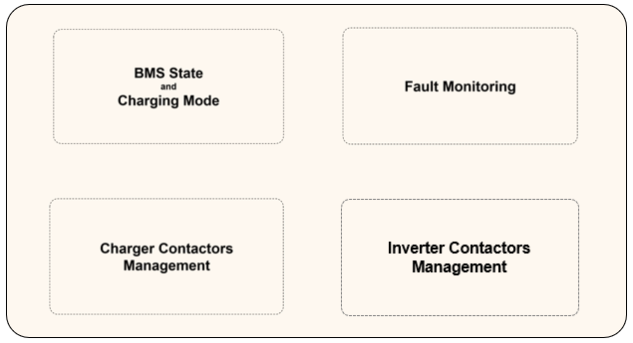

 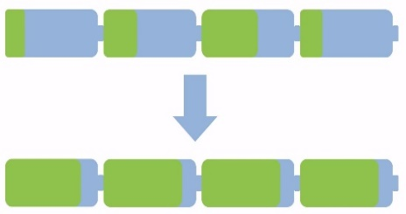

## BMS - Main State Machine

The Main State Machine has 4 main functionalities:

* Manage the BMS status evolution on driving requests and safety
* Calculate the correct charging mode
* Monitors current, voltage and temperature faults for safety
* Securely close and open the contacts to the charger e inverter



### BMS Main State Machine: Interfaces

#### Inputs

|  |  |  |  |
| --- | --- | --- | --- |
| **Name** | **Data type** | **Units** | **From** |
| StateRequest | Enum | / | CAN |
| Cell_Voltages | Single | V | Sensors |
| Cell_Temperatures | Single | K | Sensors |
| Pack_Voltage | Single | V | Sensors |
| Pack_Current | Single | A | Sensors |
| Vout_Chgr | Single | V | Sensors |
| Vout_Invtr | Single | V | Sensors |
| Current Limits | Single | A | Other BMS modules |
| Max Cell Voltage | Single | V | From other BMS modules |
| Min Cell Voltage | Single | V | From other BMS modules |

#### Outputs

|  |  |  |  |
| --- | --- | --- | --- |
| **Name** | **Data type** | **Units** | **To** |
| BMS_State | boolean | enum | CAN & other modules |
| ChargeCurrentReq | boolean | / | Plant (Charger) |
| PosContactorChgrCmd | boolean | / | Plant (BatteryPack CellMonitoring) |
| PreChargeRelayChgrCmd | boolean | / | Plant (BatteryPack CellMonitoring) |
| NegContactorChgrCmd | boolean | / | Plant (BatteryPack CellMonitoring) |
| PosContactorInvtrCmd | boolean | / | Plant (BatteryPack CellMonitoring) |
| PreChargeRelayInvtrCmd | boolean | / | Plant (BatteryPack CellMonitoring) |
| NegContactorInvtrCmd | boolean | / | Plant (BatteryPack CellMonitoring) |

### BMS Main State Machine: BMS State calculation

It is necessary to switch appropriately the BMS Mode (Standby, Charging, Driving, State) based on State Request, Relay Contactors States (charger and Inverter), Fault

### BMS Main State Machine: Charging Mode calculation

It is necessary to switch appropriately the Charge Mode (Init, Costant Current (CC) Mode, Costant Voltage (CV) Mode)

### BMS Main State Machine: Relay Charger Commands

It is necessary to open and close appropriately the Relays (Pre-charger, Positive and Negative) for the Charger

### BMS Main State Machine: Relay Inverter Commands

It is necessary to open and close appropriately the Relays (Pre-charger, Positive and Negative) for the Inverter

### BMS Main State Machine: Fault Monitor Calculation

#### Current Limitation

It is necessary detect the Over Current Pack Fault

#### Temperature Limitation

It is necessary detect the High and Low Cell Temperature Fault

#### Voltage Limitation

It is necessary detect the Over and Under Voltage Temperature Fault

## BMS – Current Limit Calculation

The Current Limit Calculation must calculate Minimum and Maximum Cell Voltage and the Current limits



### BMS Current Limit Calculation: Interfaces

#### Inputs

|  |  |  |  |
| --- | --- | --- | --- |
| **Name** | **Data type** | **Units** | **Description** |
| Cell_Voltages | single | V | Sensors |

#### Outputs

|  |  |  |  |
| --- | --- | --- | --- |
| **Name** | **Data type** | **Units** | **to** |
| Current Limits | single | A | Other BMS modules / Plant (DriveLoad) |
| Max Cell Voltage | single | V | Other BMS modules |
| Min Cell Voltage | single | V | Other BMS modules |

### BMS Current Limit Calculation: Min/Max Calculation

Calculation of Max and Min Voltage between cells

### BMS Current Limit Calculation: Discharge Current Limit

Calculate the discharge current limit following Software requirements

### BMS Current Limit Calculation: Charge Current Limit

Calculate the charge current limit following Software requirements

## BMS – SOC Estimation

The SOC Estimation must calculate SOC estimation (SOC_CC, SOC_UKF, SOC_EKF)



### BMS SOC Estimation: Interfaces

#### Inputs

|  |  |  |  |
| --- | --- | --- | --- |
| **Name** | **Data type** | **Units** | **From** |
| Pack_Current | single | A | Sensors |
| Cell_Temperatures | single | K | Sensors |
| Cell_Voltages | single | V | Sensors |

#### Outputs

|  |  |  |  |
| --- | --- | --- | --- |
| **Name** | **Data type** | **Units** | **To** |
| SOCs | % | / | CAN |

### BMS SOC Estimation: Coulomb Counting

Calculate the SOC with Coulomb Counting following Software requirements

### BMS SOC Estimation: SOC UKF

Calculate the SOC with UKF following Software requirements

### BMS SOC Estimation: SOC EKF

Calculate the SOC with EKF following Software requirements

## BMS – Balancing Logic

The Balancing Logic must securely close and open the contacts to the charger e inverter

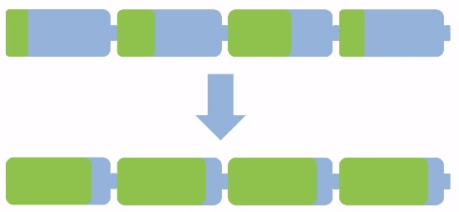

### BMS Balancing Logic Interfaces

#### Inputs

|  |  |  |  |
| --- | --- | --- | --- |
| **Name** | **Data type** | **Units** | **From** |
| BMS_State | boolean | enum | Other modules |
| Cell_Voltages | single | V | Sensors |
| Max Cell Voltage | single | V | Other BMS modules |
| Min Cell Voltage | single | V | Other BMS modules |

#### Outputs

|  |  |  |  |
| --- | --- | --- | --- |
| **Name** | **Data type** | **Units** | **To** |
| BalCmd | boolean | / | Plant (DriveLoad) |

### BMS Balancing Logic: Balancing ON/OFF

Calculate if perform balancing

### BMS Balancing Logic: Contacts Command calculation & Deactivation

Calculate the commands for inverter and charger contactors