**Experiment 1.2**

**Student Name: Alasso UID:**

**Branch: Section/Group:**

**Semester: 3RD Date of Performance:25/08/2022**

**Subject Name: DBMS Subject Code:21CSH-243**

1. **Aim/Overview of the practical:**

To create a table, insert values in it and run select commands on the table.

1. **Task to be done:**

1.Create a table.

2.Insert values in the table

3.Run queries on the table and get the output.

1. **Theme/Interests definition:**

CREATE TABLE student( Id INTEGER(3) PRIMARY KEY, Name VARCHAR(20), Physics INTEGER(3), CS INTEGER(3), City VARCHAR(20), State VARCHAR(20) );

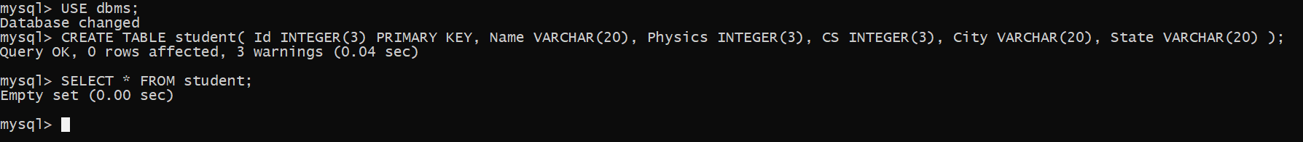

INSERT INTO student VALUES("1","Aditya","88","39","Palampur","Himachal Pradhesh");

INSERT INTO student VALUES("2","Nalin Sood","69","50","Faridabad","Haryana");

INSERT INTO student VALUES("3","Sujay","88","35","Patna","Bihar");

INSERT INTO student VALUES("4","Raghav Sharma","69","69","Kangra","Himachal Pradhesh");

INSERT INTO student VALUES("5","Vidur Chaudhary","88","32","Mandi","Himachal Pradhesh");

INSERT INTO student VALUES("6","Abhay","82","69","Chandigarh","Chandigarh");

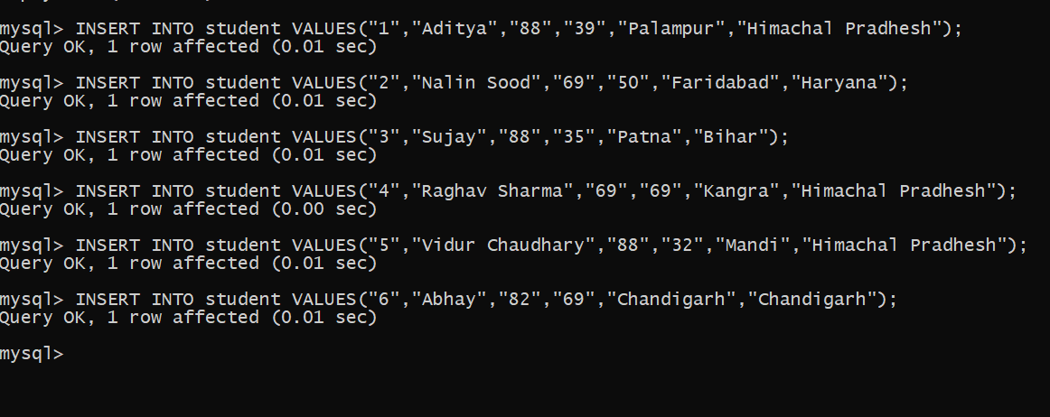

SELECT Id, Name, Physics, CS, City, State from student WHERE Physics>80 and CS<40 and not City="Chandigarh";

1. **Observations/Discussions (For applied/experimental sciences/materials-based labs):**

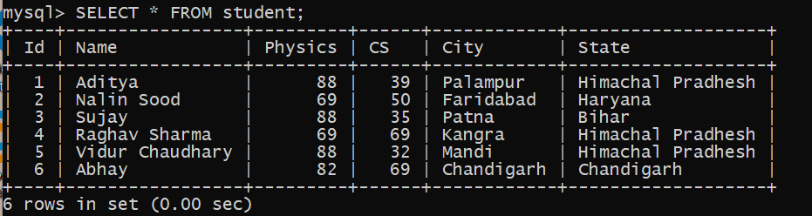

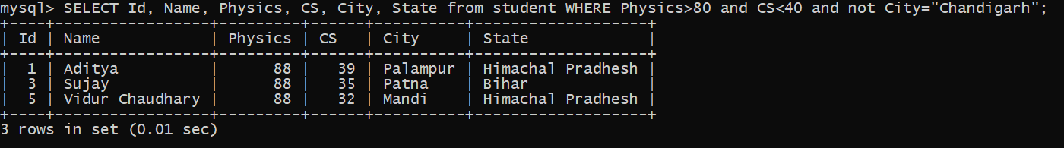

1. **Result/Output/Writing Summary:**

We have successfully created a table, inserted values in the table and printed the output according to the queries given.

1. **Graphs (If Any): Image/Soft copy of graph paper to be attached here:**

**None**

**Learning outcomes (What I have learnt):**

1.Basic SQL Commands and their implementations.

2. To create a table.

3.To insert values in a table

4.To run DQL Commands on the table data to get desired output

5.To create and Use databases.

**Evaluation Grid (To be created as per the SOP and Assessment guidelines by the faculty):**

|  |  |  |  |
| --- | --- | --- | --- |
| Sr. No. | Parameters | Marks Obtained | Maximum Marks |
| 1. |  |  |  |
| 2. |  |  |  |
| 3. |  |  |  |
|  |  |  |  |