**Experiment 1.1**

**Name: Alasso UID:**

**Branch: CSE-AML Section/Group:**

**Semester: 3 Date of Performance: 20/08/2022**

**Subject Name: Data Structures Subject Code: 21CSH-241**

**1. Aim/Overview of the practical:**

Write a menu driven program that implement following operations (using separate functions) on a linear array:

1) Insert a new element at end as well as at a given position.

2) Delete an element from a given whose value is given or whose position is given.

3) To find the location of a given element.

4) To display the elements of the linear array.

**2. Source Code:**

**#include<stdio.h>**

**#include<stdlib.h>**

**int a[10], pos, elem;**

**int n = 0;**

**void create();**

**void display();**

**void insert();**

**void del();**

**void main()**

**{**

**int choice;**

**while(1)**

**{**

**printf("\n\n~~~~MENU~~~~");**

**printf("\n=>1. Create an array of N integers");**

**printf("\n=>2. Display of array elements");**

**printf("\n=>3. Insert ELEM at a given POS");**

**printf("\n=>4. Delete an element at a given POS");**

**printf("\n=>5. Exit");**

**printf("\nEnter your choice: ");**

**scanf("%d", &choice);**

**switch(choice)**

**{**

**case 1: create();**

**break;**

**case 2: display();**

**break;**

**case 3: insert();**

**break;**

**case 4:del();**

**break;**

**case 5:exit(1);**

**break;**

**default:printf("\nPlease enter a valid choice:");**

**}**

**}**

**}**

**void create()**

**{**

**int i;**

**printf("\nEnter the number of elements: ");**

**scanf("%d", &n);**

**printf("\nEnter the elements: ");**

**for(i=0; i<n; i++)**

**{**

**scanf("%d", &a[i]);**

**}**

**}**

**void display()**

**{**

**int i;**

**if(n == 0)**

**{**

**printf("\nNo elements to display");**

**return;**

**}**

**printf("\nArray elements are: ");**

**for(i=0; i<n;i++)**

**printf("%d\t ", a[i]);**

**}**

**void insert()**

**{**

**int i;**

**if(n == 5)**

**{**

**printf("\nArray is full. Insertion is not possible");**

**return;**

**}**

**do**

**{**

**printf("\nEnter a valid position where element to be inserted: ");**

**scanf("%d", &pos);**

**}while(pos > n);**

**printf("\nEnter the value to be inserted: ");**

**scanf("%d", &elem);**

**for(i=n-1; i>=pos ; i--)**

**{**

**a[i+1] = a[i];**

**}**

**a[pos] = elem;**

**n = n+1;**

**display();**

**}**

**void del()**

**{**

**int i;**

**if(n == 0)**

**{**

**printf("\nArray is empty and no elements to delete");**

**return;**

**}**

**do**

**{**

**printf("\nEnter a valid position from where element to be deleted: ");**

**scanf("%d", &pos);**

**}while(pos>=n);**

**elem = a[pos];**

**printf("\nDeleted element is : %d \n", elem);**

**for( i = pos; i< n-1; i++)**

**{**

**a[i] = a[i+1];**

**}**

**n = n-1;**

**display();**

**}**

**3. Result/Output:**

**All Operations executed successfully.**

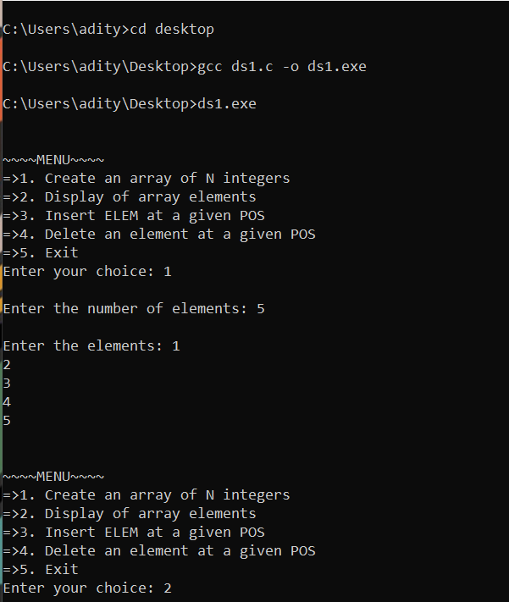

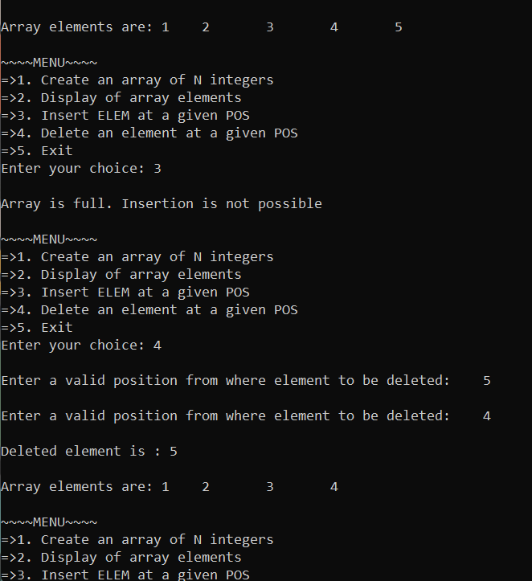

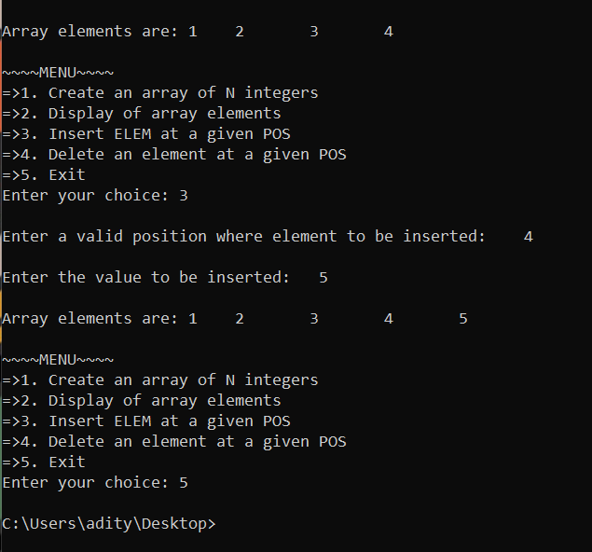

**Learning outcomes (What I have learnt):**

**1.** Inserting values in an array.

**2.** Deleting values from an array.

**3.** Finding values in an array.

**4.** Displaying an array.

**Evaluation Grid:**

|  |  |  |  |
| --- | --- | --- | --- |
| **Sr. No.** | **Parameters** | **Marks Obtained** | **Maximum Marks** |
| **1.** | **Student Performance  (Conduct of experiment) objectives/Outcomes.** |  | **12** |
| **2.** | **Viva Voce** |  | **10** |
| **3.** | **Submission of Work Sheet (Record)** |  | **8** |
|  | **Total** |  | **30** |