**Experiment Number:1.2**

|  |  |
| --- | --- |
| **Student Name**: Alasso | **UID:** |
| **Branch:**  CSE-AML | **Section & Group**: |
| **Semester:** 3 | **Date**: 29/08/2022 |
| **Course Name**: Programming in JAVA | **Course Code**: 21CSH-244 |

**1. Aim/Overview of the practical:**

The Fibonacci sequence is defined by the following rule. The first 2 values in the sequence are 1,1. Every subsequent value is the sum of the 2 values preceding it. Write a Java program that uses both recursive and non- recursive function to print the nth value of the Fibonacci sequence.

**2. Task to be done:**

Take the length of the series as input and then print the series using for loop.

**3. Algorithm:**

**Step: 1.** Start

**Step: 2.** Declare four variables int c,n,a=1,b=0.

**Step:3.** Take the length as input from user.

**Step:4.** Now print the series using for loop.

**Step:5.** Stop

**4. Code (For Programming)**

import java.util.Scanner;

class Fab{

    public static void main(String[]args){

        Scanner input = new Scanner(System.in);

            int c,n,a=1,b=0;

            System.out.println("Enter the length of series");

            n=input.nextInt();

            System.out.print(b+" "+a+" ");

            for(int i=0;i<n-2;i++){

                c=a;

                a=a+b;

                b=c;

                System.out.print(" " +a +" ");

            }

    }

    }

**5. Result/Output/Writing Summary:**

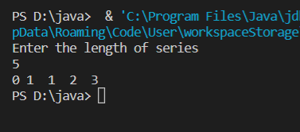

**Learning outcomes (What I have learnt):**

1. Learntabout Fibonacci series.
2. Learnt about loops in java.

**Evaluation Grid (To be created as per the SOP and Assessment guidelines by the faculty):**

|  |  |  |  |
| --- | --- | --- | --- |
| Sr. No. | Parameters | Marks Obtained | Maximum Marks |
| 1. |  |  |  |
| 2. |  |  |  |
| 3. |  |  |  |
|  |  |  |  |