Experiment No.-1.2

**Student Name: Alasso UID:**

**Branch: CSE-AML Section/Group:**

**Semester: Date of performance:26/08/2022**

**Subject: Python for machine learning Subject code:21CSH238**

1. **Aim/Overview of the practical:** Python Program to remove the Characters of odd index values in a string.
2. **Task to be done:** We have to create a program which would take a string as an input from the user and removes the character of odd index values in the string.
3. **Apparatus:**

Visual Studio code

1. **Theme/Interests definition:**

#Program to remove elements of string at odd index value

print("Aditya \n21BCS4806 \n21AML 3A")

string=str(input("enter a string "))

rmv=""

for i in range(0,len(string)):

    if i%2==0:

        rmv=rmv +string[i]

print("the string after removing odd index values ",rmv)

1. **Steps for experiment/practical:**

Step1. Take String as an input.

Step2. Declare rmv.

Step3. Run loop (0,len(string)) to the length of the string.

Step4. Imply if Statement.

Step 5. Print the output.

1. **Observations/Discussions:**

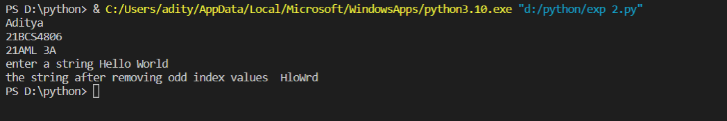

1. **Result/Output/Writing Summary:**

In this program we took String as input and after removing the elements at odd index we printed the output.

1. **Graphs (If Any): Image/Soft copy of graph paper to be attached here:**

None

1. **Learning outcomes (What I have learnt):**

Here, I learnt:

1. Loops in python.
2. String functions.
3. Conditional statements.

Evaluation Grid (To be created as per the SOP and Assessment guidelines by the faculty):

|  |  |  |  |
| --- | --- | --- | --- |
| Sr.  No. | Parameters | Marks Obtained | Maximum Marks |
| 1. |  |  |  |
| 2. |  |  |  |
| 3. |  |  |  |
|  |  |  |  |