Experiment No.-1.3

**Student Name: Alasso UID:**

**Branch: CSE-AML Section/Group:**

**Semester: Date of performance:22/08/2022**

**Subject: Python for machine learning Subject code:21CSH238**

1. **Aim/Overview of the practical:** Python Program to Check if a string is palindrome or not
2. **Task to be done:** We have to create a program which would take a string as an input from the user and reverse it, then check if it’s a palindrome or not.
3. **Apparatus:**

Visual Studio code

1. **Theme/Interests definition:**

#WAP to check if a string is a palindrome or not

print("Aditya \n 21BCS4806 \n21AML 3A")

a=str(input("enter the string:"))

print("The string is: ",a)

b=''

for i in range(-1,-(len(a)+1),-1):

    b=b+a[i]

print("The reverse of string is ",b)

if a==b :

    print("the string is palindrome")

else:

        print("the string is not a palindrome")

1. **Steps for experiment/practical:**

Step1. Take String as an input.

Step2. Print it.

Step3. Run loop (0, len(string)) to the length of the string.

Step4. Reverse the string .

Step5. Use conditional statement to check if it is a palindrome.

Step6. Print the output.

1. **Observations/Discussions:**

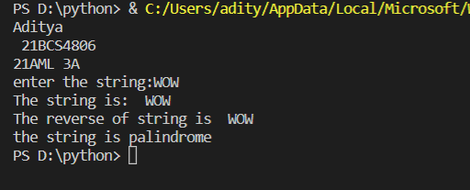 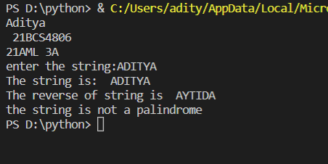

1. **Result/Output/Writing Summary:**

In this program we took String as input and after reversing it we checked if it is a palindrome.

1. **Graphs (If Any): Image/Soft copy of graph paper to be attached here:**

None

1. **Learning outcomes (What I have learnt):**

Here, I learnt:

1. Loops in python.
2. Reversing string.
3. Conditional statements.

Evaluation Grid (To be created as per the SOP and Assessment guidelines by the faculty):

|  |  |  |  |
| --- | --- | --- | --- |
| Sr.  No. | Parameters | Marks Obtained | Maximum Marks |
| 1. |  |  |  |
| 2. |  |  |  |
| 3. |  |  |  |
|  |  |  |  |