Experiment No.-1.1

Student Name: Alasso UID:

Branch: CSE-AML Section/Group:

Semester: Date of performance:22/08/2022

Subject: Python for machine learning Subject code:21CSH238

1. **Aim/Overview of the practical:** Python Program to Compute a Polynomial Equation given that the Coefficients of the Polynomial are stored in a List.
2. **Task to be done:** We have to create a program in which coefficients of the polynomial are stored in a list.
3. **Apparatus:**

Visual Studio code

1. **Theme/Interests definition:**

 #WAP to Compute a Polynomial Equation given that the Coefficients of the Polynomial are stored in a List

print("Your name")

import math

print('enter the coefficient in the form ax^3 + bx^2 + cx + d')

list=[]

for i in range(0,4):

 a=int(input('Enter the coefficient:'))

 list.append(a)

x=int(input('Enter the value of x:'))

sum=0

b=3

for i in range(0,3):

 while(b>0):

    sum=sum+(list[i]*math.pow(x,b))

    break

b=b-1

sum=sum+list[3]

print("the value of the polynomial is :",sum)

import math

1. **Steps for experiment/practical:**

1.Import the math library.

2.Make an empty list in which you stored these coefficients.

3.Enter the coefficient of the polynomial (ax3+bx2+cx+d).

4.By using the append command store these coefficients.

5.Enter the value of x.

6.Now, create two more variables (sum=0, b=3(here b is the power of the x)).

7. Store the value of polynomial in sum.

8. Now, print the polynomial’s value.

1. **Observations/Discussions:**

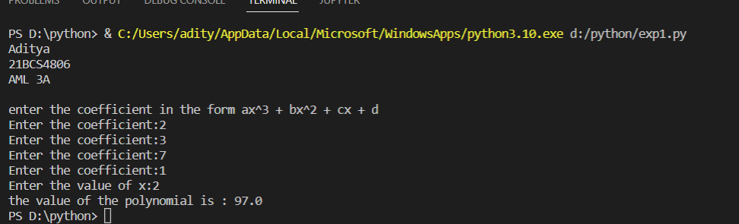

1. **Result/Output/Writing Summary:**

In this program we took values of coefficients and variable as input from user and gave value of polynomial as output.

1. **Graphs (If Any): Image/Soft copy of graph paper to be attached here:**

None

1. **Learning outcomes (What I have learnt):**

Here, I learnt:

1. Basic python commands.
2. For and while loop in python.
3. Some uses of math library in python.

Evaluation Grid (To be created as per the SOP and Assessment guidelines by the faculty):

|  |  |  |  |
| --- | --- | --- | --- |
| Sr.  No. | Parameters | Marks Obtained | Maximum Marks |
| 1. |  |  |  |
| 2. |  |  |  |
| 3. |  |  |  |
|  |  |  |  |