



**Experiment Title.: -1**

**Visit** [**https://alasso.tech/**](https://alasso.tech/)

**Name: Alasso UID: 21BCS2124**

**Branch: Section:**

**Semester: Subject Code:**

**Subject: BEEE**

**Aim:** To verify Kirchhoff’s Current Law (KCL) and study its limitations.

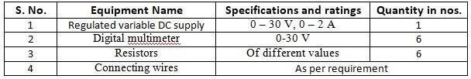**Apparatus:**

**Circuit Diagram:**

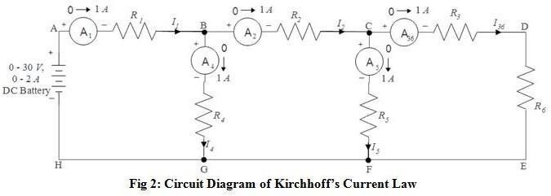



**Steps for Experiment:**

1. Took 1 battery of 9 volts, 6 multimeters of 0-30 volts, 6 resistors of any value and few meters of connecting wires
2. Then we will need to connect them in the manner as shown above in the circuit diagram.
3. Different values of R1 to R6 were taken and readings of A1 to A6 were noted down.
4. All 6-multimeter showed different current values.
5. we then calculated their theoretical values and compared it with the values shown on the multimeter.
6. By this comparison we came to know the errors in our experiment.
7. Dividing the error then theoretical values we came to knew the error perfect.

**Calculations/Theorems /Formulas used**

**Theory: -** Kirchhoff’s laws are used to determine the current and voltage in different branches of an electric circuit which may not be easily solved by Ohm’s law. These laws are applicable to both AC and DC circuits.

**Statement of Kirchhoff’s First Law or Kirchhoff’s Current Law (KCL) or Point Law:**

It states that the algebraic sum of all the currents entering into a junction or a node in any electric circuit at any instant is zero.

**Explanation:**

Kirchhoff's Current Law. Kirchhoff's Current Law (KCL) is Kirchhoff's first law that deals with the conservation of charge entering and leaving a junction. The current law states that for a parallel path the total current entering a circuits junction is exactly equal to the total current leaving the same junction.



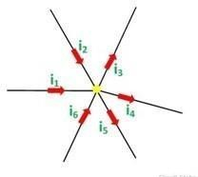

Fig 1:

Explanation of KCL From above diagram can such as:

i1+i2+i6 = i3i+i4+i5

Calculations and Formulae:

Applying KCL junction B:

Applying KVL junction C:

Calculations are done for all the readings being taken using Equations (2) and (3) to be applied at respective junctions.

**FORMULAE:**

ERROR=THEROTICAL VALUE – CALCULATED VALUE ERROR PERCENT = ERROR/THEORETICAL VALUE * 100%

Since, I1=I2+I4 –(1)

12 = I36+I5 – (2) THEREFORE, I1=(2.08+3.46)mA

= 5.54mA -THEORETICAL VALUE BUT ACCORDING TO EXPERIMENT, I2=2.08mA

THEREFORE, ERROR(I2) = -0.008mA



**Observations/Discussions:**

|  |  |  |  |  |  |  |
| --- | --- | --- | --- | --- | --- | --- |
| Sl no. | Supply Voltage Vcd(V) | Ammeter I1 (A) | Ammeter I2 (A) | Ammeter I3 (A) | Ammeter I4 (A) | Ammeter I5(A) |
| 1. | 9V | 5.53mA | 2.08mA | 0.692mA | 3.46mA | 1.38mA |

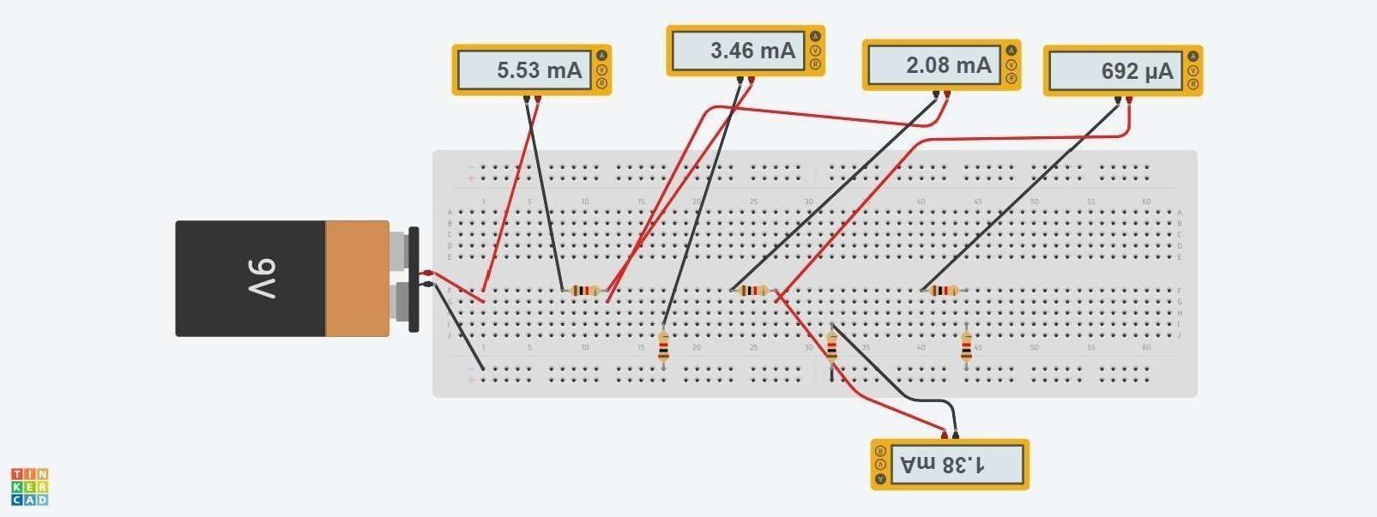

Percentage error (if any or applicable):

ERROR PERCENT = ERROR/THEORETICAL VALUE * 100% THEREFORE,

PERCENTAGE ERROR (I1) %= 0.01/15.54 * 100%

= 0.18%

ERROR PERCENT = ERROR/THEORETICAL VALUE * 100% SIMILARLY,

PERCENTAGE ERROR (12%)-0.008/2.072 * 100%

= -0.38%



|  |  |  |  |  |  |  |  |  |  |  |  |  |  |  |  |  |  |
| --- | --- | --- | --- | --- | --- | --- | --- | --- | --- | --- | --- | --- | --- | --- | --- | --- | --- |
| Sl no. | Calculated values of current (A) | | | | | | Theoretical values of current(A) | | | | | Percent error | | | | |  |
|  | I1=I2+I4 (A) | I2=I3+I5 (A) | | |  |  | I1=I2+I4 (A) | I2=I3+I5 (A) | |  |  | I1% ERROR | I2% ERROR | |  |
| 1. |  | 5.53mA | | 2.08mA |  | |  | 5.54mA | 2.072mA |  | |  | 0.18% -0 | .38% |  | |  |

**Result output:**

**Graphs (If Any):**

Image/Soft copy of graph paper to be attached here:

*NO GRAPH AVAILABLE*

**Learning outcomes.**

1. Learnt to measure the resistance and current. 2.Learnt about KCL law in details.
2. Learnt to design circuit in series or parallel connection.
3. Learnt to verify KCL law.

**Evaluation Grid:**

|  |  |  |  |
| --- | --- | --- | --- |
| Sr. No. | Parameters | Marks Obtained | Max Marks |
| 1. | Worksheet completion including writing learning objectives/Outcomes. (To be submitted at the end of the day). |  | 10 |
| 2. | Post Lab Quiz Result. |  | 5 |
| 3. | Student Engagement in Simulation/Demonstration/Performance  and Controls/Pre-Lab Questions. |  | 5 |
|  | Signature of Faculty (with Date): | Total marks obtain |  |