**EXPERIMENT TITLE - 1.2**

**Student Name: Alasso UID:**

**Branch: Section/Group:**

**Semester:**

**Subject Name: BASIC ELECTRICAL AND ELECTRONICS ENGINEERING**



**Visit** [**https://alasso.tech/**](https://alasso.tech/)

**Aim:**

To verify Kirchhoff’s Voltage Law (KVL) and study its limitations.

**Apparatus:**

|  |  |  |  |
| --- | --- | --- | --- |
| **S.NO.** | **EQUIPMENT NAME** | **SPECIFICATIONS & RATING** | **QUANTITY** |
| 1 | Regular variable DC Supply | 0-30 V , 0-2 A | 1 |
| 2 | Digital Multimeter | 0-30 V | 6 |
| 3 | Resistors | Of Different Values | 6 |
| 4 | Connecting Wires | As Per Requirement | |

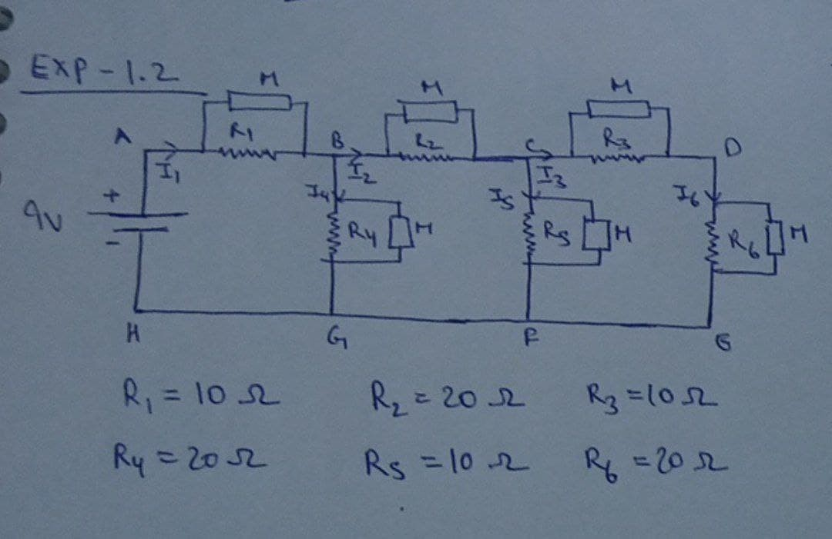**Circuit Diagram:**

**Steps for experiment:**

1. The circuit is connected as shown in Circuit Diagram above.
2. The voltage of the DC supply was set at 9 V.
3. Different values of R1 to R6 were taken and readings of I1 to I6 were noted down.
4. Accordingly, only one set of readings was taken at 9 V DC supply.
5. The observations were recorded in Table.

**Calculations/Theorems /Formulas used**

Applying KVL in loop ABGH, V = I1.R1 + I4.R4 or V = V1 + V4 Applying KVL in loop BCFG, V4= I2.R2 + I5.R5 or V4= V2+ V5 Applying KVL in loop CDEF, V5= I3.R3 + I.6.R6 or V5 = V3 + V6

**Observations/Discussions:**

**CIRCUIT SIMULATION**

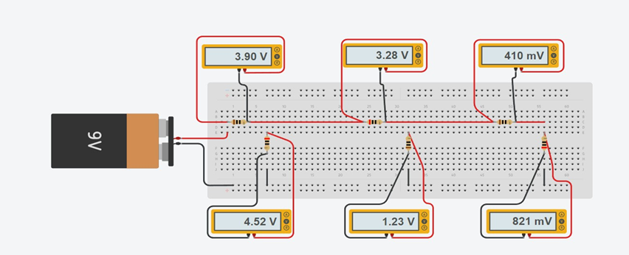

|  |  |  |  |  |  |  |  |
| --- | --- | --- | --- | --- | --- | --- | --- |
| S.NO. | SUPPLY VOLTAGE (V) | VOLTMETER 1 (V1) | VOLTMETER 2 (V2) | VOLTMETER 3 (V3) | VOLTMETER 4 (V4) | VOLTMETER 5 (V5) | VOLTMETER 6 (V6) |
| 1 | 9 V | 3.90 V | 3.28 V | 410 mV | 4.52 V | 1.23 V | 821 mV |

**Result/Output/Writing Summary:**

As per Kirchhoff’s Voltage Law, the theoretical and calculated values of algebraic sum of emfs and voltage drops.

|  |  |  |  |  |  |  |  |  |  |
| --- | --- | --- | --- | --- | --- | --- | --- | --- | --- |
| S.NO. | CALCULATED VALUE OF VOLTAGE (V) | | | THEORITICAL VALUE OF VOLTAGE (V) | | | PERCENTAGE ERROR | | |
| V = V1 +  V4 | V4= V2+ V5 | V5 = V3 +  V6 | V = V1 +  V4 | V4= V2+  V5 | V5 = V3 +  V6 | V = V1 +  V4 | V4= V2+  V5 | V5 = V3 +  V6 |
| 1. | 3.90 +  4.52 =  8.42 V | 3.28 + 1.23  = 4.51 V | 0.41 + 0.82  = 1.23 V | 9 V | 4.52 V | 1.23 V | 0.64 % | 0.22 % | NO ERROR |

**Graphs (If Any): Image /Soft copy of graph paper to be attached here**



NO GRAPH

**Sources Of Error:**

1. Internal resistance of DC battery.
2. Internal resistance of multimeter viz. voltmeter and ammeter.
3. Internal resistance of connecting wires.
4. Heating effect of rheostat coil (Joule’s law of electric heating)
5. All the sources of error related to multimeter.



**Learning outcomes (What I have learnt):**

1. Application of KVL.
2. Not applicable to circuits having distributed elements.

**Evaluation Grid:**

|  |  |  |  |
| --- | --- | --- | --- |
| Sr. No. | Parameters | Marks Obtained | Maximum Marks |
| 1. | Worksheet completion including writing learning objectives/Outcomes.(To be  submitted at the end of the day). |  | 10 |
| 2. | Post Lab Quiz Result. |  | 5 |
| 3. | Student Engagement in Simulation/Demonstration/Performance and Controls/Pre-Lab Questions. |  | 5 |
|  | Signature of Faculty (with Date): | Total Marks Obtained: |  |