

**EXPERIMENT TITLE:1.3**

**Student Name: UID:**

**Branch: Section/Group:**

**Semester: Date of Performance:**

**Subject Name: BEEE Subject Code: 21ELH-101**

**Aim:** To study voltage-current relationship in an R-L series circuit and to determine the power factor of the circuit.

**Apparatus:** Voltage Source, Resistor, Inductor, Ammeter, Voltmeter, Connecting Wires.

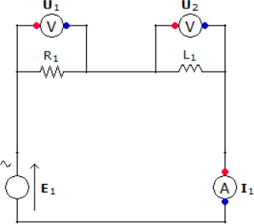**Circuit Diagram:**

**Steps for experiment:**

1. Take a Resistor of 45 ohm and Inductor of 1 Henry.
2. Connect the resistor and inductor in series using connecting wires as shown in figure.
3. Connect a voltmeter in parallel to resistor and inductor using connecting wires as shown in figure.
4. Connect an ammeter to the circuit using connecting wires as shown in figure.
5. Connect the voltage source to the circuit as shown in the figure.



**Calculations/Theorems /Formulas used**

Z= (R2 +X 2) (1/2)

**L**

XL= 2πfL

XL= 2×3.14×50×1

XL= 314 ohm

Z= (452+3142) (1/2)

Z= 317.2 ohm

Power Factor = Cosα= R/Z

=45/317.2

= 0.141

****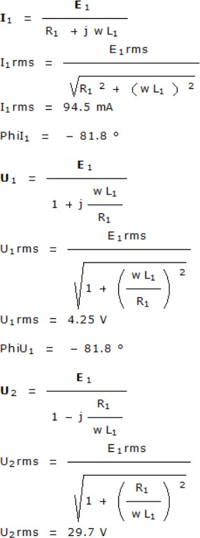

**Observations/Discussions:**

|  |  |  |  |
| --- | --- | --- | --- |
| S.NO | V | I | Power Factor |
| 1 | 30V | 94.5 mA | 0.141 |

**Percentage error (if any or applicable):**

NIL

**Result/Output/Writing Summary:**

We have observed the values of current and voltage and verified the relationship in which voltage is leading and current is lagging. We have also calculated the value of power factor.



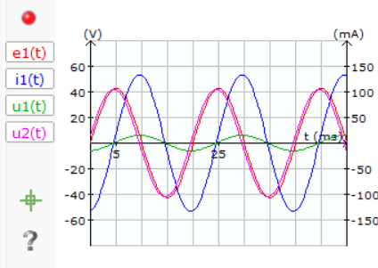**Graphs (If any):** Image /Soft copy of graph paper to be attached here



**Learning outcomes (What I have learnt):**

1. Learned how to connect resistor and inductor in series.
2. Learned how to connect voltmeter and ammeter.
3. Learned how to measure voltage and current.
4. Learned how to calculate impedance Z.
5. Learned how to calculate power factor.

**Evaluation Grid:**

|  |  |  |  |
| --- | --- | --- | --- |
| Sr. No. | Parameters | Marks Obtained | Maximum Marks |
| 1. | Worksheet completion including writing learning objectives/Outcomes. (To be Submitted at the end of the day). |  | 10 |
| 2. | Post Lab Quiz Result. |  | 5 |
| 3. | Student Engagement in Simulation/Demonstration/Performance and Controls/Pre-Lab Questions. |  | 5 |
|  | Signature of Faculty (with Date): | Total Marks Obtained: |  |