

**Experiment - 2.2**

**Student Name: Alasso UID:**

**Branch: Date of Performance:**

**Subject Name: BEEE Subject-code:**

**Aim:** To study working of Linear Variable Differential Transformer or Linear Variable Displacement Transducer (LVDT).

**Apparatus:**

|  |  |  |  |
| --- | --- | --- | --- |
| SR. NO. | Equipment Name | Specifications and Range | Quantity in numbers |
| 1. | LVDT kit | 0 - 230 V, ±10 mm | 1 |
| 2. | CRO | 0 - 230 V, 30 MHZ | 1 |
| 3. | CRO Probes | ------ | 2 |

**Circuit Diagram:**

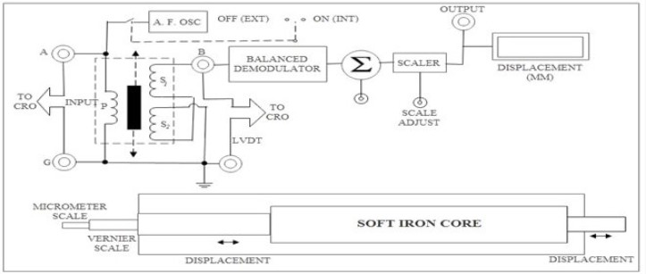

**Steps for experiment:**

1. First arrange all the required components for the given experiment as per mentioned in the apparatus part.
2. Then connect the components as per shown in the circuit diagram.
3. Then set the required parameters like frequency, voltage, etc on CRO or on given website (for online).
4. For the given, we must do the displacement and observe the graph and find the respective voltage at that displacement.
5. When the connections are done and parameters are set then, observe the waveform as shown on the screen and observe two or three readings on respective displacement done.
6. Thus, at the end, the readings and the graph nature are done. Therefore, exp. ends.



**Calculations/Theorems /Formulas used**

NIL

**Observations/Discussions:**

**For Positive Displacement:**

|  |  |  |  |
| --- | --- | --- | --- |
| Sr. No. | Meter Scale Reading | Positive Displacement (mm) | Voltage Amplitude(mV) |
| 1. | ------ | 1 | 17.45 |
| 2. | ------ | 2 | 34.77 |
| 3. | ------ | 3 | 51.82 |
| 4. | ------ | 4 | 68.48 |
| 5. | ------ | 5 | 84.62 |

**For Negative Displacement:**

|  |  |  |  |
| --- | --- | --- | --- |
| Sr. No. | Meter Scale Reading | Negative Displacement (mm) | Voltage Amplitude(mV) |
| 1. | ------ | -1 | 17.45 |
| 2. | ------ | -2 | 34.77 |
| 3. | ------ | -3 | 51.82 |
| 4. | ------ | -4 | 68.48 |
| 5. | ------ | -5 | 84.62 |

**Percentage error (if any or applicable):**

NIL

**Result/Output/Writing Summary:**

The difference in comparison of voltage amplitude values at positive and negative displacement Should be analyzed and resulting difference if any.

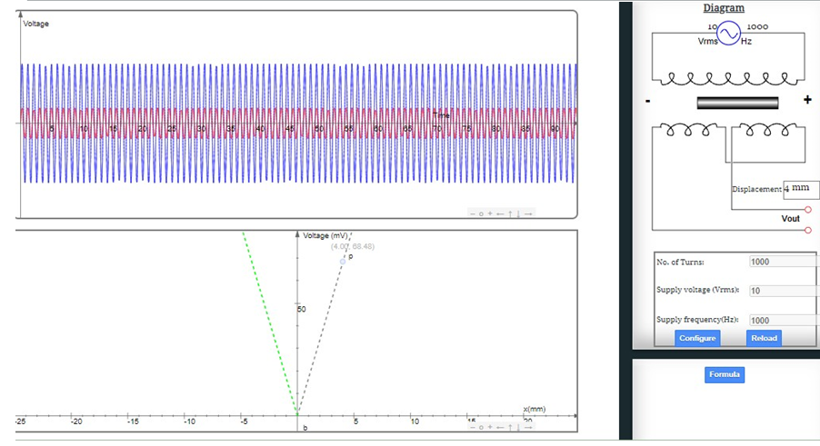



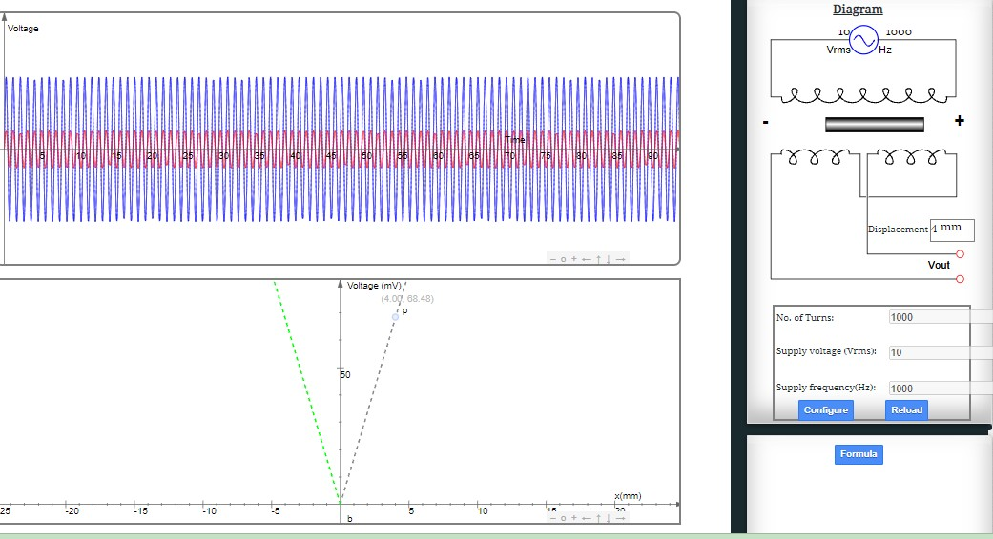



**Learning outcomes (What I have learnt):**

1. Connection of the components through circuit diagram.
2. Working of the LVDT.
3. Practically learnt the working of LVDT.

**Evaluation Grid:**

|  |  |  |  |
| --- | --- | --- | --- |
| Sr. No. | Parameters | Marks Obtained | Maximum Marks |
| 1. | Worksheet completion including writing learning objectives/Outcomes. (To be submitted at the end of the day). |  | 10 |
| 2. | Post Lab Quiz Result. |  | 5 |
| 3. | Student Engagement in Simulation/Demonstration/Performance and Controls/Pre-Lab Questions. |  | 5 |
|  | Signature of Faculty (with Date): | Total Marks Obtained: |  |