

**EXPERIMENT – 2.3**

**NAME: UID:**

**SEMESTER: CLASS/GROUP:**

**D.O.P: SUBJECT CODE – 21ELH-101**

**Aim:** To design simple DC motor control circuit.

**Apparatus:** ARDUINO UNO, DC motor, L293D, connecting wires. potentiometer.

**Circuit Diagram:**

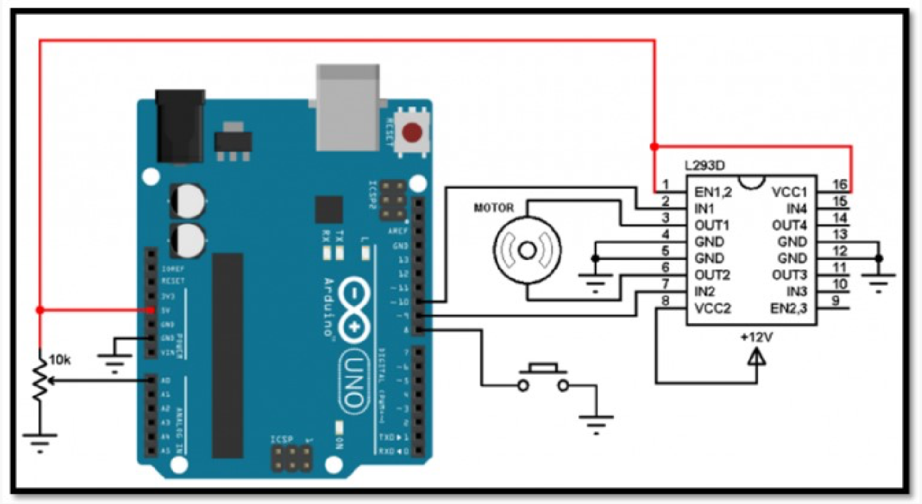

**Fig.1**

DC Motor Circuit

Program:

#define button 8

#define pot 0

#define pwm1 9

#define pwm2 10

boolean motor_dir = 0; int motor_speed;

void setup() {

pinMode(button, INPUT_PULLUP); pinMode(pwm1, OUTPUT); pinMode(pwm2, OUTPUT);

}

void loop() {

motor_speed = analogRead(pot) / 4; if(motor_dir)

analogWrite(pwm1, motor_speed); else

analogWrite(pwm2, motor_speed);

if(!digitalRead(button)){ // If direction button is pressed while(!digitalRead(button)); // Wait until direction button released motor_dir = !motor_dir; // Toggle direction variable if(motor_dir)

digitalWrite(pwm2, 0); else digitalWrite(pwm1, 0);

}

}

**Tinker Cad Result:**

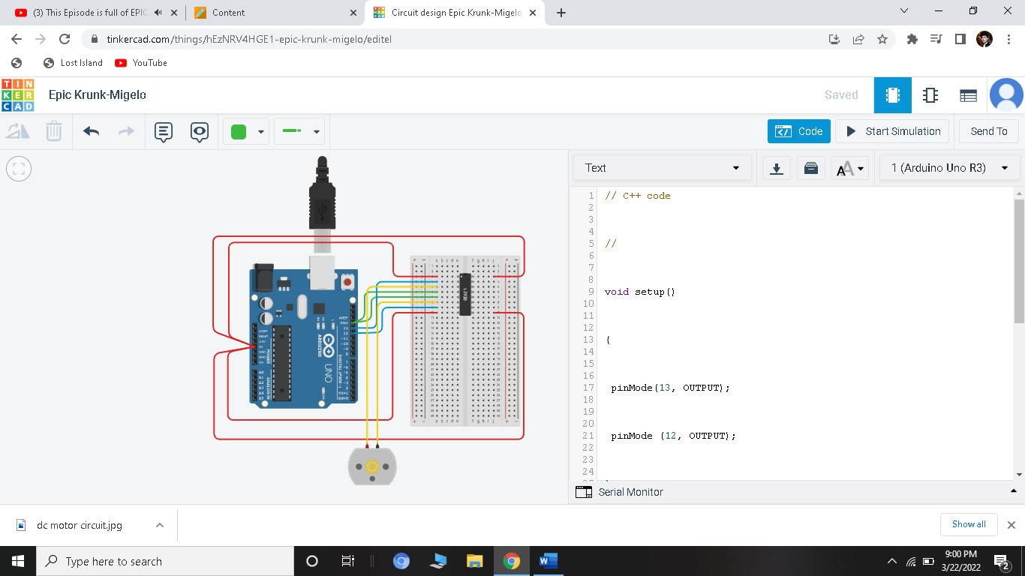

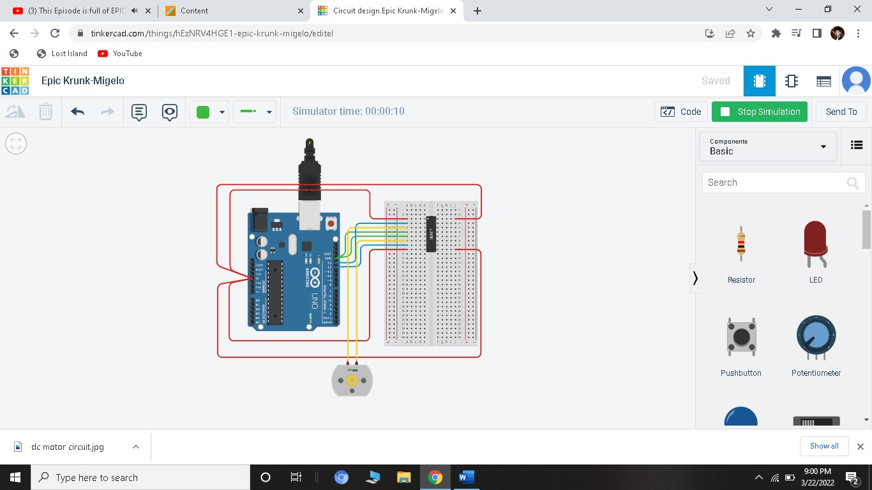

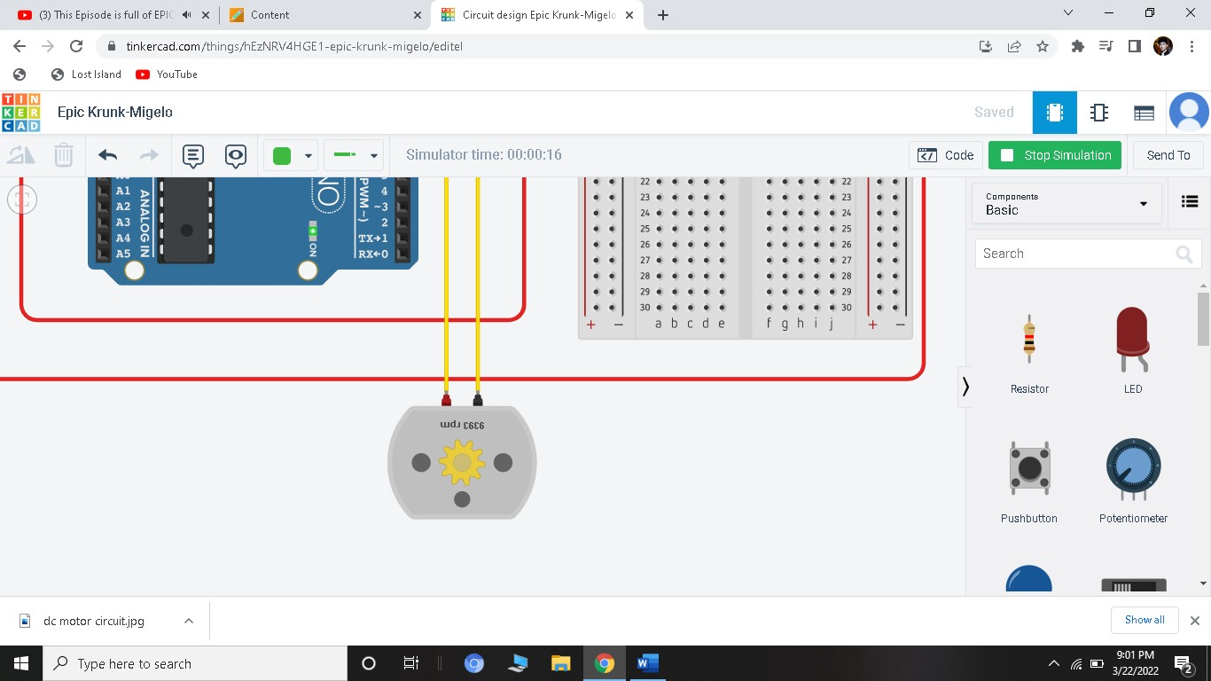

When 13 is High; 12 is Low

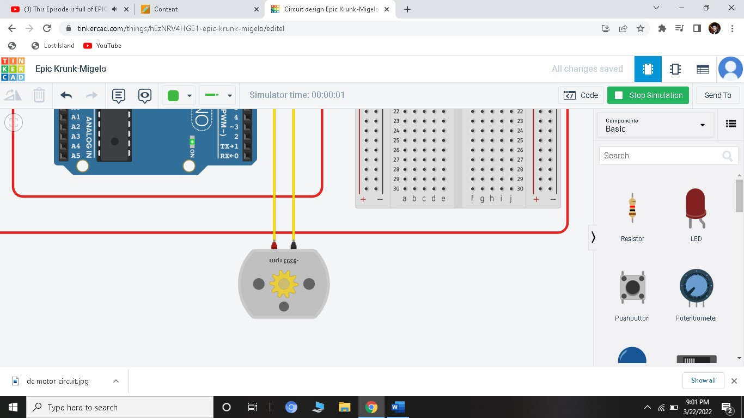

When 12 is High; 13 is Low

**Result:**

Designing of simple DC motor control circuit using Arduino is verified after uploading the program.

**Evaluation Grid:**

|  |  |  |  |
| --- | --- | --- | --- |
| Sr. No. | Parameters | Marks Obtained | Maximum Marks |
| 1. | Worksheet completion including writing learning objectives/Outcomes. (To be submitted at the end of the day). |  | 10 |
| 2. | Post Lab Quiz Result. |  | 5 |
| 3. | Student Engagement in Simulation/Demonstration/Performance and Controls/Pre-Lab Questions. |  | 5 |
|  | Signature of Faculty (with Date): | Total Marks Obtained: |  |