**Experiment - 2.4**

**Student Name: Alasso UID:**

**Branch: Section/Group-**

**Semester: Date of Performance:**

**Subject Name: Subject Code:**



**Visit** [**https://alasso.tech/**](https://alasso.tech/)

**Aim:**

To demonstrate the working of a temperature sensor circuit.

**Apparatus:**

ARDUINO UNO, temperature sensor (TMP36), connecting wires, breadboard.

**Steps of experiment:**

1. Open tinker cad and create a new circuit.
2. Now design the the ciruit in it using the insert button
3. Make sure all connections are correct
4. Open the code editor

**Program**

// C++ code

//

float temp; void setup()

{

Serial.begin(9600);

}

void loop()

{

temp = analogRead (A0); temp = temp * 0.48828125;

Serial.print ("TEMPERATURE: ");

Serial.print(temp); Serial.print ("*C"); Serial.println(); delay(1000);

}

**Observation /Output**

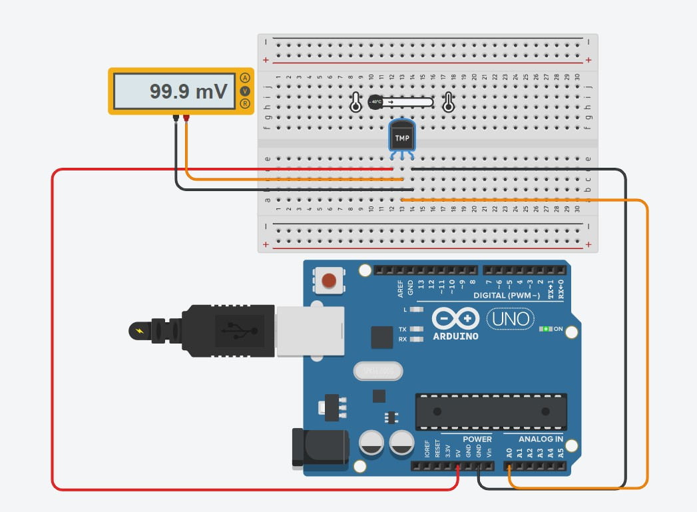



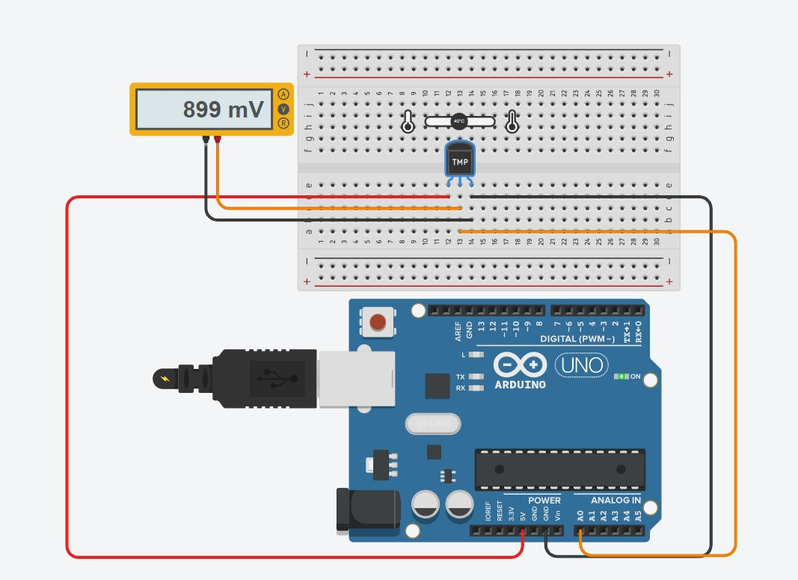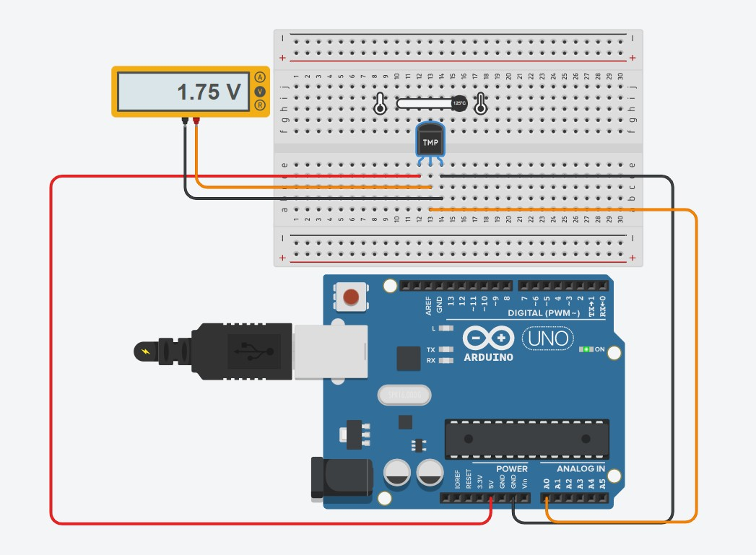

**Result**

1. Designing of temperature control circuit using arduino is verified after uploading the program.
2. ****Sources of error
3. Due to internal resistance of multimeter.
4. Due to interruption of power supply.
5. Due to wrong connection of circuit.

**Learning outcomes (What I have learnt):**

1. Learned the application of Arduino Uno IC
2. Designed and learned how to how to control the DC motor
3. Design of circuit using Arduino
4. Verify the circuit by programming.

**Evaluation Grid:**

|  |  |  |  |
| --- | --- | --- | --- |
| Sr. No. | Parameters | Marks Obtained | Maximum Marks |
| 1. | Worksheet completion including writing learning objectives/Outcomes. (To be submitted at the end of the day). |  | 10 |
| 2. | Post Lab Quiz Result. |  | 5 |
| 3. | Student Engagement in Simulation/Demonstration/Performance and Controls/Pre-Lab Questions. |  | 5 |
|  | Signature of Faculty (with Date): | Total Marks Obtained: |  |