**Experiment – 2.5**

**Student Name: Alasso UID:**

**Branch: Section/Group-**

**Semester: Date of Performance:**

**Subject Name: Subject Code:**



**Visit** [**https://alasso.tech/**](https://alasso.tech/)

**AIM:**

Design automatic street light using LDR.

**APPARATUS:**

ARDUINO, LDR, Resistance 10k ohm, wires, Photo resistor.

**CIRCUIT DIAGRAM:**

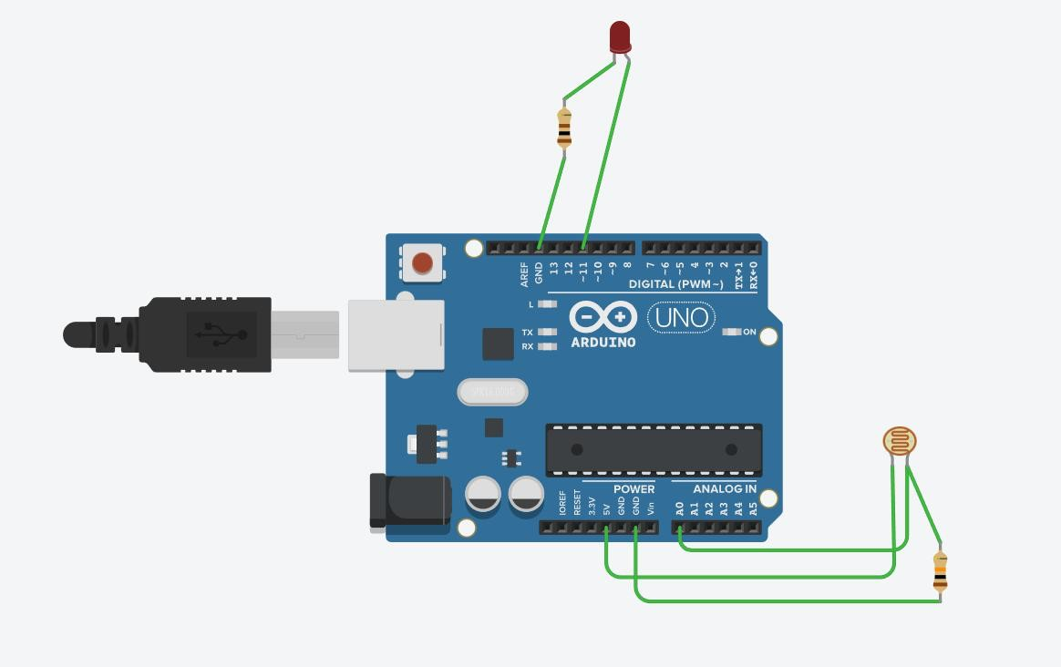

**CODE:**

****// C++ code int ldr = 0; void setup()

{

pinMode(A0, INPUT); pinMode(11, OUTPUT);

}

void loop()

{

ldr = analogRead(A0);

analogWrite(11, map(ldr, 0, 1023, 180, 0));

delay(10); // Delay a little bit to improve simulation performance

}

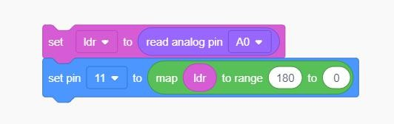



**OBSERVATIONS:**

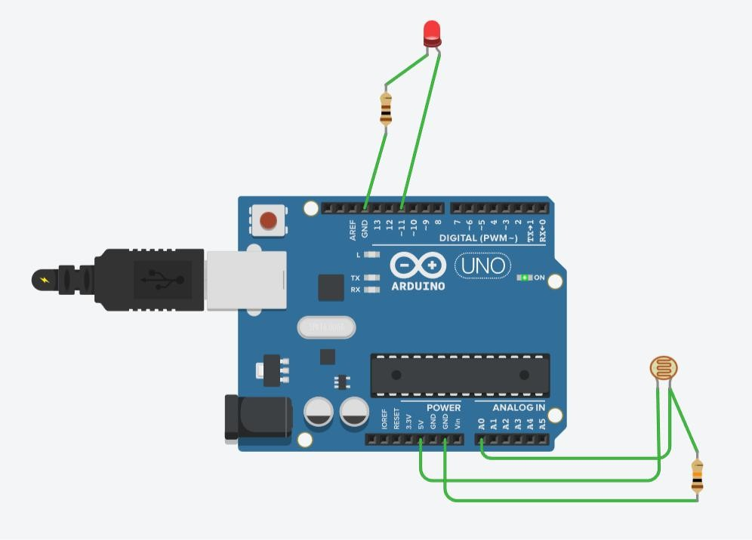

**RESULT:**

1. Designing of automatic night lamp was verified after uploading the program.
2. SOURCES OF ERROR:
3. Due to internal resistance of multimeter.
4. Due to interruption of power supply.
5. Due to wrong connection of circuit.



**LEARNING OUTCOMES:**

1. Introduction to arduino uno.
2. Circuit designing of automatic night lamp using LDR.
3. Verification of experiment.

**Evaluation Grid (To be filled by Faculty):**

|  |  |  |  |
| --- | --- | --- | --- |
| **Sr.**  **No.** | **Parameters** | **Marks Obtained** | **Maximum Marks** |
| 1. | Worksheet completion including writing learning objectives/Outcomes. (To be submitted at the end of the day) |  | 10 |
| 2. | Post Lab Quiz Result. |  | 5 |
| 3. | Student Engagement in  Simulation/Demonstration/Perform ance and Controls/Pre-Lab Questions. |  | 5 |
|  | **Signature of Faculty (with Date):** | **Total Marks Obtained:** | **20** |