**Experiment – 3.1**

**Student Name: Alasso UID:**

**Branch: Section/Group-**

**Semester: Date of Performance:**

**Subject Name: Subject Code:**

**Visit** [**https://alasso.tech/**](https://alasso.tech/)

**Aim:**

To measure gain of inverting operational amplifier.

**Apparatus:**

Op-AMP IC, CRO, Resistor, Multimeter, Function Generator, Bread board, Connecting Wires

**Circuit Diagram:**

****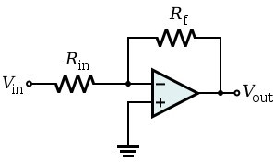

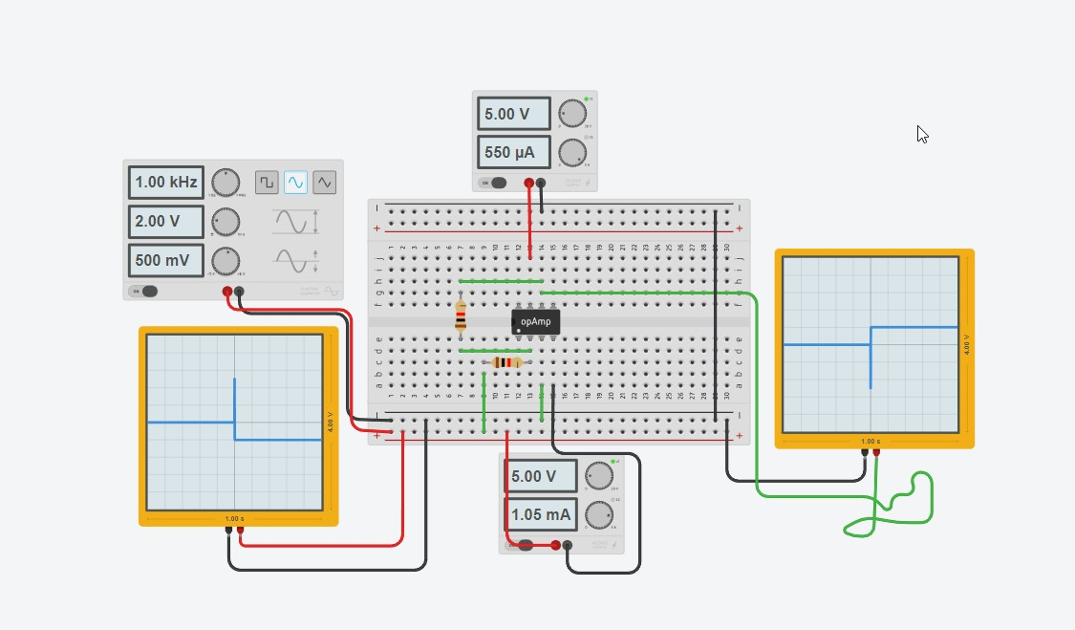



**Steps for experiment:**

1. Connect the circuit as shown in the figure.
2. Connect supply voltage to I/P.
3. Note the values of RF & Rin.
4. Note VIN & VOUT with the digital multimeter.
5. Repeat steps 2 & 3 for different values of RF &Rin.



**Calculations/Theorems /Formulas used**

Output Voltage VO = -VIN (RF/R1)

Gain == [Vo/Vin]

**Observations/Discussions:**

|  |  |  |  |  |  |
| --- | --- | --- | --- | --- | --- |
| Sr. No. | Rf | R1 | Vin | Vo | Gain [Vo/Vin] |
| 1 | **500** | **100** | **5** | **25** | **5** |
| 2 | **200** | **100** | **5** | **10** | **2** |
| 3 | **300** | **200** | **5** | **7.5** | **1.5** |

**Percentage error (if any or applicable):**

No Error

**Result/Output/Writing Summary:**

In inverting amplifier O/P is out of phase with I/P with I/P.

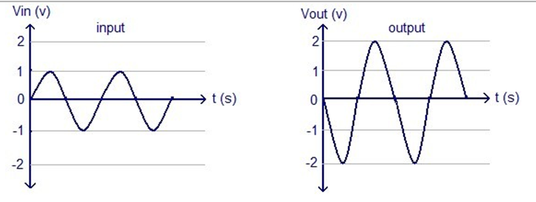

**Graphs (If Any):**

No Graphs Used

**Learning outcomes (What I have learnt):**



1. Learnt about other workings of Inverting OP Amplifiers.
2. Learnt about the need of multimeter to get values of voltages.
3. Learnt about checking the results in oscilloscope.
4. Learnt about the different functions of Operational Amplifiers.

**Evaluation Grid:**



|  |  |  |  |
| --- | --- | --- | --- |
| Sr. No. | Parameters | Marks Obtained | Maximum Marks |
| 1. | Worksheet completion including writing learning objectives/Outcomes. (To be submitted at the end of the day). |  | 10 |
| 2. | Post Lab Quiz Result. |  | 5 |
| 3. | Student Engagement in Simulation/Demonstration/Performance and Controls/Pre-Lab Questions. |  | 5 |
|  | Signature of Faculty (with Date): | Total Marks Obtained: |  |