**Experiment 1.1**

**Student Name: Alasso Branch: BE-CSE**

**UID: Section/Group:**

**Date of performance: 12/08/2022 Subject name: DBMS**

**AIM:**

To implement different types of DDL, DML, DCL queries.

**RESULT/OUTPUT:**

1. **CREATE Command:**

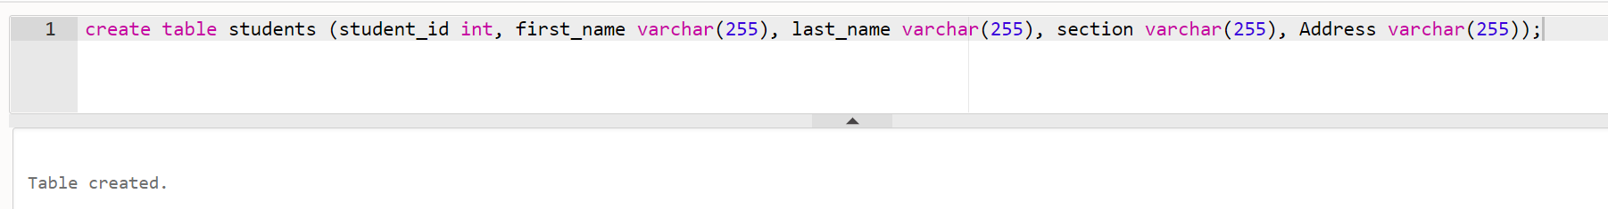

1. **DESCRIBE Command:**

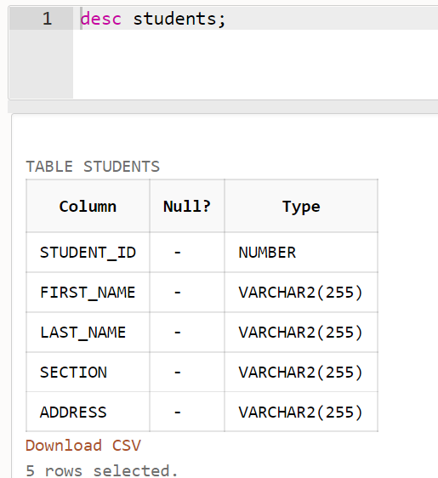

1. **INSERT Command:**

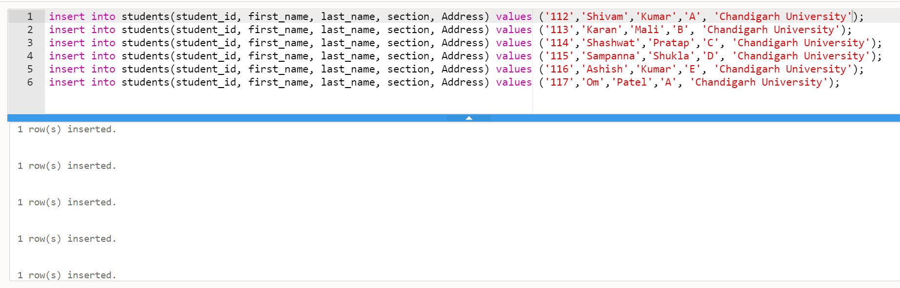

1. **SELECT Command:**

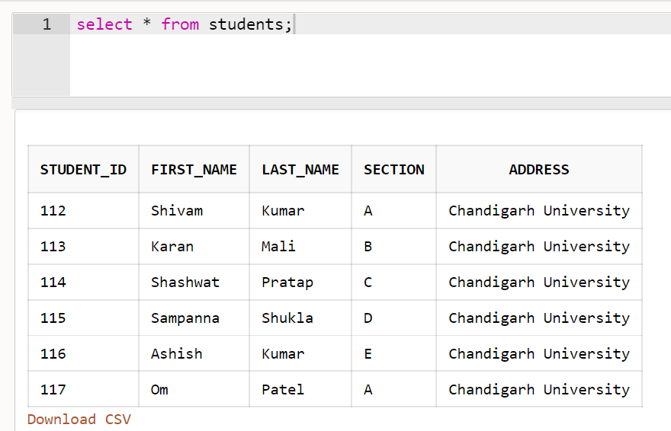

1. **DISTINCT Command:**

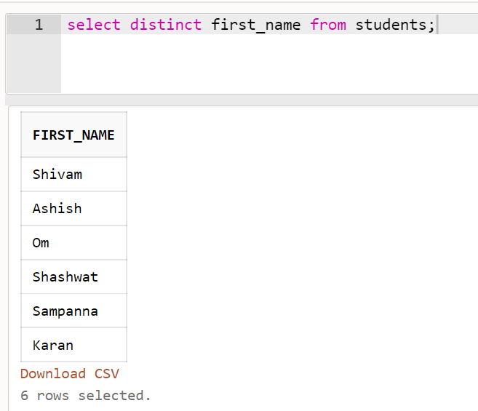

1. **DELETE Command:**

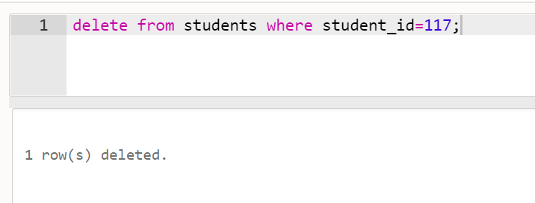

1. **ALTER Command (ADD):**

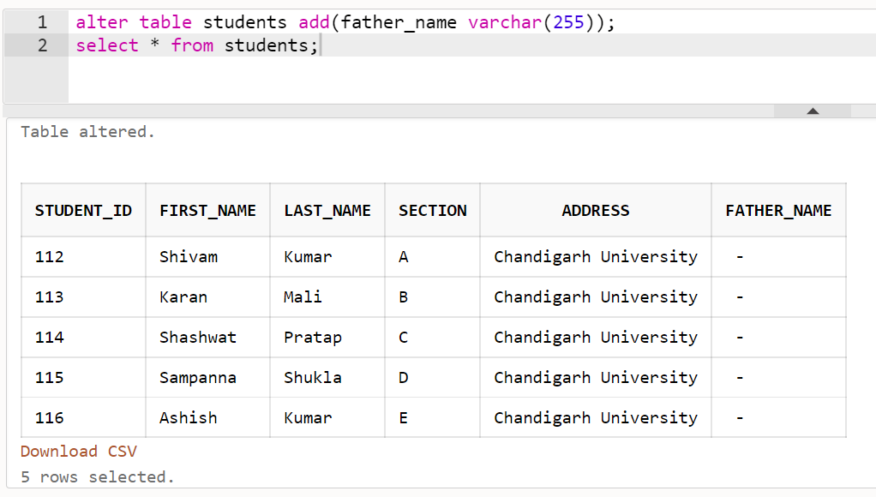

1. **ALTER Command (DROP):**

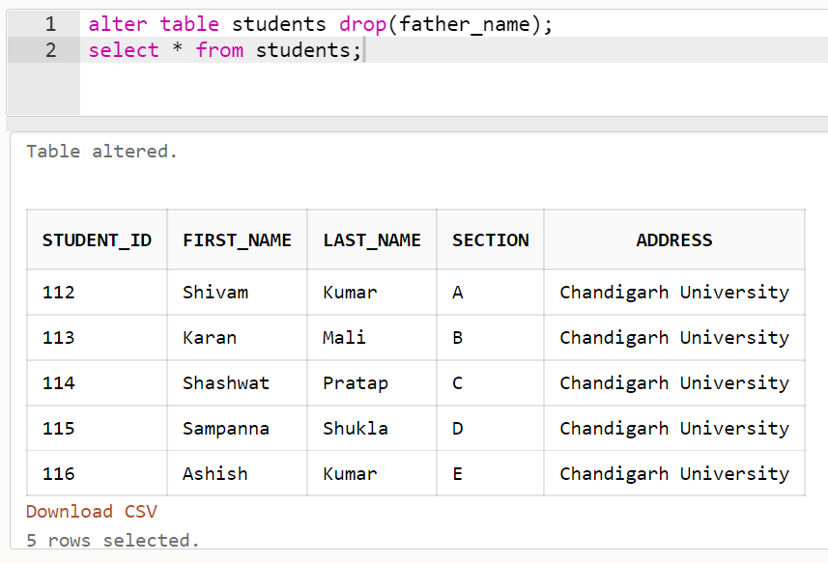

1. **RENAME Command:**

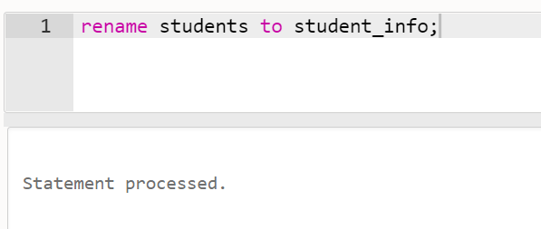

1. **TRUNCATE Command:**

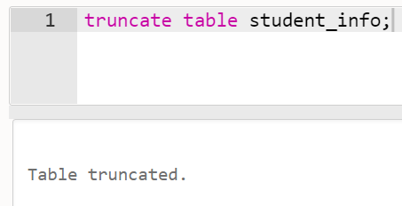

1. **DROP Command:**

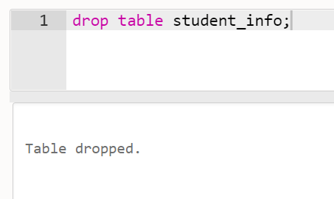

**ALL OPERATIONS:**

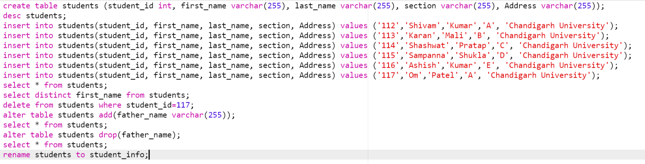

1. **UNION Command:**

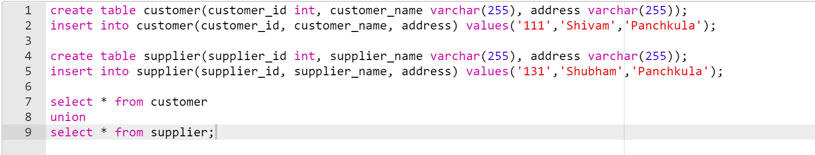

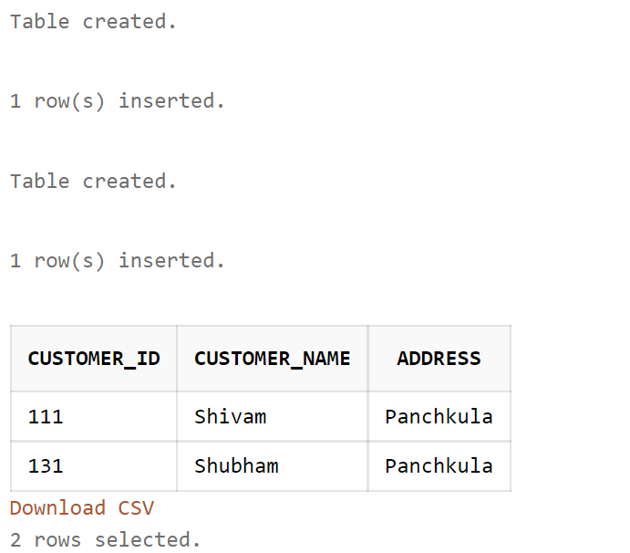

Learning outcomes:

1. Learned DDL, DML commands.
2. Learned about MYSQL commands and their uses.

Evaluation Grid:

|  |  |  |  |
| --- | --- | --- | --- |
| Sr. No. | Parameters | Marks Obtained | Maximum Marks |
| 1. | Student Performance  (Conduct of experiment) objectives/Outcomes. |  | 12 |
| 2. | Viva Voce |  | 10 |
| 3. | Submission of Work Sheet (Record) |  | 8 |
|  | Total |  | 30 |