Experiment 2.2

**Name: XYZ**

**UID: 21BCS2211**

**Section: 222-A Semester: 3**

**Subject: Database Management System (21CSH-214)**

# Aim:

1. >Write a program in PL/SQL to print factorial of a number.
2. >Write a program in PL/SQL to check whether a number is prime or not using goto statement with for loop.

# Code:

/* XYZ

21BCS1111

*/ declare n number; fac number:=1; i number;

begin n:=5; for i in 1..n loop fac:=fac*i; end loop;

dbms_output.put_line('factorial='||fac); end; /

|  |  |  |
| --- | --- | --- |
|  |  |  |

2.>

/* XYZ 21BCS1222

*/ declare n number; flag number:=1; i number;

begin n:=34; for i in 2..n/2 loop if n mod i =0 then flag:=0; exit; end if; end loop; if flag=1 then

dbms_output.put_line(n|| ' is prime');

else dbms_output.put_line(n ||' is not prime'); end if;

end; /

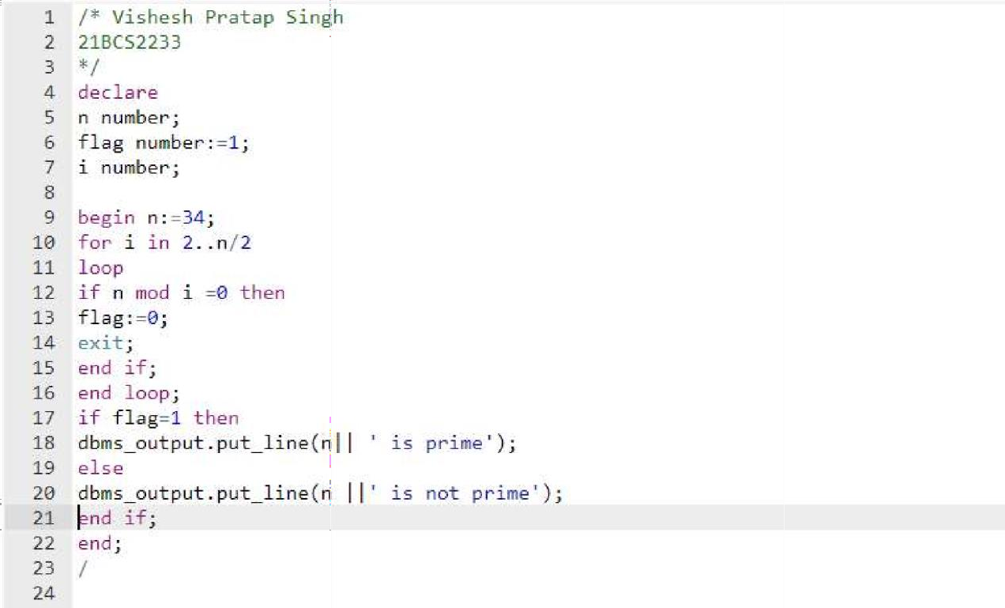

Outputs:

1.>

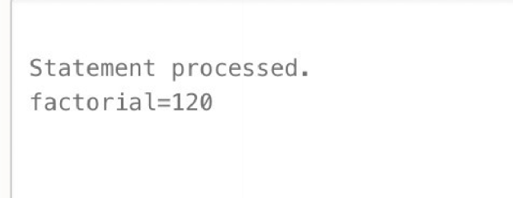

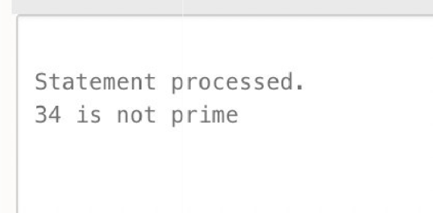2.>