**Experiment 1.1**

**Visit** [**https://alasso.tech/**](https://alasso.tech/)

Student Name: Alasso Branch:

UID: Section/Group:

Date of performance: Subject name: Digital Electronics



**Aim:**

Validate truth table for:

NAND gates HD74LS00

NOR gates HD74LS02

NOT gates HD74LS04

AND gates HD74LS08

XOR gates HD74LS86

**Task to be done:**

1.Identify various ICs and their specification

• NOR gate

• NOT gate

• AND gate

• XOR gate

• OR gate

2.To build and Simulate logic circuits, Observe and verify the output response.

**Requirements:**

IC for 7400, 7402, 7404, 7408, 7432, 7486, breadboard, connecting wires, 2 momentary switches, two 10 KΩ resistors, 220 Ω resistor, LED.

**Truth Tables:**

**NOR:**

|  |  |  |
| --- | --- | --- |
| A | B | Y |
| 0 | 0 | 1 |
| 0 | 1 | 0 |
| 1 | 0 | 0 |
| 1 | 1 | 0 |

**NOT:**

|  |  |
| --- | --- |
| A | Y |
| 0 | 1 |
| 1 | 0 |

**AND:**

|  |  |  |
| --- | --- | --- |
| A | B | Y |
| 0 | 0 | 0 |
| 0 | 1 | 0 |
| 1 | 0 | 0 |
| 1 | 1 | 1 |

**XOR:**

|  |  |  |
| --- | --- | --- |
| A | B | Y |
| 0 | 0 | 1 |
| 0 | 1 | 0 |
| 1 | 0 | 0 |
| 1 | 1 | 1 |

**OR:**

|  |  |  |
| --- | --- | --- |
| A | B | Y |
| 0 | 0 | 0 |
| 0 | 1 | 1 |
| 1 | 0 | 1 |
| 1 | 1 | 1 |

**Circuit diagram/ Block diagram:**

1. CIRCUT DIAGRAM OF NOR GATES HD74LS02

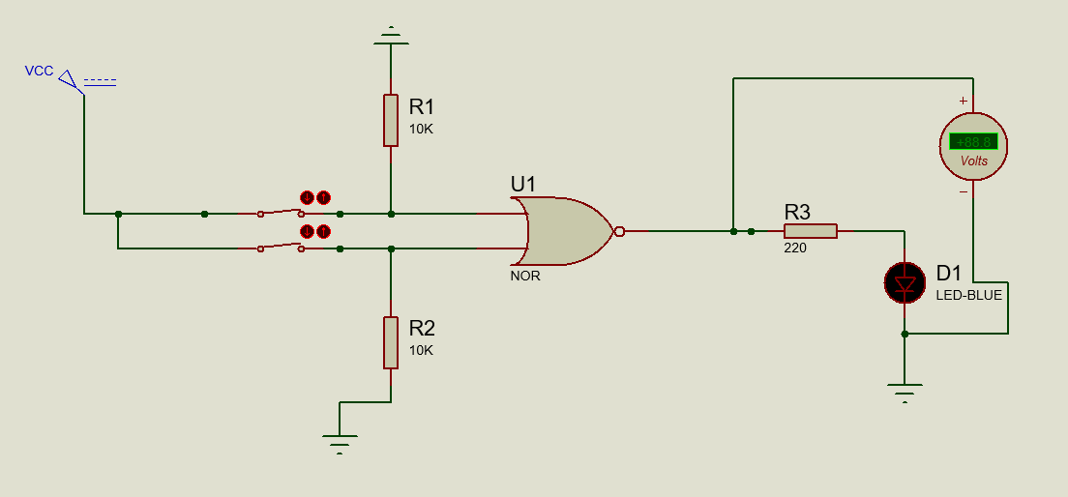

2. CIRCUIT DIAGRAM OF NOT GATES HD74LS04

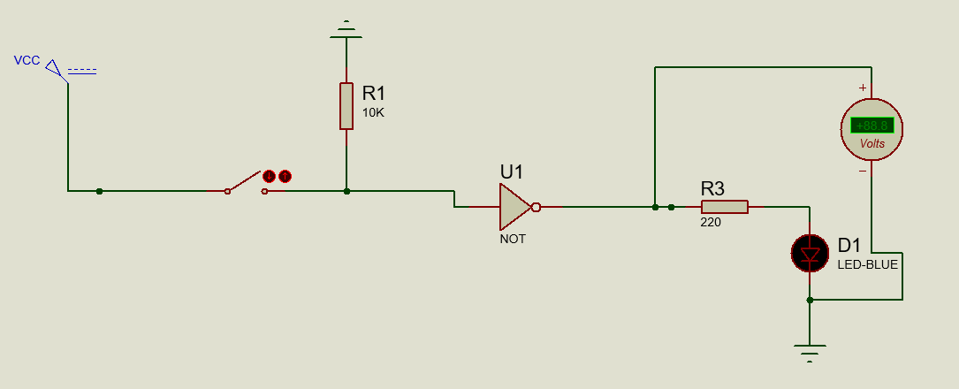

3. CIRCUIT DIAGRAM OF AND GATES HD74LS08

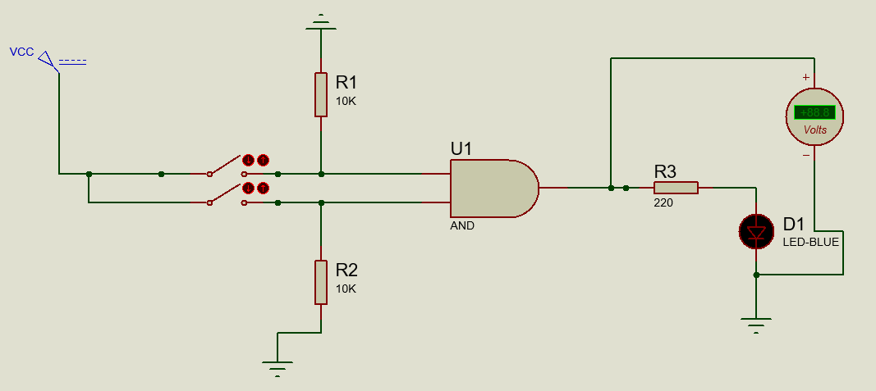

4. CIRCUIT DIAGRAM OF XOR GATES HD74LS86

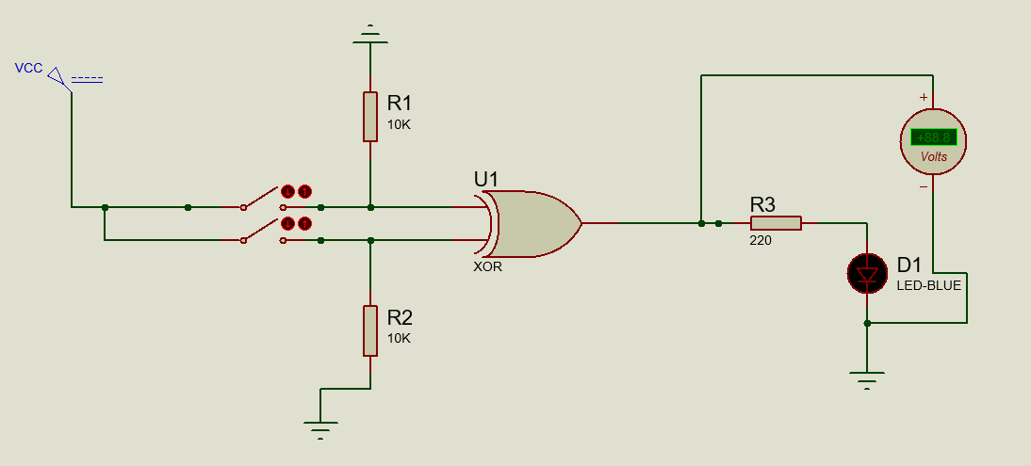

5. CIRCUIT DIAGRAM OF OR GATES HD74LS32

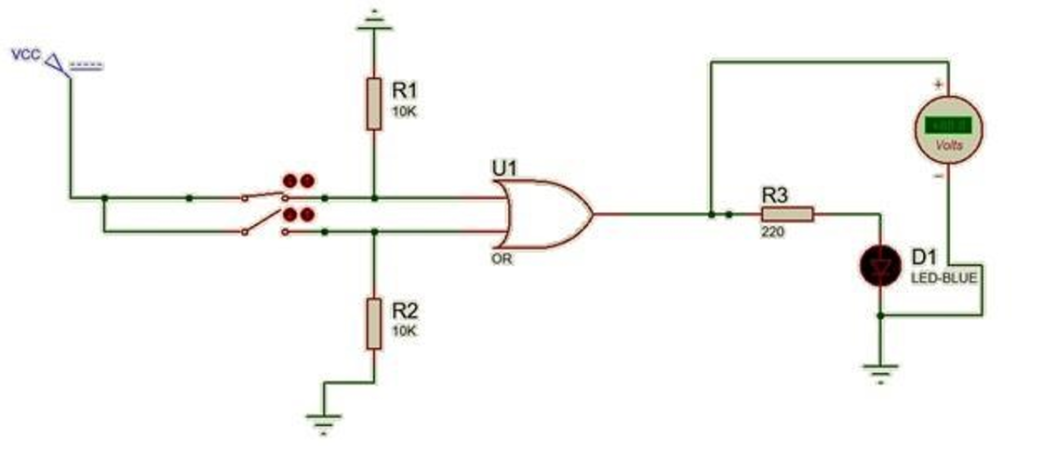

**Simulation Results:**

**NOR GATE:**

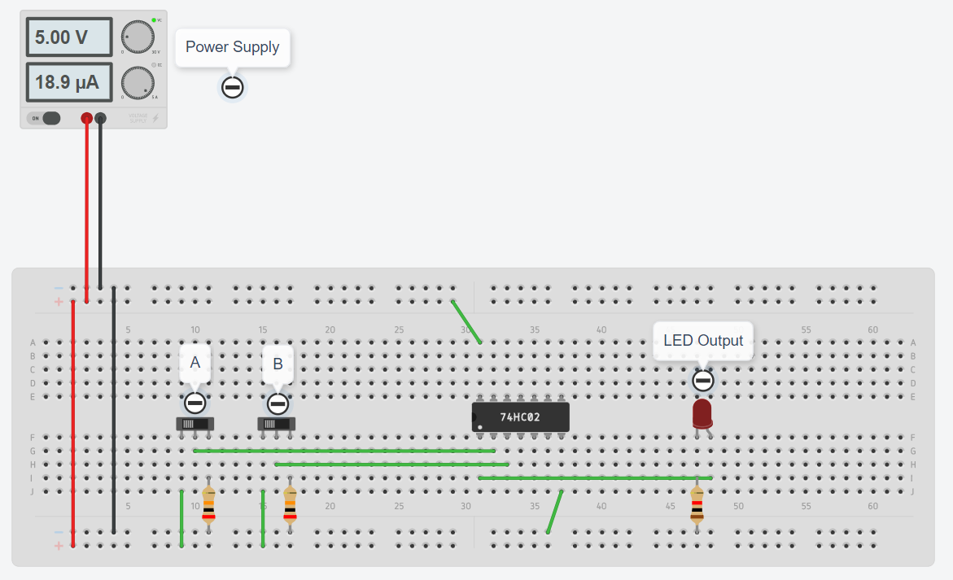

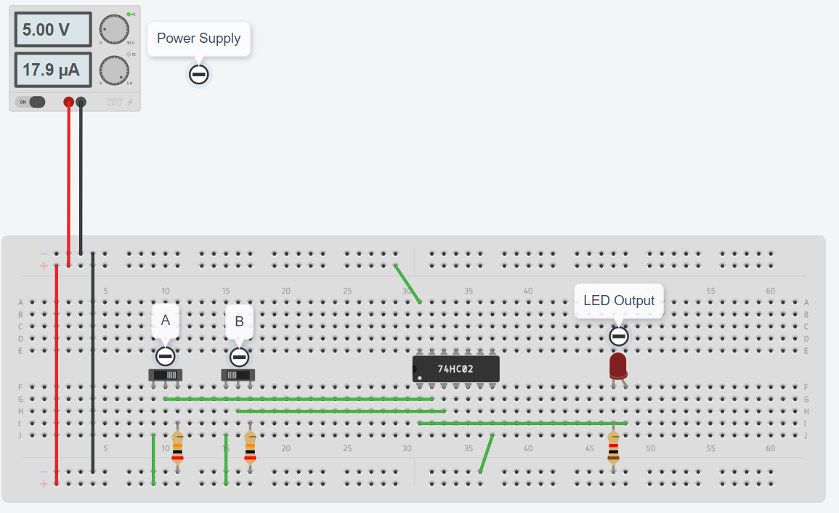

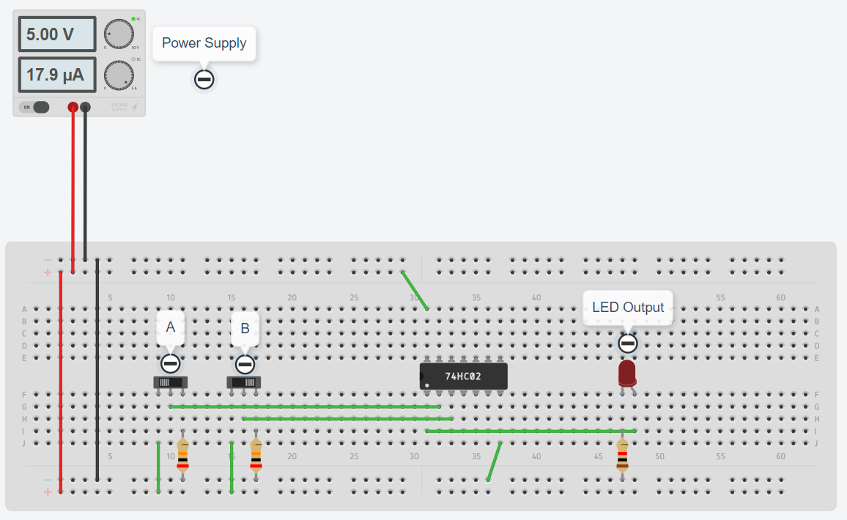

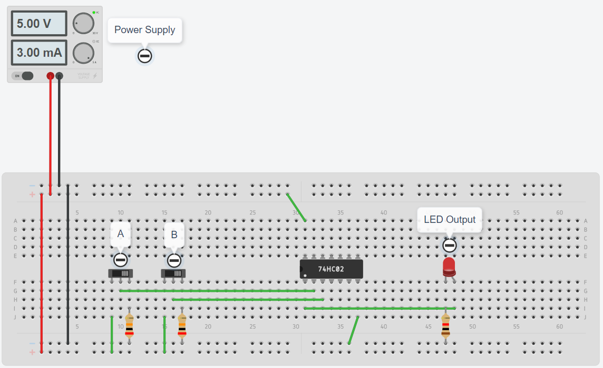

**NOT GATE:**

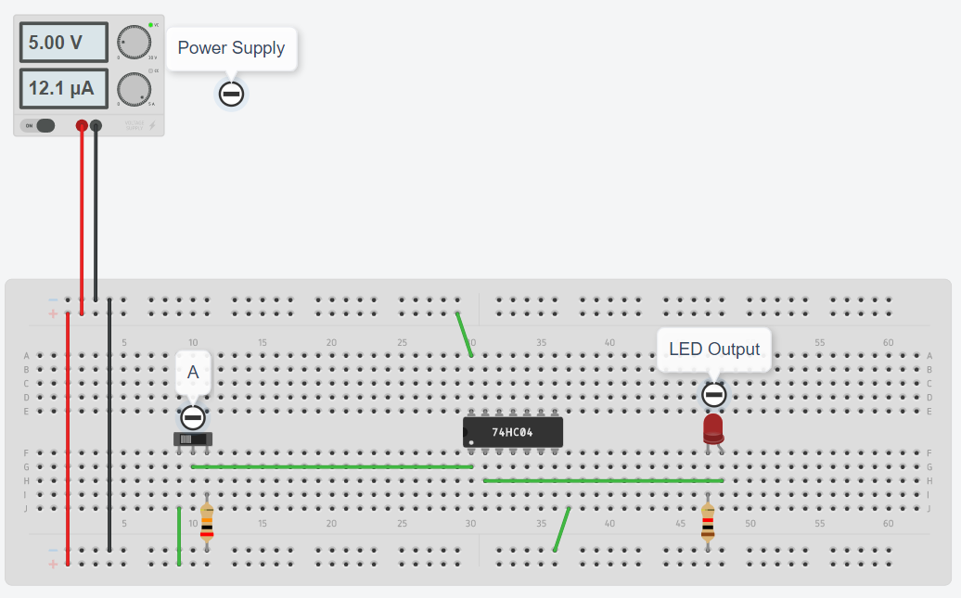

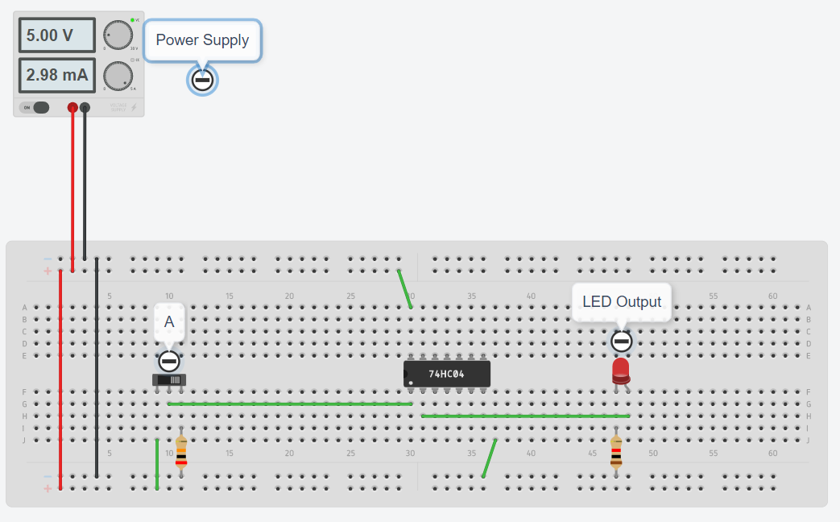

**AND GATE:**

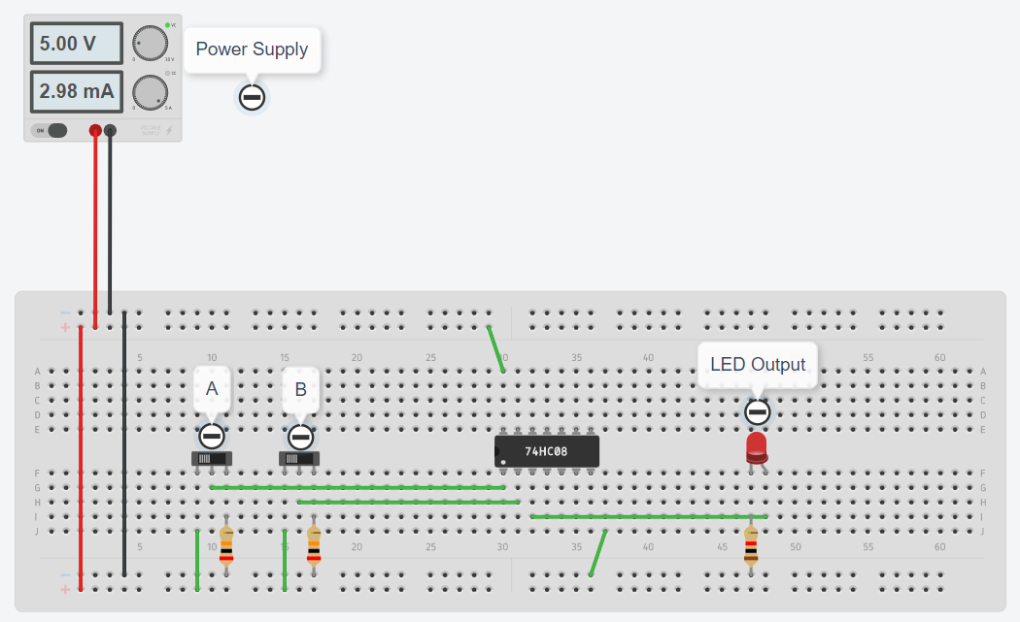

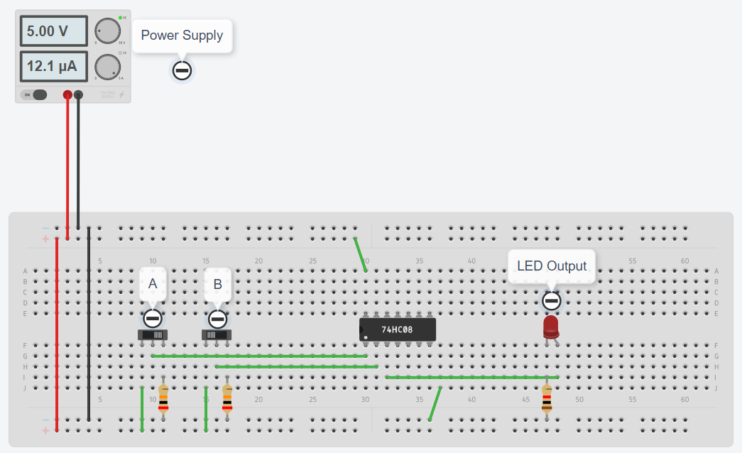

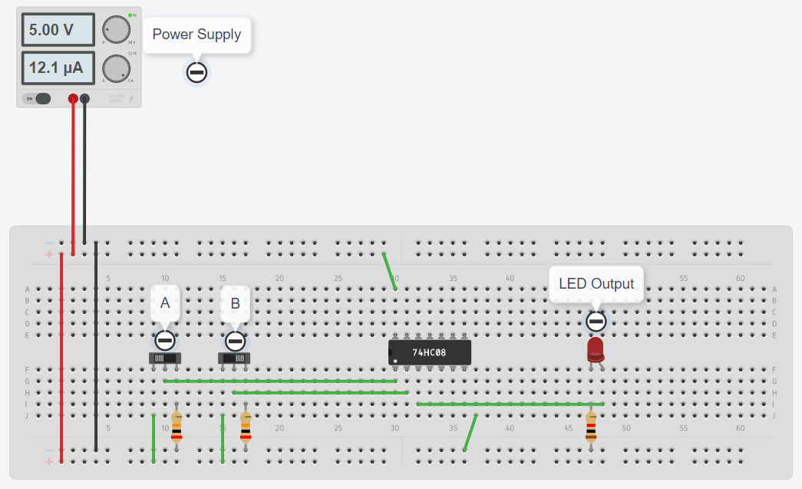

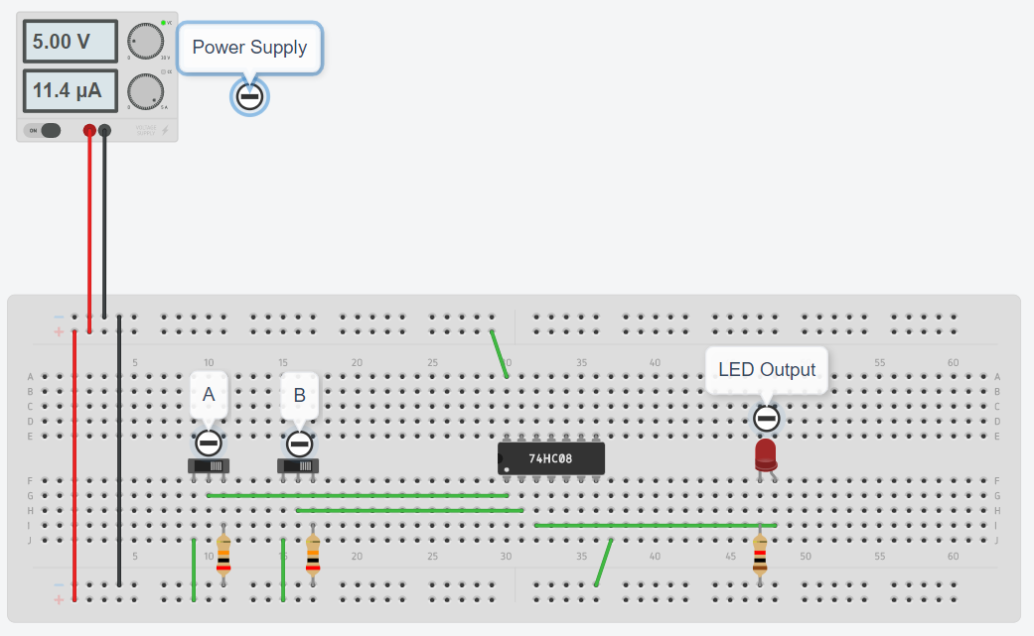

**XOR Gate:**

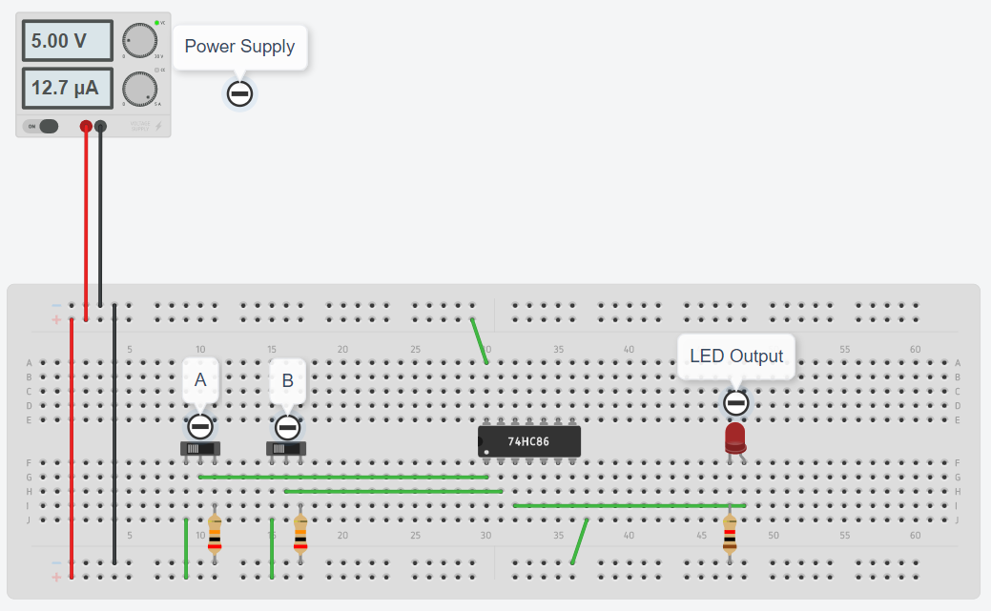

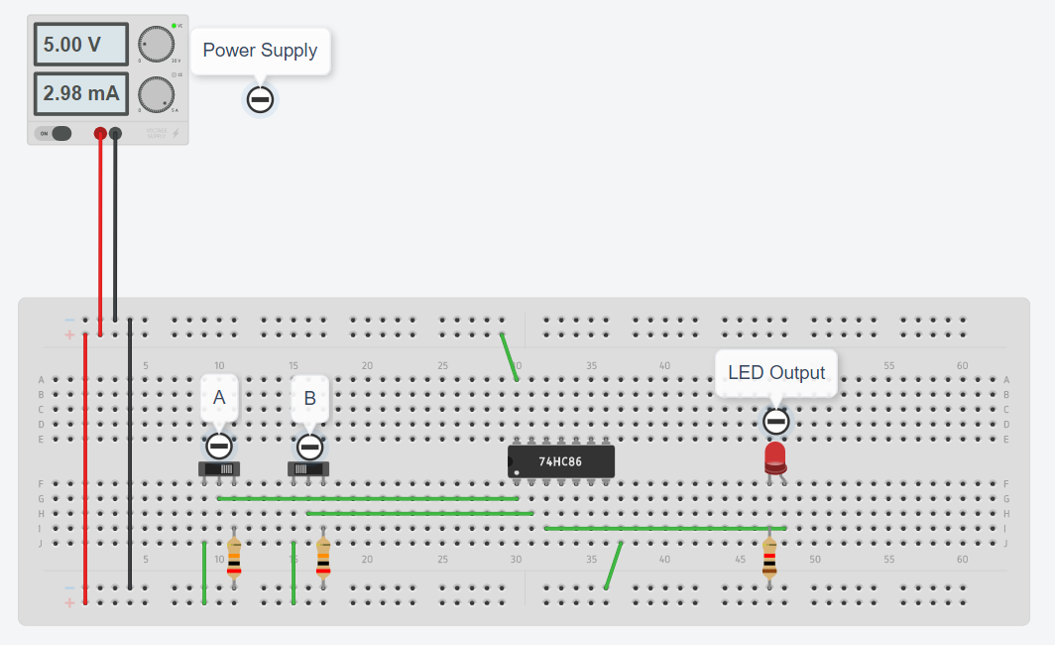

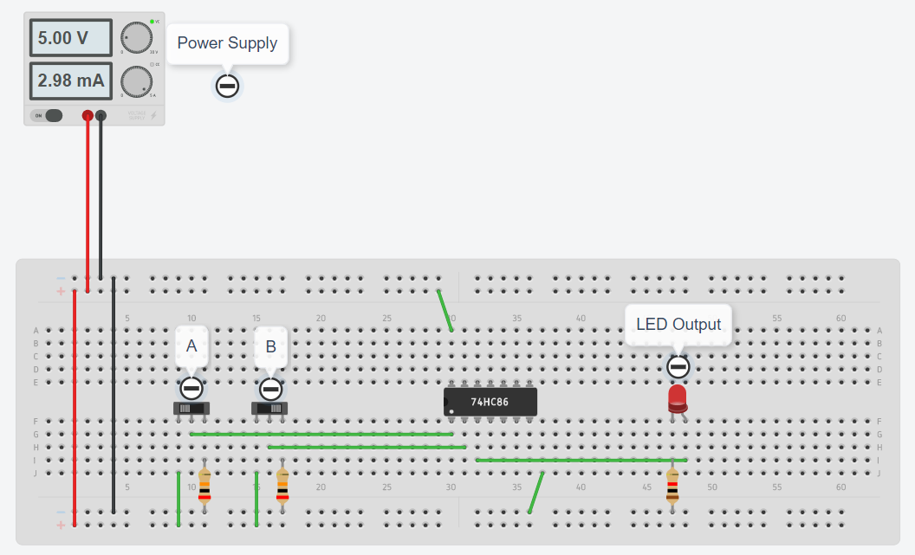

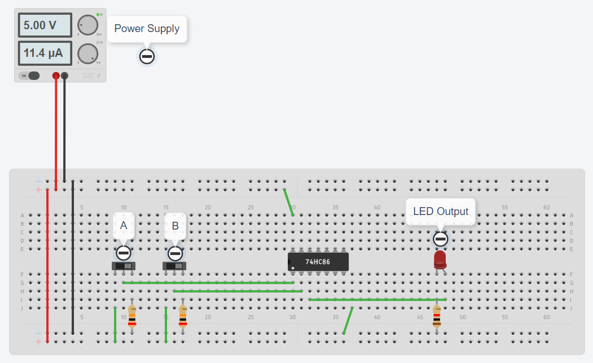

**OR GATE:**

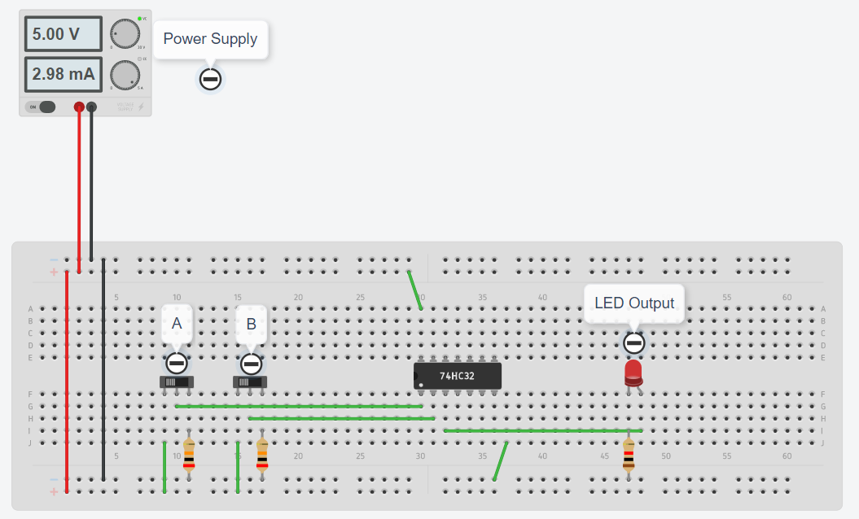

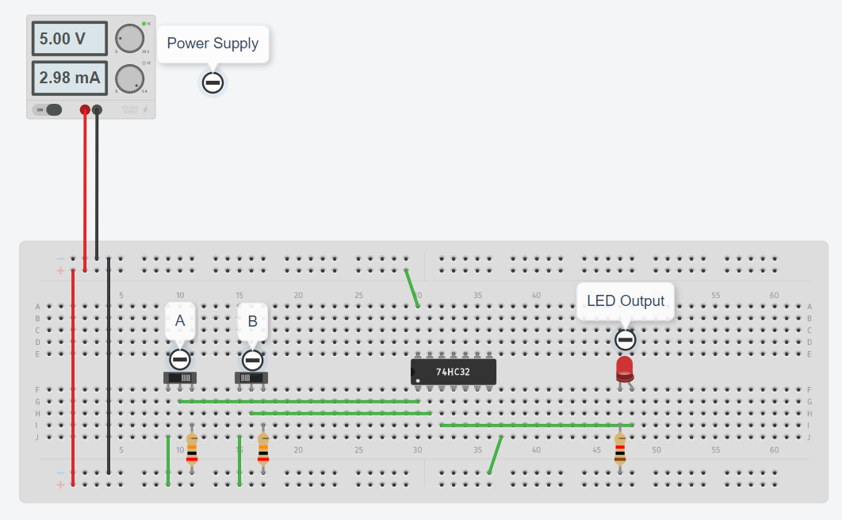

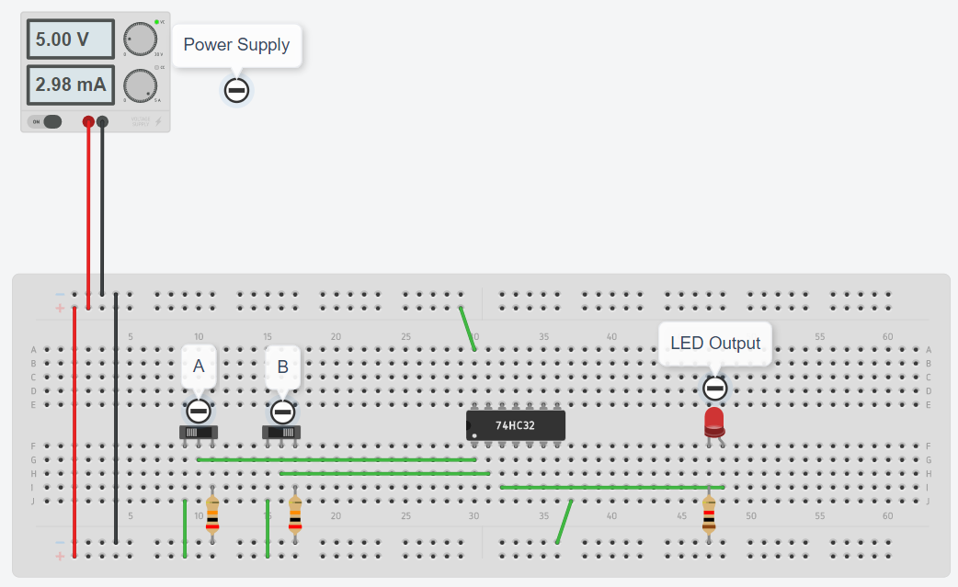

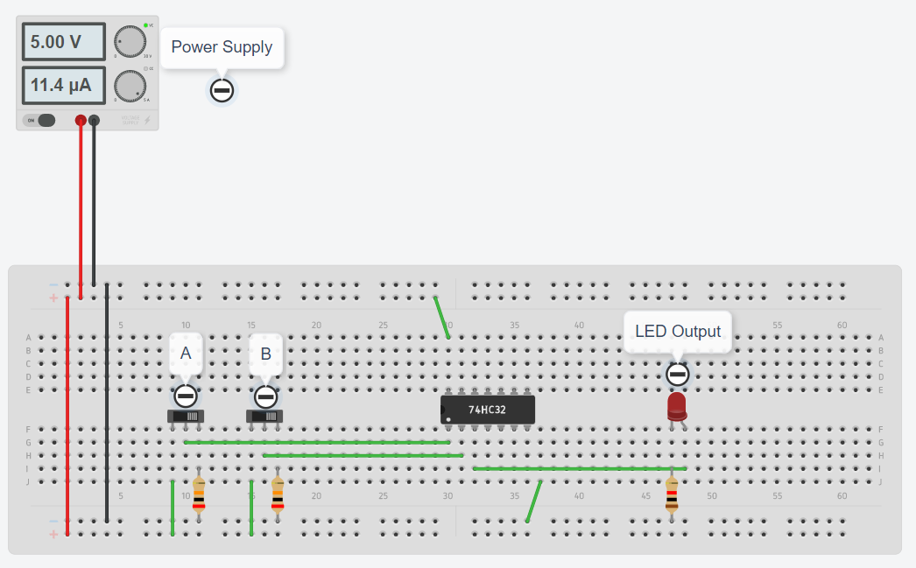



**Concept used:**

AND, OR and NOT gates are basic gates. XOR and XNOR are universal gates. Basically, logic gates are electronic circuits because they are made up of number of electronic devices and components. Inputs and outputs of logic gates can occur only in two levels. These two levels are term HIGH and LOW, or TRUE and FALSE, or ON AND off, OR SIMPLY 1 AND 0. A table which lists all possible combinations of input variables and the corresponding outputs is called a „truth table‟. It shows how the logic circuit’s output responds to various combinations of logic levels at the inputs.

1.NOR GATE: The NOR gate is a contraction of OR-NOT. The output is high when both inputs are low. The output is low when one or both inputs are high.

2.NOT GATE: The NOT gate is called an inverter. The output is high when the input is low. The output is low when the input is high.

3.AND GATE: The AND gate performs a logical multiplication commonly known as AND function. The output is high when both the inputs are high. The output is low level when any one of the inputs is low.

4.X-OR GATE: The output is high when any one of the inputs is high. The output is low when both the inputs are low and both the inputs are high.

5.OR GATE: A HIGH output results if one or both the inputs to the gate are HIGH. If neither input is high, a LOW output results.

**Learning/ observation:**

By doing this experiment we learn about the different applications of logic gates. We also learnt about their “IC” numbers the truth tables of logic gates NOR, AND, NOT, OR, XOR was verified on circuits over a breadboard. We see their use of logic gates in daily life examples such as as fan on/off switch.

**Result:**

The truth tables of logic gates NOR, AND, NOT, OR, XOR was verified on circuits over a breadboard.

**Evaluation Grid:**

|  |  |  |  |
| --- | --- | --- | --- |
| Sr. No. | Parameters | Marks Obtained | Max Marks |
| 1. | Worksheet completion including writing learning objectives/Outcomes. (To be submitted at the end of the day). |  | 10 |
| 2. | Post Lab Quiz Result. |  | 5 |
| 3. | Student Engagement in Simulation/Demonstration/Performance  and Controls/Pre-Lab Questions. |  | 5 |
|  | Signature of Faculty (with Date): | Total marks obtain |  |

