**Experiment 1.2**

**Visit** [**https://alasso.tech/**](https://alasso.tech/)

Student Name: Alasso Branch:

UID: Section/Group:

Date of performance: Subject name: Digital Electronics

**Aim:**

1. Design a burglar alarm (AND).
2. Design a single doorbell ringer for both front and back doors (OR).

**Apparatus:**

7404 (NOT) IC, 7408 (AND) IC, 7432 (OR) IC, 5V Power Supply, Breadboard, Connecting wires, Simulation software, Windows 10 PC

**Circuit diagram/ Block diagram**

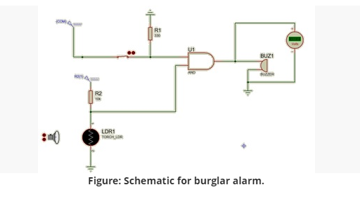

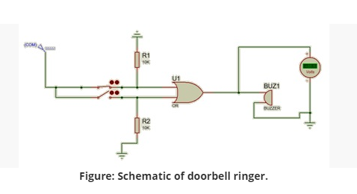

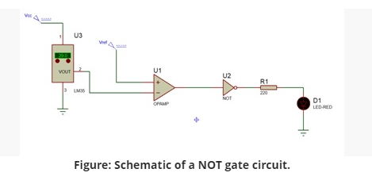

**Simulation Results:**

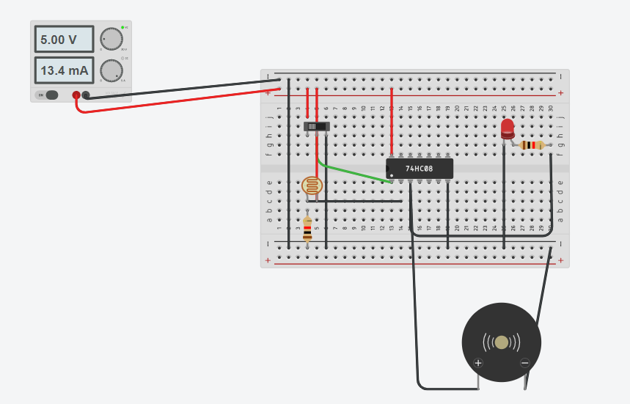

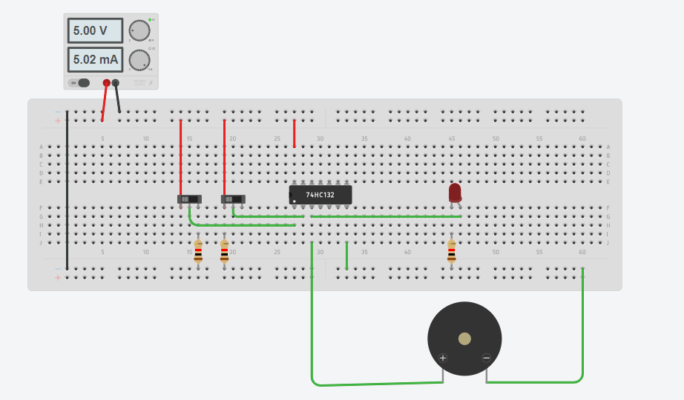

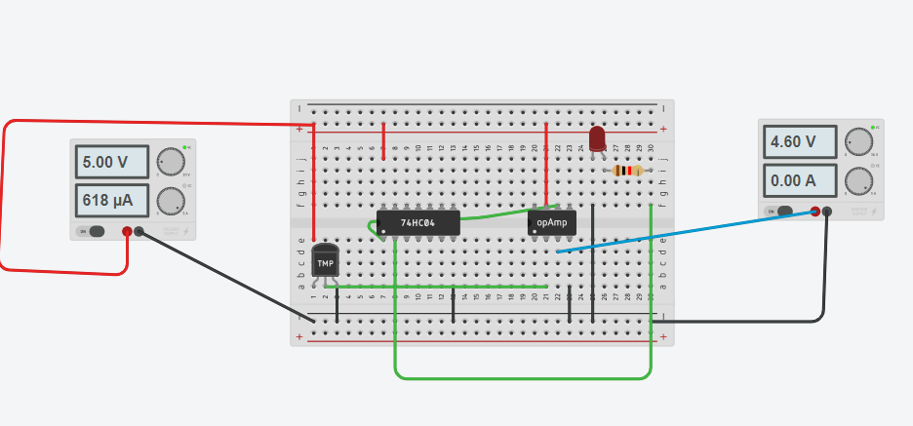

**Result**

The integrated circuits and their connections on the breadboard were studied and implemented. The practical applications of logic gates (AND, OR & NOT) were studied and implemented.

**Evaluation Grid:**

|  |  |  |  |
| --- | --- | --- | --- |
| Sr. No. | Parameters | Marks Obtained | Max Marks |
| 1. | Worksheet completion including writing learning objectives/Outcomes. (To be submitted at the end of the day). |  | 10 |
| 2. | Post Lab Quiz Result. |  | 5 |
| 3. | Student Engagement in Simulation/Demonstration/Performance  and Controls/Pre-Lab Questions. |  | 5 |
|  | Signature of Faculty (with Date): | Total marks obtain |  |

