**Experiment 1.4**

**Visit** [**https://alasso.tech/**](https://alasso.tech/)

Student Name: Alasso Branch:

UID: Section/Group:

Date of performance: Subject name: Digital Electronics

**Aim:**

Design and realize a given function using K-maps and verify its performance.

**Apparatus:**

7486 (XOR) IC, 5V Power Supply, Breadboard, Connecting wires, Simulation software, Windows 10 PC

**Circuit diagram/ Block diagram**

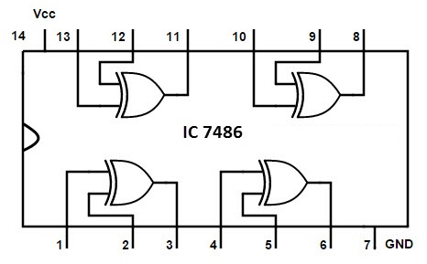

**Simulation Results:**

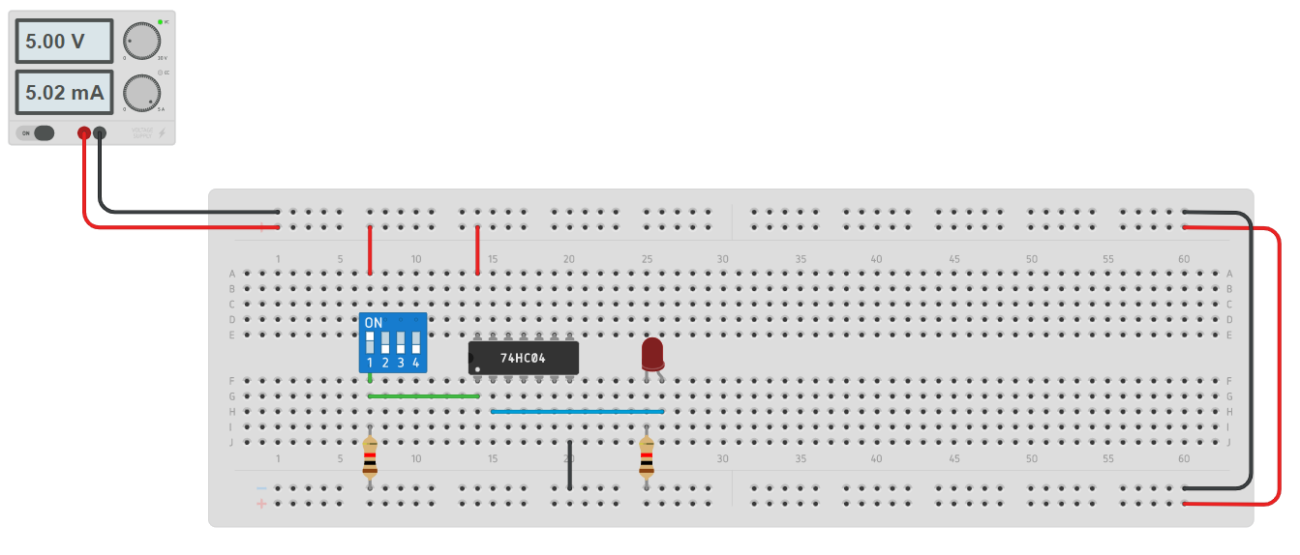

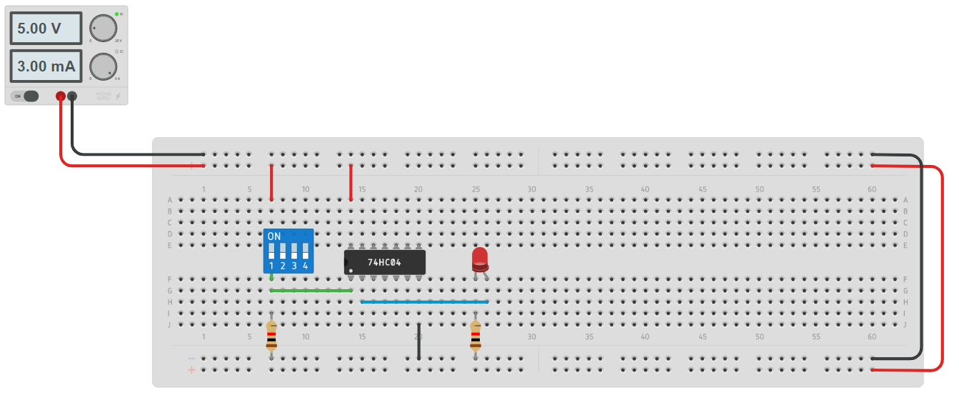

**Concept used**

|  |  |  |
| --- | --- | --- |
| INPUTS | | OUTPUTS |
| A | B | Y=A’B+AB’ |
| 0 | 0 | 0 |
| 0 | 1 | 1 |
| 1 | 0 | 1 |
| 1 | 1 | 1 |

**Result-**

Simplified and verified the Boolean function using basic gates and universal gates.

**Evaluation Grid:**

|  |  |  |  |
| --- | --- | --- | --- |
| Sr. No. | Parameters | Marks Obtained | Max Marks |
| 1. | Worksheet completion including writing learning objectives/Outcomes. (To be submitted at the end of the day). |  | 10 |
| 2. | Post Lab Quiz Result. |  | 5 |
| 3. | Student Engagement in Simulation/Demonstration/Performance  and Controls/Pre-Lab Questions. |  | 5 |
|  | Signature of Faculty (with Date): | Total marks obtain |  |

