

**Experiment 1.4**

**Visit** [**https://alasso.tech/**](https://alasso.tech/)

Student Name: Alasso Branch:

UID: Section/Group:

Date of performance: Subject name: Physics

**AIM OF THE EXPERIMENT –**

To determine the divergence of laser beam.

**APPARATUS-**

1.) Power Supply

2.) Diode Laser

3.) Stand

**PROCEDURE-**

Arrange the apparatus.

Pencil, draw the circular spot on the paper and measure the vertical and horizontal diameters of the circular spot. Calculate the mean of both values to get the accurate value of the diameter. This is the waist size WI

Now distance screen in the direction of beam propagation by a known distance D (total distance from laser becomes (Z+D) and measure spot size W2 as measured in previous step.

Now displace screen further away by same value D, so the new distance becomes (Z+2D).

Measure spot size W3

Put the values in the formula and calculate laser divergence.

**OBSERVATIONS-**

Initial distance between laser and screen 50cm

Displacement of screen D: 25cm

|  |  |  |  |  |
| --- | --- | --- | --- | --- |
| S. NO. | Distance(cm) | Diameter(mm) |  |  |
|  | z=50 | 0.028 | 0.40306 | |
| 2. | Z+D=75 | 0.042 |
| 3. | Z+2D=100 | 0.056 |

1

**CALCULATIONS-**



**Formula used:**

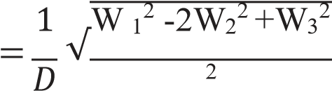

**PERCENTAGE ERROR-**

No error occurred

**GRAPH**

**1)**

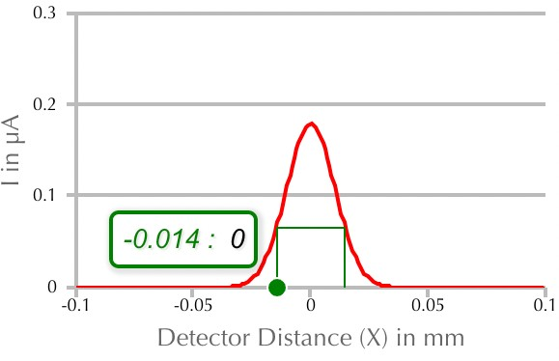

**2)**

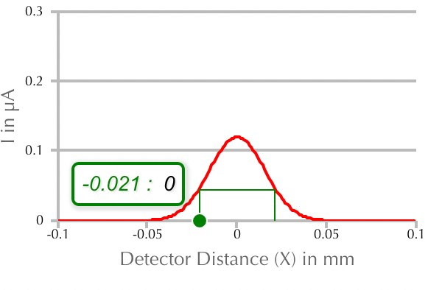

2

3.) 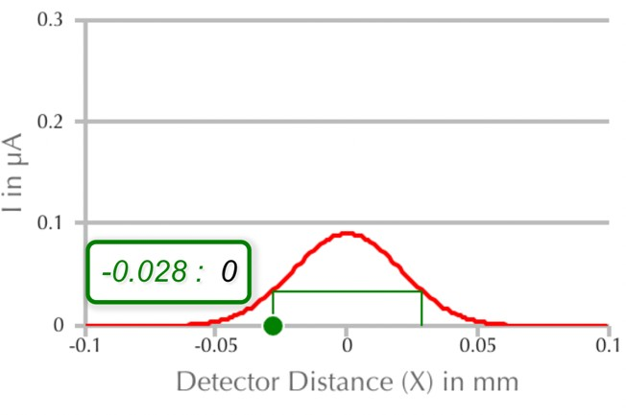



**RESULTS AND DISCUSSION-**

The angle of divergence of the diode laser is 0.40306 milliradian.

**CONCLUSION-**

Since this angle is very small (in the range of milliradian), we conclude that laser beam is highly directional as compared to ordinary light source.

**LEARNING OUTCOMES**

1. It will provide the modest experience that allows students to develop and improve their experimental skills and develop ability to analyze data.
2. Ability to demonstrate the practical skill on measurements and instrumentation techniques of some Physics experiments. Students will develop the ability to use appropriate physical concepts to obtain quantitative solutions to problems in physics.
3. Students will demonstrate basic experimental skills by setting up laboratory equipment safely and efficiently, plan and carry out experimental procedures, and report verbally and in written language the results of the experiment.
4. Students will develop skills by the practice of setting up and conducting an experiment with due regards to minimizing measurement error.

3



**EVALUATION COLUMN**

|  |  |  |  |
| --- | --- | --- | --- |
| **Sr. No.** | **Parameters** | **Maximum Marks** | **Marks Obtained** |
| 1. | Worksheet completion including writing learning objectives/Outcomes. (To be  submitted at the end of the day) | 10 |  |
| 2. | Post Lab Quiz Result. | 5 |  |
| 3. | Student Engagement in Simulation/Demonstration/Performance and Controls/Pre-Lab Questions. | 5 |  |
| 4. | Total Marks | 20 |  |
| 5. | Teacher’s Signature (with date) |  | |



4