**Experiment 1.2**

**Visit** [**https://alasso.tech/**](https://alasso.tech/)

Student Name: Alasso Branch:

UID: Section/Group:

Date of performance: Subject name: Physics

**AIM OF THE EXPERIMENT**–To determine the diffraction using laser beam and find the grating element of diffraction grating.



**APPARATUS-**

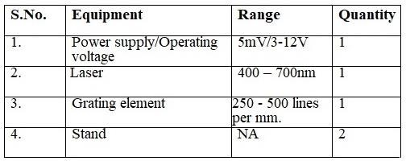

# OBSERVATIONS-

1. Wavelength of Diode laser, λ= 445
2. Distance between diffraction grating and screen, D= 10m iii. Standard Grating Element (d) = 1mm/400 = 0.0000025 m

|  |  |  |  |  |  |  |  |
| --- | --- | --- | --- | --- | --- | --- | --- |
| **S.NO.** | **Order of Diffraction( n)** | **Position of nth order maxima(m)** | **Mean distance of nth order maxima** | **Distance between Grating and screen(D) (m)** | **Sin theta** | | **d = in** (m) |
| **1.** | **1** | **OPleft = 2.3**  **OPright = 2.3** | **2.3** | **10** | **0.2441** | **0.00000281** | |
| **2.** | **2** | **OPleft = 4.6**  **OPright = 4.6** | **4.6** | **10** | **0.4117** | **0.000002660** | |

#### Mean Grating Element = 0.0000002565



**OBSERVATIONS: -**

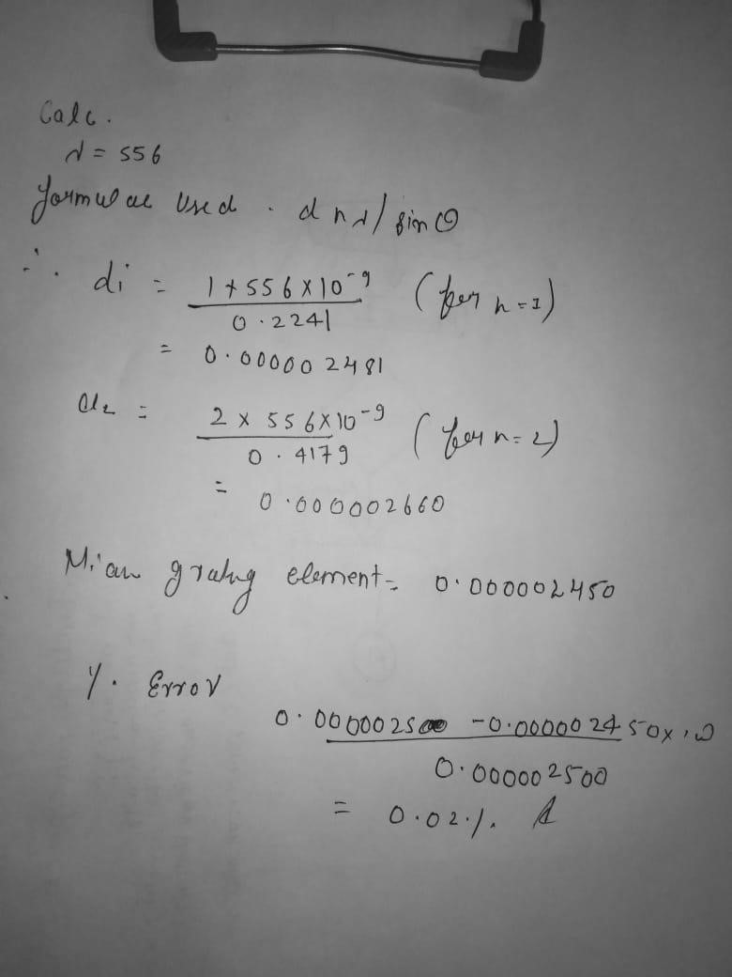



# RESULT AND DISCUSSION: -

## Grating Element, d= 0.000002565

### SOURCES OF ERROR: -

* 1. Laser light should not fall on eyes of observer directly.
  2. All lengths should be measured in same unit.
  3. Distance between the spots should be measured accurately

## CONCLUSIONS: -

We found out a diffraction grating has a very large number of equally spaced slits. When parallel light is incident on a diffraction grating each slit acts as a source of diffracted waves. Those waves therefore interact with one another. Diffracted lights shine on a distant screen which has a central bright spot labelled m=0 and a higher order bright fringes that can also be observed.

#### LEARNING OUTCOMES

#### It will provide the modest experience that allows students to develop and improve their experimental skills and develop ability to analyze data.

#### Ability to demonstrate the practical skill on measurements and instrumentation techniques of some Physics experiments. Students will develop the ability to use appropriate physical concepts to obtain quantitative solutions to problems in physics.

#### Students will demonstrate basic experimental skills by setting up laboratory equipment safely and efficiently, plan and carry out experimental procedures, and report verbally and in written language the results of the experiment.

#### Students will develop skills by the practice of setting up and conducting an experiment with due regards to minimizing measurement error.

**Evaluation Grid:**



|  |  |  |  |
| --- | --- | --- | --- |
| Sr. No. | Parameters | Marks Obtained | Max Marks |
| 1. | Worksheet completion including writing learning objectives/Outcomes. (To be submitted at the end of the day). |  | 10 |
| 2. | Post Lab Quiz Result. |  | 5 |
| 3. | Student Engagement in Simulation/Demonstration/Performance  and Controls/Pre-Lab Questions. |  | 5 |
|  | Signature of Faculty (with Date): | Total marks obtain |  |