***BIG DATA ANALYTICS(SWE2011)***

DIGITAL ASSIGNMENT-1

*Name:R.Lokesh Kannan*

*Register no.:22MIS1155*

*Aim:*

To create a mapreduce program that returns the average of the ratings given by the user for different movies.

*Tools Used:*

Hadoop-2.7.2

*Procedure:*

1.Create AverageMovieRating.java file which consists of the mapreduce program

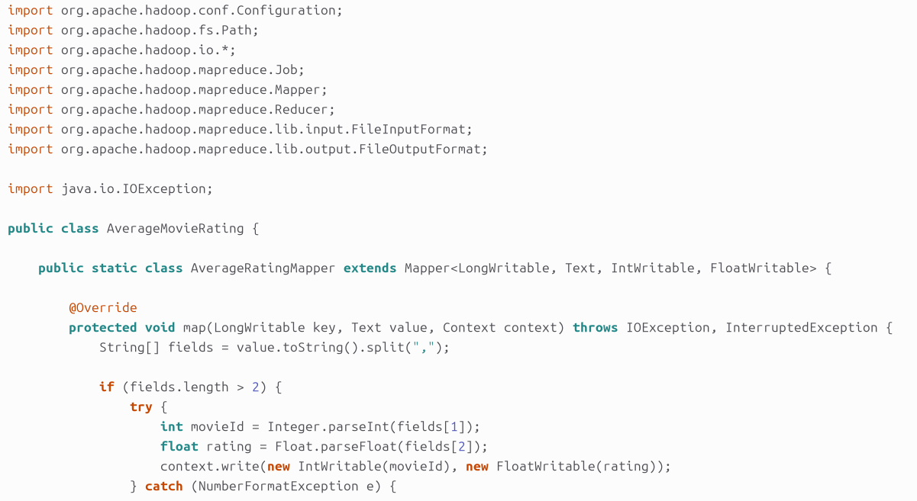

2.Convert the java file into an executable jar file using terminal

3.Execute the jar file in the terminal

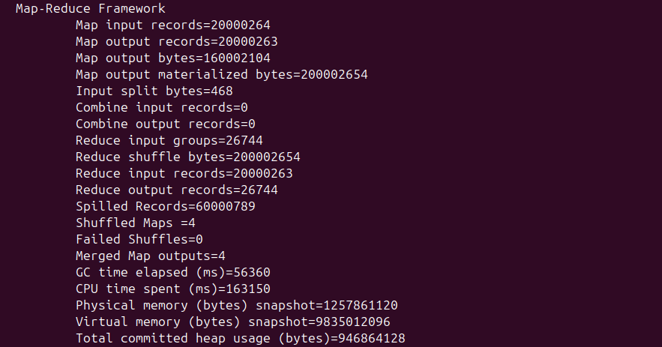

4.View output in the terminal

