**BIG DATA ANALYTICS(SWE2011)**

**Name :** Lokesh Kannan

**Reg. no :** 22MIS1155

**Aim:**

To gather a dataset (creditcard.csv) and implement the SOM model.

**Tools Used:**

Jupyter notebook

**Outputs:**

1.

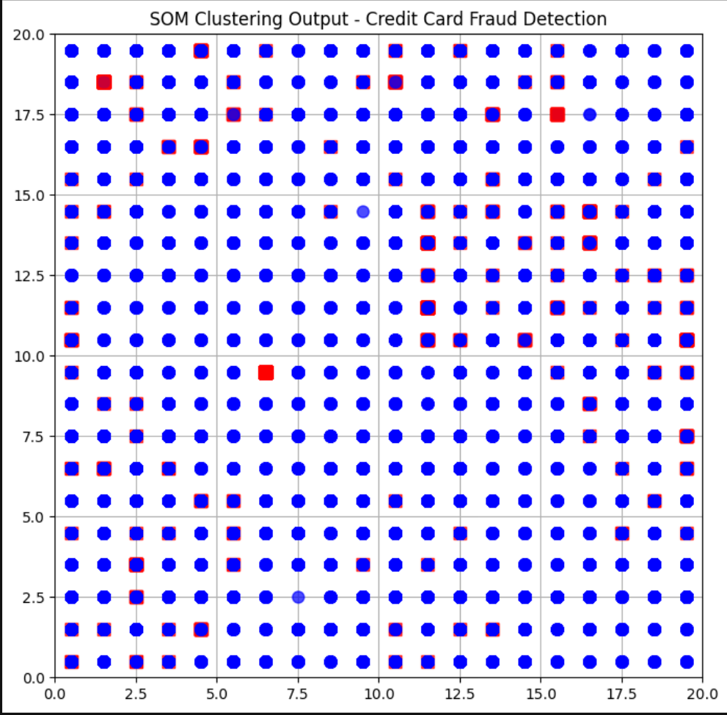

Each point on the grid represents a neuron, and the markers (dots and squares) are plotted over the neurons that correspond to the winning nodes for each transaction. **Non-fraudulent transactions** are marked with blue circles, while **fraudulent transactions** are marked with red squares.

2.

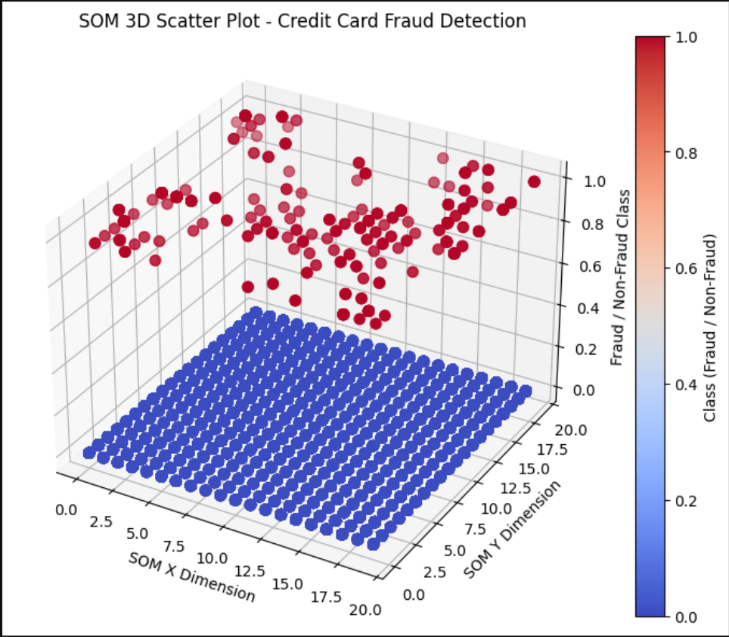

The plot represents how the credit card transactions (data points) are mapped to the SOM grid. Each point in the plot corresponds to a transaction that has been classified as either **fraudulent or non-fraudulent.** The X and Y coordinates represent the positions of the winning neurons on the SOM grid. The Z axis indicates whether the transaction is fraudulent 1 or not 0.

3.

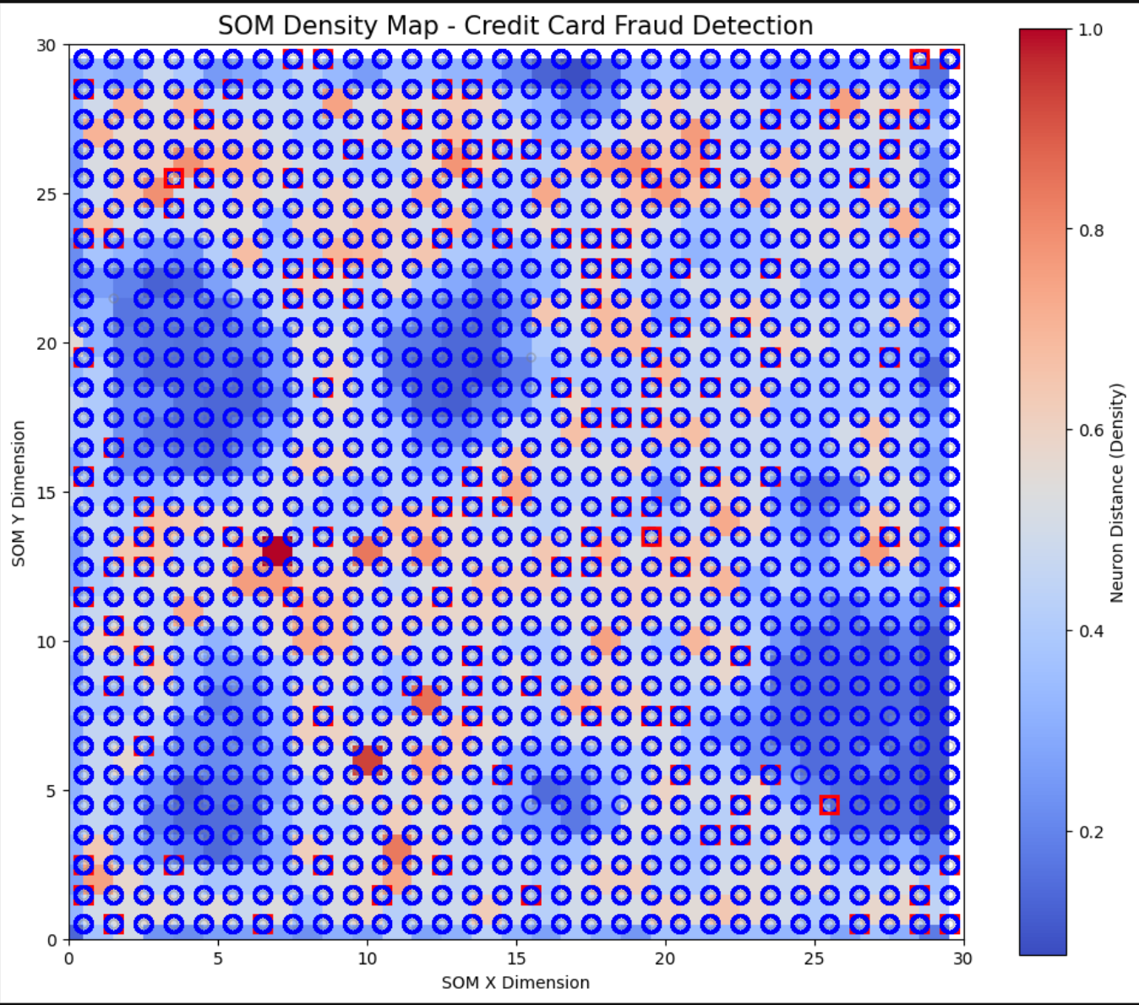

Red areas represent **sparse regions**, indicating that the neurons are distant from each other. These areas may represent data boundaries or regions where data points are dissimilar. Blue areas represent **dense regions**, indicating that the neurons are close together.**Non-fraudulent transactions** are marked with blue circles while the **fraudulent transactions** are marked with red squares.