III B.Sc ECS

Lokesh K,Anandha Krishnan ,Muhammad saheer ,Nikhil ,Vignesh

**Abstract:**

The smart weather station project employs the ESP32 microcontroller and a variety of sensors to gather environmental data, including temperature, humidity, air quality, light intensity, and rainfall. The sensors used are BMP280 for temperature, pressure, and altitude, DHT11 for temperature and humidity, MQ-135 for gas detection; LDR for light intensity; and a rain sensor for rainfall. The ESP32 collects this data and sends it to a Telegram bot, enabling real-time monitoring directly from a smartphone. This project provides a compact, efficient solution for precise and continuous weather monitoring, with applications in agriculture, environmental studies, and public safety.

**Block Diagram:**

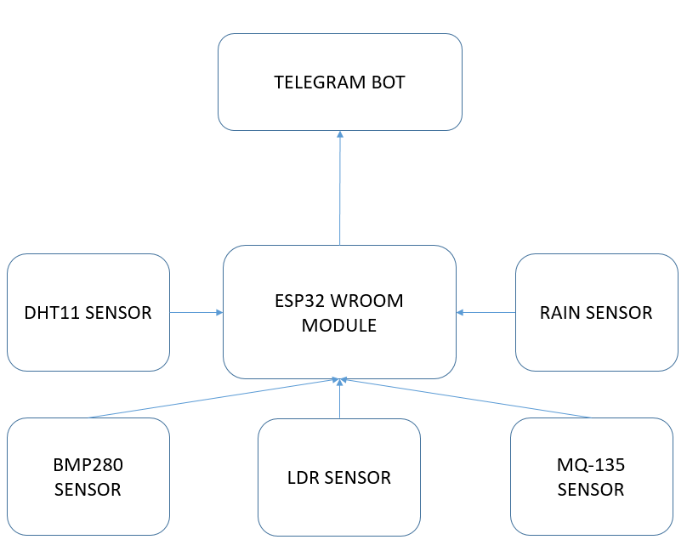

**Components:**

* **ESP32 WROOM**: Functions as the brain of the system and sends data to the Telegram bot using Wi-Fi.
* **BMP280**: Measures atmospheric pressure, temperature, and altitude.
* **DHT11**: Monitors temperature and humidity levels.
* **MQ-135**: Detects gases, providing air quality data.
* **LDR (Light Dependent Resistor)**: Measures ambient light intensity.
* **Rain Sensor**: Detects and measures rainfall.
* **Power Supply**: Powers the ESP32 and sensors.
* **Breadboard and Jumper Wires**: Used for circuit connections.

**Applications:**

* **Agricultural Monitoring**: Sends critical weather data via Telegram for improved crop management and irrigation planning.
* **Urban Environment Monitoring**: Provides air quality data through Telegram notifications, assisting in pollution control and public health awareness.
* **Weather Forecasting**: Enhances real-time meteorological data collection for improved forecasting.
* **Environmental Research**: Supplies data via Telegram for studying climate change and environmental trends.

**Advantages:**

* **Real-time Data**: Delivers continuous updates on weather and air quality conditions through instant Telegram notifications.
* **Remote Accessibility**: Data can be received on any device with Telegram, ensuring seamless remote monitoring.
* **Cost-effectiveness**: Utilizes affordable components with efficient data delivery mechanisms.
* **Scalability**: Additional sensors can be integrated, and data can be customized for Telegram reports.
* **User-friendly**: Telegram bot provides a simple interface for receiving and viewing data.