EE2026 Selected Questions Pack
Compiled from Tutorials 5–8 and Extra Practice Questions

Tutorial 5 Q2
Source: Tutorial 5 Questions, page 2
2. (a) Given the circuit diagram below, complete the timing diagram below by filling in J, K and Q. Neglect all propagation delays in this question.
(b) If the circuit below represents a type of AB flip flop, fill in its characteristic table and condensed characteristic table below.
Source figure / table:
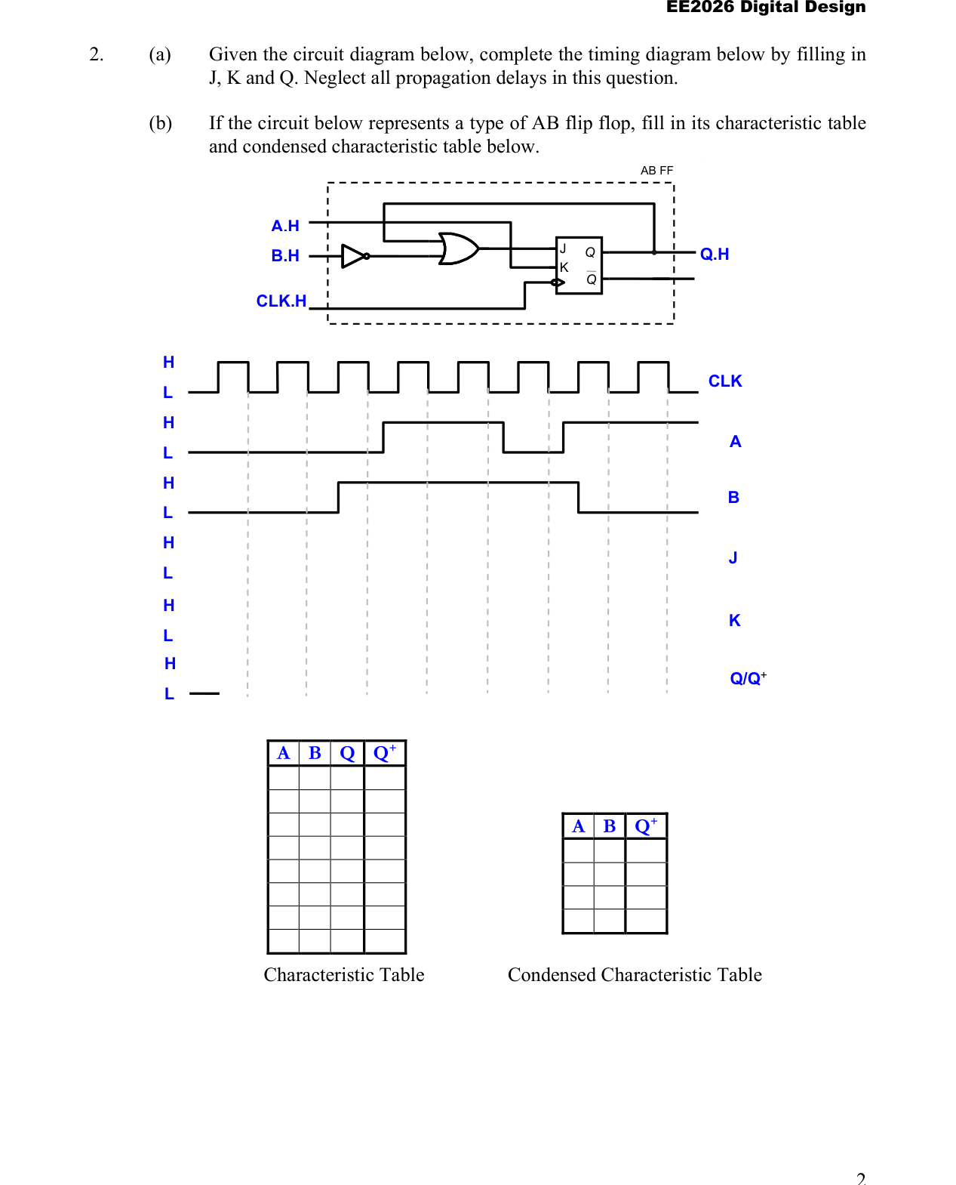

Tutorial 5 Q3
Source: Tutorial 5 Questions, page 3
3. The 74'74B is an integrated circuit containing negative-edge triggered D flip-flops with synchronous set and asynchronous reset inputs. The D flip-flop receives four 1-bit input signals, D, CLK, S, CLR and produces two 1-bit output signals, Q and QB.
Write a Verilog program that implements the D flip-flop according to the characteristic table shown below.
Source figure / table:
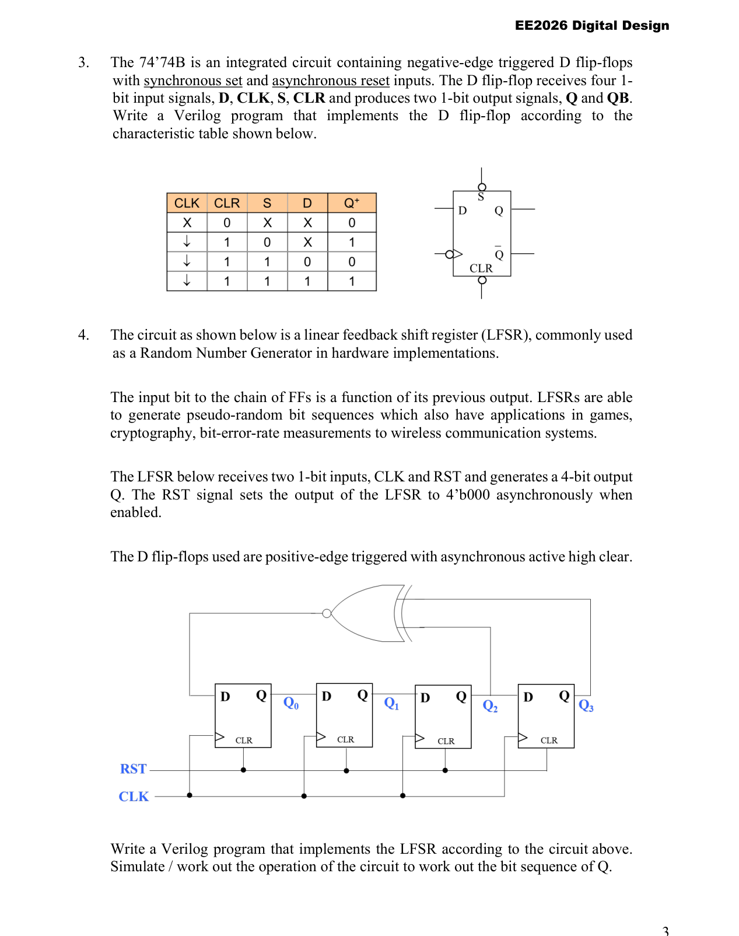

Tutorial 6 Q1
Source: Tutorial 6 Questions, page 1
1. Implement the A-B flip-flop shown below using a D flip-flop and minimum logic gates.
(i) Develop the characteristic table of the AB flip-flop.
(ii) Draw a functional block diagram for the AB flip-flop.
(iii) Implement the AB flip-flop and draw the circuit clearly.
(iv) Implement your design in Verilog.
Source figure / table:
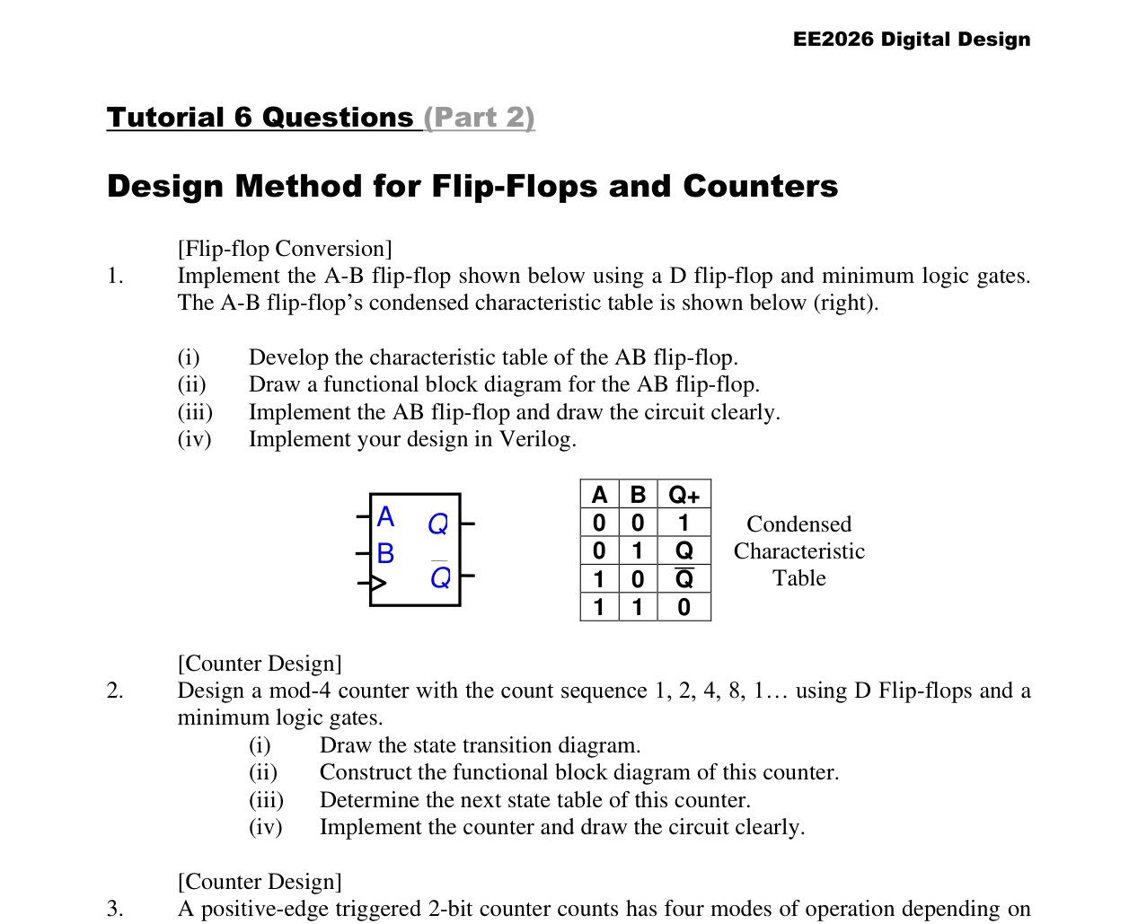

Tutorial 6 Q2
Source: Tutorial 6 Questions, page 1
2. Design a mod-4 counter with the count sequence 1, 2, 4, 8, 1... using D Flip-flops and minimum logic gates.
(i) Draw the state transition diagram.
(ii) Construct the functional block diagram of this counter.
(iii) Determine the next state table of this counter.
(iv) Implement the counter and draw the circuit clearly.
Source figure / table:
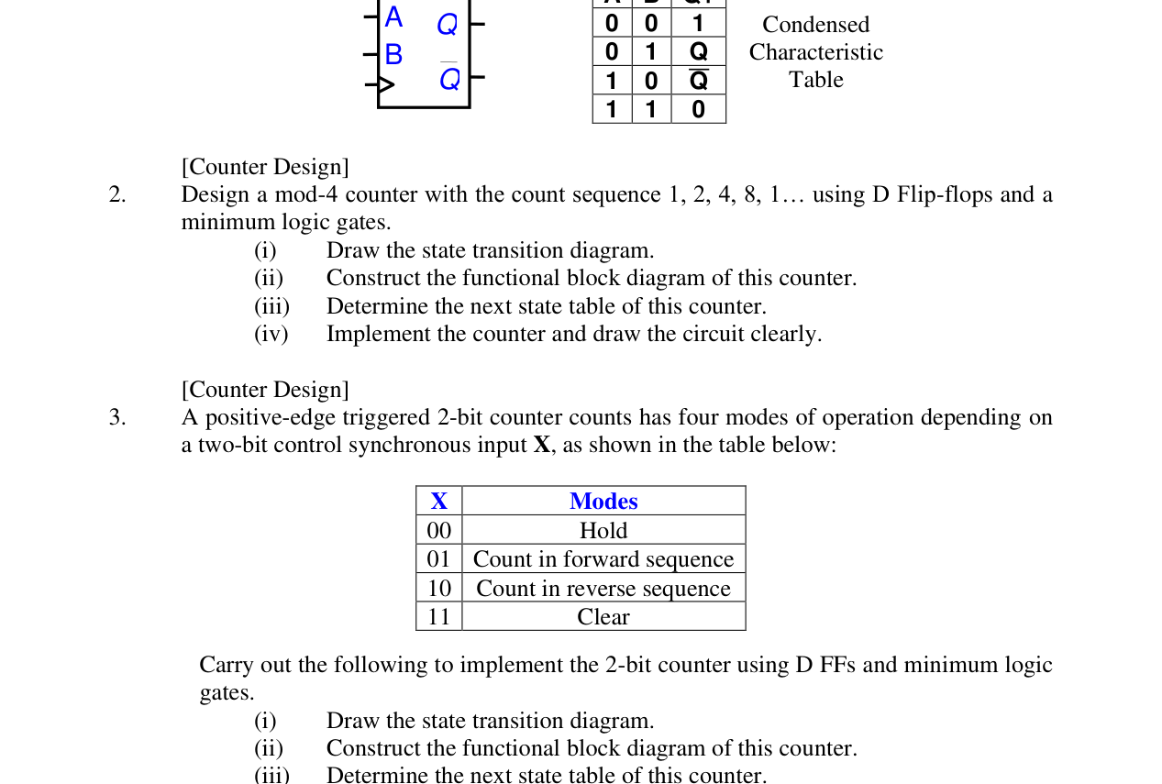

Extra Practice Q2
Source: Extra Practice Questions, page 1
2. A synchronous counter counts in the following order: 1, 2, 5, 7, 1 ...
(i) Implement this counter using J-K flip-flops.
(ii) Based on your implementation in (i), describe what are the next states of your counter if it lands in an invalid state of 3 (eg. counter output is 3)?
Source figure / table:
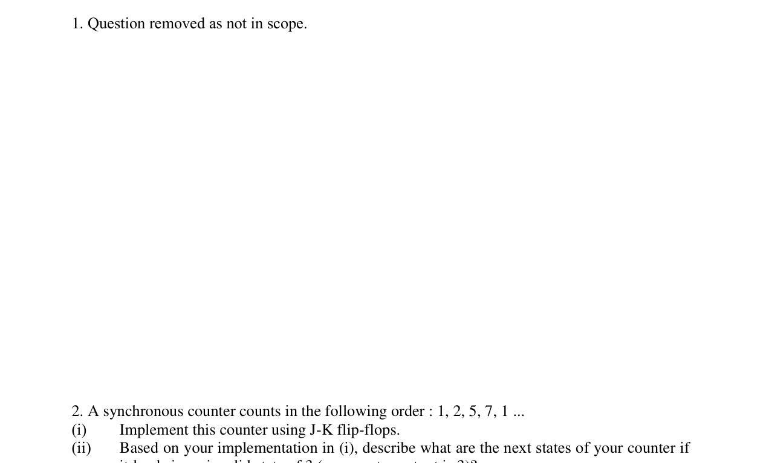

Tutorial 7 Q3
Source: Tutorial 7 Questions, page 2
Q3. For the finite state machine with the timing diagram shown in the figure below:
(i) Identify the input and output signals of the machine.
(ii) Construct the state transition diagram.
(iii) Based on (ii), fill in the next state table and output logic table below.
Source figure / table:
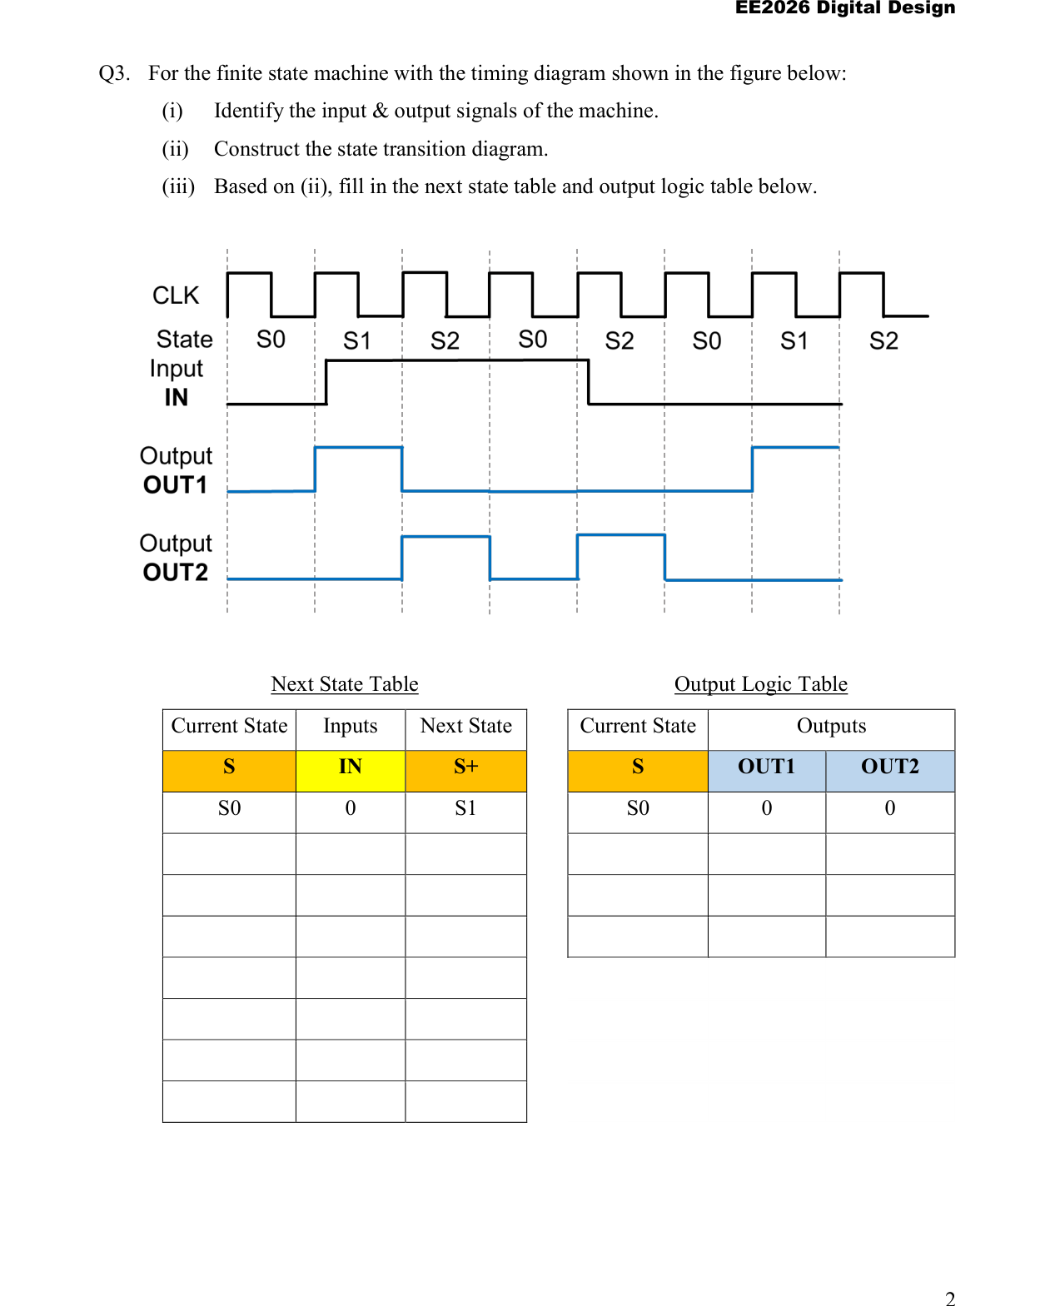

Tutorial 7 Q4
Source: Tutorial 7 Questions, page 3
Q4. Given the state transition diagram of a state machine shown in Figure (a) below,
(i) Identify the input and output signals of the machine.
(ii) Complete the corresponding timing diagram in Figure (b),
(iii) Based on (ii), fill in the next state and output logic table below.
Source figure / table:
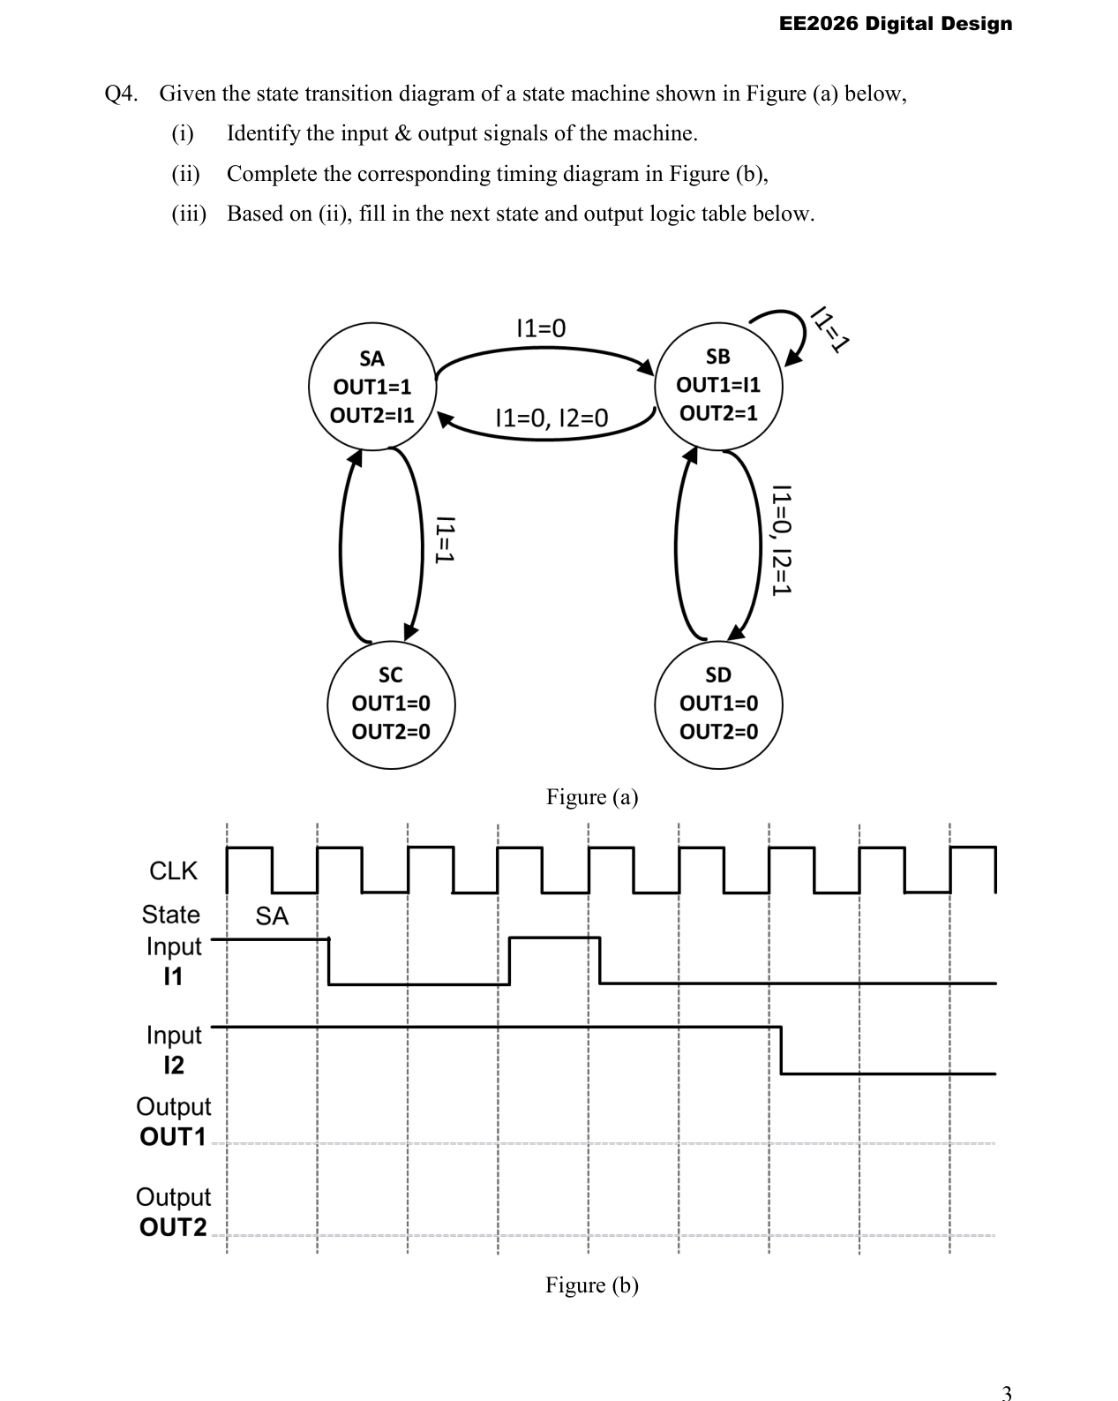

Tutorial 7 Q4 (table continuation)
Source: Tutorial 7 Questions, page 4
Q4 continuation: next state and output logic table.
Source figure / table:
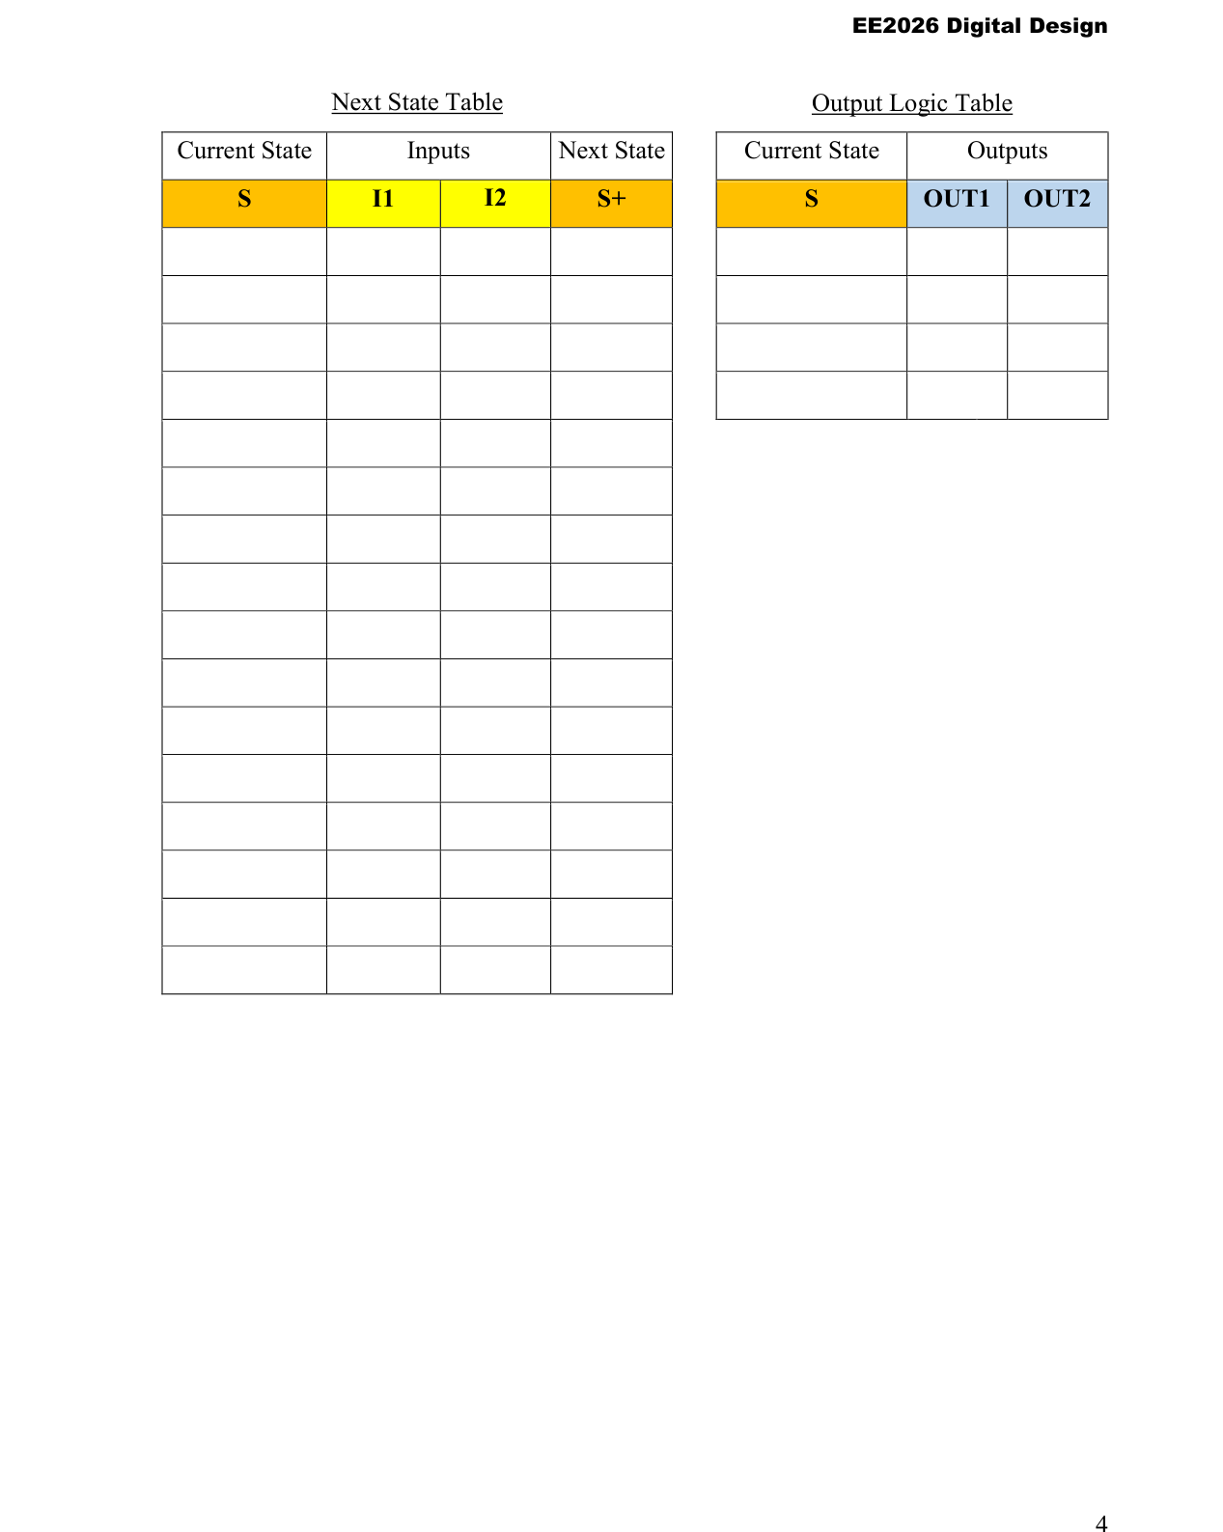

Extra Practice Q4
Source: Extra Practice Questions, page 2
4. Describe in words what the state machine below does and implement the state machine using D flip-flops with synchronous resets.
Source figure / table:
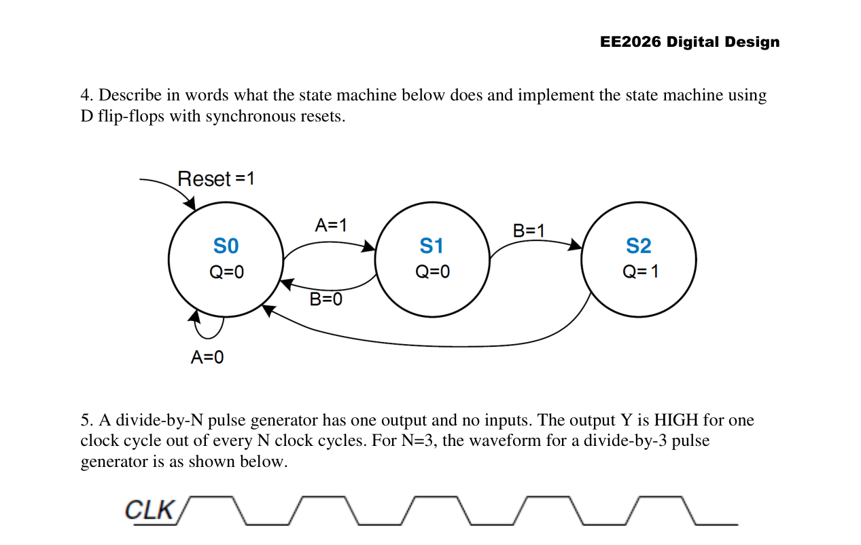

Extra Practice Q5
Source: Extra Practice Questions, page 2
5. A divide-by-N pulse generator has one output and no inputs. The output Y is HIGH for one clock cycle out of every N clock cycles. For N = 3, the waveform for a divide-by-3 pulse generator is as shown below.
(i) Develop the state transition diagram for the divide-by-3 pulse generator, assuming that the FSM starts at an initial reset state.
(ii) Implement the circuit using only D-FFs and no additional gates. You may assume that the D-FFs have synchronous resets or sets.
(Hint: Use one-hot state encoding for the state assignments eg. 3'b001, 3'b010, 3'b100.)
Source figure / table:
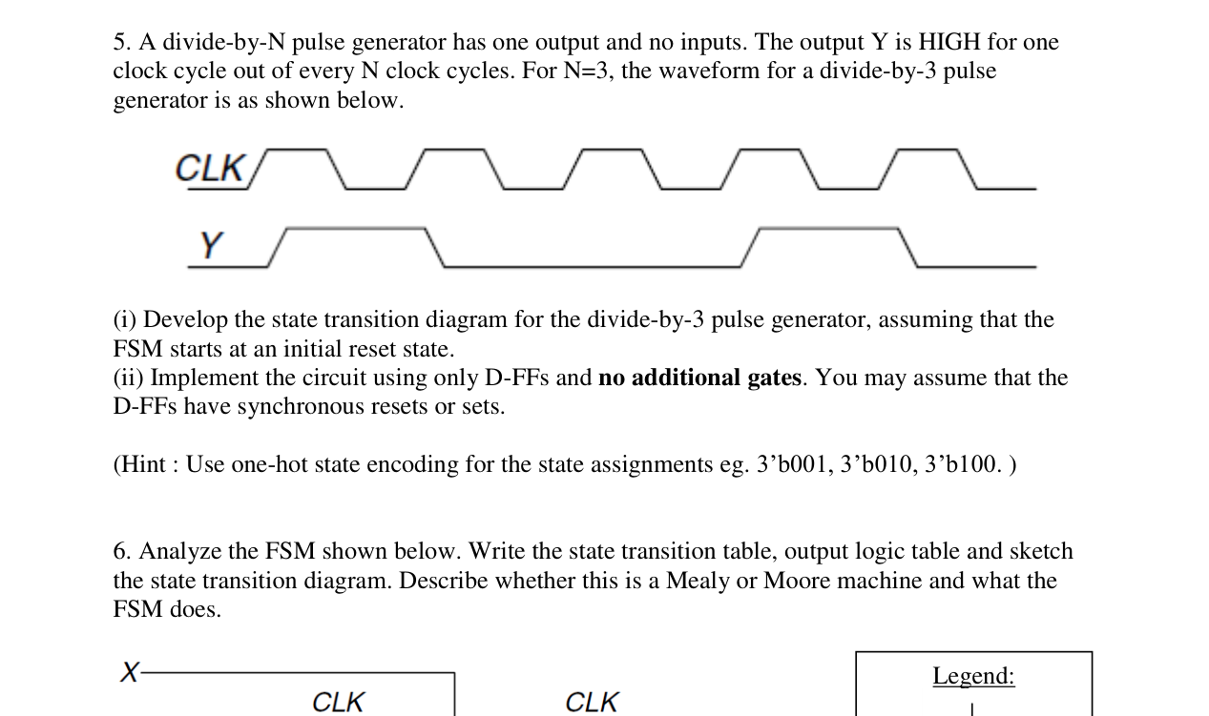

Extra Practice Q7
Source: Extra Practice Questions, page 3
7. A 3-bit synchronous counter counts in one of two sequences depending on a 1-bit synchronous control input, EVEN. When EVEN is false, the counter behaves as a normal 3-bit mod-8 up-counter, otherwise it counts in the sequence: ... 0, 2, 4, 6, 0, 2 ...
When the value of EVEN is toggled, it proceeds to the other counting sequence.
(a) Draw the state transition diagram for the counter.
(b) If the counter’s current output is “2”, under what conditions will it output “3” in the next state?
(c) Implement the counter using D-Flip-flops and any additional logic devices. Clearly show the steps in your design.
(d) Using additional logic gates, show how you would incorporate a “terminal count” output, TC, which is TRUE if the state is 7 and EVEN = 0, or if the state is 6 and EVEN = 1.
Source figure / table:
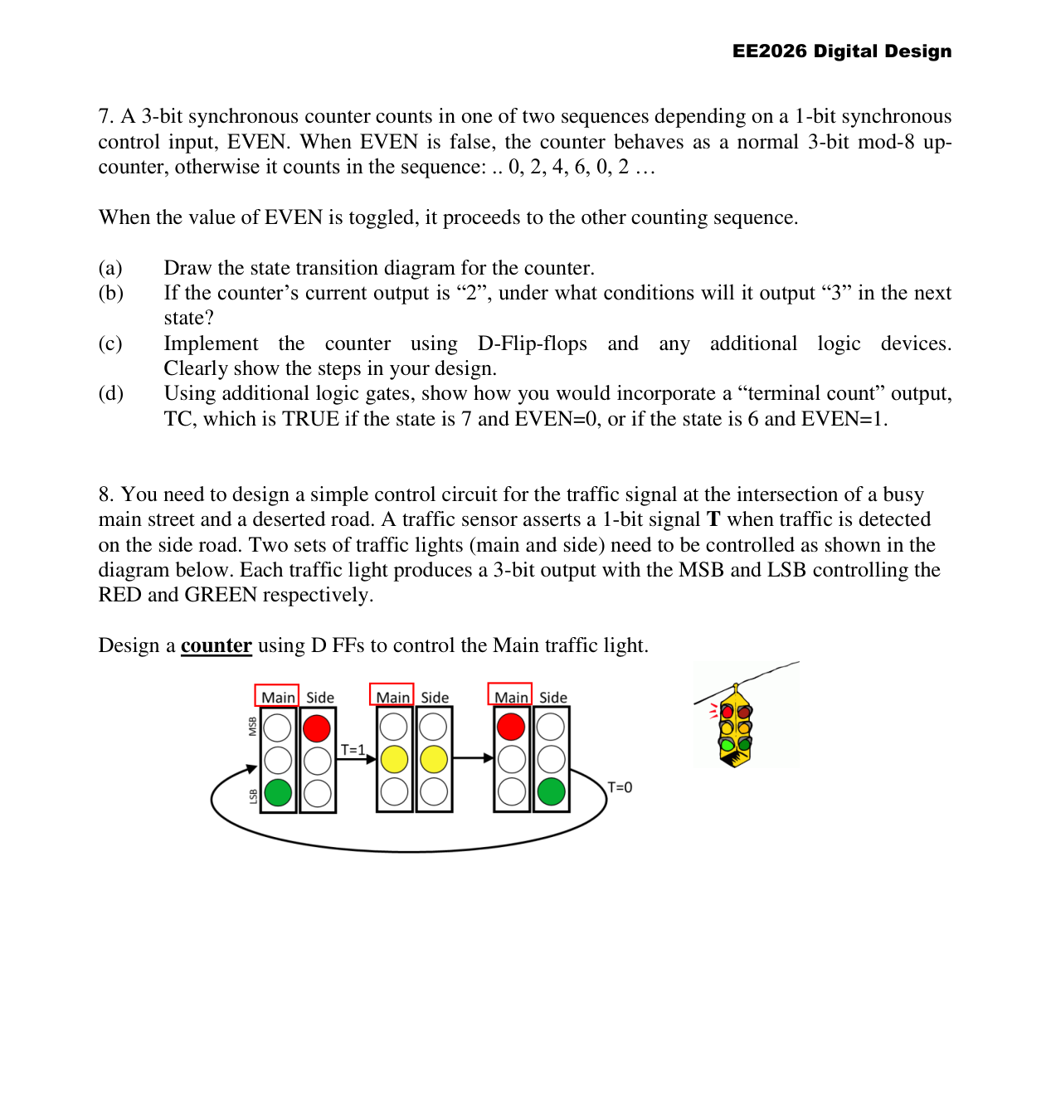

Extra Practice Q11
Source: Extra Practice Questions, page 4
11. Alyssa owns a pet robotic snail with an FSM brain. The snail crawls from left to right along a paper tape containing a sequence of 1’s and 0’s.
On each clock cycle, the snail crawls to the next bit. The snail smiles when the last four bits that it has crawled over are, from left to right, 1101. The input A is the bit currently underneath the snail’s antennae. The output Y is TRUE when the snail smiles. Design a FSM to compute when the snail should smile.
Implement your state transition diagrams for the FSM as a (i) Moore machine (ii) Mealy machine.
Source figure / table:
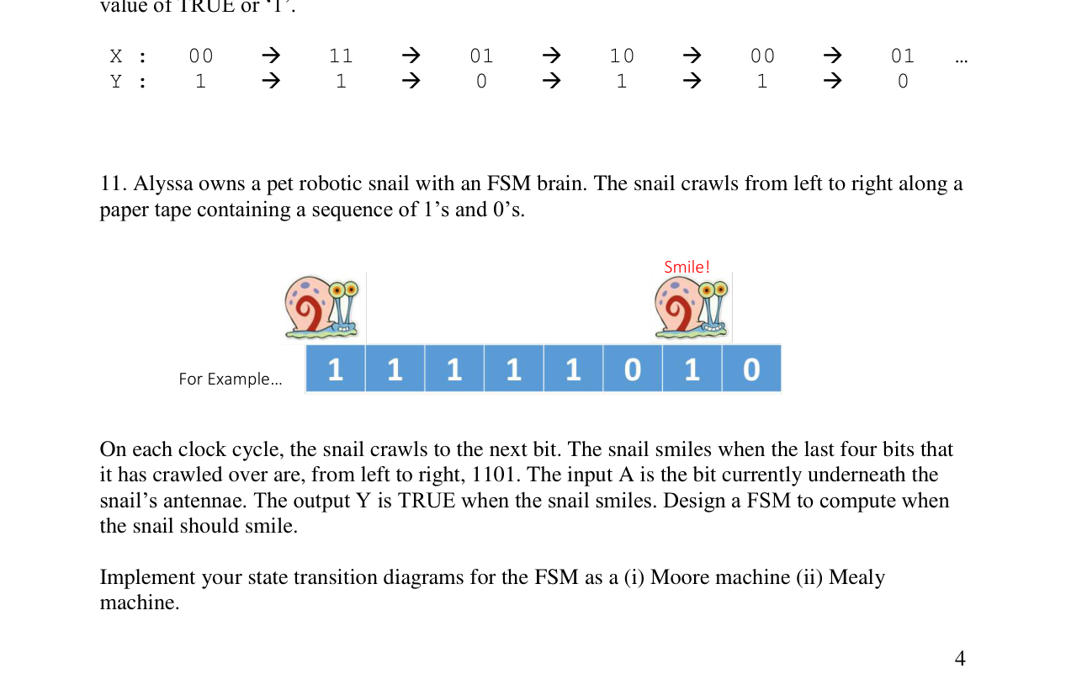

Tutorial 8 Q1
Source: Tutorial 8 Questions, page 1
Q1. A digital circuit is to be designed to implement the “snooze” function of an alarm clock. The circuit’s input and output signals are as follows:
Inputs: RING, RESET, CLK
Output: ALARM
The circuit remains in the “wait” mode until input RING is detected to be TRUE. When this happens, the circuit goes into the “snooze” mode by ringing the ALARM for 10 seconds, waiting for 1 minute and continuously repeats this cycle until the user resets the circuit causing RESET to be TRUE for one clock period.
Derive the state transition diagram, assuming that an accurate 0.1Hz clock is available as an input. To simplify the state transition diagram, adopt a suitable architectural element as a submachine.
Source figure / table:
