Manage Azure Identities and Governance

Create Users in Microsoft Entra ID Using Azure Portal

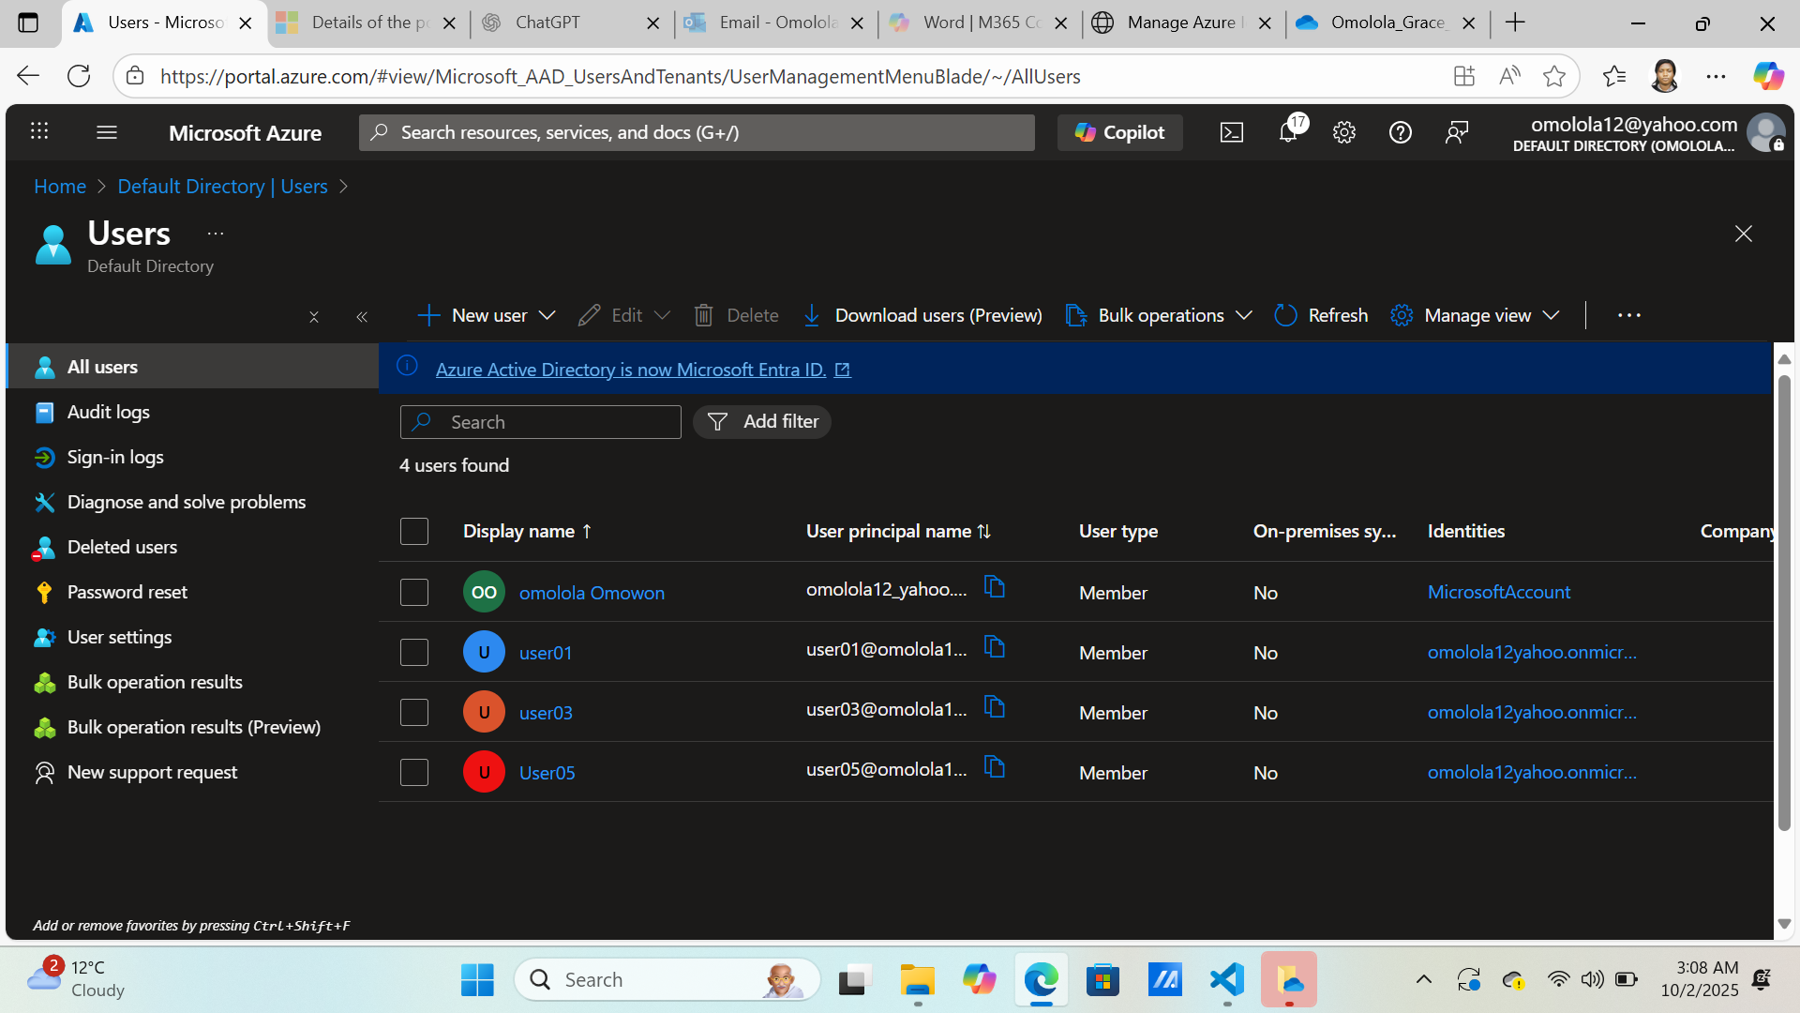

A Group for User Administrator was created for proper management

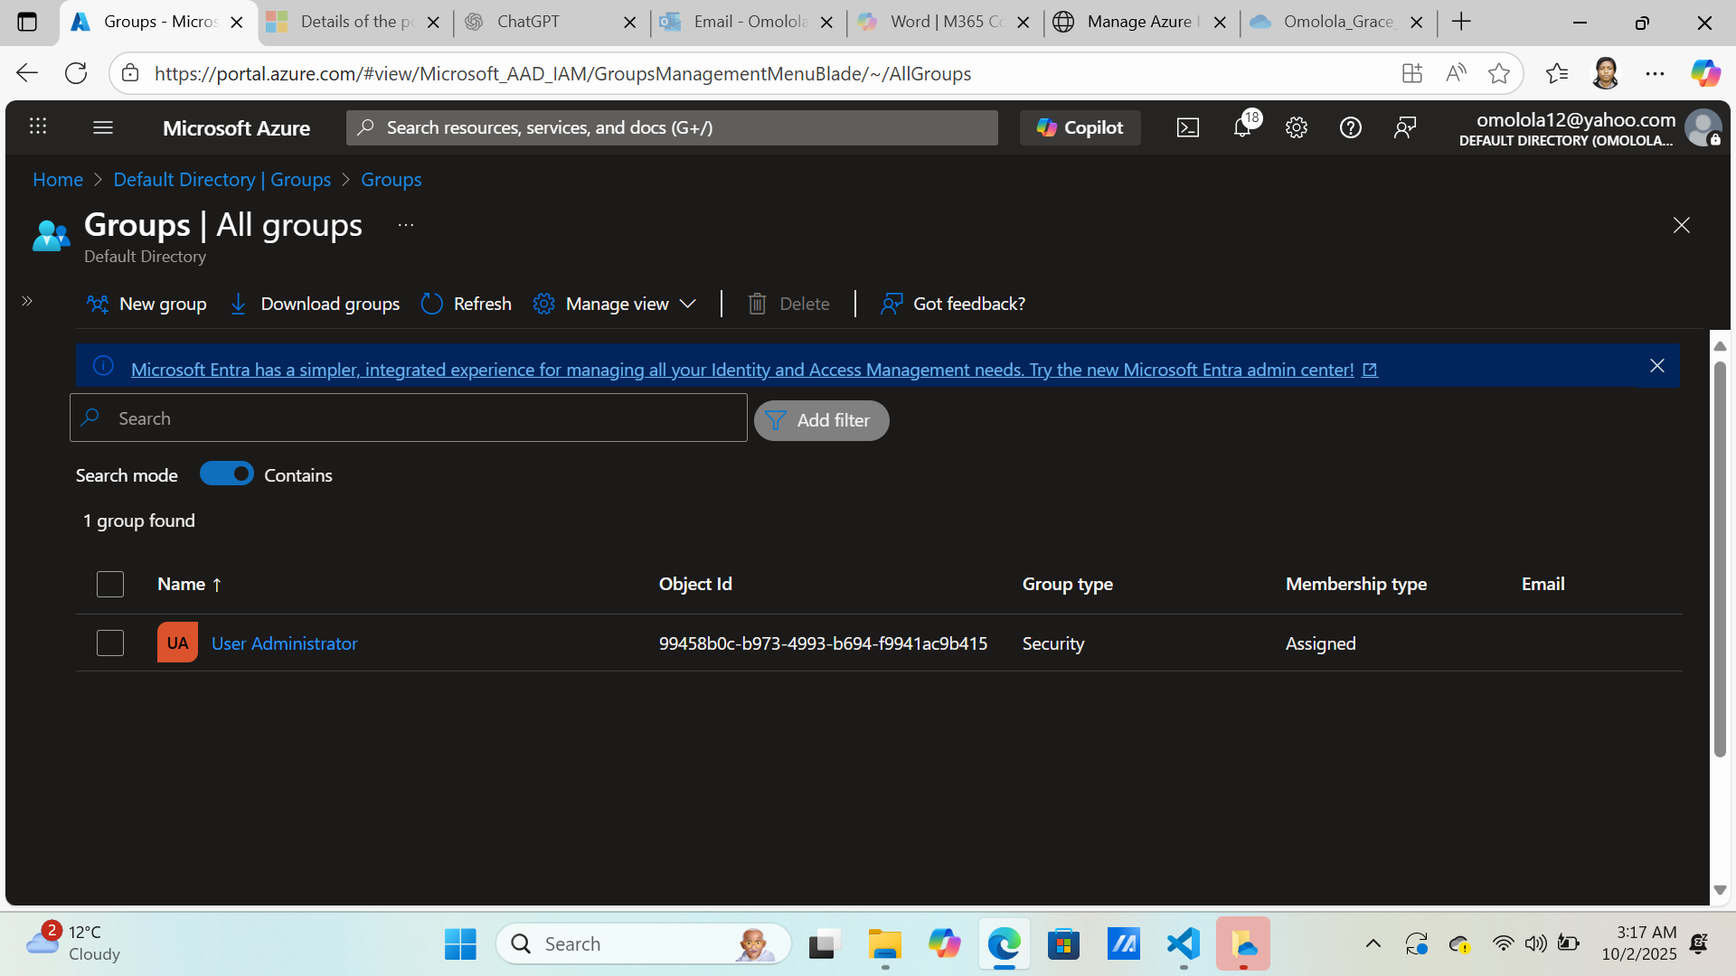

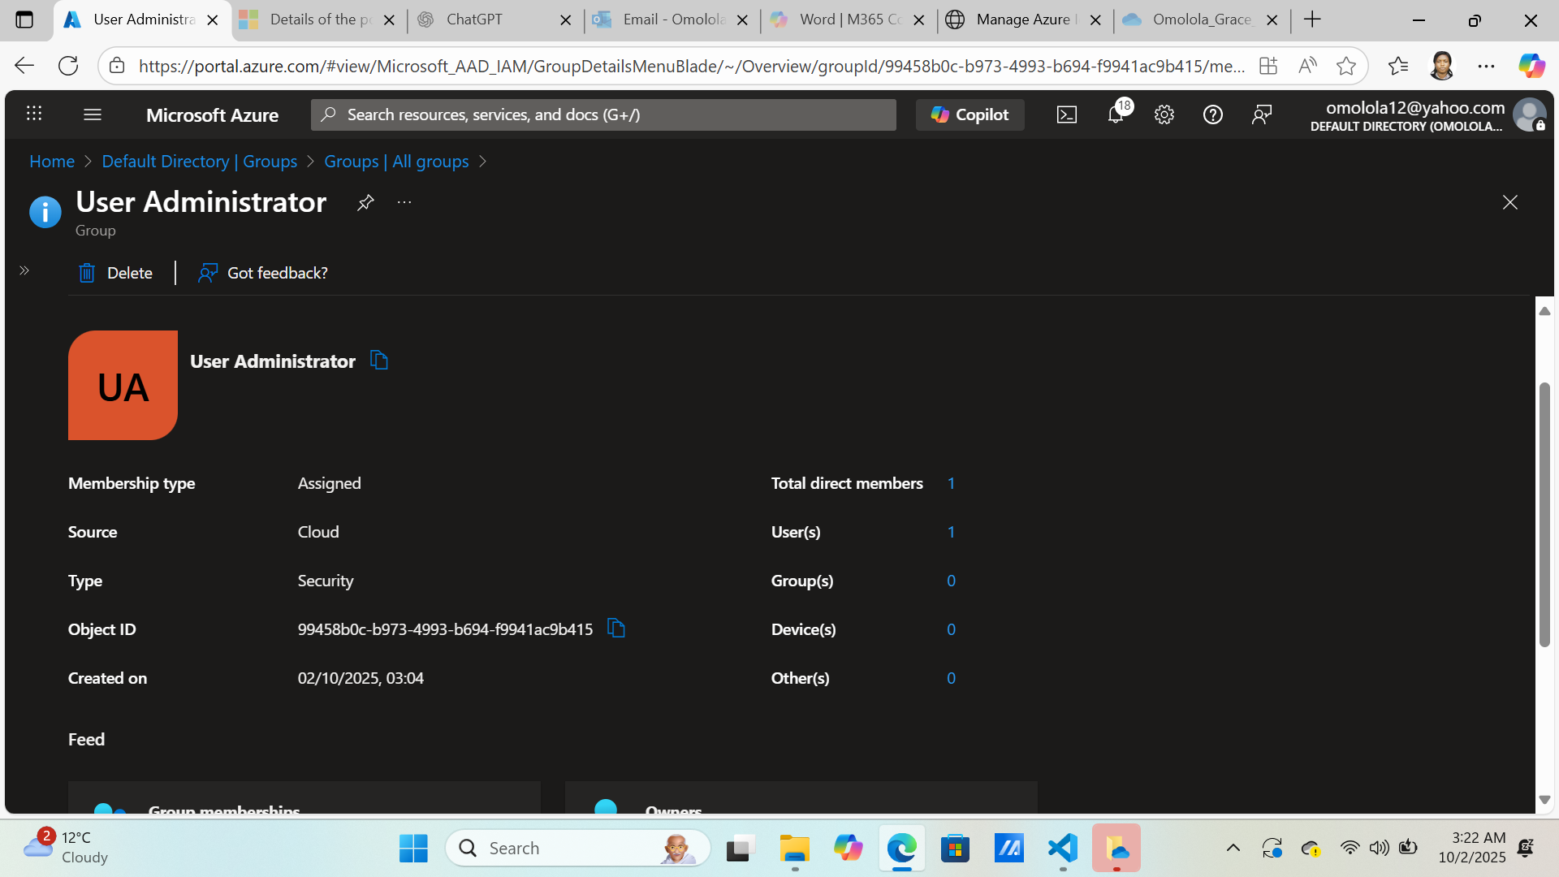

Role Assignment

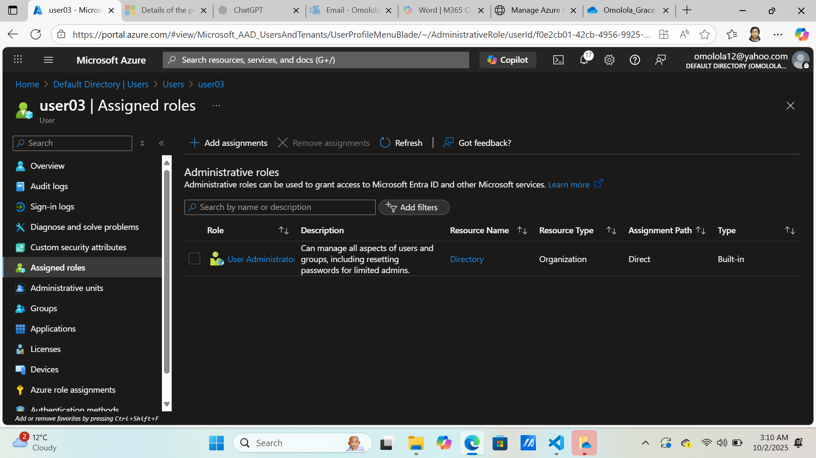

Azure Policy To Enforce Rules

In this project, policy was implemented into subscription

