APPLICATION SECURITY GROUP/ NETWORK SECURITY GROUP

Application Security Group

asg-web

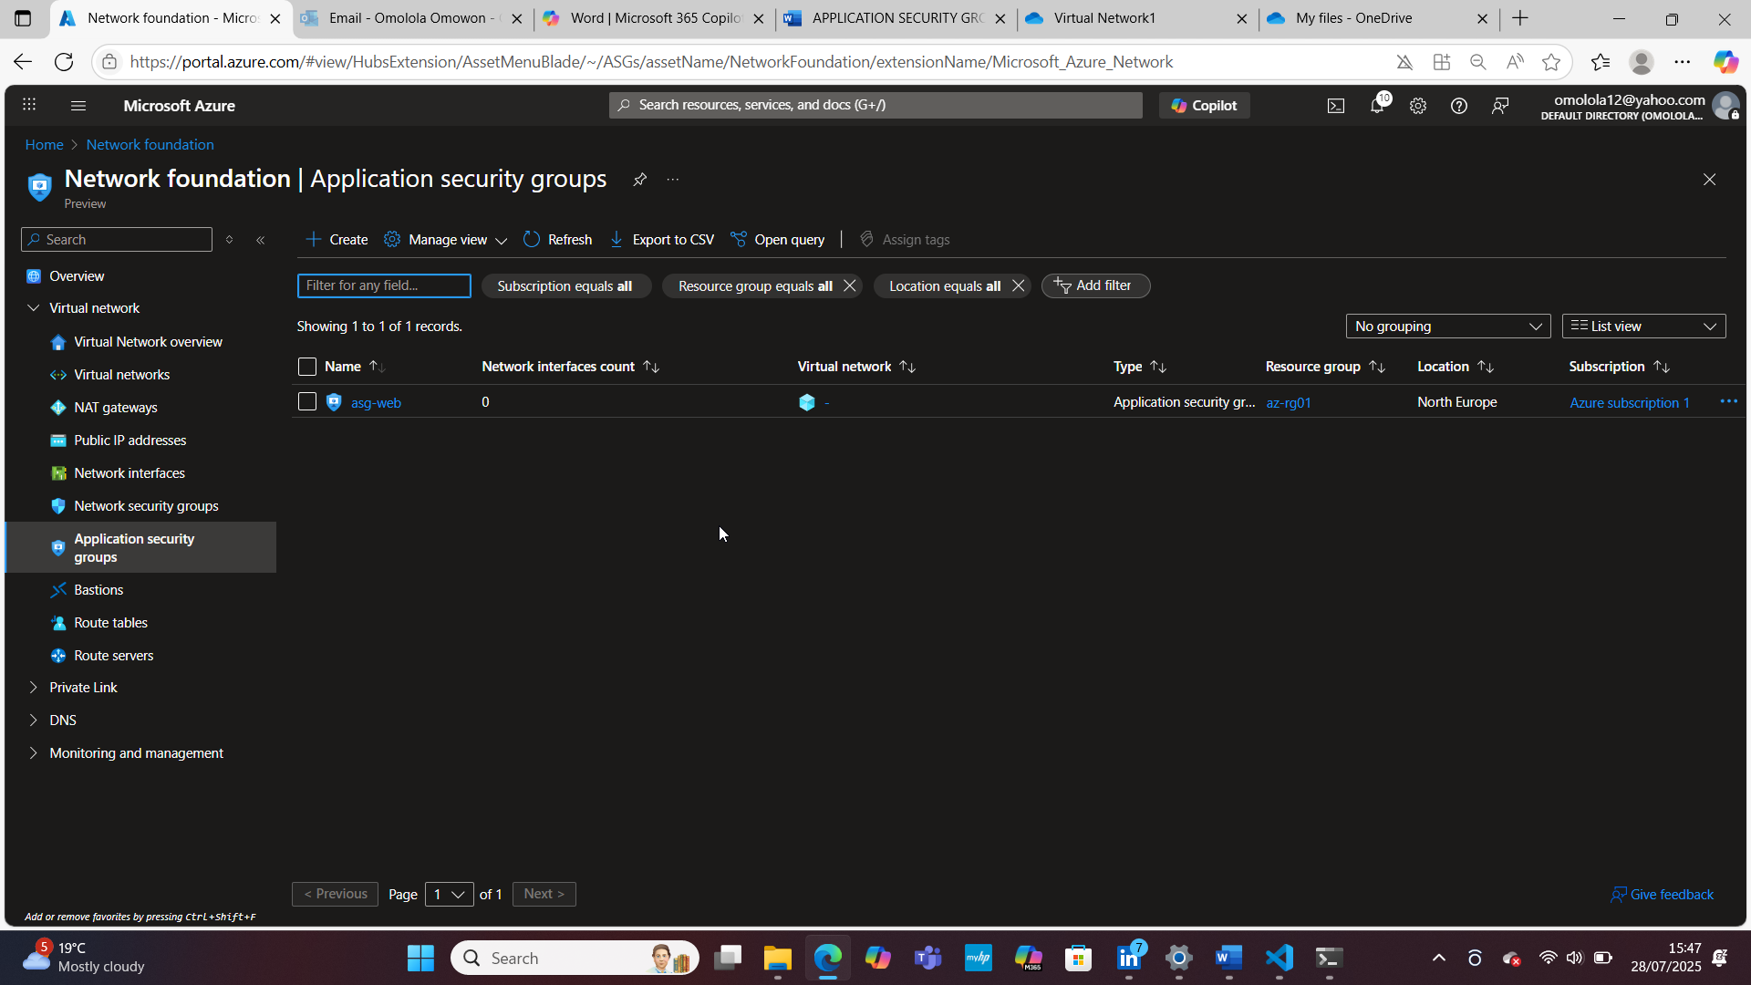

Network Security Group

myNSGsecure

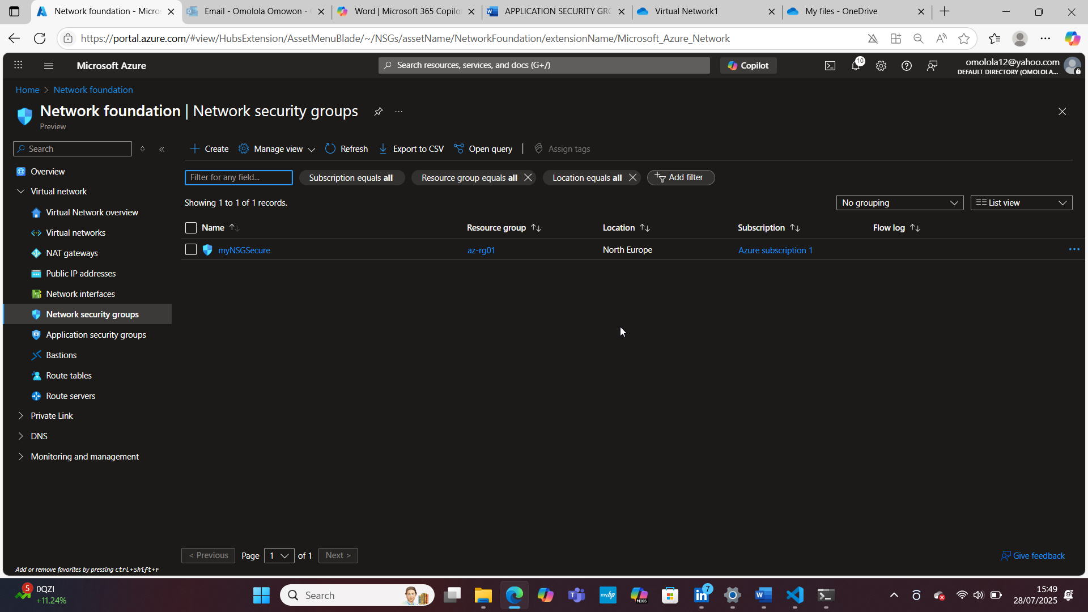

NSG Associate with Subnet

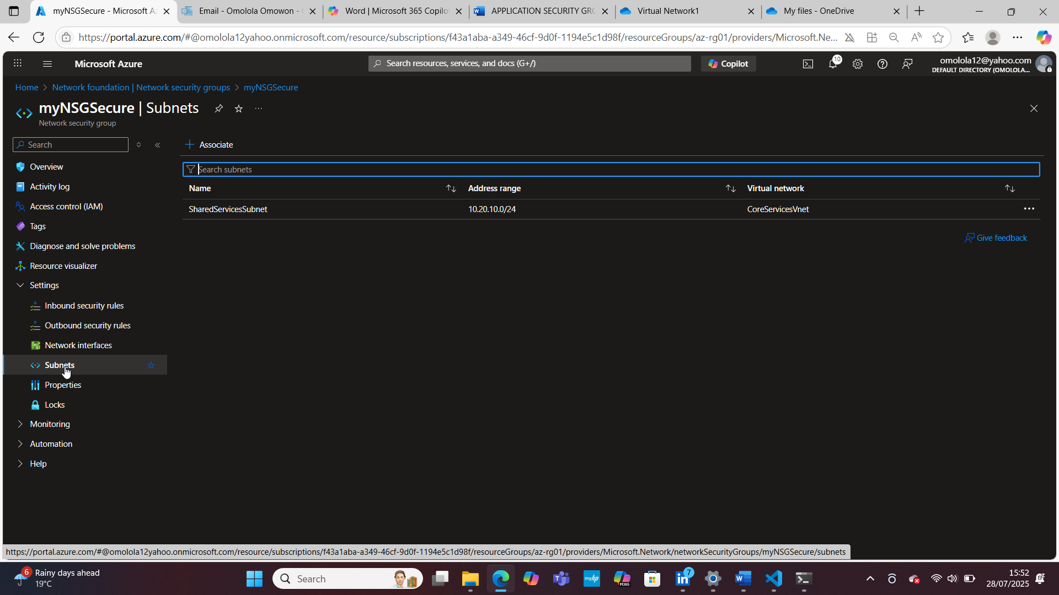

NSG Inbound Rules

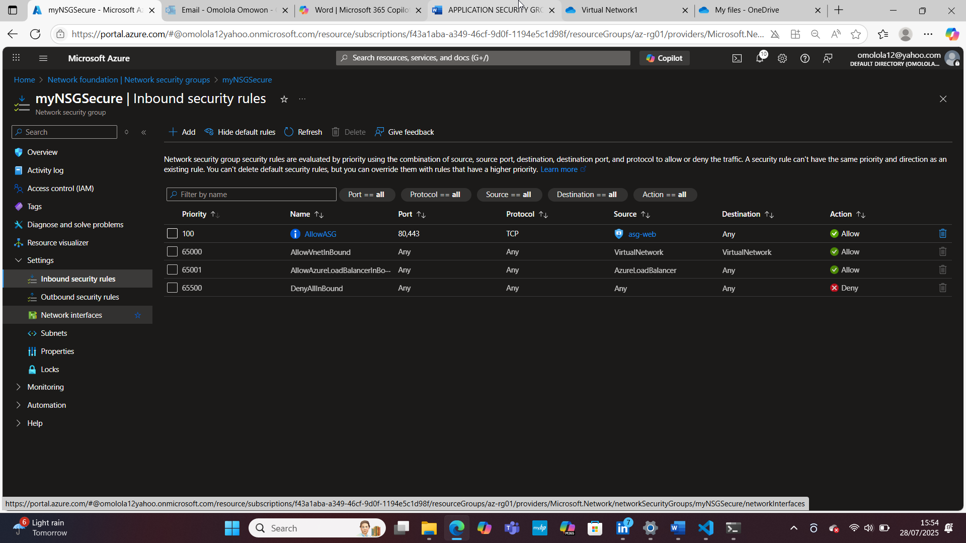

NSG Outbound Rules

