Virtual Network -A

CoreServicesvnet 10.20.0.0/16

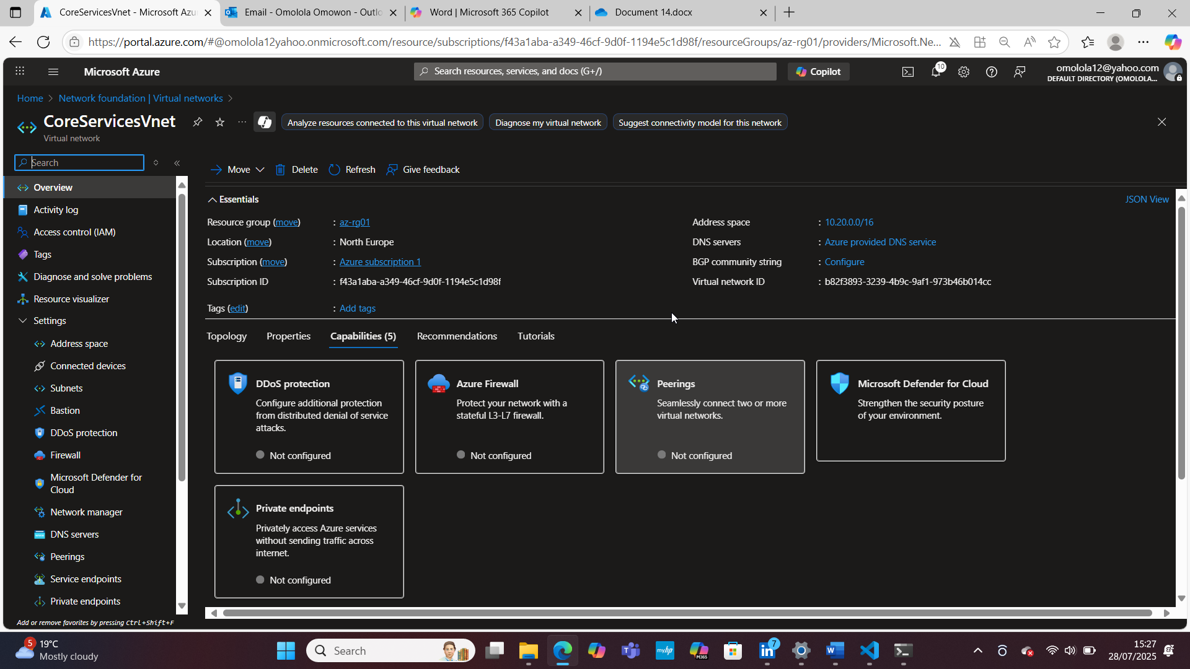

Subnet

CoreServicesvnet-SharedServicesSubnet 10.20.10.0/24

CoreServicesvnet-DatabaseSubnet 10.20.20.0/24

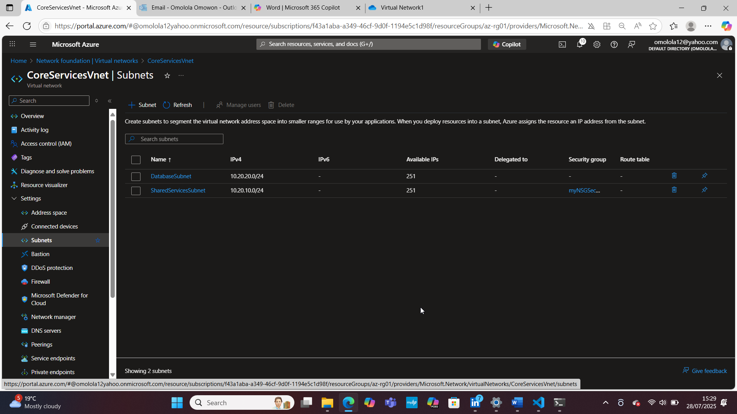

Virtual Network-B

Using Automation Script

Template.json

{

"$schema": "<https://schema.management.azure.com/schemas/2019-04-01/deploymentTemplate.json>#",

"contentVersion": "1.0.0.0",

"parameters": {

"virtualNetworks_CoreServicesVnet_name": {

"defaultValue": "ManufacturingVnet",

"type": "String"

}

},

"variables": {},

"resources": [

{

"type": "Microsoft.Network/virtualNetworks",

"apiVersion": "2024-07-01",

"name": "[parameters('virtualNetworks_CoreServicesVnet_name')]",

"location": "northeurope",

"properties": {

"addressSpace": {

"addressPrefixes": [

"10.30.0.0/16"

]

},

"encryption": {

"enabled": false,

"enforcement": "AllowUnencrypted"

},

"privateEndpointVNetPolicies": "Disabled",

"subnets": [

{

"name": "SensorSubnet1",

"id": "[resourceId('Microsoft.Network/virtualNetworks/subnets', parameters('virtualNetworks_CoreServicesVnet_name'), 'SharedServicesSubnet')]",

"properties": {

"addressPrefixes": [

"10.30.20.0/24"

],

"delegations": [],

"privateEndpointNetworkPolicies": "Disabled",

"privateLinkServiceNetworkPolicies": "Enabled"

},

"type": "Microsoft.Network/virtualNetworks/subnets"

},

{

"name": "SensorSubnet2",

"id": "[resourceId('Microsoft.Network/virtualNetworks/subnets', parameters('virtualNetworks_CoreServicesVnet_name'), 'DatabaseSubnet')]",

"properties": {

"addressPrefixes": [

"10.30.21.0/24"

],

"delegations": [],

"privateEndpointNetworkPolicies": "Disabled",

"privateLinkServiceNetworkPolicies": "Enabled"

},

"type": "Microsoft.Network/virtualNetworks/subnets"

}

],

"virtualNetworkPeerings": [],

"enableDdosProtection": false

}

},

{

"type": "Microsoft.Network/virtualNetworks/subnets",

"apiVersion": "2024-07-01",

"name": "[concat(parameters('virtualNetworks_CoreServicesVnet_name'), '/DatabaseSubnet')]",

"dependsOn": [

"[resourceId('Microsoft.Network/virtualNetworks', parameters('virtualNetworks_CoreServicesVnet_name'))]"

],

"properties": {

"addressPrefixes": [

"10.20.20.0/24"

],

"delegations": [],

"privateEndpointNetworkPolicies": "Disabled",

"privateLinkServiceNetworkPolicies": "Enabled"

}

},

{

"type": "Microsoft.Network/virtualNetworks/subnets",

"apiVersion": "2024-07-01",

"name": "[concat(parameters('virtualNetworks_CoreServicesVnet_name'), '/SharedServicesSubnet')]",

"dependsOn": [

"[resourceId('Microsoft.Network/virtualNetworks', parameters('virtualNetworks_CoreServicesVnet_name'))]"

],

"properties": {

"addressPrefixes": [

"10.20.10.0/24"

],

"delegations": [],

"privateEndpointNetworkPolicies": "Disabled",

"privateLinkServiceNetworkPolicies": "Enabled"

}

}

]

}

Parameters.json

{

"$schema": "<https://schema.management.azure.com/schemas/2015-01-01/deploymentParameters.json>#",

"contentVersion": "1.0.0.0",

"parameters": {

"virtualNetworks_ManufacturingVnet_name": {

"value": null

}

}

}

Portal Screenshot

ManufacturingVnet 10.30.0.0/16

Overview

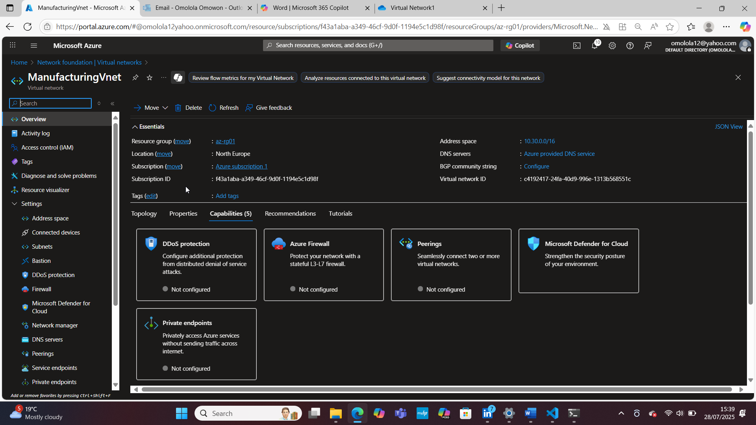

Subnet

ManufacturingVnet-Sensor1 10.30.20.0/24

ManufacturingVnet-Sensor2 10.30.21.0/24

