University of Calgary

Project Proposal

|  |  |
| --- | --- |
| To: | Dr. Nathaly Verwaal |
| TA: | Lorans Alabood |
| From: | Bernard Joshua Isaac  Gao Aaron  Kanel Adarsha  Ahmed Obad |
| Team: | T04-Team15-L01 |
| Date: | August 13, 2019 |
| Re: | Card Match Memory Game |

# Description:

The category our group chosen is a “Board Game”. We have created a turn-based board game which gives users the option to play against either a computer or play against each other. The “Multiplayer” option allows the players to play against each other until all cards have been matched, then displays who the result of the match. The computer option lets the player play against the computer which depending on the difficulty selected will have a much better probability of selecting 2 of the same card. The graphical user interface for “COMPUTER” and “MULIPLAYER” will be available on the final project. Our purpose is to create an interactive game where the objective is based on the memory of both the user and the computer program.

# Overview of the Game:

At the beginning of the game the user has three buttons to choose from; first “START” which will start the game, “CREDITS” which show information of the team who developed the game and “Exit” that will close the game. After starting the game, players get the option of selecting two buttons to play against “Multiplayer” or “Computer”. Then, the player selects the level of difficulty which would range from “EASY” to “HARD”. Each level of difficulty will result in a higher number of cards and a higher probability of the computer matching the cards. As a bonus feature music, sounds and pictures will be added to the game.

The game generates random pairs of cards depending on the difficulty selected. The objective is to allow the interaction of two players or a player and a computer taking turns attempting to match two cards. When two cards have been matched, they will continue to display permanently and will result in the player who matched them to earn a single point. After all cards have been matched and eliminated from the field of play, the player with the highest number of points will win the game and resulting in the message “PLAYER (#) WINS!” being displayed. If both players achieve the same number of points, then the game would display “Tie Game!” In the case that the player plays a match against a computer, if computer wins it would display “COMPUTER WINS!”, and a message will be show to indicate the end of the game, for example:” Game Over”; Also there will be exit button bringing the player back to the menu, if the person wants to change the difficulty selected or play a different mode of the game while playing the game.

# Specifications:

The cards will consist of various objects with sound of the objects. Each time a card is flipped there will be an animation of the card flipping. Here are the two level of difficulty for both multiplayer and computer player:

* EASY LEVEL = 4x4
* HARD LEVEL = 6X6

# Standard Game Example:

The user will be shown a home screen of a 4 X 4 game will look like this in a text base interface.

And the home screen of a 4 X 4 game will look like this in a graphical user interface:

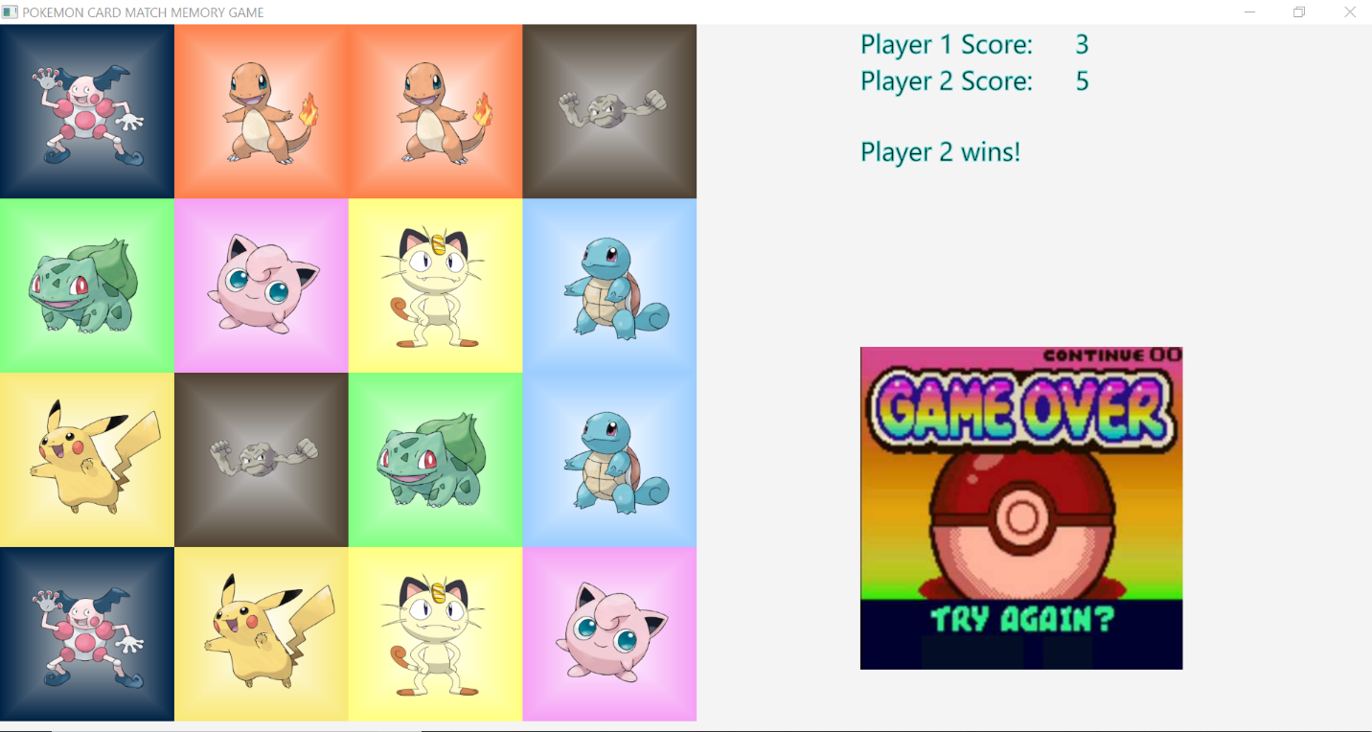

# Features

* Can play against computer player and human player.
* Able to choose level of difficulty from easy to hard for both human player and computer player.
* Have GUI and text-based game
* Properly functioning game with winning and losing and exiting of the game.

# Features not done due to challenges

* Hand controller
* Medium difficulty mode