第十二周作业

姓名：何颖岚 班级：应用统计学二班 学号：117060400230

# 计算矩阵的转秩

import numpy as np

from numpy.linalg import inv

A = np.array([[1,0,5,5], [2,3,2,3], [4,1,1,7]])

B = np.array([1,2,3])

a = inv(A)

b = B.transpose()

x = np.matmul(a,b)

print(x)

结果：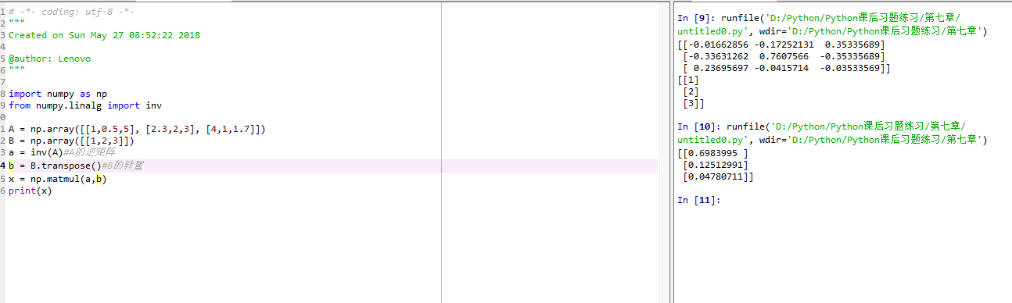

# 手绘

from PIL import Image

import numpy as np

vec_el = np.pi/2.2

vec_az = np.pi/4.

depth = 10.

im = Image.open("d:\\何颖岚\\zipai.jpg").convert('L')

a = np.asarray(im).astype('float')

grad = np.gradient(a)

grad_x, grad_y = grad

grad_x = grad_x*depth/100.

gard_y = grad_y*depth/100.

dx = np.cos(vec_el)*np.cos(vec_az)

dy = np.cos(vec_el)*np.sin(vec_az)

dz =np.sin(vec_el)

A = np.sqrt(grad_x**2 + grad_y**2 + 1.)

uni_y = grad_y/A

uni_x = grad_x/A

uni_z =1./A

a2 = 255*(dx*uni_x + dy*uni_y + dz*uni_z)

a2 = a2.clip(0,255)

im2 = Image.fromarray(a2.astype('uint8'))

im2.save("d:\\何颖岚\\zipaiHanDraw.jpg")

结果：

