**“What causes antibiotic resistance?” Alignment to reference, variant**

**calling.**

Alekseeva L., Kureev N., Ovsyannikova A.

**Abstract**Ubiquitous application of antibiotics causes development of bacterial antibiotic resistance. It’s very important to investigate which mechanism is responsible for bacterial adaptation. SNP (single nucleotide polymorphism) is one of the reasons of antibiotic resistance. Mutations in bacterial genes lead to changes in protein structures. Because of this antibiotics can’t interact with bacterial proteins anymore.  
In this study we perform antibiotic resistance causes research of *Escherichia coli* K-12 strain. Using Illumina sequencing data performed by 455876 reads we identified 5 SNPs in *E. coli* K-12 strain genome.

**Introduction**

Pathogenic *E. coli* often causes diarrhea, sepsis and other clinical symptoms and remains one of the main intestinal pathogens that affect human and animal health. Ampicillin is a semi-synthetic antibiotic used to treat various infectious diseases of the respiratory tract, urinary tract, liver and gastrointestinal tract, but its resistance level has recently increased. AMP works at the stage of active replication of bacteria, inhibiting the synthesis of the bacterial cell wall. Bacteria often resist such an antibiotic in the following ways: encodes β-lactamase, changes the target protein in the cell wall, reduces the permeability of the outer membrane and increases the expression of drug outflow [1]. The purpose of this study is to analyze the raw sequence data of *E. coli* mutant andtry to explain the hypothetical mechanism of *E. coli* resistance to ampicillin.

**Materials and methods**

1. **Quality control of the reads**

Raw reads were quality-checked with FastQC v. 0.11.8 and low-quality reads were trimmed using Trimmomatic v. 0.39.

1. **Align reads to reference**We used BWA align program with BWA-MEM mode. *E. coli* K-12 strain genome from NCBI database was used as a reference.
2. **Suspicious position search**With a help of Samtools and VarScan we got positions where mutations were more likely to occur.
3. **Visualization**Using aligned reads by BWA and annotation file from reference genome we got visual representation of SNP distribution by using IGV browser.

**Results**

There were in total 455876 read pairs of which only 445689 (97,77%) survived trimming both forward and reverse, 9758 (2,14%) forward and 284 (0,06%) reverse reads survived without pair and 145 reads were dropped (Figure 1). Total Sequences after trimming for forward and reverse were 453009 and 2821, respectively.

a.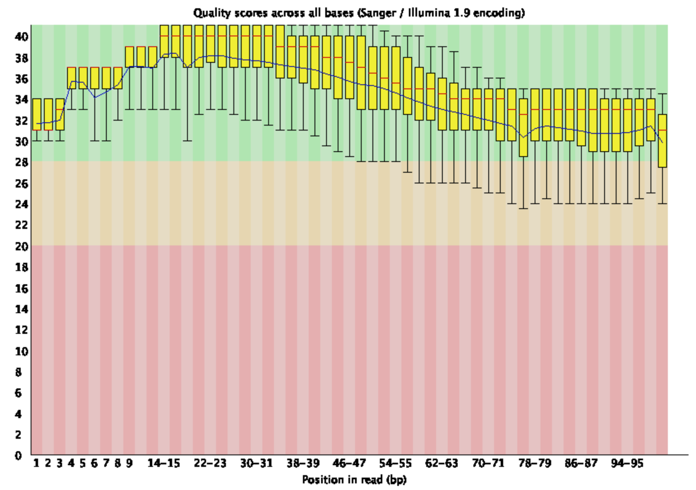b.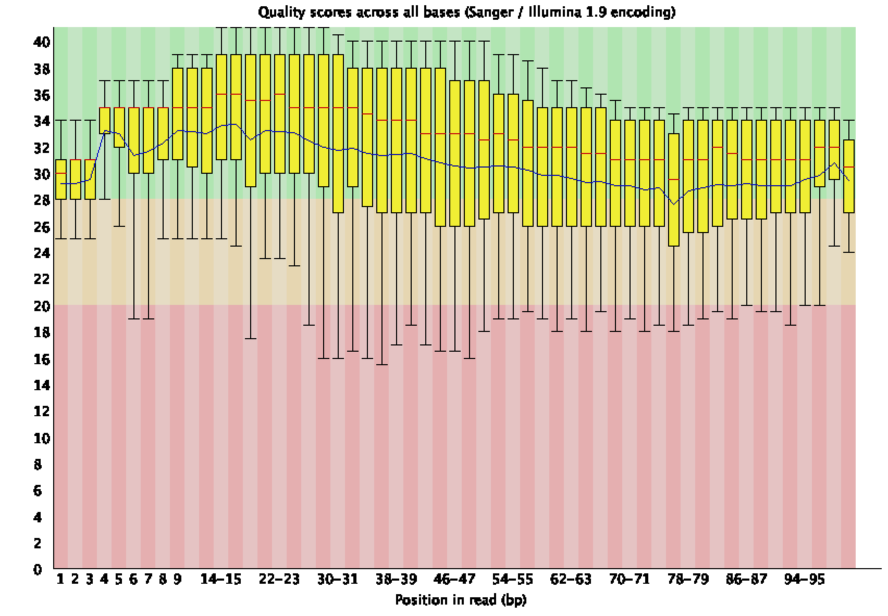

*Figure 1. Per base sequence quality after trimming a) forward b) reverse*

Compared to the original *E. coli* strain K-12 substr. MG1655, there were five SNPs in induced drug-resistant strain (Table 1).

*Table 1. The SNPs analysis results of E. coli mutant strain*

|  |  |  |  |  |  |
| --- | --- | --- | --- | --- | --- |
| Gene | Accession | Product | SNP position | Base | Codon |
| ftsI | AAC73195.1 | peptidoglycan DD-transpeptidase FtsI | 93043 | A → G | GCC → GGC |
| acrB | AAC73564.1 | multidrug efflux pump RND permease AcrB | 482698 | T → A | CTG → CAG |
| rybA | rna-b4416 | small RNA RybA | 852762 | A → G | AAA → AGA |
| envZ | AAC76429.1 | sensory histidine kinase EnvZ | 3535147 | A → C | TAC → TCC |
| rsgA | AAC77121.2 | ribosome small subunit-dependent GTPase A | 4390754 | G → T | CGG → CTG |

**Discussion**

One of the SNPs was present in *rsgA* gene. RsgA is involved in the process of proper folding of the small subunit of the ribosome during its maturation processes and at some stages of translation [2]. Therefore, mutations in the protein itself can affect the further processes of protein synthesis. Most likely this SNP is a sequencing error. Other SNP was occurred in Small RNA, regulated key-genes in the biosynthesis of aromatic amino acids under peroxide stress in *E. coli* [3]*.* Like the previous SNP is most likely a sequencing error. Another SNP was placed in peptidoglycan DD-transpeptidase *ftsI* gene. This protein is responsible for last stage of bacterial cell wall building. Also it belongs to PBP (Penicillin-binding proteins) family. This protein is a target for penicillin interaction [4]. Antibiotics have similar structure to peptidoglycan which is the most important component of bacterial cell wall. It is the reason why DD-transpeptidase interacts with antibiotic. Also we identified SNP placed in *acrB* multidrug efflux pump gene. This protein is responsible for active transport of different molecules outside the cell. Thus antibiotics such as ampicillin could be pumped out of bacteria [5]. Mutation in gene sequence could lead to changes in interaction site of transport protein. So bacterial cell becomes able to replace antibiotic molecules effectively. SNP in sensory histidine kinase gene is related to two component regulatory system [6]. These proteins play role in signal transmotion. It could be involved in expressing regulatory mechanism such as overexpressing of efflux pump. So mutation in this gene could be the reason antibiotic removing become more intensive. It is assumed that all three mutations in proteins may cause ampicillin resistance.

**References**

1. Li M, Liu Q, Teng Y, et al. The resistance mechanism of *Escherichia coli* induced by ampicillin in laboratory. *Infect Drug Resist*. 2019;12:2853–2863. Published 2019 Sep 11. doi:10.2147/IDR.S221212
2. Hase Y, Yokoyama S, Muto A, Himeno H. Removal of a ribosome small subunit-dependent GTPase confers salt resistance on Escherichia coli cells. *RNA*. 2009; 15(9):1766–1774. doi:10.1261/rna.1687309
3. Gerstle K. et al. The small RNA RybA regulates key-genes in the biosynthesis of aromatic amino acids under peroxide stress in E. coli //RNA biology. – 2012. – Т. 9. – №. 4. – С. 458-468.
4. Yocum RR, Waxman DJ, Rasmussen JR, Strominger JL (1979). "Mechanism of penicillin action: penicillin and substrate bind covalently to the same active site serine in two bacterial D-alanine carboxypeptidases". Proc Natl Acad Sci USA. 76: 2730–4. doi:10.1073/pnas.76.6.2730. PMC 383682. PMID 111240
5. Pos, K. M. (2009). *Drug transport mechanism of the AcrB efflux pump. Biochimica et Biophysica Acta (BBA) - Proteins and Proteomics, 1794(5), 782–793.* doi:10.1016/j.bbapap.2008.12.015
6. Bhagirath A. Y. et al. Two component regulatory systems and antibiotic resistance in Gram-negative pathogens // International journal of molecular sciences. – 2019. – Т. 20. – №. 7. – С. 1781.